

Deliverable Phase 1 – Climate risk assessment
CLIMARCHEX
Italy, Marche Region
Version 1.0 | March 2024

HORIZON-MISS-2021-CLIMA-02-01 - Development of climate change risk assessments in European regions and communities based on a transparent and harmonised Climate Risk Assessment approach

- Document Information
Deliverable Title | Phase 1 – Climate risk assessment
Brief Description | Summary of the activities carried out in the first semester, with the scoping analysis and the implementation of two workflows (River Flooding and Agricultural Drought) with standard methodology (phase 1)
Project name | CLIMArcheX
Country | Italy
Region/Municipality | Marche
Leading Institution | Marche Region Economic Development Department
Author(s) | - Gaia Galassi (MR – Environmental Evaluation office)  - Natalino Barbizzi (MR- Economic Development Department)  - Francesa Sini (MR- Economic Development Department)
Deliverable submission date | 31/03/2025
Final version delivery date
Nature of the Deliverable | R – Report;
Dissemination Level | PU - Public

Version | Date | Change editors | Changes
1.0 | 31/03/2025 | Marche Region | Deliverable submitted
2.0 |  | CLIMAAX’s FSTP team | Review completed
5.0 |  |  | Final version to be submitted

- Table of contents
Document Information 2
Table of contents 3
List of figures 4
List of tables 4
Abbreviations and acronyms 5
Executive summary 6
1 Introduction 7
1.1 Background 7
1.2 Main objectives of the project 7
1.3 Project team 8
1.4 Outline of the document’s structure 8
2 Climate risk assessment – Phase 1 10
2.1 Scoping 10
2.1.1 Objectives 10
2.1.2 Context 11
2.1.3 Participation and risk ownership 11
2.2 Risk Exploration 12
2.2.1 Screen risks (selection of main hazards) 12
2.2.2 Workflow selection 16
2.2.3 Choose Scenario 16
2.3 Risk Analysis 16
2.3.1 Workflow #1 Flood river 16
2.3.2 Workflow #2 Agricultural droughts 18
2.4 Preliminary Key Risk Assessment Findings 20
2.4.1 Severity 20
2.4.2 Urgency 21
2.4.3 Capacity 21
2.5 Preliminary Monitoring and Evaluation 22
3 Conclusions Phase 1- Climate risk assessment 23
4 Progress evaluation and contribution to future phases 24
5 Supporting documentation 26
6 References 27

- List of figures
Figure 2 - 1 Regional time series of average temperature anomalies from 1961 to 2020. The anomalies are based on the difference with the 1981-2010 period. The black line shows the series with a low pass Gaussian filter, the dashed line is the trend. 13
Figure 2 - 2 Summer Days of the Marche Region and Heat waves duration, anomalies between historical series and the projection. 13
Figure 2 - 3 Regional time series of annual precipitation anomalies from 1961 to 2020. The anomalies are based on the difference with the 1981-2010 period. The black line shows the series with a low pass Gaussian filter, while the dashed line is the trend. 14
Figure 2 - 4 Consecutive dry days of the Marche Region, anomalies between historical series and the projection and trend of the annual average 14
Figure 2 - 5 Consecutive dry days (cdd) and consecutive summer days (csu) in the 2041-2050 period 15
Figure 2 - 6 Mean precipitation amount on wet days of the Marche Region and Highest one day precipitation amount, anomalies between historical series and the projections 15
Figure 2 - 7 River flood potential for different return period for the river Foglia pilot, present day-scenario 17
Figure 2 - 8 River flood damages for the river Foglia Basin for 3 RP: 10yr, 50yr, 100yr 18
Figure 2 - 9 River flood damages, potential flood depths and land cover for the river Foglia Basin for 100yr RP 18
Figure 2 - 10 Wheat yield loss from precipitation deficit for rcp 2.6 (left frame) and rcp 8.5.(right frame), projection at 2046-2050, crop: wheat 19
Figure 2 - 11 Yield loss from precipitation deficit for sunflower (left frame) and lentil (right frame), under rcp 8.5, projection at 2046-2050 20
Figure 2 - 12 Revenue losses for the RCP8.5 scenario in Marche Region, starting from the left for Wheat, Sunflowers; Lentils. 20

- List of tables

Table 2 - 1 Data overview workflow #1 17
Table 2 - 2 Data overview workflow #2 19

Table 4 - 1 Overview key performance indicators 24
Table 4 - 2 Overview milestones 25

- Abbreviations and acronyms

Abbreviation / acronym | Description
CRA | Climate Risk Assessment
AWC | Available water capacity
ET0 | Soil standard evapotranspiration
ETc | Evapotranspiration potential
ETa | Actual Crop evapotranspiration
ISPRA | Istituto Superiore per la Protezione e la Ricerca Ambientale
M2R | Marche to Resilience
P2R | Pathway to Resilience
RCP | Representative Concentration Pathway
RP | Return Period
RPACC | Regional Plan for Adaptation to Climate Change
SIAR | Sistema Informativo Agricolo Regionale

- Executive summary
Marche Region participate to CLIMAAX with the project CLIMArcheX “Climate Risk Assessment in the Adriatic and Mediterranean Borders of the European Regions - the case of Marche Region in Italy”. The following document represents the first output of the project and contains preliminary analysis and results.
The document presents a general overview of the climate hazards for Marche Region, from which it emerges increase in temperature, increase in length of dry period, increase in intensity and frequency of extreme precipitation events. This evidences the need to perform a risk analysis in terms of drought and flooding.
In this first phase of the project, the standard methodology for River Flood and Agricultural drought was applied.
The River flooding workflow in the pilot area shows a high level of damage in localized spots even for low return period (10 yr). More intense events (i.e. with return period of 100 or 200 yrs), extend the areas damaged and, consequently, increase the risk.
The agricultural drought workflow shows an increase in yield loss from precipitation deficit, corresponding to an increase in the revenue loss for specific crops (wheat) comparing rcp 2.6 with rcp 2.8. For other crops considered in the analysis, only lentil seems to show a high level of risk, whereas sunflower seem not to be affected.
The analysis performed here allows to understand how to develop the next steps. In particular, for the river flood workflow at the pilot level, the analysis has allowed the understanding of the importance of the accuracy of the evaluation, which implies for the next steps the use of more accurate and localized data. Similarly, for Agricultural Drought workflow the second phase should consider localized data, also integrating the vulnerability with information accounting for the peculiar agricultural asset of Marche region. This could help to identify proper and efficient adaptation measures.

Introduction

Background
Marche Region is in central Italy on the Adriatic Sea; regional territory includes shifts from coastal area to the Appenino mountain chain. The territory includes mountains, sea, hills, plains, and river valleys, with a variety of environments and climatic conditions, and – therefore - a high vulnerability to climate change, which manifests with a wide range of effects. The gap between the increasing impacts of climate change, and the limited capacity for responding with an adequate transformative climate adaptation, is at the root of the urgency of Marche Region to develop its own multi-risk analysis.
Marche Region (NUTS 2) Vulnerability Index, produced by the JRC Disaster Risk Management Knowledge Centre (DRMKC), is 6.12 for year the 2022, it appears a high Vulnerability Index in comparison with other Italian Regions, and in particular with the Region of Central Italy. Among all the dimensions considered for the Index definition, the Physical one is the most critical for the Region and it scores 8.29 VI. The social dimension (3.70 VI) is strongly related to the climate change issue in the regional context. A social aspect to consider in this context is the poverty-related one: a difficult economic situation prevents citizens from taking measures against the various climatic phenomena which are increasingly widespread, even at a regional level (excessive heat waves, excessive rainfall, ...), through the redevelopment of homes or the purchase of suitable equipment. The economic dimension of the index (6.87 VI) scores significantly high in comparison to the previous one. Since post-disaster property loss and the effects of business disruption represent the main constituents of the economic component, it is evident that the disasters that have strongly affected the regional territory and society during the last years (earthquake, flooding, etc) have left their mark on the Region. Also, the political dimension scores quite high (6.20 VI) according to the average. In relation to the environmental dimension of the Index (5.53 VI), which considers the environmental and ecosystem-related aspects of vulnerability, the Region is subjected to the main common risks for the Mediterranean area, such as desertification or expansion of the adjacent arid and semi-arid systems. Climate change has strong impacts on ecosystems and the regional vulnerability may be accentuated by the lack of specific analysis aimed at creating a specific assessment of climate change effects on the areas of particular naturalistic and ecological interest (Natura 2000 and other protected areas).

Main objectives of the project
The Regional Plan for Adaptation to Climate Change (RPACC) of Marche Region, has allowed a qualitative identification of potential risks and possible adaptation actions. The project allows introducing a multi-risk analysis combining climatic, social, environmental and territorial data in a quantitative way, which is essential for the implementation of adaptation measures.
This is of peculiar importance for risk of flooding (both riverine and coastal), for which the PRACC indicates measures dealing with the increasing of resilience, promoting adaptation options for existing and future structures and infrastructures. The delocalisation (displacement of existing buildings, settlements, infrastructures) is included between the adaptation measures, both as pilot action and cost benefit analysis to compare the convenience of defence interventions in respect to delocalisation. To do that, a more accurate analysis of risks, including an adequate definition of vulnerabilities and hazards, is essential.
The main objective of the project is hence to improve knowledge and awareness on addressed risks and in the implementation of specific adaptation measures of the RPACC. This, in turn will lead to better identify the population with priority needs of training to increase human being resilience.
The application of the CLIMAAX toolbox trough phases 1 and 2 allows data systematization of all climate-related data available in the regional context. The integrated analysis performed by the tool, allows to refine identified adaptation measures. The approach chosen for project implementation, based on exchange of experiences and stakeholder involvement, helps to capitalize experiences and to spread awareness. Specific objectives of the project are:
1. To obtain a regional multidisciplinary analysis addressed to climatic risks and vulnerabilities;
2. To create and consolidate a multiregional network for sharing and capitalizing experiences;
3. To refine adaptation measures identified in the RPACC, identifying path for adaptation.
The high vulnerability of the Marche Region’s territory to the effect of climate change makes necessary to optimize the efforts of policies in increasing the system resilience. Even if the Regional administration has an adaptation plan, the possibility of an efficient implementation is hindered by the interference of multiple factors. Hence, a multi-risks analysis is a precondition to make the adaptation measures identified in the RPACC able to reduce vulnerability and increase resilience.
The CLIMAAX common methodology for multi-risk assessment is the first step and allows an identification of addressed risk, providing in the meantime indication for a further refinement of the analysis at local level.
The complete CRA (phase 1 and 2) will improve the risk assessment performed in the RPACC. In addition, from the CRA are expected practical indication about adaptation measure (i.e. displacement). The involvement of stakeholders on specific risks (with increase in awareness and preparedness) also represents an adaptation measure of the RPACC. In this sense, the participation of Marche in Climaax became itself an action for the actuation of the RPACC.

Project team
The project team is internal to Marche regional administration and involves different offices with different competences. In particular, the team is led by the Economic Development Department with experts on economic development and on European project management. The Territorial and infrastructure department, includes offices with different climate and environmental competences, such as the Civil protection direction, which participates with expert on civil protection, hydrology and floods. The Energy and waste sector, participates with expert on sustainable development strategy. This latter, together with the Environmental Assessment Office, it is also responsible for the actuation of the RPACC, and participate with experts on climate change protection.
Together to the internal team, the University Polytechnical of Marche Region, engineering department, intends to contribute to the project (in the second phase) for the common research interest.

Outline of the document’s structure
The document is organized as follow.
In section 2, the preliminary information for the risk analysis is presented. With the scoping (Sec. 2.1) the objectives are identified and a broad presentation of the climate situation in Marche Region is presented, together with the first elements for participation. This section also includes results of the analysis performed for the RPACC Then, a screening of relevant risk and the workflows selection is included (section 2.2). The risk analysis for phase 1 (application of standard methodology) is then presented for the two workflows selected (sec. 2.3). The preliminary key risk assessment is shown in sec. 2.4 whereas the preliminary findings in terms of monitoring and evaluation is presented in sec. 2.5.
In Section 3 are summarized the conclusions for the first phase and in Section 4 is presented an evaluation and contribution for the future phase. Supporting documentation and references are listed in Sections 5 and 6, respectively.

Climate risk assessment – Phase 1

Scoping
The RPACC has allowed to analysed the climate context and the related risk at regional level. The methodological approach used in the RPACC is the “impact chain” that combine information on climate framework with the analysis of critical issues for adaptation to obtain lines of action. Inside the climate framework, in addition to climate variables (both in terms of current situation and scenarios), was analysed also the current situation and the tendency of “factors and resources”, i.e. the social, economic and territorial variables related to climate change. Starting from the framework, critical issues have been identified, in terms of vulnerability and risks. To determine the objectives, also the adaptation capacity is taken in to account.
The analysis performed in the RPACC need to be refined and scaled in a more detailed climate risk assessment (CRA).
Addresses and line of actions
- Priority to actions included in existing tools

Objectives
The main objective of the CRA is to identify, between the risks explored in the RPACC, which are the most relevant: for these the CRA will explore in depth the connection with sectors and target group affected to find specific solutions in terms of adaptation. The RPACC has identified, for all the risks, possible adaptation measures. These measures refer to the administrative competences of the regional public administration. Nevertheless, for specific risks it is necessary to refine the RPACC adaptation measures focusing on a more active and localised approach.
Based on the analysis already performed has emerged that between the most relevant potential climate change impacts there are those directly linked to changes in precipitation, namely drought and floods. The purpose of the CRA is to investigate these impacts on different aspects of society and economy, in particular related to agriculture and to urban planning.
The expecting outcome is a set of practical indication for the risk reduction.
As mentioned above, the RPACC has already identified possible adaptation measures. The RPACC is a policy instrument, in which the path for the implementation is defined in terms of decision-making process. This means that for all the adaptation measures, the RPACC has identified roles and responsibilities for the different actors involved in the adaptation process.
Concerning the limitation, for some risks, has emerged a lack of data for the whole regional territory or uncertainties concerning the level of information. In this case, the CRA is performed on pilot areas to test the approach, which could be replicated in other contexts in the region.
In other case, the lack of data is not a matter of distribution but of content of information. In this case, the development of the CRA should consider only the approach based on consistent information. This is peculiarly important since the outcome, as mentioned above, is a set of specific measure that will interact with different interests with economic implication. For examples, rules that deal with delocalization of settlements or infrastructures has to be based on reliable analysis and predictions.

Context
The climate hazards have been analysed for the preparation of the RPACC following the Impact Chains, an approach for conceptualizing climate risk and its components. In the approach, different impacts link together in a chain that describes a cascade effect. This approach in the RPACC has allowed identifying specific risks that deserve to be more specifically addressed here, namely drought and floods.
Concerning the droughts, at national level, in line with the Water Framework Directive 2000/60/EC, the permanent district observatory for water use, are competent for the assessment of severe water shortage. The observatory pertain to the River Basin District Authority, a non-economic public body, of national relevance, controlled by the Ministry of Ecological Transition. Marche Region pertains to the Central Apennines River Basin District. The River Basin District Authority drafts and approves the Basin Plan and the related drafts, among which, the River Basin Management Plan and the Flood Risk Management Plan.
Beside the information on the hazards, it assume increasing importance to have information on how this hazards could affect the economic sector involved, such as the agriculture. The agricultural drought is defined as “a period with declining soil moisture and consequent crop failure” (Villani et al., 2022). An appropriate risk analysis has to consider economic loss to identify appropriate adaptation measures. The adaptation measure, intended as government responses to drought refers to actions taken in advance of a drought that reduce potential drought-related impacts when the event occurs (García-León et al., 2021). This kind of measures includes climate services or early warning systems, preparedness plans, water demand reduction, etc.
At national level risk of floods is managed in application of the Directive 2007/60/EC (“Floods Directive”), which established “a framework for the assessment and management of flood risks aimed at reducing the negative consequences for human health, the environment , cultural heritage and flood-related economic activities within the Community”. The responsibility for the preparation of preliminary risk assessments, the preparation of hazard and risk maps and the drafting of management plans is entrusted to the District Basin Authorities, in accordance with the activities preparation of the Hydrogeological Management Plans. The Regions, in coordination with each other and with the Civil Protection Department, are responsible for preparing the part of the management plans for the hydrographic district of reference relating to the national and regional alert system for hydraulic risk for the purposes of civil protection.
Whereas climate change is increasing the hazard of river flooding (Arnell & Gosling, 2016), economic and territorial development are increasing exposure (people, properties, infrastructures, industrial activities, etc.) and vulnerability (the capability of the properties to withstand the forces due to the event). Adaptation measures need to reduce exposure and vulnerabilities, also including displacement.

Participation and risk ownership
The definition of the RPACC was a collective process, made possible by identifying a multi-sector governance capable of combining all the dimensions involved in climate change. The Climate Plan, being an implementation of the SRSvS, is governed by the control room, composed of the top managers of the regional departments. The control room makes use of an intermediate level formed by the referents identified by the Department Directors who follow the implementation of the policies relating to sustainable development and who collaborate in the definition of the Climate Plan.
The involvement of stakeholders begun with the preliminary analysis of the RPACC, actively involving the officials of the Marche Region experts in climate-related issues (Hydrogeological risk, Weather forecasting and snow science, Industries at risk of major accidents, Transport, air quality and energy, Agriculture, Fishing and aquaculture, Tourism, Health). This involvement was implemented through a series of technical consultations both at sectoral and intersectoral level. The involvement of the regional responsible for specific policies has allowed to (i) define current situation and trends for economical, social and territorial issues affected by climate change; (ii) discuss in more detail the possible impact dynamics induced directly or indirectly by climate change, and to engage, sometimes for the first time, with professionals from other sectors connected by these impacts; (iii) investigate the “adaptation capacity” for the regional administration.
Other relevant stakeholders (such as local administrations, civil society, universities and research centres, etc.) have been involved in specific consultation both on the analysis and on the adaptation measure identified.
The specific risks addressed in the CRA require the involvement of regional offices, namely Water management, Civil protection, Agriculture.
For the specific risk addressed in the CRA, main stakeholders identified are: local administrations (municipalities), farmers, citizens (local group targeted by specific risks).
Marche Region also participate to Path2Resilience, with Marche2Resilience (M2R) project. M2R focuses on the climate adaptation plan for the Municipalities of the Covenant of Mayors. In synergy with M2R, the CliMarcheX project has started the involvement of municipality for the risk exploration.
Inside the capacity building meeting of the 26 February 2025 the municipalities involved in M2R project, project CliMarcheX was introduced to discuss the potential of CRA for risk flooding. To the meeting attended 26 participants from municipalities plus 3 members of Climate Alliance (partner of M2R project).

Risk Exploration

Screen risks (selection of main hazards)
The analysis performed in the RPACC shows increase in temperature and shift in the precipitation regime.
In order to underline the vulnerabilities of the Region, the RPACC investigate the changes through time series and projections of the relevant variables. Marche is characterized by a Mediterranean climate in the coastal and hill area, with an average temperature of 20-25° C during summer and 5-10° C during winter (for the period 1981-2010), while in the Appenino mountain area, the winter average is 0°C. Precipitation levels follow a similar territorial path, with an average of 500 mm per year in the coastal area while in the mountains it can exceed 1200 mm per year.
Anomalies with the 1981-2010 period show that either the annual and seasonal average temperatures have increased with a statistically significant trend between 1961 and 2020, with an increase of the annual mean temperature anomalies of +0,4% per decade.
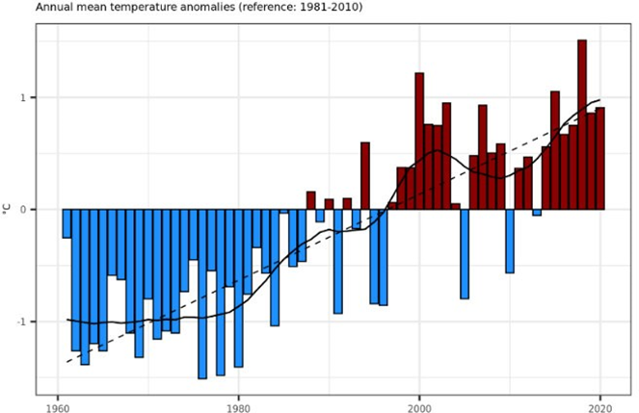
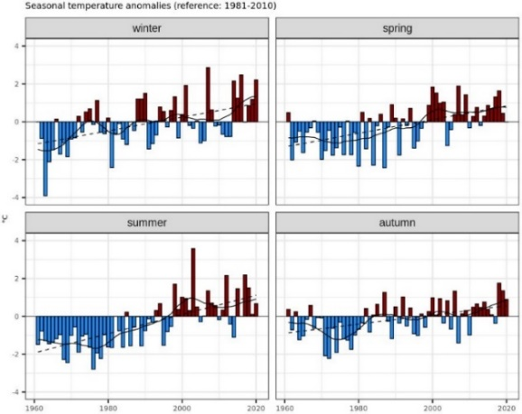
Figure 2 - 1 Regional time series of average temperature anomalies from 1961 to 2020. The anomalies are based on the difference with the 1981-2010 period. The black line shows the series with a low pass Gaussian filter, the dashed line is the trend.
To identify the areas subjected to the highest risks, the study presents the maps of anomalies between 1991-2020 data and the 2021-2050 projections. The climate change impacts are evaluated based on the worst-case scenario (RCP 8.5).
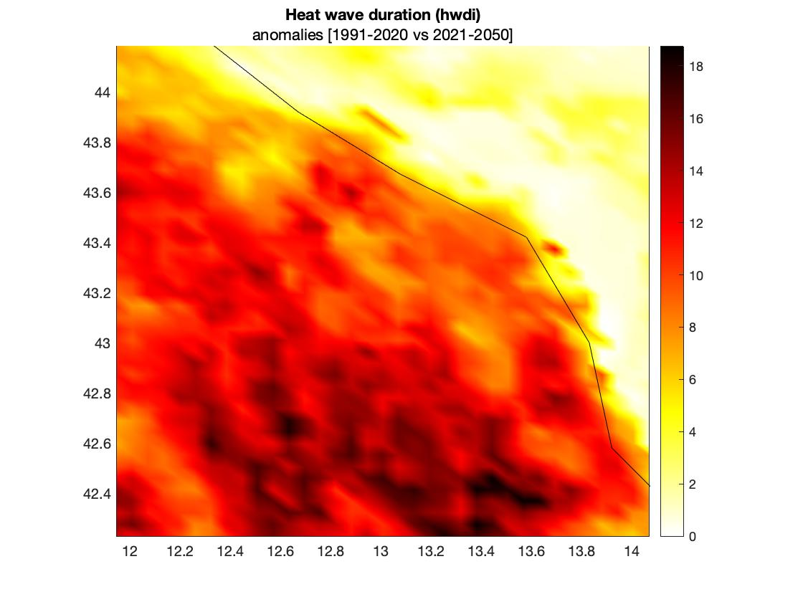
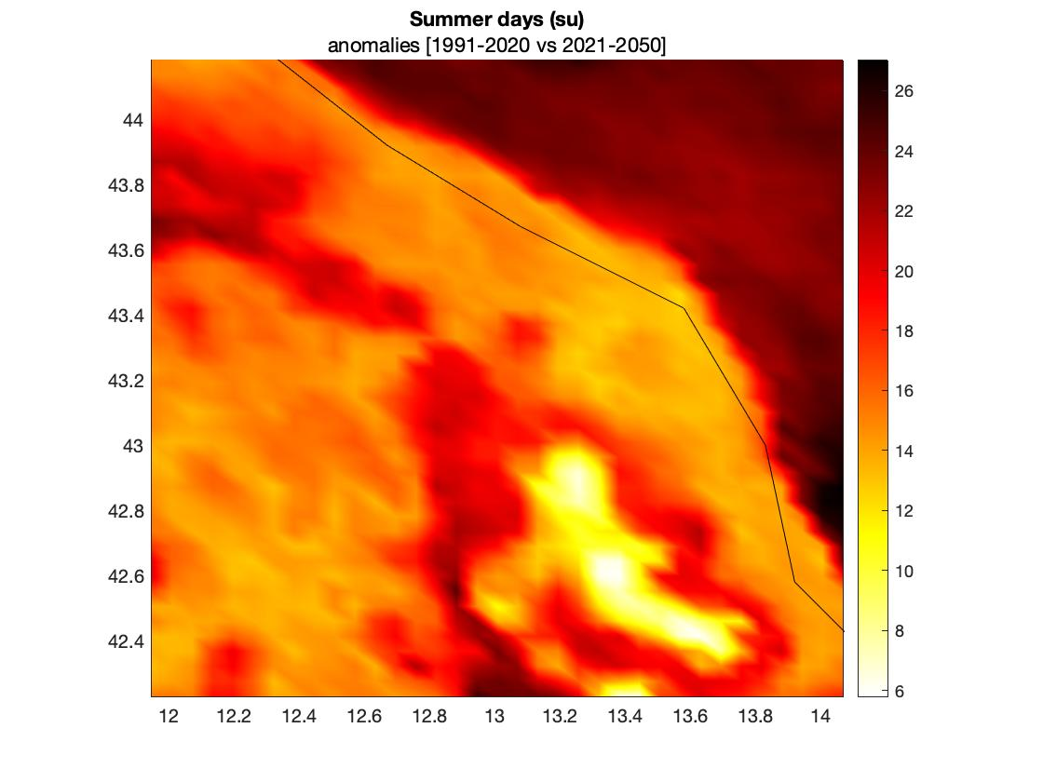
The indicator of Summer days (su) shows that the anomalies increase mainly in the hills and mountains, except for the southern area. The anomalies of the Heat wave duration assume higher values in the inland area, particularly in the southern mountain area.
Figure 2 - 2 Summer Days of the Marche Region and Heat waves duration, anomalies between historical series and the projection.
For the precipitation, the anomalies in respect to the 1981-2010 period, show no statistically significant trend for the annual average. Nevertheless, data show change in the annual distribution of events and in the intensification of extreme events.

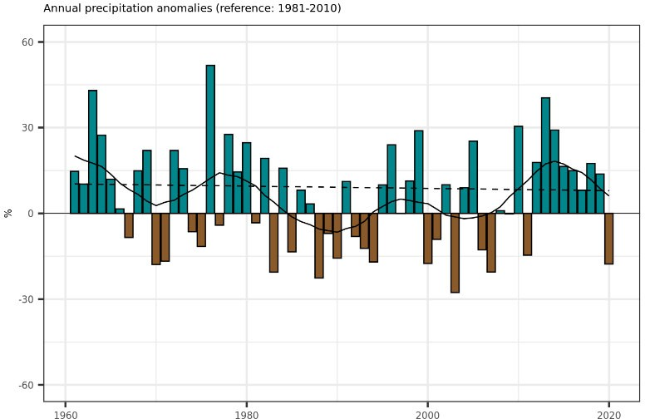
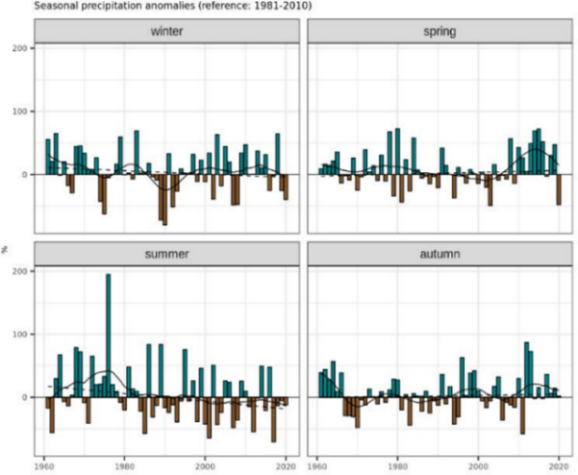
The Consecutive dry days (referred to the annual highest number of consecutive dry days), changes from an average value of 35.87 days (1991-2020) to 51.23 days in 2021-2050, with an increase of 42.8%.
Figure 2 - 3 Regional time series of annual precipitation anomalies from 1961 to 2020. The anomalies are based on the difference with the 1981-2010 period. The black line shows the series with a low pass Gaussian filter, while the dashed line is the trend.
Figure 2 - 4 Consecutive dry days of the Marche Region, anomalies between historical series and the projection and trend of the annual average
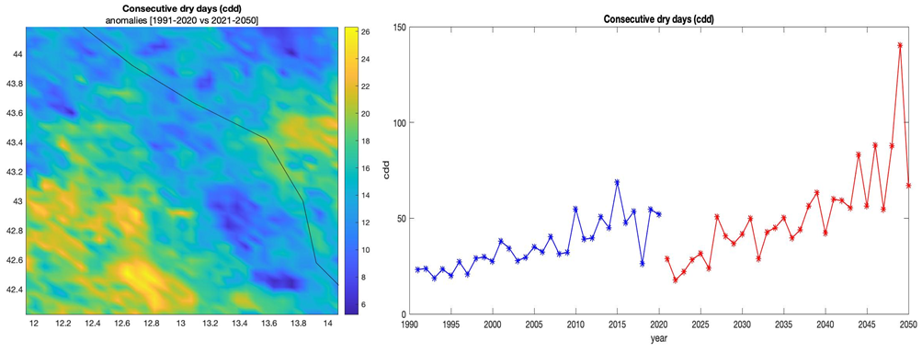
The increase in temperature and the shift in precipitations implies higher risk of drought. Although the drought is caused by various ecological and geo-pedological factors, climate factors can be used to identify the areas subjected to potential hazard. In particular, the anomalies in the projections of the Consecutive dry days are critical in the northern coastal area and the southern inland areas. The Consecutive summer days distribution is related to the orography of the Region, with higher values along the coastal areas and lower in the inland areas. Therefore, it is expected an increased risk of drought in the northern coast, the center hill areas, and an hotspot in the southern mountain.

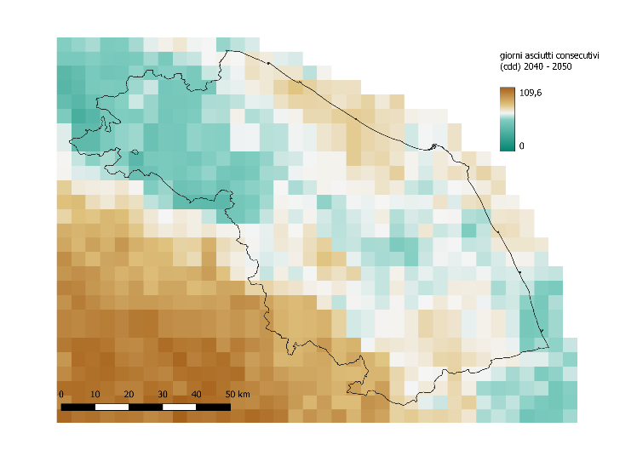
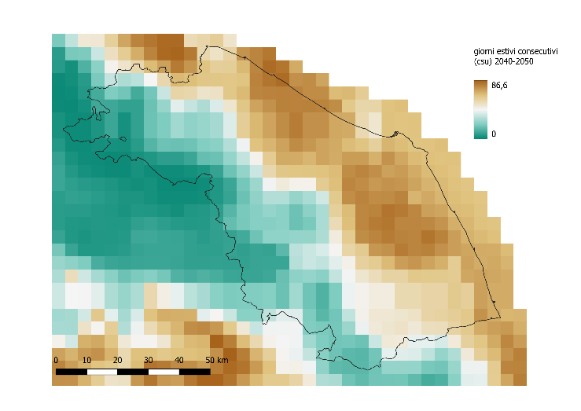
The shift in precipitation regime, and especially the intensification of extreme events, imply a risk in the frequency and intensity of river floods.
Figure 2 - 5 Consecutive dry days (cdd) and consecutive summer days (csu) in the 2041-2050 period
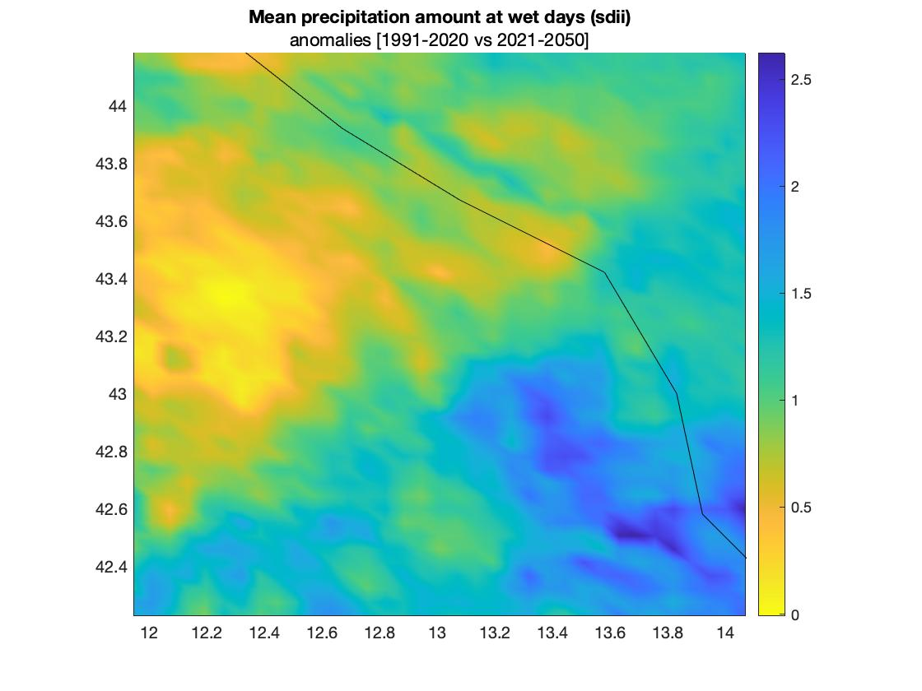
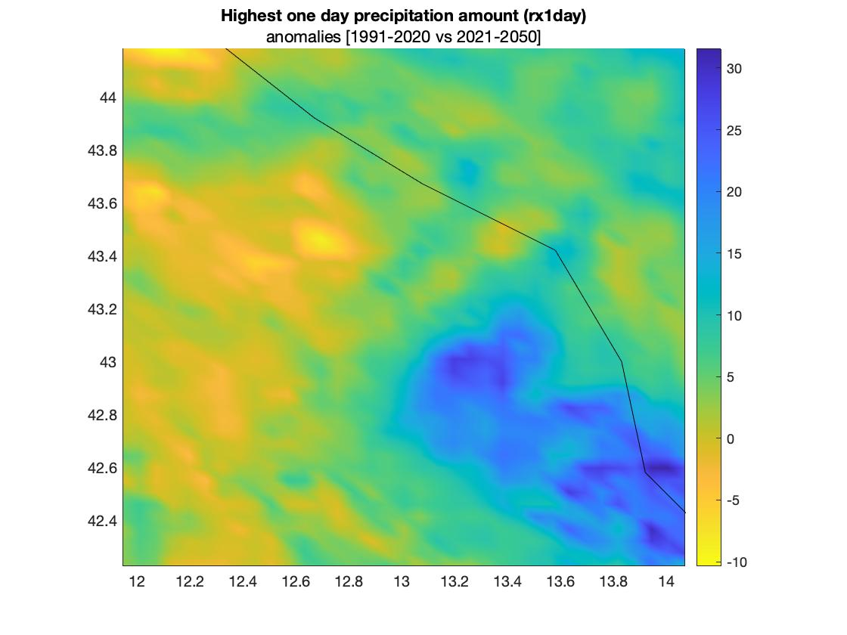
To investigate the risk of floods, important indices are the following. The Mean precipitation amount on wet days increases on average from 7,75 mm/per day during the 1991-2020 period, to 8,82 mm/per day in the projection. The anomalies are higher in the South of the region. The Highest one day precipitation amount rises by 12,9% in the projections; the highest value are in the coastal southern area.
Figure 2 - 6 Mean precipitation amount on wet days of the Marche Region and Highest one day precipitation amount, anomalies between historical series and the projections
For the risk of flood, it is important to consider vulnerability and exposure, related to the characteristic of the territory. The Floods Directive (2007/60/EC) identifies the areas at hydraulic risk based on three scenarios. ISPRA presents the data regarding the areas at hydraulic risk produced by the District Basin Authorities on the three scenarios defined by the Floods Directive. In the Region, 0.1% of the territory is associated with high-risk flood events areas, 2.7% with medium-risk areas and 4% with low-risk areas. The values are lower than the national averages, which are respectively 5.4%, 10% and 14%. Nevertheless, direct experiences show, in recent years, an increase of flooding with economic damages and in some case with loss of lives, both in terms of frequency and intensity. An example is the event occurred in September 2022 and associated with extreme precipitation (with peak of 419 mm recorded by rain gauges) and causing catastrophic damage to infrastructure and property, as well as tragic loss of life.
Maps of flooding with different return period are essential to properly assess the risk. In addition to those provided by JRC, the department of Civil Protection of Marche region has produced simulation for some river basin. This simulation can be integrated in the workflow for the risk analysis.
Concerning droughts, the agricultural sector, by its nature closely linked and dependent on variations in temperatures and precipitation, is strongly affected by the alterations caused by climate change, also in terms of economic yield. To properly assess the risk, it is essential to have information on the type of cultivation. This data is available at regional level from the regional service of agriculture, but are not complete and homogeneous.

Workflow selection

Workflow #1 – River flooding
The workflow river flooding is finalised to the estimation of damage, displacement, economic losses and other impact. The workflow is applied in a selected pilot. One of the main adaptation measure for the risk of flooding is related to the displacement of infrastructures, of urban settlement and of construction in general. Urban planning is the primary instrument for the application of this adaptation measure. For this reason, local authorities are the main stakeholder for this risk analysis. Nevertheless, local population, local enterprise and owner of local infrastructures, are the vulnerable groups exposed to the risk.

Workflow #2 –Agricultural drought
The workflow Agricultural drought allows quantifying the revenue losses deriving from the reduction in crops yield due to precipitation scarcity and absence of irrigation. Agriculture in Marche is scarcely dependent from irrigation: less than the 4% of the available agricultural area in the region is irrigated. Nevertheless, climate change is creating problems to traditional cultivation. The awareness about the potential loss related to specific cultivar is important to address the agricultural choice. Farmers are the primary stakeholder, together with the regional service for Agriculture that can provide tools to adapt the agricultural system to climate change.

Choose Scenario
The choice of the scenario combines the need of accounting for the time-frame of public policies with the effect and consequence of climate change on social and economic dynamics. Public policies are usually focused on short-term impact; nevertheless, climate dynamics impose to act now to prevent future impact. For this reason, the medium term is assumed as relevant scenario, with a near-future time term fixed at 2050. This coincide with the scenario chosen for the RPACC and it is available in the workflows.

Risk Analysis

Workflow #1 Flood river
In this first phase of the project, the workflow was applied with the standard methodology. A pilot area was chosen for the application, corresponding to the last part of River Foglia Basin. For this area map of flooding developed locally are available and could be used for the refinement of the workflow (second phase). The hazard expresses the probability that a damaging flood of a given severity occurs in a given timeframe (return period - RP). The following RP have been considered in the analysis: 10yr, 50yr, 100yr, 200yr, 500yr. In this phase for the hazard are used flood depth maps, available from the Joint Research Centre for different return periods.
Exposure is accounted with the land use map, available from the Copernicus Land Monitoring Service and with the Flood-damage curves for infrastructure expressed as relative damage percentage, available from JRC. The economic value for different types of land use account for vulnerability.

Table 2 - 1 Data overview workflow #1
Hazard data | Vulnerability data | Exposure data | Risk output
River flood maps | Economic value for land use | Land use | River flood damage
 |  | Flood damage curve

      - Hazard assessment

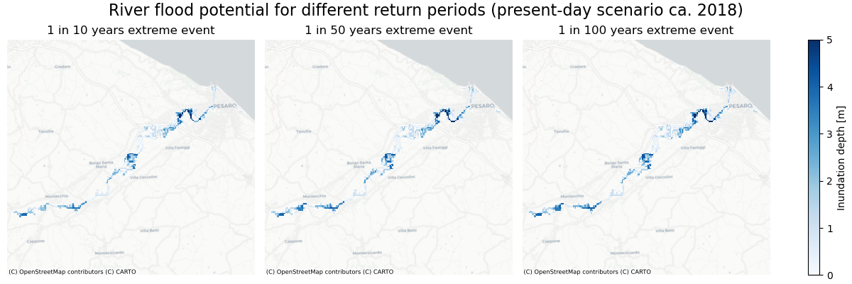
The hazard assessment has analyzed different return the flood potential with different return period. In this first attempt, present day scenario was considered.
Figure 2 - 7 River flood potential for different return period for the river Foglia pilot, present day-scenario
The inundation depths are analyzed to assess the impact of climate change b on the projected extreme river flooding y a coarse-resolution dataset from Aqueduct Floods to assess the impact of climate change.
The comparison between the projected inundation depths in the future under climate scenarios and the baseline maps (1980 climate) show slightly negative values, expecting a decrease in inundation depth, possibly due to reduced river flow (see supplementary material).
      - Risk assessment
The risks of river flooding to built infrastructure are expressed in the form of economic damage, combining data regarding river flood maps, land use maps and economic vulnerability. Country-specific information is required to calculate the economic damages, adjusted to GDP.
Figure 2 - 8 River flood damages for the river Foglia Basin for 3 RP: 10yr, 50yr, 100yr
In order to evaluate locations potentially most economically affected, the damage maps, the potential flood depths and the associated economic damages are used.
Figure 2 - 9 River flood damages, potential flood depths and land cover for the river Foglia Basin for 100yr RP

Workflow #2 Agricultural droughts
In this first phase of the project, the workflow was applied with the standard methodology. The whole Marche region was selected as study area. According to the standard methodology, the soil standard evapotranspiration (ET0) is combined with a series of crop-specific information to derive the crop standard evapotranspiration (ETc) and the actual crop evapotranspiration (Eta).
Climate data (daily mean precipitation flux, maximum and minimum temperature, 2 m relative humidity, surface downward solar radiation and 10 m wind speed) are from CORDEX regional climate models.
For exposure, data of common methodology includes: soil available water capacity in mm (Hengl and Gupta, 2019), elevation (Danielson & Gesch, 2011) and thermal climate zone (Van Velthuizen et al., 2007)
To determine the exposure to precipitation scarcity, different crops were selected (namely, sunflower, wheat and lentil) and global production [ton] in 2010 was extracted from the MapSPAM repository (International Food Policy Research Institute, 2019). Crop aggregated value [US$] was derived from the FAO-IIASA Global Agro-Ecological Zones data repository (GAEZ). Global production [ton] for 42 crops in 2010.

Table 2 - 2 Data overview workflow #2
Hazard data | Vulnerability data | Exposure data | Risk output
yield loss | Distribution of fully-irrigated cropland | Crop specific information (lentil, sunflower and wheat) | Revenue loss
 |  | Crop aggregated value

      - Hazard assessment
The hazard analysis has been performed following:
- rcp 2.6 for wheat
- rcp 8.5 for wheat, sunflowers and lentil
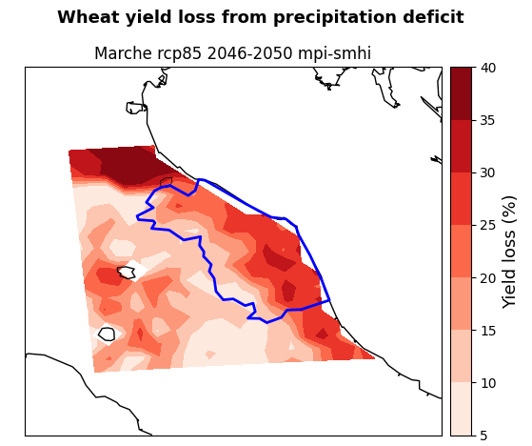
In the following are shown the comparison between the yield loss for the two rcp for wheat and the rcp 8.5 for lentil and sunflower.
Figure 2 - 10 Wheat yield loss from precipitation deficit for rcp 2.6 (left frame) and rcp 8.5.(right frame), projection at 2046-2050, crop: wheat

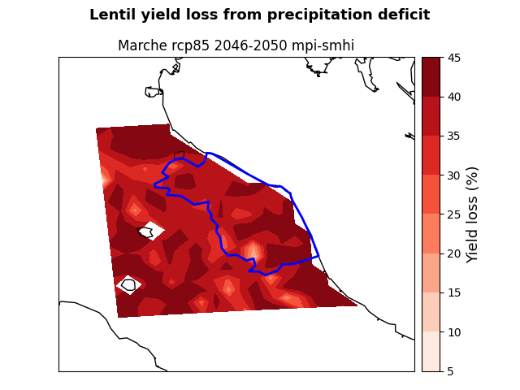
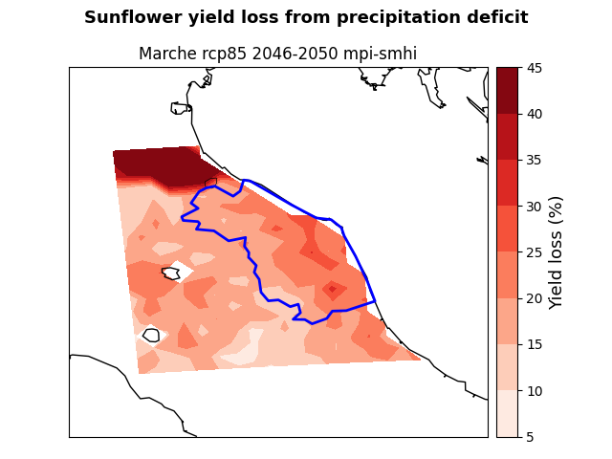
Figure 2 - 11 Yield loss from precipitation deficit for sunflower (left frame) and lentil (right frame), under rcp 8.5, projection at 2046-2050
      - Risk assessment
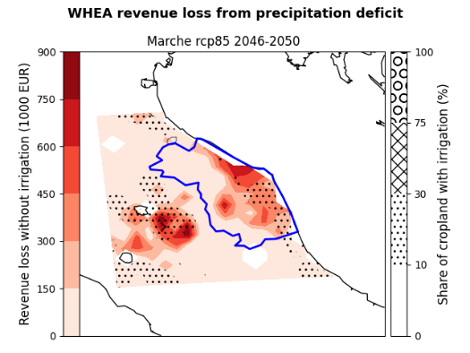
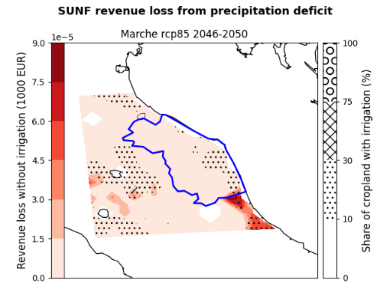
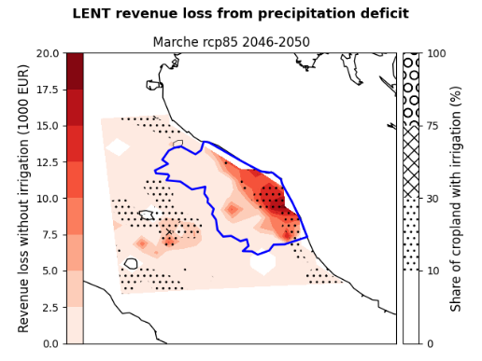
The analysis shows the potential revenue losses from irrigation deficit in the region for the selected crops, for the emission scenario RCP 8.5 at 2046-2050. The revenue losses are the ‘lost opportunity cost’ in thousands of euros if crops are grown under non-irrigated conditions. The areas of the region that are expected to suffer the greatest losses are the coastal center area for wheat and the coastal south area for lentils, while there are not relevant losses for sunflowers.
Figure 2 - 12 Revenue losses for the RCP8.5 scenario in Marche Region, starting from the left for wheat, sunflowers; lentils.

Preliminary Key Risk Assessment Findings

Severity
For the flood river, the risk analysis in the pilot area shows high level of damage in localized spot even for low return period (10 yr). More intense events (i.e. with return period of 100 or 200 yrs), extend the areas damaged and, consequently, increase the risk. The presence of such kind of risk is confirmed by recent experience. The analysis performed here indicates an increase in the intensity and frequency of risk.
Concerning agricultural drought, comparing the rcp 2.6 with the rcp 8.5 scenario for wheat, it emerges an increase in yield loss from precipitation deficit, corresponding to an increase in the revenue loss. Wheat shows high level of revenue loss especially in coastal-hill areas. For the other crops considered in the analysis, only lentil seems to show high level of risk, whereas sunflower seem not to be affected by such a risk.

Urgency
For the flood river risk, the analysis shows potential consistent damage even with low return period (10 yr). This implies an urgency in the application of adaptation measures. Furthermore, the concept of “return period” is associated to the probability of the occurrence of the event; a return period of 200 yr represents a high intensity with low (but not null) probability. In recent year, occurred several catastrophic events with high return period. For example, the flash flood that hit the Misa basin in central on September 15, 2022 was an event with a return period of over 500 years, causing 13 victims, 50 wounded, and damage for 2 billion euros.
In recent years (2017, 2022, 2024) was officially recognized from national and regional governments the state of natural calamity for agricultural drought for the territory of Marche. These situations provoked loss of income to agricultural sector. It is hence clear the urgency to act to prevent this situation. The risk modelled with the CRA allow to better understand which vulnerabilities could be addressed to reduce the risk.

Capacity
To afford the risk of flooding, civil protection has developed systems for alert and response to the events. Furthermore, the municipalities, are developing and improving their climate adaptation plans, also with the coordination and support of Marche region, with the project Marche2Resilience (in P2R project) are addressing flood risk as a priority: in their adaptation plans, municipalities consider river flood as a priority.
Nevertheless, the application of adaptation measure such as displacement or revision of urban planning, needs of a more accurate risk analysis of those obtained with the application of Climaax standard methodology. In particular, more accurate data on exposure would help to better quantify the potential loss.
For agricultural drought, the regional Agricultural Department (managing the European funds for agriculture), for past events has restored farmers for loss of income derived by drought episode recognized has natural calamity. This can be considered a mitigation measure, since it acts to mitigate a damage after this is happened. Both the RPACC and the Regional Program for the Agricultural Fund has adaptation measures, finalized to make the agricultural systems more resilient acting directly on agricultural systems (in terms of choice of culture, modality of cultivation, use of water resources, etc.) and/or on knowledge and awareness (with climate service addressing farmers’ choices, but also with information and formation of farmers).
Results emerging from the CRA will help public policies to address they effort to the most affected and vulnerable areas in order to implement the adaptation strategies. At the same time, the information, provided by the data regarding the areas and products less affected by water stress, can be used to guide cropland expansion.
The regional Agricultural Department also manage the SIAR (Regional Informative System for Agriculture) that could supply local data on crop production for better assessing vulnerability and exposure and hence drive the adaptation measures.

Preliminary Monitoring and Evaluation
As mentioned in previous paragraph, this first application of the workflows has allowed to have a first broad analysis of risks addressed and to identify the potentiality for improvement.
For the river flood, accuracy in information is essential: thus the use of more accurate data (such as those deriving for urban planning) instead of the general land use is planned for the phase 2.
The stakeholder involvement on this topic has confirmed this need, since the indication in terms of risk will be transposed in adaptation measure inside urban planning.
Similarly, for agricultural drought the first application has shown the potential risks but the use of the workflow need to be refined with more accurate information for the regional context. Since uniform data on exposure and vulnerability for Marche are lacking, a possibility is to select for phase 2, one or more pilot with data available.

Conclusions Phase 1- Climate risk assessment
The first phase of the application has allowed reaching different kind of conclusion for the two workflows.
The Flood River workflow at the pilot level has allowed understanding the importance of the accuracy of the evaluation. Since from this workflow it is expected to understand the opportunity of displacement (or, more in general, where and how by urban planning we would increment the resilience in respect to the specific risk), it is important to evaluate the potential damages in terms of “real” exposure. The second phase will include in the workflow information from urban planning, with the actual presence of settlement, infrastructures, industries, etc.
In addition, a more accurate knowledge of the hazard in terms of flooding with different return period, is essential to better address the adaptation measures. In this regard, during the second phase, the simulation produced by the department of Civil Protection of Marche region could be integrated in the workflow for the risk analysis.
The agricultural drought shows the risk in terms of revenue loss from precipitation deficit. One of the elements used for the vulnerability is the share of cropland with irrigation. In this respect, Marche region has an agricultural asset based on traditional practices with a low use of irrigation, especially for traditional crops (as wheat and legumes). In this respect, the use of irrigation to measure the vulnerability could be not appropriate. The choice of vulnerability and exposure indicators is critical since vulnerability is influenced by many processes and over-simplifications might lead to unrealistic estimates (Villani et al., 2022). In the second phase should be useful to consider local data on crop and production to refine the analysis. This could help to identify proper and efficient adaptation measures.

Progress evaluation and contribution to future phases
According to the project presented, in the following are listed the key performance indicator and the state of the progress.
Table 4 - 1 Overview key performance indicators
Key performance indicators | Progress
[n. 1] M-R-A formally completed in Marche Region using CLIMAAX methodology | In progress, phase 1 completed
[n. 2] annual meeting report on stakeholder engagement | The stakeholder engagement is tarted, but the report have not yet been produced.
[n. 2] of notes for policy makers | To be done
[n. 4] of adaptation measures identified/refined | 2 adaptation measures identified for the river floods (displacement and urban planning) but need to be refined.  The further 2 adaptation measures on agricultural drought are under evaluation
[n. 10] articles in regional media mentioning the project | To be done
[n. 1] scientific article published regarding Marche Region CLIMArcheX project and its pilot action | To be done

For the milestones, according to the project, for the first semester the following two were expected, and both have been achieved. The first milestone corresponds to the application of the common methodology, for river flood, that is presented in this deliverable.
The second milestone requires organization of internal meetings. The internal task force has established and applied the following organization:
    - One designated member (climate expert) participates to the CLIMAAX support drop-in sessions
    - Internal meetings with other staff member were organized to transfer information and organize the work.
In the first semester, two internal meetings were organized for the organization of the work:
    - 05/11/2024 (online)
    - 28/01/2025 (hybrid – presence + online)
In addition, quick meetings on specific topic were organized by sub group for the implementation of the work.

Table 4 - 2 Overview milestones
Milestones | Progress
M1: Application of the common methodology for the flood risk made | First application of the CLIMAAX common methodology and toolbox in the regional context for the flood risk is performed, through the collaboration internal project staff and regional officers
M4: At least 2 internal meeting are organized | Participation to CLIMAAX support drop-in sessions plus 2 internal meeting with regional staff

Supporting documentation

- River floods workflow
  - Hazard – Floodmap_overview_JRC_PresentScenario_Foglia_Italy.png
  - Hazard – Floodmap_overview_JRC_PresentScenario_Foglia_Italy_2.png
  - Hazard – Floodmaps_AqueductFloods_Foglia_Italy_RCP4.5.png
  - Hazard – Floodmaps_AqueductFloods_Foglia_Italy_RCP8.5.png
  - Hazard – Floodmap present scenario Foglia_Italy RP 10-50-100-200-500 (tif)
  - Hazard – Acqueduct floods (netcdf)
  - Hazard - Floodmaps_all_JRC_PresentScenario_Foglia_Italy (netcdf)
  - Risk – Floodmap resampled Foglia_Italy RP 10-50-100-200-500 (tif)
  - Risk – Land_use_Foglia_Italy.tif
  - Risk – Result_map_Foglia_Italy_damages_overview.png
  - Risk – Result_map_Foglia_Italy_rp100.png
  - Risk – Flood_Foglia_Italy_damagemap RP 10-50-100-200-500 (tif)
  - Risk - LUISA_damage_info_curves_Foglia_Italy.xlsx
  - Risk – Maxdam_luisa.csv
  - Risk - Curves.csv
  - Risk – Flood_Foglia_Italy_ damages RP 10-50-100-200-500 (csv)

- Agricultural drought workflow
  - Rcp8.5 – Marche Standard evapotraspiration (png)
  - Rcp8.5 – Marche_yield_loss_SPREADSHEET.csv
  - Rcp8.5 – Marche yield loss for lentil, sunflower wheat (png)
  - Rcp8.5 – Marche revenue loss for lentil, sunflower wheat (png)
  - Rcp2.6 – Marche Standard evapotraspiration (png)
  - Rcp2.6 – Marche_yield_loss_SPREADSHEET.csv
  - Rcp2.6 – Marche yield loss for l wheat (png)
  - Rcp2.6 – Marche revenue loss for wheat (png)

- References
Arnell, N. W., & Gosling, S. N. The impacts of climate change on river flood risk at the global scale. Climatic Change, 134, 387-401. doi:10.1007/s10584-014-1084-5 2016.
Danielson, J. J., & Gesch, D. B. Global multi-resolution terrain elevation data 2010 (GMTED2010) (No. 2011-1073). US Geological Survey. https://doi.org/10.3133/ofr20111073 2011.
García-León, D., Standardi, G., & Staccione, A. An integrated approach for the estimation of agricultural drought costs. Land Use Policy, 100, 104923. https://doi.org/10.1016/j.landusepol.2020.104923. 2021.
International Food Policy Research Institute. Global spatially-disaggregated crop production statistics data for 2000 version 3.0.7. Harvard Dataverse, V1. doi:10.7910/DVN/A50I2T 2019.
Tomislav Hengl, & Surya Gupta. Soil available water capacity in mm derived for 5 standard layers (0-10, 10-30, 30-60, 60-100 and 100-200 cm) at 250 m resolution (v0.1) [Data set]. Zenodo. https://doi.org/10.5281/zenodo.2629149. 2019.
Van Velthuizen, H. Mapping biophysical factors that influence agricultural production and rural vulnerability (No. 11). Food & Agriculture Org. https://openknowledge.fao.org/handle/20.500.14283/a1075e 2007.
Villani, L., Castelli, G., Piemontese, L., Penna, D., and Bresci, E. Drought risk assessment in Mediterranean agricultural watersheds: A case study in Central Italy. Agricultural Water Management, 271, 107748, https://doi.org/10.1016/j.agwat.2022.107748, 2022.

