Comparison of accumulated precipitations maps (after the CRAHI-AEMet meeting on July 3, 2026)

First Part – Comparison between the maps shown and the rain gauges measurements
Second Part – Application of spatial filters to remove “white spots”

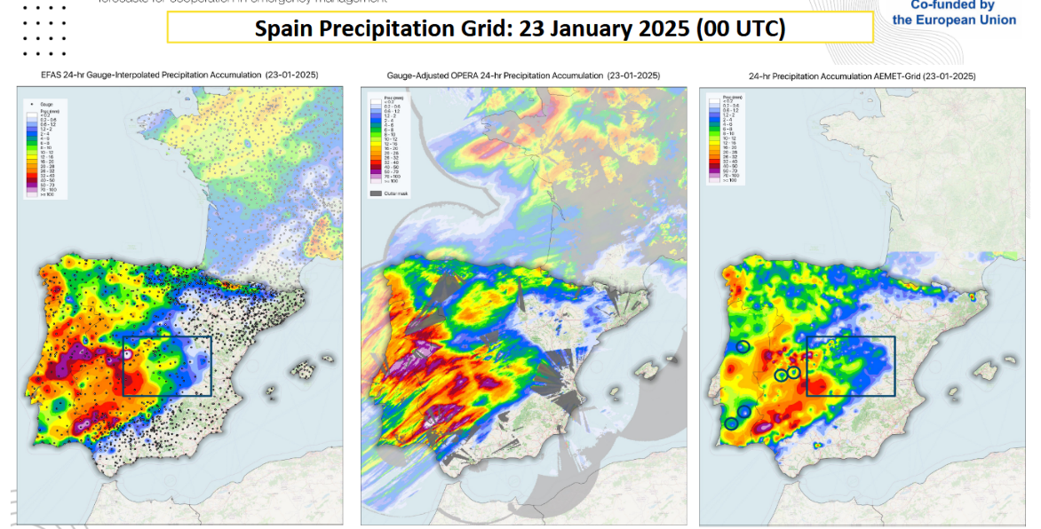
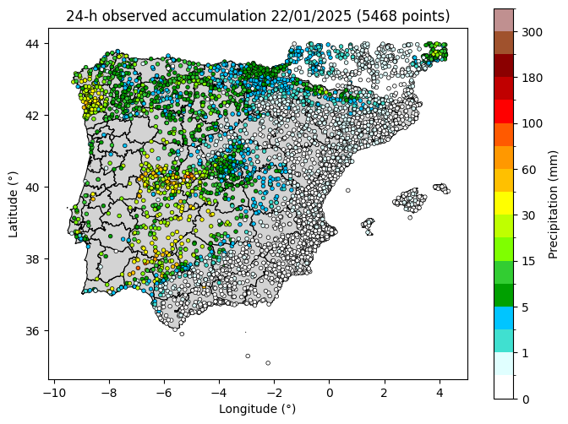
Figure 1 – Meeting slide and 24h- Acc. Precipitation on 23/01/2026 at 00:00
The inconsistency in central Portugal may be due to the lack of observations we have. Comparing the blue boxes, AEMet-grid shows that precipitation was more scattered than EFAS has suggested, probably due to the higher data density.
The circular highlights indicate localized low-precipitation values, embedded within higher-accumulation zones, as can be seen in the observation map below. Some spatial filters have been applied in order to remove these white spots. However, since some of them are relatively isolated (Figure 1), comparing them with their nearest neighbors requires applying a coarse filter that compromises the grid resolution. The results will be presented in Part Two of this document.

Comment: Any recommendations on spatial methods to address this issue without overly compromising the remaining data?

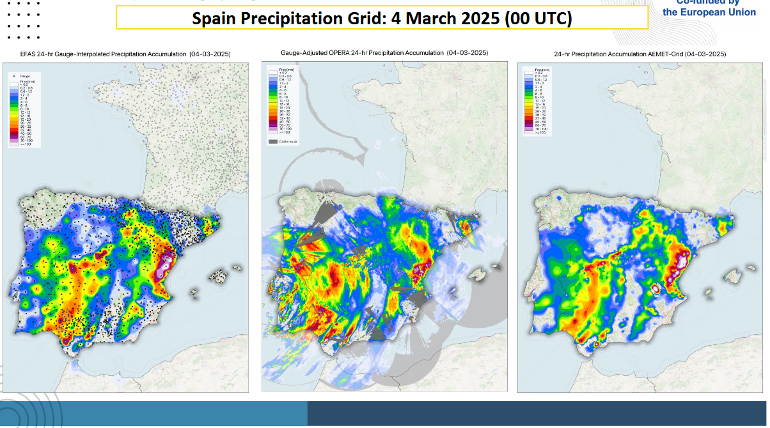

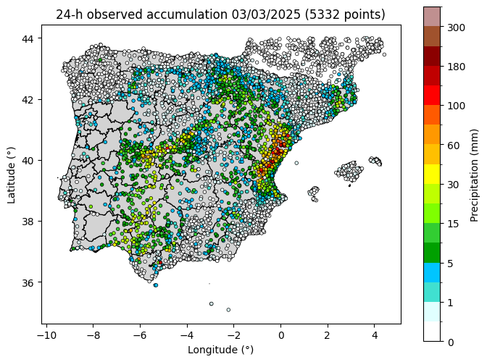

Figure 2 – Meeting slide and 24h- Acc. Precipitation on 04/03/2026 at 00:00

We see better consistency among the different methods of spatial precipitation estimation. As in the previous case, the lack of rain gauge data leads to an underestimation of high precipitation amounts in Portugal. The area with the highest accumulated precipitation in Spain on this day – The Valencian Community- shows consistent results between the EFAS interpolation and the AEMet kriging-interpolation. In addition, due to the higher density of data points in the region, the kriging interpolation map reflects a more detailed spatial distribution of precipitation.

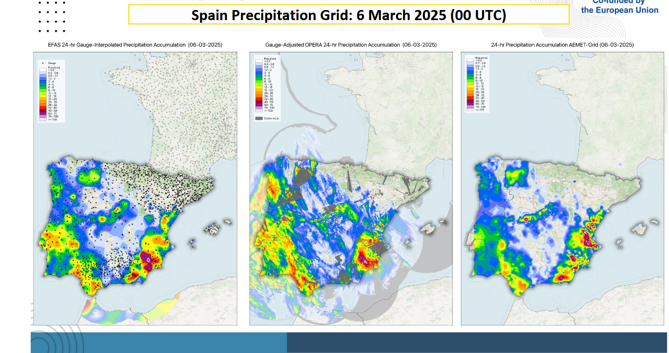
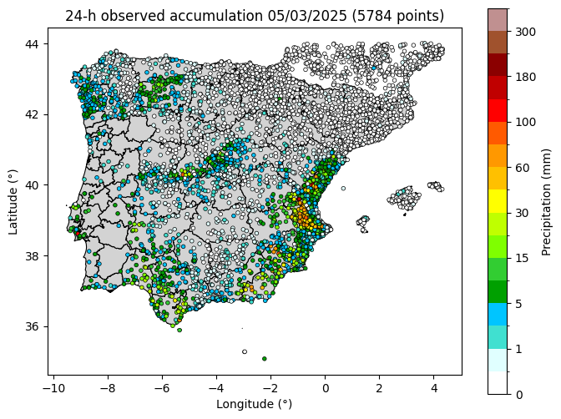

Figure 3 – Meeting slide and 24h- Acc. Precipitation on 06/03/2026 at 00:00

EFAS suffers from a spatial sampling bias (high density where no rain occurred and low density where the heavy precipitation was registered). In contrast, the national AEMet network along the east coast resolves the structure using kriging.

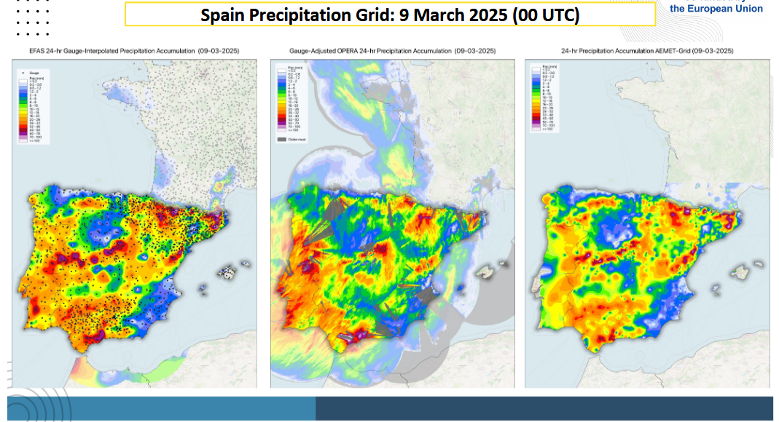
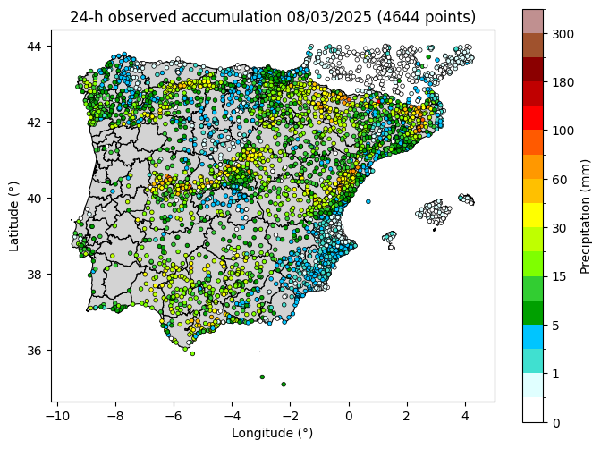

Figure 4 – Meeting slide and 24h- Acc. Precipitation on 09/03/2026 at 00:00
In this last case, we observe similar patterns to those previously highlighted. The higher data density of the AEMet network yields a finer-grained spatial interpolation that avoids the smoothing of the EFAS 24-hr gauge interpolated product. Here, the precipitation maxima align spatially, scattered across the central Peninsula, the northeast and the south. Based on observations, the areas with the heaviest rainfall are well covered by a significant density of rain gauges.

Second Part – Application of spatial filters to remove “white spots”
To improve the quality of the precipitation grid, two different method have been implemented to remove the “white spots” observed in maps:
- Comparison with local maximum precipitation. The value of each gauge is compared against the maximum precipitation reported by surrounding stations within a fixed search radius (5 km), using a threshold of 3.0. Under this criterion, a point is removed if its value is less than de local maximum divided by the threshold. For example, if the maximum local precipitation is 30 mm, the precipitation is removed if it is under 10 mm.

- Comparison with k-nearest neighbors. On average, there are 2.5 stations within 5 km and 8 within 10 km around each gauge. Based on these spatial metrics, k=6 nearest neighbors (regardless of distance) were selected for comparison. Each station’s value is compared against the average precipitation of its 6 nearest neighbors, and any value falling below 40% of this local mean is removed.

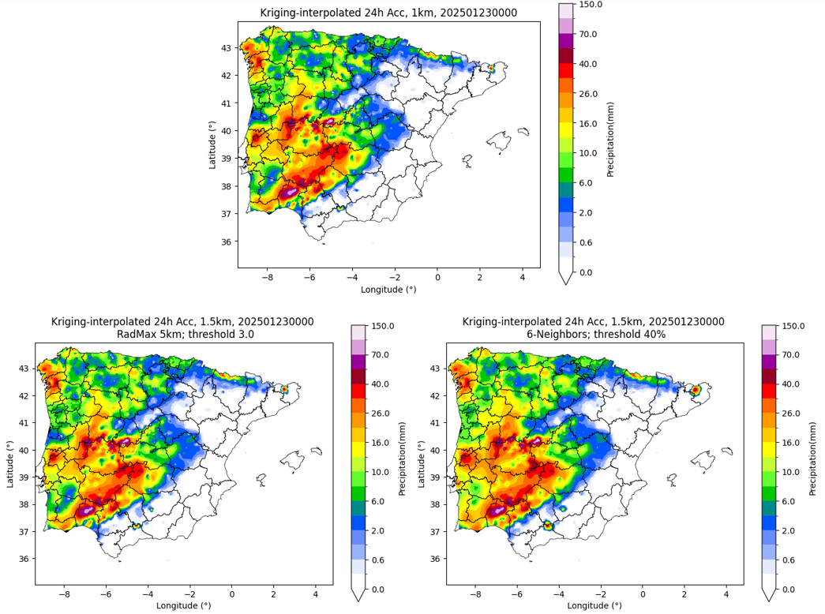

Figure 5 – Kriging-interpolated 24h- accum precipitation on 22/01/2025 with different
spatial filters applied
Although the filter/comparison with maximum local precipitation (left) removed approximately 4% of the total network (223 station), it failed to resolve the visual artifacts in the kriging output. The reason is the irregular spatial density of the measurement stations. Most stations meeting the criterion are located in densely populated urban areas with a high density of measurement points. Stations located in sparse regions had zero or insufficient neighbors within 5 km. Consequently, the map obtained after applying this filter is almost identical to the original one.

On the other hand, the k-nearest neighbors filter shows higher efficiency. It successfully eliminated isolated false minima, regardless of local network density. The resulting interpolated field displayed smoother patters.
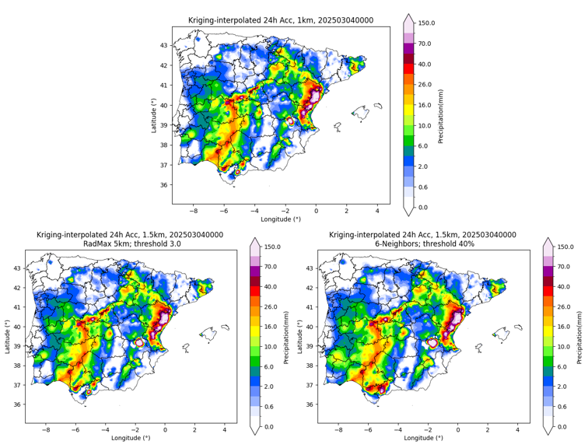

Figure 6 – Kriging-interpolated 24h- accum precipitation on 23/03/2025 with different spatial filters applied

Large white patch due to the removal of a point with excessively low value within a rainfall area:
While the k-neighbors filter removes localized anomalies, in sparce networks it can occasionally remove transition stations, creating interpolation voids (large white parches) in kriging procedure. Probably adjusting the threshold to a slightly more conservative radio or adding a distance constraint balances noise removal while preserving regional spatial continuity
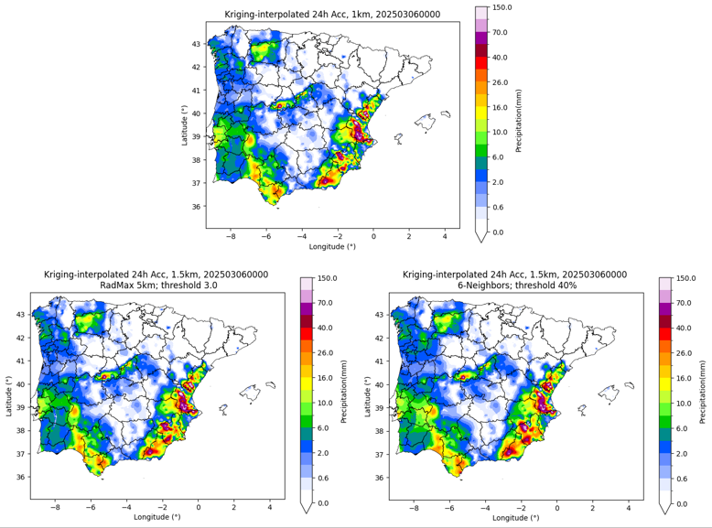

Figure 7 – Kriging-interpolated 24h- accum precipitation on 05/03/2025 with different spatial filters applied

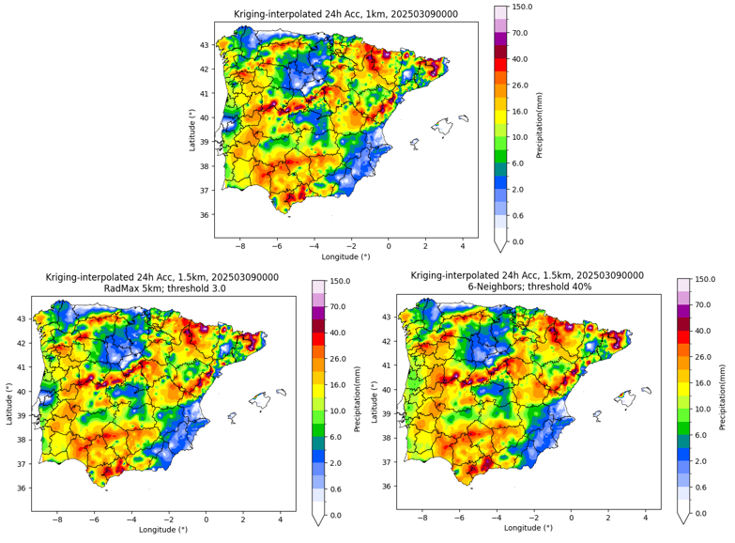

Figure 8 – Kriging-interpolated 24h- accum precipitation on 08/03/2025 with different spatial filters applied

