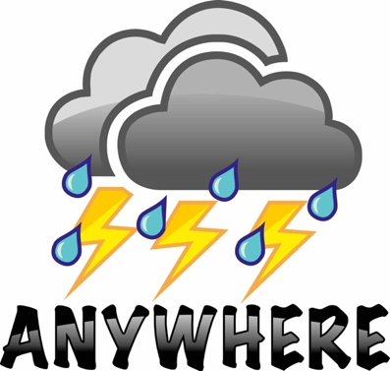

Project Number 700099
Call: H2020-DRS-01-2015

Project Title:
ANYWHERE
EnhANcing emergencY management and response to extreme
WeatHER and climate Events

Subject:
Deliverable 7.4:
Innovation Exploitation Plan

Dissemination Level:
CO | Confidential, only for members of the consortium (including the Commission Services)

Delivery date: 31st December 2019
Month: Month 43
Organisation name of lead contractor for this deliverable: RINA Consulting S.p.A.


This project has received funding from the European Union’s H2020 Programme under the topic of potential of current and new measures and technologies to respond to extreme weather and climate events under grant agreement no. 700099.
This document reflects only the authors’ views and not those of the European Community. The information in this document is provided “as is” and no guarantee or warranty is given that the information is fit for any particular purpose. The user thereof uses the information at its sole risk and neither the European Community nor any member of the Consortium is liable for any use that may be made of the information.

Document Information
Title | Innovation Exploitation Plan
Lead Author | Francesca Zappia, Ivan Tesfai – RINA-C
Contributors | WUR (Henny A.J. van Lanen and Remko Uijlenhoet), HYDS (Xavi Llort), AIRBUS (Christophe Vegetto), CIMA (Nicola Rebora), KAJO (Milan Kalas), METEODAT (Mario Rohrer), UNIGE (Markus Stoffel), GEO7 (Peter Mani), PREDICT Services (Eurico De Carvalho), WATERNUMBERS (Paul Smith), ECMWF (Fredrik Wetterhall and Claudia Vitolo), UPC-CRAHI (Marc Berenguer)
Distribution | CONFIDENTIAL
Document Reference

Document History:
Date | Revision | Prepared by | Organisation | Approved by
06-03-2018 | 1 - Exploitaiton approach and Definition of key exploitable results tables (Meeting in Spiez) | Ivan Tesfai | RINA-C | UPC-CRAHI, AIRBUS
31/07/2018 | 2- Delivery of first TOC version | Francesca Zappia, Ivan Tesfai, Christophe Vegetto, Bernardo Espinosa | RINA-C, AIRBUS, UPC-CRAHI | UPC-CRAHI
23/10/2018 | 3 – Draft document with preliminary content based on contribution from the Exploitation Workshop in Bastia | Francesca Zappia, Ivan Tesfai | RINA-C | AIRBUS, UPC-CRAHI
Oct - Nov 2019 | 4- Exploitation interview to responsible partners ok KERs | ALL | UPC-CRAHI, HYDS, WUR, AIRBUS, CIMA, SINTEF, KAJO, METEODAT/UNIGE, GEO7, PREDICT Services, UNS, RAB, FMI, UPB, CFR, ECMWF, WATERNUMBERS | RINA-C
9/11/2018 | 5-Results from the interwies included inside in the document | Francesca Zappia, Ivan Tesfai | RINA-C | UPC-CRAHI, AIRBUS
30/01/2019 | 6- Updated version of the document based on stakeholder’s comments during the Workshop in Barcelona | Francesca Zappia, Ivan Tesfai, Bernardo Espinosa | RINA-C, UPC-CRAHI | UPC-CRAHI
May 2019 | 7-Updated version of the document based on results from the Leipzig meeting | Francesca Zappia, Ivan Tesfai | RINA-C | RINA-C
29-30/10/2019 | 8- ANYWHERE foundation and exploitation routes information | Daniel Sempere-Torres | UPC-CRAHI | UPC-CRAHI
8/11/2019 | 9 - Addressing request to complete the report due to announced changes and further information acquired | Francesca Zappia, Ivan Tesfai | RINA-C
11-14/11/2019 | 10 – Share of material regarding the idea of foundation | Alexandre Sanchez | UPC-CRAHI | UPC-CRAHI
22/11/2019 | 11-Updated version of the document based on the material received | Francesca Zappia, Ivan Tesfai | RINA-C | UPC-CRAHI
27/11/2019 | 12-Share of material regarding foundation and association concepts | Gisela Vilalta | UPC-CRAHI | RINA-C
03/12/2019 | 13 – Updated version of the document with integration of UPC-CRAHI contributions | Francesca Zappia, Ivan Tesfai | RINA-C | RINA-C
19/12/2019 | 14 – Contributions from partners regarding exploitation intentions and integration of them inside the document | Henny A.J. van Lanen and Remko Uijlenhoet, Xavi Llort, Christophe Vegetto, Nicola Rebora, Milan Kalas, Mario Rohrer, Markus Stoffel, Peter Mani, Eurico De Carvalho, Paul Smith, Fredrik Wetterhall and Claudia Vitolo, Marc Berenguer | WUR, HYDS, AIRBUS, CIMA, KAJO, METEODAT, UNIGE, GEO7, PREDICT Services, WATERNUMBERS, ECMWF, UPC-CRAHI | RINA-C
20/12/2019 | 15 – Final version of the document | Francesca Zappia, Ivan Tesfai | RINA-C | UPC-CRAHI

Related Documents:
This report and others are available from the ANYWHERE Project Website at: http://www.anywhere-h2020.eu/

© Members of the ANYWHERE Consortium

Summary
This document constitutes Deliverable D7.4 “Innovation Exploitation Plan” in the framework of ANYWHERE project. Activities reported within the document are related to Work Package 7 “Innovation Exploitation, Business models and Market development (M3-M43)”, and specifically to Task 7.6 “Innovation Exploitation plan.
The goal of Task 7.6 is to achieve an Innovation Exploitation Plan that considers the complexity of the several types of participants in the project, including the developers of background and of the unique innovations that constitute the exploitable results, as well as the stakeholders participation on the definition and validation of the results on the pilot sites and also the implementing parties through the Market Exploitation Committee that will use their current and future solutions to help to push ANYWHERE into many sectors.
The deliverable is focused on:
- the description of the exploitation methodology (Section 3)
- the identification and characterization of Exploitable Results and their prioritization (Section 4)
- the exploitation perspective per partner and the identification of background/foreground for each result and the exploitation claims of each partner (Section 5)
- the description of the IPR protection management (Section 6)
- insights from the business model and business plan activities from the deliverable D7.2 Business Plan Report by Market Segment (B2G,B2B, B2B2C) (Section 7)
- the last section briefly outlines the conclusions (Section 8).

Table of Contents
Document Information i
Document History: i
Related Documents: iii
Summary iv
Table of Contents v
List of figures viii
List of Tables ix
1 Introduction 10
1.1 Scope of Deliverable 11
1.2 Deliverable Structure 11
2 Work Methodology 12
3 ANYWHERE Exploitation approach 14
3.1 Current status of tools in emergencies management and weather forecast 15
4 Key Exploitable Results: final characterization and prioritization towards potential exploitation routes 24
4.1 Characterization of the Key Exploitable Results 26
4.2 Prioritization and integration of Exploitable results 28
5 Exploitation strategy at project and partner level 30
5.1 Exploitation strategies at project level 32
5.1.1 Association definitions 32
5.1.1.1 Aim and purpose 33
5.1.1.2 Membership 33
5.1.1.3 Governing bodies 33
5.1.1.4 Liability 33
5.1.1.5 Incorporation 34
5.1.1.6 Registration 34
5.1.1.7 Distribution of profit and losses 34
5.1.1.8 Taxes 34
5.1.2 Foundations 34
5.1.2.1 Aim and purpose 34
5.1.2.2 Membership 35
5.1.2.3 Governing bodies 35
5.1.2.4 Liability 35
5.1.2.5 Incorporation 35
5.1.2.6 Registration 35
5.1.2.7 Distribution of profit and losses 35
5.1.2.8 Taxes 36
5.1.3 The ANYWHERE foundation 36
5.1.3.1 Stage 1 – Management IP Royalties 38
5.1.3.2 Stage 2 – Facilitate agreement with implementing parties 49
5.1.3.3 Stage 3 – Facilitate commercialisation and distribution 50
5.2 Exploitation strategies at partner level 51
6 IPR management approach and plan 57
6.1 IPR protection strategy 57
6.1.1 Formal and informal IP protection – Intellectual Property Rights 57
6.2 IPR protection plan 59
6.2.1 ANYWHERE Exploitable Results and possible IPR protection tools 61
6.2.2 Patent mapping analysis 62
6.2.2.1 Meteorological forecast and nowcast 63
6.2.2.2 Floods, flash floods, debris flow and landslides 70
6.2.2.3 Storm surges 74
6.2.2.4 Heatwaves and weather induced health impacts 79
6.2.2.5 Weather induced forest fires 82
6.2.2.6 Droughts 89
6.2.2.7 Convective storms, severe winds 91
6.2.2.8 Snowfall 94
7 Insights from Business Model and Business Plan activities 97
7.1 ANYWHERE Business Model Canvas 97
7.1.1 ANYWHERE Unique Value Proposition 98
7.1.2 Achieving Break-Even 99
7.1.2.1 Fixed and Variable costs 99
7.1.2.2 Stages towards Self-Supportive Operation 100
7.2 Business Models for the ANYWHERE Foundation market segments 101
7.3 Business Models for the B2G market segment 103
7.3.1 B2G Value Proposition 103
7.3.2 B2G Business Model Canvas 106
7.4 Business Models for the B2B market segment 106
7.4.1 B2B Unique Value Proposition 106
7.4.2 B2B Business Model Canvas 107
7.5 Business Models for the B2B2C market segment 107
7.5.1 B2B2C Value proposition 107
7.5.2 B2B2C Business Model Canvas 108
8 Conclusions 109
9 ANNEX A.1 110
10 ANNEX A.2 112
11 ANNEX A.3 114
12 ANNEX A.4 117
13 ANNEX A.5 120
14 ANNEX A.6 123
15 ANNEX A.7 126
16 ANNEX A.8 129
17 ANNEX A.9 132
18 ANNEX A.10 135
19 ANNEX A.11 138
20 ANNEX A.12 141
21 ANNEX A.13 144
22 ANNEX A.14 146
23 ANNEX A.15 149
24 ANNEX A.16 152
25 ANNEX A.17 155
26 ANNEX A.18 158
27 ANNEX A.19 161
28 ANNEX A.20 163
29 ANNEX A.21 166
30 ANNEX A.22 169
31 ANNEX A.23 171
32 ANNEX A.24 173
33 ANNEX A.25 175
34 ANNEX A.26 178
35 ANNEX A.27 181
36 ANNEX A.28 184
37 ANNEX A.29 187
38 ANNEX A.30 190
39 ANNEX A.31 193
40 ANNEX A.32 196
41 ANNEX A.33 198
42 ANNEX A.34 201
43 ANNEX A.35 204
44 ANNEX A.36 207
45 ANNEX A.37 209
46 ANNEX A.38 212
47 ANNEX A.39 215
48 ANNEX A.40 218
49 ANNEX A.41 221
50 ANNEX A.42 224
51 ANNEX A.43 227
52 ANNEX A.44 230
53 ANNEX A.45 233
54 ANNEX A.46 236
55 ANNEX A.47 239
56 ANNEX A.48 242
57 ANNEX A.49 245

List of figures
Figure 1: Exploitation Plan building process 10
Figure 2: Preliminary list of Exploitable Results 12
Figure 3: Characterization Table 13
Figure 4: Potential exploitation routes 13
Figure 5: WMO Flood Forecasting Initiative (FFI) 19
Figure 6: DEWETRA platform 19
Figure 7: METEOALARM web site view 20
Figure 8: Dissemination and exploitation activities 24
Figure 9: ANYWHERE Value chain 30
Figure 10: ANYWHERE market uptake 32
Figure 11: Schematics of interaction of the ANYWHERE Foundation that through the core component of the MH-EWS would link the Supplier (Developers) towards the Clients (Platforms) that can be either 3rd party as well as internal like in the case of the A4EU and A4U Platform 37
Figure 12: Stage 1 – Management IP royalties 38
Figure 13: Stage 2 – Facilitate agreement with implementing parties 49
Figure 14: Stage 3 – Facilitate commercialisation and distribution 50
Figure 15: Different Intellectual Property Rights 57
Figure 16: Patent temporal trend (2009-2018) 64
Figure 17: Patent Publication Countries 64
Figure 18: Trend of the main applicants 64
Figure 19: Patent temporal trend (2009-2018) 70
Figure 20: Patent Publication Countries 70
Figure 21: Trend of the main applicants 71
Figure 22: Patent temporal trend (2009-2018) 74
Figure 23: Patent Publication Countries 74
Figure 24: Trend of the main applicants 75
Figure 25: Patent temporal trend (2009-2018) 80
Figure 26: Patent Publication Countries 80
Figure 27: Trend of the main applicants 80
Figure 28: Patent temporal trend (2009-2018) 82
Figure 29: Patent Publication Countries 82
Figure 30: Trend of the main applicants 83
Figure 31: Patent temporal trend (2009-2018) 90
Figure 32: Patent Publication Countries 90
Figure 33: Trend of the main applicants 90
Figure 34: Patent temporal trend (2009-2018) 92
Figure 35: Patent Publication Countries 92
Figure 36: Trend of the main applicants 92
Figure 37: Patent temporal trend (2009-2018) 94
Figure 38: Patent Publication Countries 94
Figure 39: Trend of the main applicants 95
Figure 40: Stage 1 of Operation - Start-Up. The Income is less than the total operational costs. The Vendor Entity must face the Deficit by funding it economically or by holding profit gains. 100
Figure 41: Stage 2 of Operation - Break-Even Point. The Income is equal to the total operational costs. The Vendor Entity records no gains but the partners stop funding the operation. 101
Figure 42: Stage 3 of Operation - Profit. The Income is superior to the total operational costs. The Vendor Entity records shares the gains towards the developer that must be reinvested into new solution, fixes and dissemination, but at the end should be a not-for-profit operation. 101
Figure 43: Hybrid Business Model for the ANYWHERE Foundation including the possible Revenue Streams. Adjusted from Karl Popp, 2010. 103
Figure 44: B2G - Public Protection and Disaster Relief 104
Figure 45: B2G for Small and Medium Municipalities 104
Figure 46: B2G for Governmental strategic provider and Operator of Strategic Sites 105
Figure 47: B2G Business Model Canvas 106
Figure 48: B2B Business Model Canvas 107
Figure 49: B2B2C Business Model Canvas 108

List of Tables
Table 1: ANYWHERE solutions – Value added beyond the state of the art 21
Table 2: List of Exploitable Results 25
Table 3: Characterization table template 27
Table 4: Integration of Exploitable Results 28
Table 5: IPR collaboration agreements models 39
Table 6: Relation among exploitable results and type of initial agreement 40
Table 7: BF Table 51
Table 8: MULO Table 52
Table 9: Individual partner exploitation intentions 53
Table 10: Potential exploitation routes for ANYWHERE MH-EWS by product 54
Table 11: Potential exploitation routes for A4EU platforms by product 55
Table 12: Potential exploitation routes for Local Tools by product 55
Table 13: Potential exploitation routes for Self-p* Tools by product 56
Table 14: Formal IPRs measures 58
Table 15: IPR protection tools 61

- Introduction
The present document represents the Deliverable 7.4 “Innovation Exploitation Plan” of the ANYWHERE project. It includes the work carried out in Task 7.6 of WP7 to frame the methodology followed to set the exploitation strategy, to identify possible exploitable results of the project as well as any activities to be undertaken so partners can fully exploit the project results.
The report considers the material from the different WP7 tasks as necessary input to be in compliance with, namely the IPR Protection Plan (D7.1), the Business Models Report and the Business Plan Report by Market Segment (B2G, B2B and B2B2C) (D7.2).
In order to building up support services and solutions providers at building up the commercial exploitation plan in a co-funded project, it is necessary to have a structured methodology. Figure 1 below shows the building process considered to define the exploitation plan and strategy.
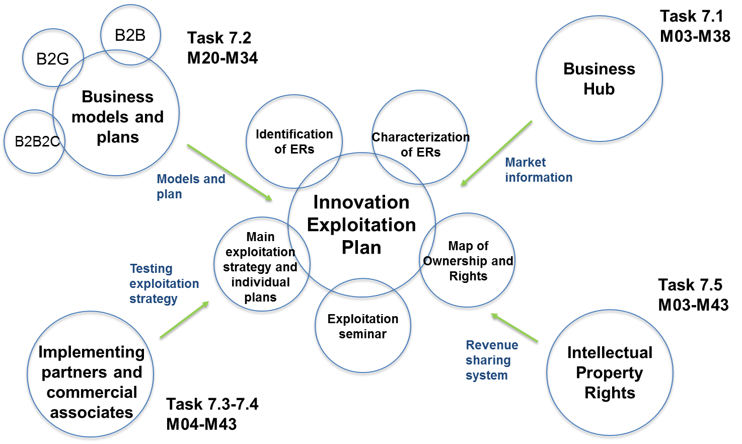
Figure 1: Exploitation Plan building process
Measures for the IPR protection and the procedures to be followed by the partners on this issue guarantee that all project results are formulated and compiled in a way that protection could be formalised in the future after the project. All the activities required to protect the knowledge generated will be duly taken into account before exploitation activities are undertaken.
The ANYWHERE project represents a unique opportunity for the project partners to reinforce their market positions or enter into new markets, properly exploiting the results developed within the project. It is a critical condition for the Consortium participants (R&D, SMEs, etc.) to turn innovative ideas and technological progress into marketable products and services while keeping competitive advantage. For this reason, a proper exploitation plan is crucial in order to maximize the potential benefits for each project partner.

Scope of Deliverable
The aim of this document is to provide common guidelines as well as a common plan for the participants to undertake the exploitation and the IPR protection actions with a structured and well-organised approach and routes for future implementation. Only in this way, the widest communication and dissemination of the foreground generated by the project can be carried out and the foreground can be adequately protected and exploited.

Deliverable Structure
The deliverable is structured and organized in the following chapters:
Chapter 1 is the introduction of this document, outlining the main objectives and the purpose of the report.
Chapter 2 presents the work methodology conducted to prepare the exploitation plan.
Chapter 3 presents the approach and the framework of the activities planned for the development of the ANYWHERE exploitation strategy and plan development.
Chapter 4 presents the list of exploitable results and their characterization and prioritization.
Chapter 5 describes the final ANYWHERE exploitation strategy, both at project and partner level, providing the overview on the Consortium expectation and claims, based on the BFMULO analysis, evaluating Background and Foreground developed by each partner and the use of the project results (Manufacturing, Using, Licensing, or Other).
Chapter 6 provides the IPR management strategy.
Chapters 7 provides the main outcomes related to Business Models and Business Plan activities reported in detail in the deliverable D7.2 Business Plan Report by Market Segment (B2G,B2B, B2B2C).
Finally, in Chapter 8 conclusions are reported for this report.
- Work Methodology
This chapter aims to describe the methodological approach used to perform the Exploitation activities. Most of the information used to perform such activities were provided by Consortium partners during the interactive Workshop – conducted by RINA-C and held in Bastia on 28th of June 2018 – whereas partners provided useful inputs to define and characterize the project results and their exploitation. The main objectives of the workshop were to validate the list of Exploitable Results identified, to complete the key exploitable result characterization tables and to discuss about exploitation routes.
More detailed information were defined during dedicated interviews with the responsible partners of each exploitable results with the aim to characterize them in terms of innovative content, target market, exploitation claims and responsibility.
In detail, starting from the development of the exploitation strategy a preliminary list of exploitable results was identified and shared during the interactive Workshop in Bastia to be validated. The updated list of Exploitable Results defined during the Workshop is reported in Chapter 4. The updated list consists of 48 Exploitable Results that were characterized during dedicated interviews with their responsible partners. The characterization tables of them are reported in Annex 1 to Annex 48.
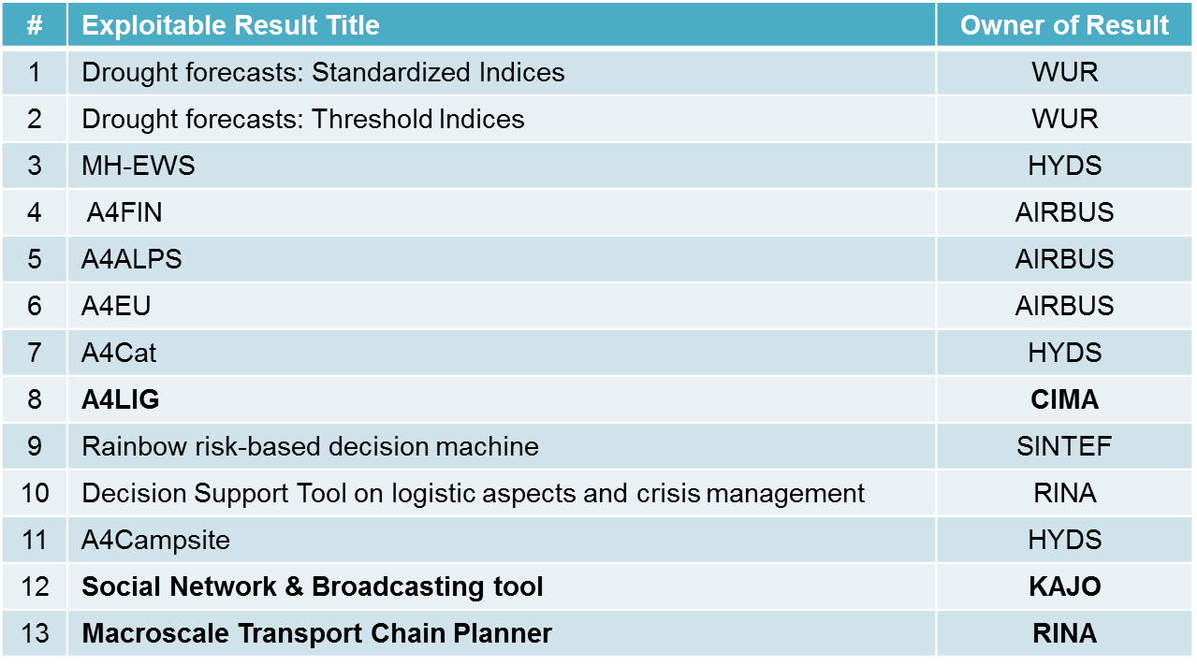
Figure 2: Preliminary list of Exploitable Results
Each exploitable result was characterized through an ad-hoc table in which partners were asked to provide some relevant information related to results for which they are responsible.
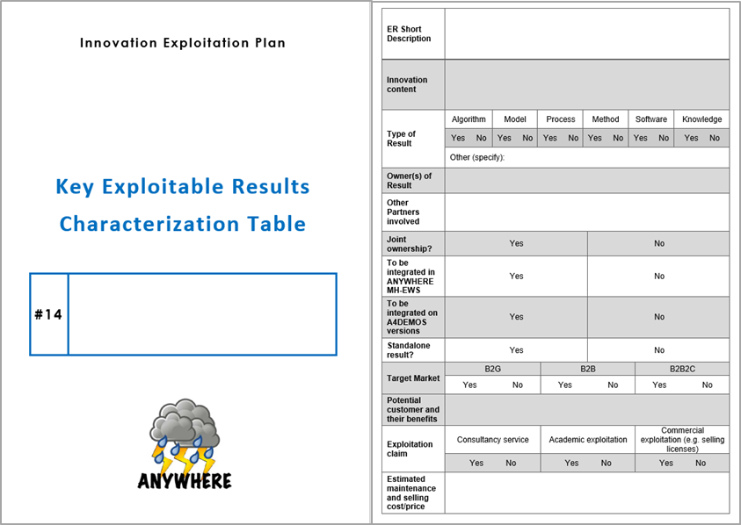
Figure 3: Characterization Table
In order to manage better the high number of results (48 exploitable results has been identified) a preliminary combination of them was defined according to their characteristics.
During the Workshop in Bastia, the Consortium partners were asked to find the best exploitation routes that intend to pursue for each group of results identified in order to draft the Exploitation Plan that was updated and revised for its final version.
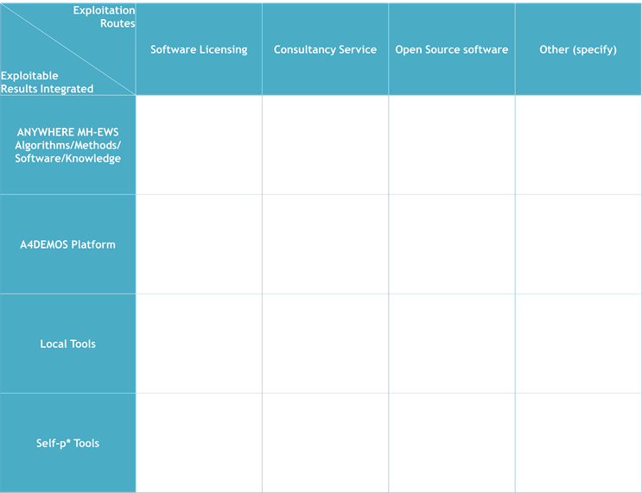
Figure 4: Potential exploitation routes
The integrated results help to understand the relationships between the various results.
In order to have a clear comprehension on the tools and methodologies under patents on the main and relevant topics of the ANYWHERE project, a patent mapping analysis was performed for the different type of hazards addressed by the project. In particular, for each of them the following aspects were detailed:
- an overview of the current patents scenario
- an overview of the geographical location of patents
- an overview of the main applicants.
- ANYWHERE Exploitation approach
The Exploitation activity, within EU projects but not limited to these, is a methodological and value driven process to approach long-term sustainability. The exploitation procedure is to be indeed applied taking into consideration specific goals:
- to generate revenues making worth the EC to invest in project results
- to find further co-investments and future partnering opportunities.
In brief, the exploitation process can be summarized as a procedure that allows, “deriving a benefit from the project outcomes” or “making use of the project outcomes”. The project level is fundamental in order to perform well-structured exploitation strategies.
These activities have the aim, indeed, to develop a common vision and agreement on the project results and their interest to each of the partners towards a commercial approach, potential marketing strategy but also towards not commercial purposes (e.g. research and training). Therefore, results are to be addressed at a whole project and consortium level.
The first step of exploitation concerns the assessment of the effective exploitability of results, eventually proposing new ones and/or deleting the ones not expected to generate incomes to the partners, thus not to be exploited. The approach to be considered within this process is the value driven one, with “value” having different meanings.
A project result might create value for the consortium generating revenues if there are customers available to pay for the new technology/product; increasing the partners’ distinctive skills set and improving their internal processes and/or quality; or simply fulfilling an existing gap. The exploitability assessment process leads to the definition of the project key exploitable results that are the ones selected by the consortium and further developed for market introduction.
In general, a key exploitable result could be a new product or process, a new service, a new standard, a new training course or a new patent fitting a specific need or responding to the demand of a defined group of users.
The following exploitation step is the key exploitable results characterization. The aim of this activity is to collect information in order to detail the project key results and to facilitate the development of an exploitation and business plan for each of the project outcomes.
The exploitation strategy and plan development in the ANYWHERE project can be considered at two levels:
- At partner level: where research and technology partners (especially dedicated to the development of models, tools, algorithms, etc.) identified components of the overall ANYWHERE solution that maybe exploited and ultimately commercialized.
- At Consortium level: the objective is to better define the ANYWHERE types and forms of exploitation paths and derive a priority actions plan for further exploitation.
The ANYWHERE exploitation approach will investigate the following activities:
- Intellectual property protection: protection of the knowledge and operational systems resulting from the project.
- Promotion of the exploitation of the results: development of a plan for the use and dissemination of the knowledge produced. These activities should help in shaping some marketing strategy for the future commercial exploitation of ANYWHERE results and further “take-up” actions.
Therefore, it is clear that any plan for exploiting the foreground generated by the ANYWHERE project includes several elements:
- Since the project involves industry, academic partners, research organizations and end-users, an appropriate exploitation strategy needs to be developed which is in line with the general rules outlined by the European Commission and which ensures that the interests of all the partners are appropriately taken into account in the exploitation of the foreground generated by the project.
- Such a strategy needs to be well set up depending on the different maturity levels (TRL) of the results, as this will allow investigating the best exploitation routes and preparing for the setup of appropriate agreements among the Partners on the use of the foreground after the project.
The Exploitation plan contains the required support measures for improving awareness beyond the project and prepare potential deployment of results within industry and other interested parties. In addition, it should develop a programme of additional demonstrators across participating countries to help the future exploitation of ANYWHERE results.
The Exploitation Plan deals also with the strategic impact of the project, academic advancement, possible competitive advantage or creation of market opportunities for the participants.

Current status of tools in emergencies management and weather forecast
Over the past 30 years, a major change has occurred in the way emergencies and crises are managed. In the past, in fact, the attention was given to humanitarian response and relief activities at national or international level, instead of to strategies and actions that could mitigate the effects of these events. The capabilities to provide weather forecasts were based on regional or national level and each National Meteorological Service was in charge of providing forecasts with their own resources.
In the last years, the European Centre for Medium range Weather Forecasts (ECMWF) became the world leader institution in global medium range numerical meteorological forecasting and specifically in severe weather prediction. Nowadays, ECMWF is the main provider of numerical weather predictions to the EU member states.
In this framework, the need and requirement of a model transforming weather predictions into high-impact hazard forecasts rise. This is possible combining advanced Numerical Weather Prediction (NWP) models and observation techniques (remote sensing - meteorological radars and satellites and point sensors - radio soundings and surface stations measuring atmospheric pressure, temperature, humidity, wind, precipitation, etc.) with advanced high-resolution impact assessment models for each of the different processes. In this way, severe weather and climate phenomena is transformed into the resulting high impact hazard events.
Thus, it is crucial to have access to the best meteorological and climate forecasts, which will be the base to forecast the impacts caused by weather and climate induced hazards.
At present, there are already successful examples of operational pan-European platforms providing support to Civil Protection authorities and other emergency managers in their decision processes. Among them, the most successful are described in the following tables.
 | EFAS – European Flood Awareness System
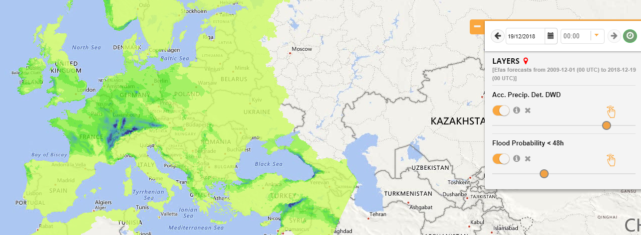
The European Flood Awareness System (EFAS) is the first operational European system monitoring and forecasting floods across Europe developed by JRC. It provides complementary, flood early warning information up to 10 days in advance to its partners, the National/Regional Hydrological Services and the European Response and Coordination Centre (ERCC).
The aim of EFAS is to support preparatory measures before major flood events strike, particularly in the large transnational river basins and throughout Europe in general.
It provides complementary, added-value information (e.g. probabilistic, medium range flood forecasts, flash flood indicators or impact forecasts) to the relevant national and regional authorities. Furthermore, EFAS keeps the Emergency Response Coordination Centre (ERCC) informed about ongoing and possibly upcoming flood events across Europe.
Since 2012 EFAS is running fully operational as part of the Copernicus EMS.

EFFIS | EFFIS – European Forest Fire Information System
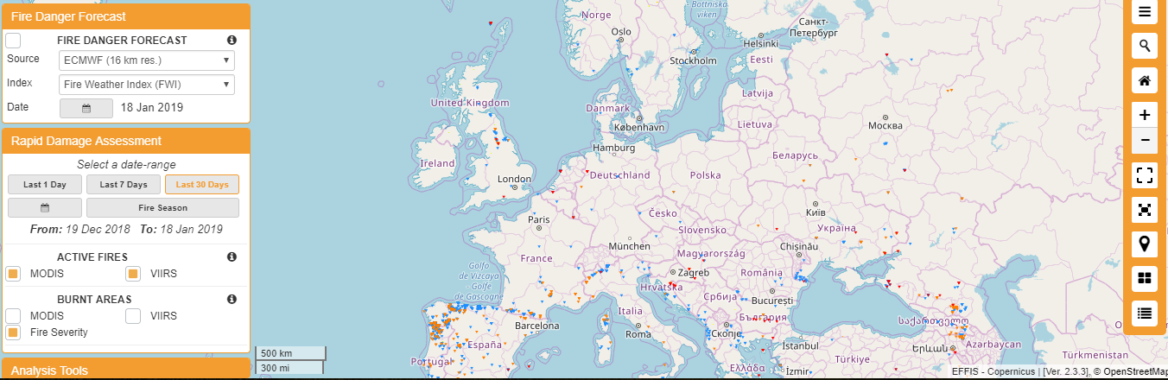
The European Forest Fire Information System (EFFIS), developed by JRC, supports the services in charge of the protection of forests against fires in the EU countries and provides the European Commission services and the European Parliament with updated and reliable information on wildland fires in Europe.
Since 1998, EFFIS is supported by a network of experts from the countries in what is called the Expert Group on Forest Fires, which is registered under the Secretariat General of the European Commission. Currently, this group consists on experts from 40 countries in European, Middle East and North African countries. In 2015, EFFIS became one of the components of the Emergency Management Services in the EU Copernicus program.

EDO | EDO – European Drought Observatory
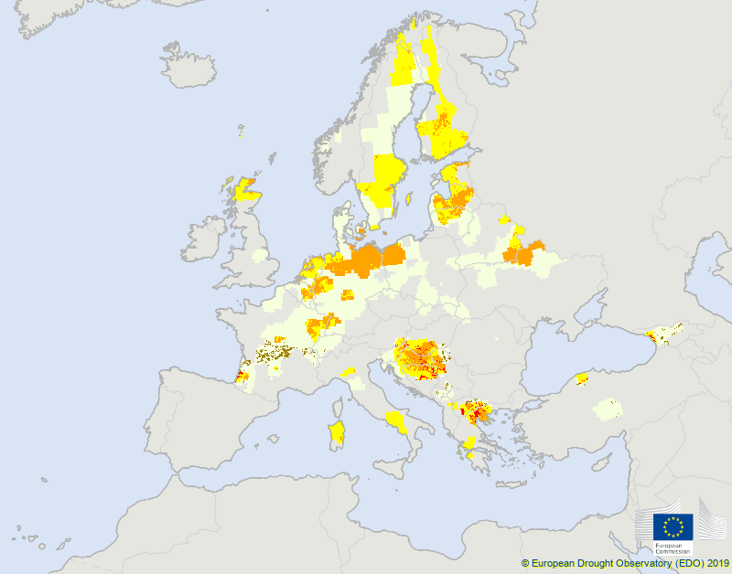 | The European drought observatory (EDO) is a service developed and operationally run by the Joint Research Centre. The EDO pages contain drought-relevant information such as maps of indicators derived from different data sources (e.g. precipitation measurements, satellite measurements, modelled soil moisture content).
These operational platforms provide significant support to responders in front of weather and climate induced emergencies. Since they are developed on a single hazard approach, they are the most advanced operational technologies in the field worldwide.
It is also worth mentioning the global platform GDACS - Global Disaster Alert and Coordination System, which is a cooperation framework between the United Nations and the European Commission. It includes disaster managers and disaster information systems worldwide and aims at filling the information and coordination gaps in the first phase after major disasters.
The aim of this platform is to provide alerts and impact estimates after major disasters through a multi-hazard disaster impact assessment service. However, it is more oriented to support the coordination of the international cooperation after the disaster than to provide support to the local response operations.
At global level, it is important to mention the Worldwide Meteorological Organisation (WMO), the authoritative voice of the United Nations on weather, climate and water. The WMO purpose includes:
- Facilitate worldwide cooperation in the fields of meteorology and hydrology and their application for the benefit of all
- Promote the establishment and maintenance of systems and networks for the rapid exchange of data information in meteorology, climatology and hydrology
- Promote standardization of observations and ensure the uniform publication of observations and statistics
- Further the application of meteorology, climatology and operational hydrology to development issues (water management, agriculture, policy formulation, etc.) and disaster prevention and mitigation
- Encourage research and training, and assist in coordinating their international aspects.
Regarding hydrology, Early Warning Systems for Floods are promoted through the WMO Flood Forecasting Initiative (FFI), whose objectives are:
- to provide guidance and advice on the hydrological forecasting elements of a number of flood related initiatives in progress under WMO programmes
- to provide broad-based support to improve collaboration between the meteorological and hydrological communities for improved flood forecasting related practices.
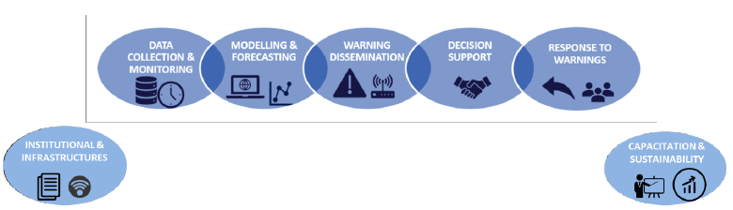
Figure 5: WMO Flood Forecasting Initiative (FFI)
Through a Memorandum of Understanding between the Italian Civil Protection Department
and WMO, since 2013 the DEWETRA platform can be provided to WMO Members requesting it free of charge.
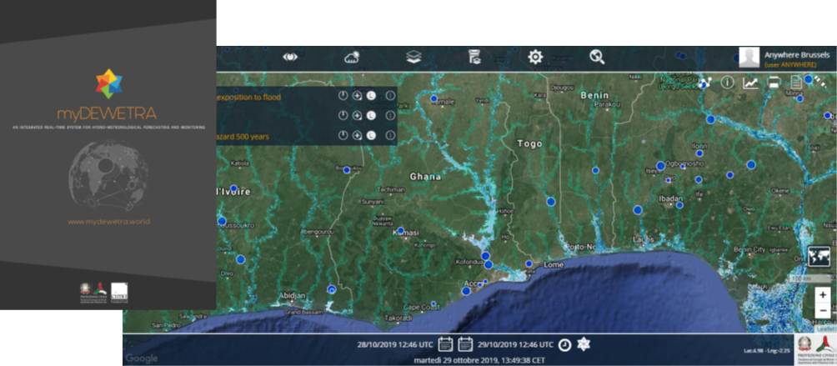
Figure 6: DEWETRA platform
Based on the accumulated experience of these platforms, ANYWHERE proposes to combine the operational products generated in these platforms with additional and complementary algorithms and local data to better adapt the improved products to the responders’ needs in a real multi-hazard approach.
These sources of knowledge will be used as a fundament for the proposed Multi-Hazard Early Warning System (MHEWS). However, Multi-Hazard approaches are not a new concept and there are several examples of systems trying to achieve this step ahead.
In the framework of the ANYWHERE project, the most important Multi-Hazard system is METEOALARM, developed by the EUMETNET (Network of European Meteorological Services) program EMMA (European Multi-services Meteorological Awareness).
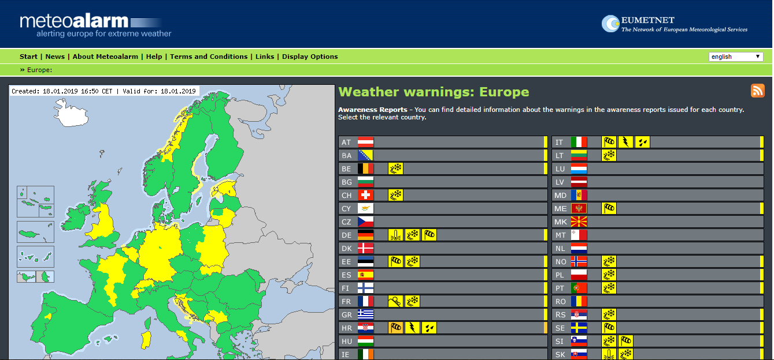
Figure 7: METEOALARM web site view
It is a regionally based tool that provides relevant information needed to prepare for extreme weather, expected to occur somewhere over Europe. In particular, it reports in real time multi-hazard warnings generated by the National Meteorological and Hydrological Services (NMHS) grouped in EUMETNET at regional scale.
The warnings relate to the possible occurrence of severe weather, such as heavy rain with risk of flooding, severe thunderstorms, gale-force winds, heat waves, forest fires, fog, snow or extreme cold with blizzards, avalanches or severe coastal tides.
A dedicated map on the METEOALARM web site shows warnings indicating the severity of the danger and its possible impact using a 4-color code based on regional thresholds for the meteorological variables identified as hazard indicators. By clicking on a region within a country, detailed information for the danger level indicated are shown. Information include the expected period for any given event to happen and additional aspects such as the intensity (e.g. snow amounts expected).
This program is a successful example of EU cooperation in the field of disseminating warnings for weather-induced hazards and it has been adopted even for public announcements by the associated NMHS.
However, the resolution of these multi-hazard warnings is not adequate to support Civil Protections and first responders to manage correctly emergency operations during situations of risk. Because of this, METEOALARM is just used in the pre-alert phase by the Civil Protections.
On the other hand, there is not a common methodology and the same phenomena can have different hazard intensities depending on the country and region.
Therefore, although it is a successful first step and a relevant experience to take into account in the ANYWHERE design, it essentially shows the need to develop a more advanced integrated high-resolution Multi-Hazard system that could support the real management needs of responders during emergency operation, as proposed in ANYWHERE.
The following Table 1 summarizes the list of ANYWHERE tools providing their position on the market in terms of value added (innovative elements) respect to the current state of the art (tools already used on the market).
Table 1: ANYWHERE solutions – Value added beyond the state of the art
ANYWHERE solution | Current state of art | Value added beyond the state of art
A4Campsite | Sensor with warning levels | - Integration of sensors data, official warnings and self-protection plans.  - Use of advanced radar-based products in terms of return period (river warning, rain warning)  - Direct access to self-protection plans, evacuation maps.  - Real-time connection with official warnings from administration.  - Real-time access to several sensors (river gauges, rain gauges)
Nowcasting of snowfall limit | Snowfall limit estimation based on air temperature interpolation. | - More accurate snowfall limit estimation based on micro rain radar (MRR).  - Better spatial resolution as the state of the art.
Optimal convective index for heavy precipitation | Convective indices of operational weather forecast models (e.g. CAPE) are not optimal for mountainous areas. | - New combined index much better adapted for mountainous regions than state of the art products.  - Expert level giving insight how probability of extreme precipitation is calculated.
Downscaling of numerical forecast models for mountainous regions | - Resolution of global weather forecasts remains coarse in mountainous regions.  - Global models tend to overestimate small precipitation events and tend to underestimate extreme precipitation events. | - Statistical downscaling based on local precipitation stations to a finer spatial resolution as the operational global forecast models.  - Correction of the inherent biases of the operational forecast models.
Disposition Model for Shallow Landslides | Up to now hazard indication maps show where a disposition for shallow landslides exists. In addition, there exist regional precipitation thresholds for triggering shallow landslides. Shallow landslides are a quit common but complex process. They are affected for examples by soil parameters and the actual soil water content. For both the current state typically is unknown. | Using a nearest neighborhood approach the actual and forecasted precipitation parameters (sum, intensity, duration) are compared with the records in a database which contains more than 1,8000 events of shallow landslides including the precipitation information of the events. From this, an assessment of the susceptibility that shallow landslides will occur can be de-rived.
Disposition Model Permafrost Degradation Process Chains | A permafrost indication map over the alpine area in Europe was elaborated. Furthermore at some places in the Alps temperature measurements in boreholes exists. From this, the past and actual thawing depth in the permafrost body, which is an important parameter for triggering debris flows, can be derived. | Using the 1D Snowpack model developed at the SLF Davos the conditions in permafrost bodies (temperature, thawing depth, water content) are simulated over time, based on measured meteorological parameters. In addition, a forecast of the further development of the permafrost bodies is simulated, based on the ensemble midrange weather forecast from ECMWF.
RIVERTRACK | - “Watch and warn” systems reporting local data back to a central server which issues warnings.  - Initial attempts at simplified forecasting to compliment “watch and warn” systems.  - Community flood action groups, possibly supported/assisted by local government or national agencies, developing local knowledge and resilience strategies. | - Robust local distribution of data using LoRa communications protocol. Separate display with (audible) alarm in the property giving more reliable dissemination of warnings. Warning are evaluated onsite and can be set by users. Significantly cheaper observation costs due to advanced IoT sensor technologies.  - Proven low cost forecasting techniques which can be used generically and many sites and make use of multiple data sources (e.g. radar as well as gauge data).  - Work with these groups to provide information to empower them to take proactive, preventative actions at the local level. Increased ‘localization’ of the early warning process.
Convective Cell Classification Algorithm for Electricity providers (PDR-161) | There is no similar tools in Finland. Something similar can be found in US. | Convective cells are developed at national scale but can be used at European level (by EFFAS) but they are the only one with input from historical data from companies.
European storm surge model | - ECMWF global wave forecast.  - Global Copernicus sea surface height forecast.  - Regional Copernicus sea surface height forecast. | - Coupling wave and circulation model.  - Coupling effect of tide, wave and wind in a single model. It provides storm surge hazard level.
Regional storm surge model | - Meteorologist institute.  - Regional Copernicus sea surface height forecast. | Coupling effect of tide and waves at high resolution.
Heatwave Index (UTCI) | Current heat health watch forecast systems are based on temperature or on a combination of temperature and humidity. Furthermore, do not directly consider the stress these environmental parameters force on the human body. | The ANYWHERE heat health watch forecast system is the first system of this type that consider multiple environmental parameters – air temperature, humidity, wind, radiation – and predicts the thermal stress they induce on the physiology on the human body. It is also the first system of this type at the pan-European level.
Site specific database mechanistic flood forecasts | - Initial attempts at simplified forecasting to compliment “watch and warn” systems.  - Forecasting systems based on conceptual, physically based catchment models set up by ‘experts’.  - Forecasts for future discharge or water level issued by responsible authorities. | - Proven low cost forecasting techniques which can be used generically and many sites and make use of multiple data sources (e.g. radar as well as gauge data).  - Non-experts are able to develop models – democratizes the generation of flood forecasts.  - Significantly lower computational and data resources for both set-up and forecast generation.  - Forecasts are typically more specific then the public summaries currently provided. Fully probabilistic forecasting system giving quantities forecast uncertainty.
Calibrated meteorological forecasts | Various calibration methodologies exist but are generally used by consultancies or national meteorological services to tailor forecasts for specific users. | Ability for users to calibrate one or more forecast variables on demand.
Rainfall now casting model | Different applications of precipitation nowcasting systems for up to a few hours | First application at European scale
Flash flood FF-EWS algorithm | - Different alternatives based on rainfall-runoff models in gauged catchments.  - Few large scale applications. | - Based on the catchment-aggregated rainfall.  - Applied for flash flood hazard assessment and nowcasting at scales from regional to Continental.  - Adapted to the use of different precipitation data sets and resolutions at regional, national and continental scale
Flash flood impact estimation algorithm |  | - Connected to the algorithms for high-resolution rainfall nowcasting and flash flood hazard forecasting  - Combining information
Landslide nowcasting algorithm | - Real time local early warning systems  - Based on rain gauge observations | - Adapted to real time conditions  - Based on weather radar observations and nowcasts  - At regional scale combining rainfall products with information of vulnerability and exposure
Road conditions forecasting module | - Several snowfall forecasting systems based on NWP models  - Some applications for predicting road surface conditions based on modeling the energy fluxes at the ground surface with a 1D model using NWP forecasts | - 1D energy balance model combining observations and NWP forecasts  - Adapted to the characterization of the impacts on road and traffic conditions  - Adapted to the needs of the end user
Air quality and health products (Regional Air Quality, RAQ) | Copernicus Atmosphere Monitoring Service (CAMS). | Integration to a multi-hazard platform.
- Key Exploitable Results: final characterization and prioritization towards potential exploitation routes
At the beginning of the project, when approaching the identification of the main results, the definition of Exploitable Result as defined by the European Commission has been taken as reference. According to the definition provided:
“An Exploitable Result is defined as the knowledge having a potential for industrial or commercial application in research activities or for developing, creating or marketing a product or process or for creating or providing a service.”
Dealing with exploitation of results means to evaluate the use of results in further research activities other than those covered by the project concerned, or in developing, creating and marketing a product or process, or in creating and providing a service, or in standardisation activities.
As explained by mean of an extract from the European Commission slides on Dissemination and Exploitation activities in Figure 8 below, it is important to:
  - Make use of the results for scientific, societal and economic purposes; recognising exploitable results and their stakeholders, as group of entities that are making concrete use of results
  - Concretise the value and impact of the Research & Innovation activity for societal challenges; with this respect, partners shall make best efforts to exploit the results it owns, or to have them exploited by another legal entity.
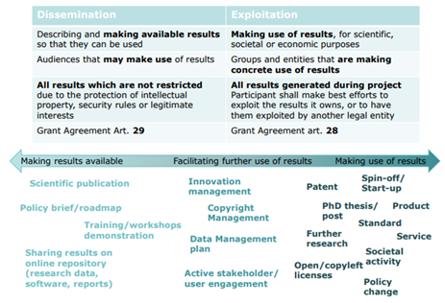
Figure 8: Dissemination and exploitation activities

The exploitability assessment process leads to the definition of the project key exploitable results that are the ones selected by the consortium and further developed for market introduction.
In general, a key exploitable result could be a new product or process, a new service, a new standard, a new training course or a new patent fitting a specific need or responding to the demand of a defined group of users.
In the following Table 2, the list of Key Exploitable Results (KERs) together with the related responsible partner(s) is reported and confirmed by the Consortium partners.
Table 2: List of Exploitable Results
# | Exploitable Results | Responsible Partner(s)
1 | Standardized Drought Indices | WUR
2 | Threshold Drought Indices | WUR
3 | MH-EWS | HYDS
4 | A4FIN | AIRBUS
5 | A4LPS | AIRBUS
6 | A4NOR | AIRBUS
7 | A4CAT | HYDS
8 | A4LIG | CIMA
9 | Rainbow risk-based decision machine | SINTEF
10 | Decision support Tool on logistic aspects and crisis management | RINA
11 | A4CAMPSITE | HYDS
12 | Social network & broadcasting tool | KAJO
13 | Weather-based Macroscale transport chain planner | RINA
14 | Nowcasting of snowfall limit | METEODAT/UNIGE
15 | Optimal convective index for heavy precipitation | METEODAT/UNIGE
16 | Downscaling of numerical forecast models for mountainous regions | METEODAT/UNIGE
17 | Disposition model for shallow land slides | GEO7
18 | Permafrost degradation disposition model | GEO7
19 | PREDICT Support decision making services | Predict services
20 | Resilience tool ORI (DSS) | UNS
21 | RISICO & Propagator (fire danger rating system) | CIMA
22 | FloodPROOF algorithm | CIMA
23 | Nowcast model - PhaSt | CIMA
24 | A4SCHOOLS | CIMA
25 | RIVERTRACK | RAB Consultants, RIVARTRACK, WATERNUMBERS
26 | Convective cell classification algorithm for electricity providers | FMI
27 | Scenario technique (ST) tool | UPB
28 | European storm surge model | CFR
29 | Local inundation-erosion model | CFR
30 | Regional storm surge model algorithm | CFR
31 | Fire danger: reanalysis + forecast (ECMWF more detail) | ECMWF
32 | Ptype: Probability of precipitation type | ECMWF
33 | Heatwave index (UTCI) forecasts | UOR
34 | Site specific database flood forecast | WATERNUMBERS
35 | Calibrated meteorological forecast | WATERNUMBERS
36 | Common information space (CIS) | UPB
37 | WP5 guidelines, good practices and recommendations | UPB, SSSA, CNRS
38 | Rainfall nowcasting algorithm | UPC-CRAHI
39 | Flash flood algorithm - FF-EWS | UPC-CRAHI
40 | Flash flood impact estimation algorithm | UPC-CRAHI
41 | Landslide nowcasting algorithm | UPC-CRAHI
42 | Road conditions forecasting module | UPC-CRAHI
43 | Performance assessment of the meteorological forecasts and nowcasts products | ECMWF
44 | Flood products (EFAS-ERIC Model) | JRC
45 | Air quality and health products | UOR
46 | Debris flows and landslide algorithm | UPC
47 | A4CENEM | HYDS
48 | A4COR | PREDICT

Characterization of the Key Exploitable Results
The present section aims to provide a clear overview of the final characterization of the KERs identified as they have been developed by project partners in order to allow a prioritization and a detailed analysis of potential exploitation routes for the most advanced ones.
The aim of this activity is to collect information in order to detail the project key exploitable results and to facilitate the development of an exploitation and business plan for each of the project outcomes.
The characterization tables of each exploitable result were preliminary filled in during the exploitation workshop in Bastia and updated through dedicated conference call scheduled with each responsible partner. Lead partners were asked to answer questions regarding the innovation content of results; their final destination (if it will be integrated in the ANYWHERE MH-EWS or in the different implemented versions or skins of the A4EU platform); the role of partners; the target market in which the product might be introduced; the potential customers and their benefits; the exploitation claims and other relevant information useful to plan future exploitation activities.
The current KER characterization tables are reported in Annex A.1 to A.48. Below the template used for the characterization of the results is reported.

Table 3: Characterization table template
Exploitable Result Title
Exploitable Result Short description
Innovation content
Type of Result | Algorithm | Model | Process | Method | Software | Knowledge
Type of Result | Yes/No | Yes/No | Yes/No | Yes/No | Yes/No | Yes/No
Type of Result | Other (specify):
Owner(s) of Result
Other Partners involved
Joint ownership? | Yes |  |  | No
To be integrated in ANYWHERE MH-EWS | Yes |  |  | No
To be integrated on A4EU versions | Yes |  |  | No
Standalone result? | Yes |  |  | No
Target Market | B2G |  | B2B |  | B2B2C
Target Market | Yes/No |  | Yes/No |  | Yes/No
Potential customer
Benefit to customers
Exploitation claim | Consultancy service |  | Academic exploitation |  | Commercial exploitation (e.g. selling licenses)
Exploitation claim | Yes/No |  | Yes/No |  | Yes/No
Estimated maintenance cost (yearly)
Estimated yearly selling price

Prioritization and integration of Exploitable results
Given the large number of exploitable results, they were grouped in some families according to their characteristics. In this way, they can be managed better and will help understanding the relationships between the various results.
The following groups of results were considered:
- ANYWHERE MH-EWS - Algorithms, methods, software, knowledge integrated in the ANYWHERE Multi Hazard Early Warning System (MH-EWS).
- A4EU platforms - Implemented and demonstrated versions of the general ANYWHERE DSS A4EU platform in the 7 pilot sites (A4LIG, A4CAT, A4FINN, A4ALPS, A4NOR, A4COR, A4CENEM).
- Local tools.
- Self-p* Tools - Self-preparedness and self-protection tools are used and tested in the four case studies designed in the WP5 to demonstrate and evaluate the interest of the ANYWHERE approach to raise self-preparedness and self-protection of the population and institutions.
The Table 4 below indicate to which group each result belongs.
Table 4: Integration of Exploitable Results
# | Exploitable Results | ANYWHERE MH-EWS | A4EU Platforms | Local Tools | Self p* Tools
1 | Standardized Drought Indices | ✓
2 | Threshold Drought Indices | ✓
3 | MH-EWS | ✓
4 | A4FIN |  | ✓
5 | A4LPS |  | ✓
6 | A4NOR |  | ✓
7 | A4CAT |  | ✓
8 | A4LIG |  | ✓
9 | Rainbow risk-based decision machine |  |  | ✓
10 | Decision support Tool on logistic aspects and crisis management |  |  | ✓
11 | A4CAMPSITE |  |  |  | ✓
12 | Social network & broadcasting tool |  |  |  | ✓
13 | Weather-based Macroscale transport chain planner |  |  |  | ✓
14 | Nowcasting of snowfall limit | ✓
15 | Optimal convective index for heavy precipitation | ✓
16 | Downscaling of numerical forecast models for mountainous regions | ✓
17 | Disposition model for shallow land slides | ✓
18 | Permafrost degradation disposition model | ✓
19 | PREDICT Support decision making services |  |  | ✓
20 | Resilience tool ORI (DSS) |  |  | ✓
21 | RISICO & Propagator (fire danger rating system) | ✓
22 | FloodPROOF algorithm | ✓
23 | Nowcast model - PhaSt | ✓
24 | A4SCHOOLS |  |  |  | ✓
25 | RIVERTRACK |  |  | ✓
26 | Convective cell classification algorithm for electricity providers |  |  |  | ✓
27 | Scenario technique (ST) tool |  |  |  | ✓
28 | European storm surge model | ✓
29 | Local inundation-erosion model | ✓
30 | Regional storm surge model algorithm | ✓
31 | Fire danger: reanalysis + forecast (ECMWF more detail) | ✓
32 | Ptype: Probability of precipitation type | ✓
33 | Heatwave index (UTCI) forecasts | ✓
34 | Site specific database flood forecast | ✓
35 | Calibrated meteorological forecast | ✓
36 | Common information space (CIS) |  |  |  | ✓
37 | WP5 guidelines, good practices and recommendations |  |  |  | ✓
38 | Rainfall nowcasting algorithm | ✓
39 | Flash flood algorithm - FF-EWS | ✓
40 | Flash flood impact estimation algorithm | ✓
41 | Landslide nowcasting algorithm | ✓
42 | Road conditions forecasting module | ✓
43 | Performance assessment of the meteorological forecasts and nowcasts products | ✓
44 | Flood products (EFAS-ERIC Model) | ✓
45 | Air quality and health products | ✓
46 | Debris flows and landslide algorithm | ✓
47 | A4CENEM |  | ✓
48 | A4COR |  | ✓
Each of the results identified can be exploited as a single module. However, the most promising result has been agreed to be to exploit all of them integrated in the ANYWHERE DSS platform A4EU, involving the entire consortium in its development as well as providing a complete and innovative offering to the market. The ANYWHERE platform A4EU includes a kit of early warning tools included in MH-EWS and additional specific tools to respond to the community expectations in order to develop the market.
The potential exploitation route for the ANYWHERE A4EU has been provided in Chapter 5 as it also corresponds to the exploitation strategy at project level as this result involves all the project partners.

- Exploitation strategy at project and partner level
The ANYWHERE project brings together a comprehensive, experienced and multi‐disciplinary team with a highly diverse expertise and skills set. Indeed, the ANYWHERE consortium includes 34 partners from 11 European countries (Spain, France, Italy, Germany, Switzerland, Finland, United Kingdom, Netherlands, Norway, Belgium, Slovakia) plus an international institution, each having specific and high value knowledge in all needed scientific and technological branches required for meeting the objectives of the project. The consortium consists of:
- 9 industrial provider of solutions (AIRBUS, HYDS, KAJO, METEODAT, GEO7, RINA-C, PREDICT, ARANTEC, RAB CONSULTANTS)
- 13 public and academic provider of solutions (UPC, CIMA, WUR, UFZ, UPB, SINTEF, CFR, UNIGE, UNS, UOR, CNRS, SSSA, JRC)
- 12 operational authorities or institutions (INTC, DGPCE, CDG, ARPAL, SIS2B, FMOI, HSUH, VOLBE, FMI, ACA, AMAYA, ECMWF).
In the following Figure 9, the role of the partners involved in the project has been underlined in order to describe the starting point for the exploitation routes for the ANYWHERE system.
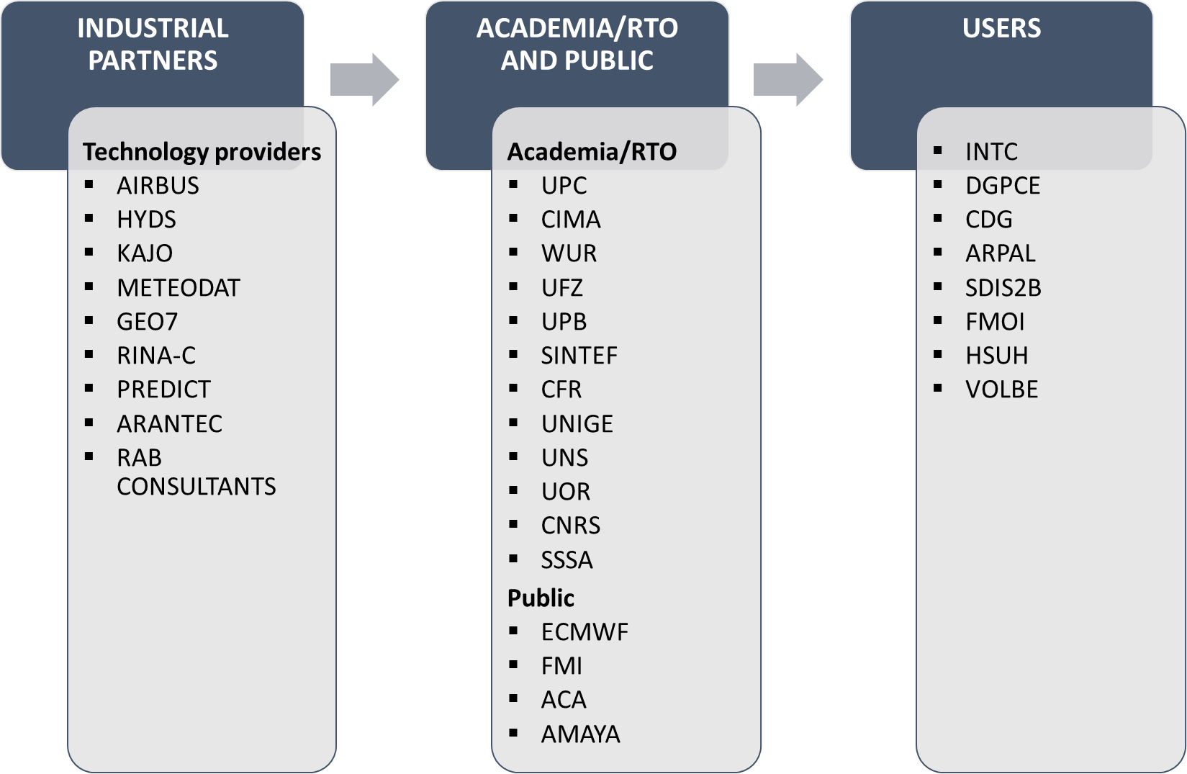
Figure 9: ANYWHERE Value chain
All partners, carefully selected based on the added value they could provide to the project, were highly committed to the approach and the objectives of ANYWHERE and each of them provided the needed to cover the overall value chain of the project, to guarantee project completion and exploitation.

The foreground generated by the project may be subject to different types of exploitation:
- industrial exploitation: it deals with the direct or indirect use of the generated foreground for commercial purposes.
- academic and research centre exploitation: it deals with its use in further research activities other than those covered by the project, whereas the exploitation by end-users aims on to ensure a cost effective planning, delivery, operation and maintenance activities for large infrastructure or infrastructure network.
- exploitation by end-users.
The ANYWHERE exploitation strategy is based upon a multilayer approach, which allows for a number of viable parallel and interlinked exploitation scenarios. In particular, three exploitation scenarios have been identified, which could be characterized as follows:
- A4EU Platform. The integration of MH-EWS products and other dynamic information layers throughout the modular A4EU DSS platform with the systems used by Civil Protection and First Responder Authorities. ANYWHERE will offer them an adapted integrating DSS able to include their legacy systems with the improved weather and climate and impact forecasts generated by the MH-EWS multi-risk platform. The platform will also ingest into MH-EWS the local data (high definition regional forecasts, meteorological sensors, crowdsourcing and social media information) in order to allow for a finest locally adapted portfolio of functionalities. The concept of extending current systems will open up further improvement opportunities to the Emergency Management Operation systems that Civil Protection and First Responder Authorities are currently using at their control centres. It will also offer an integrated approach bringing extra synergies from various sources to improve decision-making.
- Third-party informational products and services. The project will also define the rules and conditions applicable for third parties to get access to the ANYWHERE products and services, after a broad-enough analysis of possible licensing and access models. In doing so, the operational platform will also allow for the generation of additional sustainability resources based upon incomes derived from the services to be developed by selected commercial partners who will be given access to the ANYWHERE products, technologies and services, including development toolkits and support services. The commercial partners will be intended to cover a wide range of sectors and stakeholders affected by extreme and high-impact induced W&C events, with the aim to support more effective and faster emergency management and response in Europe, and ultimately worldwide.
- Direct informational services. The operational availability of the products generated with the MH-EWS engine and the information integration of the A4EU platform will also allow ANYWHERE to offer informational services specifically targeted to the citizenship and companies with activities at risk, based on the tools for self-preparedness and self-protection developed within the project. In particular, ANYWHERE will exploit the services provided with the four tailored products developed during the WP5 and demonstrated/validated in WP6 to raise self-preparedness and self-protection in specific sectors.
In the following paragraphs the exploitation routes for exploiting the ANYWHERE project results, both at partner level and at project level (with respect to the ANYWHERE results) are analysed, to achieve by the closure of the project the definition of the most appropriate commercialisation strategies to foresee a potential market penetration.

Exploitation strategies at project level
Defining ANYWHERE exploitation strategy at project level, taking into consideration the ERs characterisation and prioritisation reported in the previous sections, means identifying possible exploitation routes for the ANYWHERE results. Particularly for the DSS platform A4EU in its different versions, which is the result that better allows considering and following a holistic approach for the exploitation. Indeed, an exploitation route on the A4EU platform involves all the partners having contributed in the design and development of the different tools and methodologies that constitute the results.
The potential exploitation route for the overall consortium involved in the development of the ANYWHERE project, consider the possibility to create a foundation or association in order to ensure the ANYWHERE market uptake. In the paragraph below, the difference between a foundation and association is described.
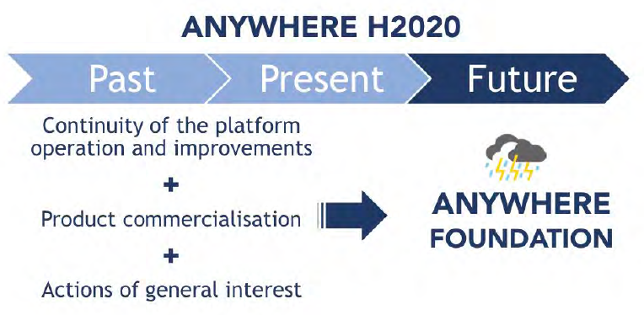
Figure 10: ANYWHERE market uptake
In particular, the purpose of the potential ANYWHERE foundation is to:
- promote coordination between scientists, operational authorities, citizens and enterprises
- drive society’s response to the climatic emergency
- inform about the society needs to adapt to the effects of climate change
- create a community of users
- make recommendations
- promote standardisation and good practices in the sector
- create a quality brand for products and service suppliers

Association definitions
An association is a non-profit entity composed by a group of people that organize themselves in order to carry out a collective activity. Associations have legal personality and can be created following the laws of the EU member state in which is created.
In what follows the details refer to the case of creating the institution in the country of the coordinator (Spain).

Aim and purpose
Associations are incorporated by three or more individuals or legal entities in order to fulfil general or particular common purposes by means of the pooling of personal and/or patrimonial resources of a temporary or indefinite nature. Legal entities, in particular, includes both private and public entities. Associations may engage in additional or subsidiary economic activities to its main purpose if the income derived therefrom is used exclusively for the performance thereof.
In accordance with Spanish law, under no circumstances may the assets of the association be distributed among the members, nor may they be transferred free or charge to specific individuals or profit-making entities.
Applicable law does not require a minimum capital for the incorporation of an association.

Membership
The founders and any other individual or entity accepted afterwards in accordance with its internal rules become members of the association, with the same standard of rights each, unless specific and duly motivated categories of members are provided in the bylaws.

Governing bodies
Associations need to have the following bodies:
- The general assembly, formed by all the association members, can decide over any matter concerning the association, can adopt all the resolutions of its competence and can control the activity of the association’s governing board. It has to meet at least once a year to approve, when applicable, the management of the governing board, the budget and the association’s annual accounts. Generally, decisions are adopted by simple majority (exceptions may be made in certain areas, where a more qualified favourable vote may be requested). Each member has the right to one vote.
- The governing board that manages and represents the association. It is empowered to perform the necessary acts for the fulfilment of the purposes of the association except for those that need to be agreed by the General Assembly or which need its prior authorization. The members of the governing board need to be, at the same time, members of the association and are appointed by the General Assembly.

Liability
Registered associations respond with all their present and future assets. However, its members are not personally liable for the debts of the association. However, the members of the governing board of the association are liable before the association, its members and third parties for the damages caused and the debts derived from intentional, culpable or negligent acts.

Incorporation
An association does not require any specific formality for its incorporation. It comes to existence immediately upon the act of foundation by means of the signature of a written document.
The intervention of a Notary Public, although not essential, is advisable as it provides advantages such as giving public proof of the date of incorporation of the association and of the identity of the persons or legal entities incorporating such association.

Registration
Registration is not mandatory for the association to exist, as the law provides that legal personality is given from the act of association itself (i.e. the agreement or deed of incorporation). However, registration is advisable in order to enable the association to enjoy some of the advantages set forth in the applicable legislation (i.e. to exempt the founders from liability that is assumed by the association therefrom, or to become a public utility association, which enables tax benefits for the association).

Distribution of profit and losses
The profits obtained by the association from the exercise of the economic activities have to be destined exclusively to the fulfilment of its purposes, without the distribution of such profits between the association’s members being possible.

Taxes
Associations benefit from a partial exemption from corporate income tax. The results obtained from the activities within its corporate purpose and that are not economic exploitations are exempted from corporate income tax. Economic exploitation is not exempted. The incorporation of the association is exempted from the tax on transfer and documented legal acts. Special tax regime for non-profit entities (like foundations) is applicable to associations subject to request and proof of being of public utility after two years from incorporation.

Foundations
Foundations are non-profit entities incorporated by one or several founders, by means of the affectation of goods or rights of economic content (i.e. an endowment). Foundations have legal personality.

Aim and purpose
A foundation can be incorporated by one or several founders and requires a minimum initial endowment of EUR 30,000, which can be made in-cash or in-kind (profitable assets). Foundations can be incorporated by either by individuals or legal entities, both private and public. In any event, such assets need to be adequate to the foundational purposes of the foundation. Such minimum endowment can be disbursed in part, provided that at least twenty-five per cent (25%) is disbursed initially. The remaining amount has to be disbursed within five years from incorporation. Foundations need to pursue general interest purposes.

Membership
Foundations do not have members. Founders do not become members but may be appointed as members of the governing body (the board of trustees).

Governing bodies
Foundations are governed by the board of trustees, which is the body governing and representing the foundation. The appointment of trustees is according to the rules established in the bylaws (founders may have a permanent appointment at the board of one or more positions as trustees). The board of trustees may grant powers of representation to positions within the foundation or to contracted personnel so that they can carry out the tasks of such positions.
However, the governance of the Foundation is subject to legal and economic supervision from the Protectorate of Foundations (“Protectorat”, the public body in charge of control and supervision of the activities of foundations in Catalonia). As a result, certain agreements and decisions need the Protectorate’s prior authorization or subsequent revision.

Liability
The members of the board of trustees are responsible for any damages caused to the foundation due to breach of law, foundation’s by-laws or by negligent acts or omissions while exercising their functions as members of the board of trustees.

Incorporation
Incorporation of a foundation needs to be carried out by means of the signature of a public deed before a Notary Public. In addition to the initial endowment as described above, the following documents may be required:
- First action program to justify the adequacy and sufficiency to carry out the foundational purposes and economic study proving the feasibility of the foundation using such resources, in the event the initial endowment is inferior to EUR 30,000.
- Valuation by an independent expert, in the event the initial endowment is in-kind.

Registration
Registration is mandatory in order for the foundation to be effectively deemed incorporated (unlike associations, which exist as from the act of incorporation).

Distribution of profit and losses
At least 70% of the results of the foundation’s economic exploitation and the income obtained from any concept has to be destined to the foundation’s foundational purposes. The remaining must be applied to the deferred fulfilment of such foundational purposes or to the increase of the foundation’s own funds.

Taxes
Special tax regime for non-profit entities is applicable to foundations.

The ANYWHERE foundation
Based on the juridical comparison between association and foundations reported above, a discussion about the best suited Non-Profit organization form for an entity who eventually may drive the exploitation has been carried out. Taking into account teh governance requirements for being able to integrate the diversity of countries and types of organizations that currently participate in the Consortium, it seems that a foundation able to oversee the operations of development and rollout, even commercially, of the exploitable results would be the most suited one.
The Foundation’s mission would be to ensure the development of high-end scientific solutions and technologies for forecasting weather-induced and climate emergencies and minimizing their impacts, focusing on public security and civil protection and including their environmental effects. This mission is to be achieved through scientific research, technology development and licensing plus customization of tools and expert consultancy, including:
- Development of scientific knowledge from within the Partners Research Organizations, including external collaborations and participation on other European Projects.
- Provide consultancy on IT development, research, leverage of institutional qualifications on meteorology, hydrology, hydrogeology, atmosphere and ocean dynamics, hydro-meteorology and climatology, earth observation, evaluation of weather-induced hazards, evaluation of the impact of climate events, and security and operational support.
- Facilitate the technology transfer of top-tier scientific knowledge into operational products, to be readily available for PPDR entities and institutions.
- Promotion of self-protection awareness culture and best practices towards the Civil Protection and Security areas, focusing on prevention and preservation of terrestrial and water-related ecosystems by scientific applications with a social impact.
The ANYWHERE Foundation ideal sees that Knowledge Transfer from the Scientific Community towards the Civil Society and Government should be done on a transparent and pragmatic way, through state-of-the-art developments that are readily available for use on different scenarios and improving straightforward on the societal and administrative processes, and sees its dissemination complemented through scientific publications, R&D of prototype projects and their operational solutions, hosting courses, workshops, and training events, as well as allowing areas of research for doctorate and graduate students and engaging on collaborative research and exchange programs, including the welcoming visiting scientists.
The ANYWHERE Foundation requires complying with a minimum set of considerations that have been already expressed by the Consortium partners in order to be able to participate, so up to this level, the aspects to be considered include:
- Is to be a legally entity, set-up in the home country of the Coordinator (the idea is that the foundation will be based in Barcelona) as Member State of the European Union that will include Supplier Partners from within the ANYWHERE Consortium. On the following Figure 11, the general functional structure is shown.
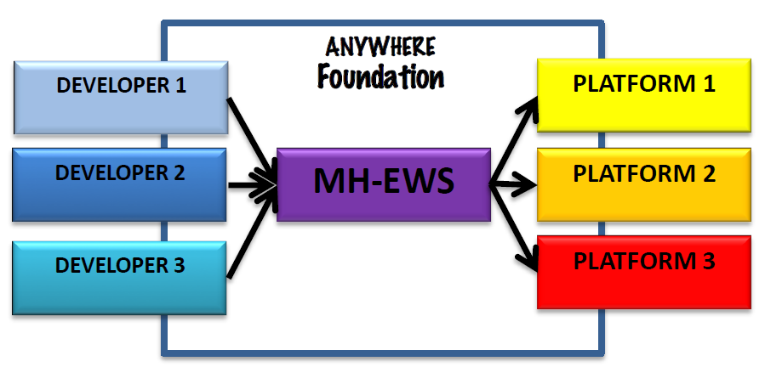
Figure 11: Schematics of interaction of the ANYWHERE Foundation that through the core component of the MH-EWS would link the Supplier (Developers) towards the Clients (Platforms) that can be either 3rd party as well as internal like in the case of the A4EU and A4U Platform
- PPDR Entities can participate as Advisers for mutual benefit, although several partners have expressed their incapability to become formal members. Nonetheless, the PPDR members will be recognized on the rollout by its participation on the Co-Ownership and Co-Creation concepts. One way to achieve this recognition is to withdraw from charging initial set-up and customization fees, or else some other method jointly negotiated that is feasible and mutually beneficial.
- Will include Technical and Commercial Staff, hosted directly by the Foundation structure, leading eventually towards a 24/7 Event Monitoring and expert support, ideally from a profile of meteorology expertise.
- The Foundation Staff would be directly Responsible of first contact, consultancy and implementations of upcoming Clients.
- The Foundation would transfer tasks and roles to Expert Partners as best fitting per case scenario, forwarding the Revenues of due activities regarding their collaboration.
- The directing board with handle the Revenue Sharing System, likewise monitoring the critical stages through Start-Up, Break-Even Point and Self Sustainability. It is foreseen that the first Two years of Revenue would be reinvested to secure continuity.
- During the Start-Up and Break-Even Point, Partners should participate with Services, IPR or Funding to ensure the Foundation is able to start its operation until the User-base and its contacts is capable to financially support the operations without the partners financial aid.
- The technical relation of the ANYWHERE Foundation with the partners would be defined either by them being a Supplier, participating as a Developer Party, or as a Client, as a receiving Platform for the MH-EWS tools.
- Regarding the Platform-based exploitation, a special consideration would be taken towards the A4EU and A4U Platform as they are developments that will become part of the Foundation, so their use and exploitation would be as 3rd Party Implementation with a License fee in any case.
In the paragraphs below, the main features and actors involved in the structure of the potential AYWHERE foundation are described in detail.

Stage 1 – Management IP Royalties
The scheme below summarises the way in which IP royalties are managed between the IP holder and the ANYWHERE foundation.

Figure 12: Stage 1 – Management IP royalties
Details about features of the ANYWHERE foundation are reported in the previous chapter. Each partner providing foreground to the ANYWHERE project and contributing to the ANYWHERE foundation is defined IP holder. Partners interested to participate to the ANYWHERE foundation are HYDS, WUR as IP holder (e.g. drought algorithms), UPC as IP holder (algorithm developer) and project coordinator, WATERNUMBERS (depending on the level of financial commitment required), KAJO and PREDICT Services.
RINA-C does not exclude to participate to the ANYWHERE foundation. However, the adhesion to the foundation will be subject to the evaluation of the RINA management.
In this regard, it is important to establish a license agreement between the IP holders and the ANYWHERE foundation in order to manage the exchange of royalties. For example, in the case of drought algorithms that are included in the ANYWHERE MH-EWS and in several A4EU platforms, a license agreement with HYDS (developer of the MH-EWS) needs to be established.
UPC would participate as licensors of their algorithms and models and they would prefer to run their algorithms with data under licenses (e.g. with ECMWF for the IFS forecasts) signed by the foundation.
At this stage of the project, there is not a specific license agreement available. However, the table below reports some ideas of the different IPR collaboration agreement models to be taken into account. More details about them are reported in the deliverable D7.1 IPR Protection Plan.

Table 5: IPR collaboration agreements models
IPR Collaboration Agreement Models | Scenario
Model Collaboration Agreement 1 | The Institution owns the Results and grants the Collaborator a non-exclusive License to use the Results
Model Collaboration Agreement 2 | The Institution owns the Results and grants the Collaborator a non-exclusive License to use the Results. The Collaborator has the right to call on the Institution to negotiate an exclusive License.
Model Collaboration Agreement 3 | The Institution owns the Results and grants the Collaborator a non-exclusive License to use the Results. The Collaborator has the right to call on the Institution to negotiate an assignment.
Model Collaboration Agreement 4 | The Collaborator owns the Results and Institution has the right to use the Results for Academic and Research Purposes. Academic Publication is permitted.
Model Collaboration Agreement 4A | Each party has the right to exploit certain of the Results created in the course of the Project and takes an assignment of the Results which it has the right to exploit. The Institution has the right to use the Results owned by the Collaborator for Academic and Research Purposes and the Collaborator has the right to use the Results owned by the Institution for Research Purposes.
Model Collaboration Agreement 5 | (Contract Research) The Collaborator owns the Results and Institution does NOT have the right to use the Results for Academic and Research Purposes. Academic Publication is NOT permitted.
Model Collaboration Agreement 6 | (Knowledge Transfer Partnership). A graduate student carries out the Project and the Company owns the Results. The Institution has the right to use the Results for Academic and Research Purposes. Academic Publication is permitted.
End-user License Agreement - EULA | This is a legal contract entered into between a software developer or vendor and the user of the software, often where the software has been purchased by the user from an intermediary such as a retailer. A EULA specifies in detail the rights and restrictions, which apply to the use of the software.
In order to understand in which way partners responsible for the development of exploitable results intend to make available their foreground to the ANYWHERE foundation, the table below reports the types of exploitation agreement they have with the other partners involved in the development of results.

Table 6: Relation among exploitable results and type of initial agreement
ERs | Owner of Result | Other partners involved | Background claims | Exploitation agreement
Standardized Drought Indices | WUR | - | No specific limitations and/or conditions for implementation and exploitation | No exploitation agreement with other partners. WUR has developed the result.
Threshold Drought Indices | WUR | - | No specific limitations and/or conditions for implementation and exploitation | No exploitation agreement with other partners. WUR has developed the result.
MH-EWS | HYDS | Data providers and partners developing algorithms | No specific limitations and/or conditions for implementation and exploitation | EULA (End User License Agreement)
A4FIN | AIRBUS | FMI, UPC, CIMA | No specific limitations and/or conditions for implementation and exploitation | No contractual agreement has been signed out of the “Consortium Agreement”
A4LPS | AIRBUS | VOLBE | No specific limitations and/or conditions for implementation and exploitation | No contractual agreement has been signed out of the “Consortium Agreement”
A4NOR | AIRBUS | SINTEF | No specific limitations and/or conditions for implementation and exploitation | No contractual agreement has been signed out of the “Consortium Agreement”
A4CAT | HYDS | Data pool providers and Local Vulnerability information providers. DINT. | No specific limitations and/or conditions for implementation and exploitation | EULA (End User License Agreement)
A4LIG | CIMA | - | A4Lig is based on MyDewetra system that is a part of the CIMA Background and has been developed by CIMA before the beginning of ANYWHERE project. MyDewetra is owned by the Italian Civil Protection Department (ICPD). CIMA hereby excludes from its obligation to grant Access Rights to Background all Background that has been and/or will be derived outside the Project and/or which CIMA due to third party rights is not able to grant Access Rights to or for which it needs to get permission to grant Access Rights. | Specific agreements with ICPD should be defined before implementing the systems for other Beneficiaries.
Rainbow risk-based decision machine | SINTEF | - | No specific limitations and/or conditions for implementation and exploitation
Decision support Tool on logistic aspects and crisis management | RINA | CIMA, Municipalità di GenovaCatalunia Civil Protection, UPC | The Background is provided to be used in the framework of the ANYWHERE project only and cannot be transmitted outside the scope of ANYWHERE-specific project activities, without explicit request and prior agreement of RINA and the technical team directly involved in the project. This is applicable for the Software Object Code, the Software Source Code (which will not be made available in any case), algorithmic logic and process workflow.  RINA-C furthermore hereby excludes the following Background:  All Background generated by employees, agents or representatives of RINA-C, other than the technical team of the Industry, Transport & Infrastructure unit of RINA, and especially representatives of RINA R&D Project technical coordination unit directly involved in the Project;  All Background generated by employees, agents or representatives of RINA-C that are directly involved in the Project, which is unrelated to the work plan, aims and objectives of the Project;  All Background which RINA-C, due to third Party rights, is unable to grant Access Rights to;  All Background in patents and current patent applications owned by RINA-C;  All RINA-C proprietary materials and software, whether covered by patents or not. | Software Object Code, algorithmic logic and process workflow shall be subject to negotiated license and/or royalty fees. They shall not be used for exploitable purposes /sold as bundle options for current transport, logistics an crisis management related analysis applications without prior written agreement
A4CAMPSITE | HYDS | - | No specific limitations and/or conditions for implementation and exploitation | EULA (End User License Agreement)
Social network & broadcasting tool | KAJO | - | No specific limitations and/or conditions for implementation and exploitation | EULA (End User License Agreement)
Weather-based Macroscale transport chain planner | RINA | UPC-CRAHI | The Background is provided to be used in the framework of the ANYWHERE project only and cannot be transmitted outside the scope of ANYWHERE-specific project activities, without explicit request and prior agreement of RINA and the technical team directly involved in the project. This is applicable for the Software Object Code, the Software Source Code (which will not be made available in any case), algorithmic logic and process workflow.  RINA-C furthermore hereby excludes the following Background:  All Background generated by employees, agents or representatives of RINA-C, other than the technical team of the Industry, Transport & Infrastructure unit of RINA, and especially representatives of RINA R&D Project technical coordination unit directly involved in the Project;  All Background generated by employees, agents or representatives of RINA-C that are directly involved in the Project, which is unrelated to the work plan, aims and objectives of the Project;  All Background which RINA-C, due to third Party rights, is unable to grant Access Rights to;  All Background in patents and current patent applications owned by RINA-C;  All RINA-C proprietary materials and software, whether covered by patents or not. | Software Object Code, algorithmic logic and process workflow shall be subject to negotiated license and/or royalty fees. They shall not be used for exploitable purposes /sold as bundle options for current transport and logistics analysis applications without prior written agreement.
Nowcasting of snowfall limit | METEODAT/  UNIGE | - | UNIGE hereby excludes the following Background:  All Background generated by employees, agents or representatives of UNIGE, other than the research team of Prof. Martin Beniston of the Institute F.A. Forel, who is directly involved in the Project.  All Background generated by employees, agents or representatives of UNIGE that are directly involved in the Project, which is unrelated to the work plan, aims and objectives of the Project.  All Background which UNIGE, due to third Party rights, is unable to grant Access Rights to.  All Background in patents and current patent applications owned by UNIGE.  All UNIGE proprietary materials and software, including but not limited to transgenic and/or knock out animals, whether covered by patents or not. | EULA (End User License Agreement)
Optimal convective index for heavy precipitation | METEODAT/  UNIGE | - | UNIGE hereby excludes the following Background:  All Background generated by employees, agents or representatives of UNIGE, other than the research team of Prof. Martin Beniston of the Institute F.A. Forel, who is directly involved in the Project.  All Background generated by employees, agents or representatives of UNIGE that are directly involved in the Project, which is unrelated to the work plan, aims and objectives of the Project.  All Background which UNIGE, due to third Party rights, is unable to grant Access Rights to.  All Background in patents and current patent applications owned by UNIGE.  All UNIGE proprietary materials and software, including but not limited to transgenic and/or knock out animals, whether covered by patents or not. | EULA (End User License Agreement)
Downscaling of numerical forecast models for mountainous regions | METEODAT/  UNIGE | - | UNIGE hereby excludes the following Background:  All Background generated by employees, agents or representatives of UNIGE, other than the research team of Prof. Martin Beniston of the Institute F.A. Forel, who is directly involved in the Project.  All Background generated by employees, agents or representatives of UNIGE that are directly involved in the Project, which is unrelated to the work plan, aims and objectives of the Project.  All Background which UNIGE, due to third Party rights, is unable to grant Access Rights to.  All Background in patents and current patent applications owned by UNIGE.  All UNIGE proprietary materials and software, including but not limited to transgenic and/or knock out animals, whether covered by patents or not. | EULA (End User License Agreement)
Disposition model for shallow land slides | GEO7 | VOLBE, WSL | No specific limitations and/or conditions for implementation and exploitation | Terms of service
Permafrost degradation disposition model | GEO7 | WSL | No specific limitations and/or conditions for implementation and exploitation | Terms of service
PREDICT Support decision making services | PREDICT services | - | PREDICT Services hereby excludes from its obligation to grant Access Rights to all Background that has been and/or will be derived outside the Project. | EULA (End User License Agreement)
Resilience tool ORI (DSS) | UNS | - | No specific limitations and/or conditions for implementation and exploitation
RISICO & Propagator (fire danger rating system) | CIMA | - | RISICO & Propagator models have been developed by CIMA. They represent a part of the CIMA Background and have been developed in their original version by CIMA before the beginning of ANYWHERE project. RISICO & Propagator are owned by the Italian Civil Protection Department (ICPD) that participates to the ANYWHERE stakeholder’s board.  CIMA hereby excludes from its obligation to grant Access Rights to Background all Background that has been and/or will be derived outside the Project and/or which CIMA due to third party rights is not able to grant Access Rights to or for which it needs to get permission to grant Access Rights. | Specific agreements with ICPD should be defined before implementing the algorithms & models in other systems or for other beneficiaries. In particular, the Software Object Code of the algorithm for Use is subject to license fees and have to be negotiated upon request.
FloodPROOF algorithm | CIMA | - | CIMA hereby excludes from its obligation to grant Access Rights to Background all Background that has been and/or will be derived outside the Project and/or which CIMA due to third party rights is not able to grant Access Rights to or for which it needs to get permission to grant Access Rights. | Software Object Code of the algorithm for use is subject to license fees, to be negotiated upon request on fair and reasonable conditions.
Nowcast model - PhaSt | CIMA | - | Nowcast model - PhaSt developed by CIMA represents part of the CIMA Background and has been developed in their original version by CIMA before the beginning of ANYWHERE project. PhaSt is owned by the Italian Civil Protection Department (ICPD) that participates to the ANYWHERE stakeholder’s board.  CIMA hereby excludes from its obligation to grant Access Rights to Background all Background that has been and/or will be derived outside the Project and/or which CIMA due to third party rights is not able to grant Access Rights to or for which it needs to get permission to grant Access Rights. | Specific agreements with ICPD should be defined before implementing the algorithm in other systems or for other beneficiaries. In particular the Software Object Code of the algorithm for Use is subject to cense fees and have to be negotiated upon request.
A4SCHOOLS | CIMA | - | No specific limitations and/or conditions for implementation and exploitation | No exploitation agreement with other partners. CIMA has developed the result.
RIVERTRACK | RAB Consultants | RIVARTRACK WATERNUMBERS | No specific limitations and/or conditions for implementation and exploitation
Convective cell classification algorithm for electricity providers | FMI | - | No specific limitations and/or conditions for implementation and exploitation
Scenario technique (ST) tool | UPB | - | UPB hereby excludes from its obligation to grant Access Rights to Background all Background that has been and/or will be derived outside the Project and/or which UPB due to third party rights is not able to grant Access Rights to or for which it needs to get permission to grant Access Rights.
European storm surge model | CFR+JRC | EU-Joint Research Centre | No specific limitations and/or conditions for implementation and exploitation
Local inundation-erosion model | CFR | - | No specific limitations and/or conditions for implementation and exploitation
Regional storm surge model algorithm | CFR | - | No specific limitations and/or conditions for implementation and exploitation
Fire danger: reanalysis + forecast (ECMWF more detail) | ECMWF | Copernicus Emergency Management Services + JRC | No specific limitations and/or conditions for implementation and exploitation | Fall under Copernicus Data licenses
Ptype: Probability of precipitation type | ECMWF | – | No specific limitations and/or conditions for implementation and exploitation | Subject to ECMWF data licence for commercial use
Heatwave index (UTCI) forecasts | UOR+ECMWF | – | No specific limitations and/or conditions for implementation and exploitation | Subject ECMWF data license for commercial use
Site specific database flood forecast | WATERNUMBERS | Depending on data providers | No specific limitations and/or conditions for implementation and exploitation
Calibrated meteorological forecast | WATERNUMBERS | Depending on data providers | No specific limitations and/or conditions for implementation and exploitation
Common information space (CIS) | UPB | WP5 partners | UPB hereby excludes from its obligation to grant Access Rights to Background all Background that has been and/or will be derived outside the Project and/or which UPB due to third party rights is not able to grant Access Rights to or for which it needs to get permission to grant Access Rights.
Guidelines, good practices and recommendations | UPB, SSSA, CNRS | WP5 partners | UPB hereby excludes from its obligation to grant Access Rights to Background all Background that has been and/or will be derived outside the Project and/or which UPB due to third party rights is not able to grant Access Rights to or for which it needs to get permission to grant Access Rights.
Rainfall nowcasting algorithm | UPC-CRAHI | – | Software Object Code of the algorithm for Implementation: any Party entitled to use if Needed for the Implementation during the Project.  Software Object Code of the algorithm for Use: subject to license fees, to be negotiated upon request on fair and reasonable conditions. | EULA (End User License Agreement)
Flash flood algorithm - FF-EWS | UPC-CRAHI | – | Software Object Code of the algorithm for Implementation: any Party entitled to use if Needed for the Implementation during the Project.  Software Object Code of the algorithm for Use: subject to license fees, to be negotiated upon request on fair and reasonable conditions | EULA (End User License Agreement)
Flash flood impact estimation algorithm | UPC-CRAHI | – | No specific limitations and/or conditions for implementation and exploitation | EULA (End User License Agreement)
Landslide nowcasting algorithm | UPC-CRAHI | – | Software Object Code of the algorithm for Implementation: any Party entitled to use if Needed for the Implementation during the Project.  Software Object Code of the algorithm for Use: subject to license fees, to be negotiated upon request on fair and reasonable conditions. | EULA (End User License Agreement)
Road conditions forecasting module | UPC-CRAHI | – | No specific limitations and/or conditions for implementation and exploitation | EULA (End User License Agreement)
Performance assessment of the meteorological forecasts and nowcasts products | ECMWF | – | No specific limitations and/or conditions for implementation and exploitation | Subject ECMWF data license for commercial use
Flood products (EFAS-ERIC Model) | JRC + Copernicus | ECMWF | To be used only for implementing tasks within ANYWHERE. No real time information can be shared with the public.  Access to EFAS real time flood forecasts for exploitation is subject to restrictions as notified to all partners before acceding to the agreement. Acces to EFAS real time forecasts for exploitation is subject to the approval of all EFAS partner institutions. | Copernicus Data license for all products older than 30 days. All other access restricted to EFAS partners.
Air quality and health products | UOR | – | No specific limitations and/or conditions for implementation and exploitation
Debris flows and landslide algorithm | UPC | – | Software Object Code of the algorithm for Implementation: any Party entitled to use if Needed for the Implementation during the Project.  Software Object Code of the algorithm for Use: subject to license fees, to be negotiated upon request on fair and reasonable conditions. | EULA (End User License Agreement)
A4CENEM | HYDS | Data pool providers and Local Vulnerability information providers. DGPCE. | No specific limitations and/or conditions for implementation and exploitation | EULA (End User License Agreement)
A4COR | PREDICT | CIMA, HYDS, UPC, KAJO and UNS | PREDICT Services hereby excludes from its obligation to grant Access Rights to all Background that has been and/or will be derived outside the Project. | EULA (End User License Agreement)

Stage 2 – Facilitate agreement with implementing parties
The scheme below summarises the way in which the ANYWHERE foundation communicate with an implementing party, namely the development company.
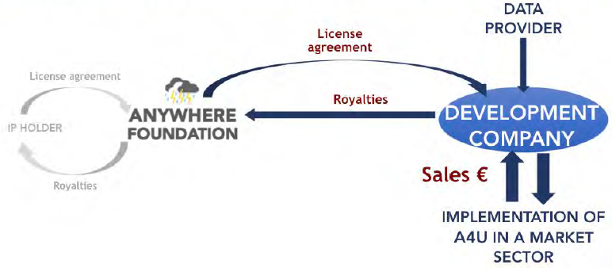
Figure 13: Stage 2 – Facilitate agreement with implementing parties
The main actor of the above scheme is the development company. The development company is a society (e.g. SME, LE) involved in the selling of software services. Its role is to have the capacity to implement into the market the A4EU product, improving it with additional data/model provided by external partners. From the selling of the AEU products in a market sector, the development company is able to provide royalties to the ANYWHERE foundation according to a license agreement between them.
Below, the list of ANYWHERE partners expressing the intention to be a development company is provided.
- HYDS
- UNIGE/METEODAT
- GEO7
- WATERNUMBERS (in a second phase)
- KAJO
- PREDICT Services
- RINA-C
According to HYDS, expressing the intention to be a development company, the agreement to be established with data/model provider would foresee a progressive fee that allows paying small amounts of money at the beginning and do not block commercialisation. They are opened to any exploitation strategy that makes the system sustainable: the tools developed by HYDS can be implemented at any place, so there will not be barriers to their exploitation.
WATERNUMBERS would establish a license agreement to use real time ERICHA (radar rainfall) forecast data (or algorithm to generate data). Depending on what will happen with the potential foundation, WATERNUMBERS intends to establish the agreement with CRAHI and HYDS. According to WATERNUMBERS exploitation intentions, they would sell local flood forecasts products initially in UK.
KAJO, as a development company, would establish an End User Licence Agreement with data/model provider of ANYWHERE. In particular, they refer to CRAHI, HYDS, CIMA, GEO7, WUR, RAB, RINA, METEODAT/UNIGE, and ECMWF. In terms of exploitation intentions, they intend to exploit the full suite of ANYWHERE products in East/Central Europe.
PREDICT Services, as a development company, would establish a Partnership Agreement with data/model providers of ANYWHERE. In particular, they refer to CIMA, HYDS, KAJO and UPC-CRAHI. In terms of exploitation intentions, they intend to deploy their tools and data to their current customers in France and around the world.
RINA Consulting S.p.A., as an engineering company, would establish a Partnership Agreement with data/model providers of ANYWHERE. In particular, they refer to HYDS, KAJO and UPC-CRAHI. In terms of exploitation intentions, RINA-C intends to deploy its services that might be enriched with ANYWHERE data for their customers (in agreement with data providers).

Stage 3 – Facilitate commercialisation and distribution
The scheme below summarises the way in which the ANYWHERE foundation communicate with a distributor in order to facilitate commercialisation and distribution of the A4EU products.
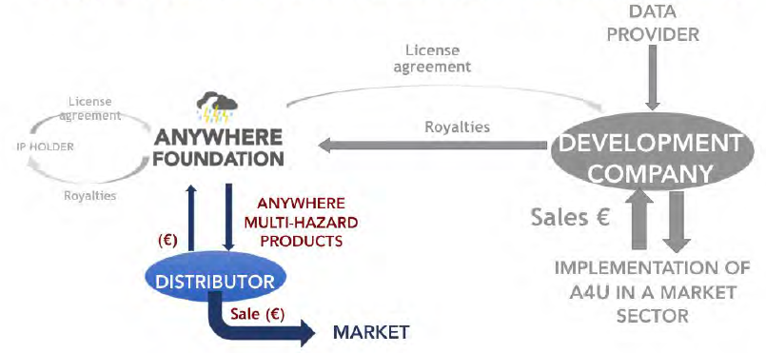
Figure 14: Stage 3 – Facilitate commercialisation and distribution
The main actors involved in the third stage of the potential ANYWHERE foundation are both the development company, with the same role of stage 2, and the distributor that has the role to create a channel between the ANYWHERE foundation and the market. The distributor (e.g. external consultant) asks the access to the ANYWHERE products to sell them into the market in exchange of royalties.
The distributor cannot be a development company but a development company can be a distributor.
Below, the list of ANYWHERE partners expressing the intention to be a distributor is provided.
- UNIGE/METEODAT would be developer and distributor (consultant)
- WATERNUMBERS (probably initially after the end of the project)
- KAJO
- PREDICT Services
- RINA-C
Beyond them, a number of companies from the Network of Associated Enterprises to the ANYWHERE project have expressed their interest, and are waiting for the clarification of the models and prices. This deliverable will be the first step, that will be completed once teh ANYWHERE Foundation will be created after the end of the project.

Exploitation strategies at partner level
This section aims at providing the Individual Exploitation Plans for the partners involved in the project. As a first step, the BFMULO Analysis has been reviewed in order to update if necessary the IPR on Background and Foreground information provided (Table 7) as well as the exploitation intentions of each partner with respect of each group of Exploitable Results (Table 8).
Table 7: BF Table
Results  Partners | ANYWHERE MH-EWS | A4EU Platforms | Local Tools | Self p* Tools
1-UPC-CRAHI | B,F |  |  | F
2-CIMA | B | B |  | F
3-AIRBUS |  | B,F
4-WUR | F | F
5-UFZ
6-HYDS | F | F |  | F
7-UPB
8-SINTEF
9-RINA | B |  | B,F | B,F
10-FMI
11-ECMWF | F | F | F | F
12CFR
13-UNIGE | F | F | F | F
14-UNS
15-JRC
16-UOR
17-KAJO | B,F | B,F | B,F | B,F
18-CNRS
19-SSSA
20-INTC
21-ACA
22-DGPCE
23-AMAYA
24-CDG
25-ARPAL
26-SDIS2B
27-FMOI
28-HSUH
29-VOLBE
30-METEODAT | F | F | F | F
31-GEO7 | F | F | F | F
33-PREDICT |  | B,F | B,F
34-ARANTEC
35-RAB CONSULTANTS
The exploitation intentions from the perspective of each partner related to each of the exploitable results have been reviewed according to the willing of i) producing and selling the results (M), by using them internally (U) through research projects, and lectures in case of universities, by licensing them (L) or by providing services (O) such as external consultancy.
Table 8: MULO Table
Results  Partners | ANYWHERE MH-EWS | A4EU Platforms | Local Tools | Self p* Tools
1-UPC-CRAHI | M,L,O |  |  | U,L,O
2-CIMA | M,U,L | M,U,L,O |  | M,U
3-AIRBUS |  | M,U,L,O
4-WUR | M,L | M,L
5-UFZ
6-HYDS | M,L | M,L |  | M,L
7-UPB
8-SINTEF
9-RINA | O |  | U,L,O | U,L,O
10-FMI
11-ECMWF | L | L | L | L
12CFR
13-UNIGE | M,L | M,L | M,L | M,L
14-UNS
15-JRC
16-UOR
17-KAJO | M,O | M,O | M,O | M,O
18-CNRS
19-SSSA
20-INTC
21-ACA
22-DGPCE
23-AMAYA
24-CDG
25-ARPAL
26-SDIS2B
27-FMOI
28-HSUH
29-VOLBE
30-METEODAT | M,L | M,L | M,L | M,L
31-GEO7 | M,L | M,L | M,L,O | M,L
33-PREDICT |  | M,L,O | M,L,O
34-ARANTEC
35-RAB CONSULTANTS
Then, based on the final version of the BFMULO Analysis as well as on the KERs characterisation and related partners involvement, individual exploitation plans for each of the project partners have been updated and provided hereafter. So far, the individual commercial expectations coincide with the ones reported in the Description of Action. They are reported for completeness hereafter, in a summarized way.
Table 9: Individual partner exploitation intentions
Role in the Consortium | Partner | Exploitation Intentions
RESEARCH ORGANIZATIONS |  | They intend to exploit the project outcomes:  - Licensing the algorithms included in the MH-EWS.  - Providing expertize in tailored products and high-level consulting services. Research organizations will exploit the opportunity of ANYWHERE implementations to provide expertize when needed through high-level consulting and designing tailored products.  In particular, UPC are open to license the algorithms and models to whoever is wiling acquire the license. They could also advice about the best datasets to be used with the algorithm in the domain of interest. Their initial intention is to license the codes of the algorithms under a EULA agreement. Some of the end-users might prefer to get the outcomes of the algorithms, so they can be provided as a service, which could be licensed. Either of the two possibilities would be ok. In particular, they intend to make money by licensing their algorithms for their exploitation (mostly). They could also provide some consultancy or a service by running the algorithms and supplying the outputs of them.  WUR exploitation intentions are licensing of the drought algorithms forecasting standardized drought products and threshold-based drought products as IP holder.
CIVIL PROTECTION AND FIRST RESPONDER AUTHORITIES |  | They not plan to exploit ANYWHERE results directly. The aim of the Civil Protection and first responder authorities participating in ANYWHERE is to obtain customized solutions for their needs with licensing privileges for their beta-testing role in the project.
INDUSTRY | AIRBUS | It intends to exploit the project outcomes to further enhance its market positioning in the area of Crisis Management Solutions. Airbus contribution complemented with other specific solutions and specific tools for other kind of Crisis (CBRN or External) will allow the company to further expand its position as main Solution provider for large Crisis at global scale.
INDUSTRY | HYDS | It intends to exploit the project outcomes to further enhance its market positioning in the area of Early Warning Systems, by expanding its service portfolio with the provision of specific services targeted to both public and private bodies, with the aim also to expand its market share.
INDUSTRY | RINA-C | It intends to exploit the project outcomes to further enhance its offering concerning territorial planning as well as climate change policy advisory and capacity building services. The company has a commercial interest oriented at extending the range of its consultancy services by developing new skills and capabilities in regard to logistics management/planning and services (re-)organization in the occurrence of a Crisis in order to enhance a territory’s pro-active capacity of response to face the effects of extreme and high-impact weather and climate-induced events. The applications and solutions developed in the project will be used to enrich he portfolio of Resilience Engineering service of RINA.
INDUSTRY | KAJO | It intends to expand the market offering tailored services based on combining of the operational prototype of the MH-EWS and information derived from social media. Experience gained within the project will open new market possibilities and provide a solid basis to support existing or new customers in the implementation of the services and tools developed within the project. KAJO business model relies on direct selling, consultancy services, services selling and developing/selling downstream services.
INDUSTRY | METEODAT | It intends to exploit the project outcomes to further enhance its offering concerning early warning systems (EWS) and related topics. The company has also a commercial interest oriented at extending the range of its consultancy services by developing new skills and capabilities in order to improve its understanding and services related to a more understandable and intuitive user interface for the public.
INDUSTRY | GEO7 | It intends to exploit the project outcomes to further expand its offerings to public and private bodies in the area of emergency preparedness and response related to extreme and high-impact weather and climate events.
INDUSTRY | PREDICT Services | PREDICT Services aims to exploit their product portfolio through consultancy services, services selling as well as indirect selling through distributors.
In addition, during the exploitation workshop held by RINA-C in Bastia, the Consortium partners were asked to indicate the potential exploitation routes of their single products for each group of results identified. The potential exploitation routes suggested to partners were software licensing, consultancy service and open source software. However, partners were free to indicate other potential exploitation routes different from those suggested.
The following tables provides the results of the workshop for each group of results.
Table 10: Potential exploitation routes for ANYWHERE MH-EWS by product
ANYWHERE MH-EWS
Partner | Software licensing | Consultancy service | Other
UPC-CRAHI | - rainfall nowcasting algorithm  - flash flood forecasting  - flash flood impact evaluation  - landslide nowcasting | - rainfall nowcasting algorithm  - flash flood forecasting
METEODAT |  | - snowfall limit  - heavy precipitation  - downscaling  - flash flood impact evaluation  - landslide nowcasting
WUR |  |  | Academic Exploitation  - standardized indexes  - threshold indexes
HYDS |  |  | SaaS  - MH-EWS
UOR |  |  | Data License  - Heatwave indexes (UTCI)
ECMWF |  |  | Data License  - Heatwave indexes (UTCI)  - Meteorological products  - Flood products
CFR |  |  | Data License  - EU storm surge model (other - not specified)  - Regional storm surge model (other - not specified)  - Inundation erosion model (other - local tool - local scale - not specified)

Table 11: Potential exploitation routes for A4EU platforms by product
A4EU Platforms
Partner | Software licensing | Consultancy service | Other
AIRBUS | - Software A4FIN, A4ALPS, A4NOR |  | Alert services/Subscription fees  - A4FIN, A4ALPS, A4NOR
HYDS | - A4CAT, A4CENEM |  | SaaS  - A4CAT, A4CENEM
GEO7 | - Disposition model shallow landslides  - Permafrost degradation disposition model | - Shallow landslides disposition model  - Permafrost degradation disposition model
Table 12: Potential exploitation routes for Local Tools by product
Local Tools
Partner | Software licensing | Consultancy service | Other
UNS | - Resilience tool - Operational Resilience Index (DSS)  - Support decision-making service for municipal safety teams, civil protection and Industrial site's safety managers | - Resilience tool - Operational Resilience Index (DSS)
LAB CONSULTANTS  RIVERTRACK  WATERNUMBERS |  | - RIVERTRACK (Community-based flood alerting + forecasting) | Direct selling  - Rivertrack
WATERNUMBERS |  | - Local flood forecasting  - Calibrated meteorological forecasts | Open Source Software  - Local flood forecasting algorithms  SaaS  - Local flood forecasting  - Calibrated meteorological forecasts
RINA-C |  | - Decision support tools for logistics aspect and crisis operations
PREDICT |  | - Support decision-making service for municipal safety teams, civil protection and Industrial site's safety managers
CFR |  |  | To be defined  - Local scale Inundation erosion model
Table 13: Potential exploitation routes for Self-p* Tools by product
Self-p* Tools
Partner | Software licensing | Consultancy service | Other
UPC-CRAHI | - road conditions forecasting models | - road conditions forecasting models
UPB | - ANYWHERE Scenario Technique Tool (AST) | - ANYWHERE Scenario Technique Tool (AST) | Academic/Open  - Common Information Space (CIS)  - Guidelines, recommendations, good practices
HYDS |  |  | SaaS  - A4CAMPSITE
RINA-C | - Weather-based Macroscale Transport Chain Planner | - Weather-based Macroscale Transport Chain Planner
FMI |  |  | Electricity case study  - Convective cell algorithm

- IPR management approach and plan

IPR protection strategy
Outcomes generated within the project must be properly protected, in order to guarantee their effective commercial exploitation.
Protection of results must be ensured in a reasonable and justified way for an appropriate period of time and in a suitable territory.
In particular, Intellectual Property protection measures can be distinguished in:
- Industrial property that can be protected through Patents, Designs and Trademarks
- Non-technical intellectual creations, e.g. literature or artistic ones including software, that can be protected through Copyrights
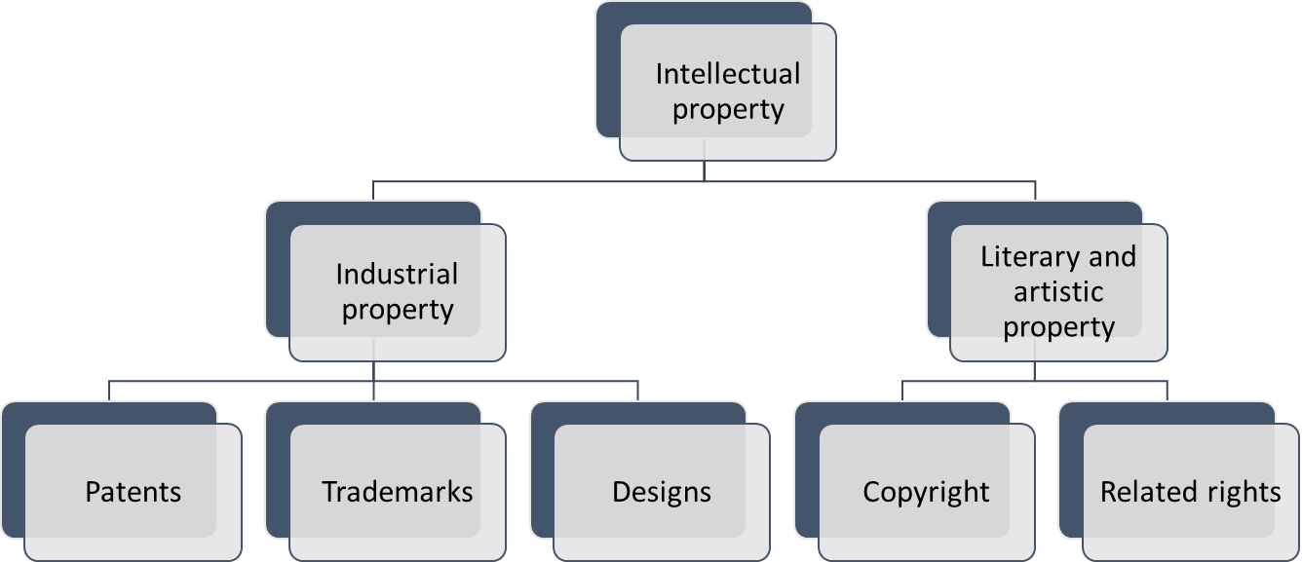
Figure 15: Different Intellectual Property Rights
The choice of the most suitable form of IP protection, as well as the duration and geographical coverage depends on the results at stake, but also on the business plans for their exploitation and on the legitimate interests of consortium partners.
Patents, trademarks, designs and copyrights are described further in the following section, while related rights are not covered in this manual since they deal with rights that benefit to performers (e.g. actors, musicians), producers of phonograms (CDs) and broadcasting organizations (TV, radio).

Formal and informal IP protection – Intellectual Property Rights
Formal IP is designed to provide incentives to innovate by providing a reward system that makes it easier for innovators to make profits if their innovation is successful by allowing them to exclude imitators for a finite period.
A number of common formal IPRs measures are listed in the table below :

Table 14: Formal IPRs measures
Patents | A patent is an industrial property right that protects a technical invention for a limited period (generally 20 years), giving the holder an exclusive right to prevent other from selling, making and using the patented invention. An invention to be patentable must fulfil three criteria: being new, innovative and be susceptible of industrial application. Patents are the most likely IP protection type to be used in the ANYWHERE project.
Utility Models | A Utility Model is an exclusive right granted for an invention, which allows the right holder to prevent others from commercially using the protected invention, without his authorization and for a limited period of time (usually between 7 and 10 years, without the possibility of extension or renewal). It may be any useful machine, implement, tools, product, composition, process, improvement or part of the same, that is of practical utility, novelty and industrial applicability. In practice, protection for utility models is often sought for innovations of a rather incremental character that may not meet the patentability criteria.
Industrial Design | Industrial Design is a type of protection dedicated to the intellectual creation used by designers; it is provided for a shape, configuration, surface pattern, colour, or line (or a combination of these), which, when applied to a functional product, produces or increases aesthetics, and improves the visual appearance of the design, be it a two-dimensional or a three-dimensional product. The subject of the design protection is the outwardly visible appearance of the product or its part, packaging or the ornamentation itself. At this stage, it is not expected to apply for such type of protection under the ANYWHERE project, so it is not further detailed in this document.
Copyrights | Copyrights protect non-technical intellectual creations; in practice, it refers to all of the rights owned by creators over their literary or artistic work. In order to be protected by copyright, a work must first have sufficient originality and, second, have taken form. Protection arises automatically giving the holder the exclusive right to control reproduction or adaptation. This type of protection could be envisaged in the context of the ANYWHERE project, particularly if specific software or programming codes would be developed as support for the exploitation of other ANYWHERE results.
Trademarks | Trademarks are distinctive signs identifying brands of products or services. Any sign that can be represented graphically may be registered as a trademark for a period of 10 years, with the option for indefinite renewal. If not already registered, the ANYWHERE acronym and logo should most probably be registered as a trademark in view of reinforcing other IPR types.

Protection of the Intellectual Property generated within the ANYWHERE Project can be ensured also through ‘informal’ methods, such as:
- Secrecy of information
- Restricted access to information
- Database and network protection
- Confidentiality
- Technical protection (imitation difficult)
- Components and system design protection
The previous list consists of conventional procedures, which will be adopted by each Partner in the ANYWHERE project and will be strictly followed also post-project to ensure that no information may leak outside of the Consortium.
Below, some examples of project outcomes that may be subjected to IPR protection are reported, and possible IPR protection measures for each of them are identified.
Subject Matter | Patent | Utility  Model | Industrial  Design | Copyright | Trademark | Confidential  Information
Invention | ✓ | ✓ |  |  |  | ✓
Software | ✓ |  |  | ✓ |  | ✓
Scientific article |  |  |  | ✓
Design of a product |  |  | ✓ | ✓ | ✓
Name of a product, service /project |  |  |  |  | ✓
Know - How |  |  |  |  |  | ✓
Website |  |  | ✓ | ✓ | ✓

IPR protection plan
In order to ensure an adequate share in the protection of joint efforts it is recommended to notify whenever an innovation or any foreground is generated, as well as to ensure that the foreground sharing is ascertained and agreed among the partners creating it. This should occur on a case-by-case basis and under the supervision of the Innovation Manager, who should act as a supervisory on behalf of the PC.
Any partner intending to apply for any kind of protection of Intellectual Property informs the Innovation Manager.
The acknowledgement of the intention to protect the generated foreground has to be accompanied by a synthetic description of the foreground subject of the intention for IPR protection by filling a specific template that will be provided.
The template requires the following fields to be filled:
- Subject
- Description
- Type of protection (Patent, Trademark, Industrial Design, Copyright, Other)
- Protection Rationale
- Potential Market
- Scientific Responsible
- Keywords
- Work-package(s)
- Partners involved
The Subject field enables a unique identification of the innovation (possible patentable idea): the subject should be well suited to enable a quick retrieval of the different claimed innovations. Partners are encouraged to describe in the field description the main terms of the innovation, according to simple and clear terms precisely referring to the activities performed in the project.
The Keyword field is optional; however, it is strongly recommended to provide at least one keyword for a unique identification of the innovation. This enables the Coordinator and the Innovation Manager to better perform the work of review and evaluation of the effective potentiality of the innovation.
The different possible protection mechanisms (more than one choice is possible) can be indicated in the field Type of Protection. This is only a suggestion and a preference for the evaluator, but will not constitute a restriction for the evaluation activity.
Other fields are related to the Protection rationale and the Potential market. The latter enables the partner to identify the possible potential market of the innovation. This can be useful both for the definition of the foreseen economic impact and for achieving a rough estimate of the potential geographical market penetration. Such information could be relevant for the definition of places where it can be crucial to protect the claimed innovation.
Specific fields to be filled have been foreseen in order to identify the Work package in which the innovation has been developed and the Partners involved in the new innovation.
The description shall be sufficiently detailed to allow to evaluate whether the application for protection of the IPR may endanger other Partners of the Consortium, though it shall be sufficiently general not to disclose too much information related to the subject.
The Coordinator shall track all acknowledgements of partners expressing the intention for IPR protection as well as the date of the acknowledgement. The intention for IPR application shall be archived. This will be useful to uniquely identify the partner’s ownership and attribute a clearly defined date to the claimed invention.

ANYWHERE Exploitable Results and possible IPR protection tools
Data collected from partners confirms the potential IPR strategy preliminarily identified by the consortium. The Table 15 below summarises the possible protection tools applicable for each identified exploitable results.
Table 15: IPR protection tools
Exploitable Results |  | IPR Protection tool
 |  | Patent | Trademark | Copyright | Industrial design | Utility models
1 | Standardized Drought Indices | WUR does not plan to use any of the IPR Protection tool
2 | Threshold Drought Indices | WUR does not plan to use any of the IPR Protection tool
3 | MH-EWS | HYDS does not plan to use any of the IPR Protection tool
4 | A4FIN |  |  |  | ✓
5 | A4LPS |  |  |  | ✓
6 | A4NOR |  |  |  | ✓
7 | A4CAT | HYDS does not plan to use any of the IPR Protection tool
8 | A4LIG |  |  | ✓
9 | Rainbow risk-based decision machine
10 | Decision support Tool on logistic aspects and crisis management | Patent or utility model under evaluation
11 | A4CAMPSITE | HYDS does not plan to use any of the IPR Protection tool
12 | Social network & broadcasting tool | KAJO does not plan to use any of the IPR Protection tool
13 | Weather-based Macroscale transport chain planner | Patent or utility model under evaluation
14 | Nowcasting of snowfall limit |  |  | ✓
15 | Optimal convective index for heavy precipitation |  |  | ✓
16 | Downscaling of numerical forecast models for mountainous regions |  |  | ✓
17 | Disposition model for shallow land slides |  |  |  |  | ✓
18 | Permafrost degradation disposition model |  |  |  |  | ✓
19 | PREDICT Support decision making services | PREDICT Services does not plan to use any of the IPR Protection tool
20 | Resilience tool ORI (DSS)
21 | RISICO & Propagator (fire danger rating system) |  |  | ✓
22 | FloodPROOF algorithm |  |  | ✓
23 | Nowcast model - PhSt |  |  | ✓
24 | A4SCHOOLS | CIMA does not plan to use any of the IPR Protection tool
25 | RIVERTRACK
26 | Convective cell classification algorithm for electricity providers
27 | Scenario technique (ST) tool
28 | European storm surge model
29 | Local inundation-erosion model
30 | Regional storm surge model algorithm
31 | Fire danger: reanalysis + forecast (ECMWF more detail) | Copernicus license
32 | Ptype: Probability of precipitation type | Data license cannot be used freely after the project end
33 | Heatwave index (UTCI) forecasts | Data license cannot be used freely after the project end
34 | Site specific database flood forecast
35 | Calibrated meteorological forecast
36 | Common information space (CIS)
37 | WP5 guidelines, good practices and recommendations
38 | Rainfall nowcasting algorithm |  |  | ✓
39 | Flash flood algorithm - FF-EWS |  |  | ✓
40 | Flash flood impact estimation algorithm |  |  | ✓
41 | Landslide nowcasting algorithm |  |  | ✓
42 | Road conditions forecasting module |  |  | ✓
43 | Performance assessment of the meteorological forecasts and nowcasts products | No license or copyright
44 | Flood products (EFAS-ERIC Model)
45 | Air quality and health products
46 | Debris flows and landslide algorithm
47 | A4CENEM | HYDS does not plan to use any of the IPR Protection tool
48 | A4COR | PREDICT Services does not plan to use any of the IPR Protection tool
In order to have a clear comprehension on the tools and methodologies under patents on the main and relevant topics of the ANYWHERE project, a patent mapping analysis has been performed for the different type of hazards addressed by the project. They are:
- Meteorological forecast and nowcast
- Floods, flash-floods, debris flow and landslides
- Storm surges
- Heatwaves and weather induced health impacts
- Weather induced forest fires
- Droughts
- Convective storms, severe winds
- Snowfall
Paragraphs below provide the patent analysis for the above groups of results, detailing the following aspects:
- an overview of the current patents scenario
- an overview of the geographical location of patents
- an overview of the main applicants

Patent mapping analysis
Patent analysis is a unique management tool for addressing the strategic management of the firm’s technology and product or service development process. Translating patent data into competitive intelligence allows the firm to gauge its current technical competitiveness, to forecast technological trends, to plan for potential competition based on new technologies.

In this section is presented the patents analysis. The analysis has been done out exploiting Derwent Innovation (website: www.derwentinnovation.com) database. Derwent Innovation is unrivalled as a search and analytics platform for IP and business-critical decision-making. It is powered by best-in-class technology including artificial intelligence, together with unparalleled expertise in patent data and IP workflows built in. It is underpinned by global, standardized patent data including bibliographic data, full text documents, drawings, Derwent Word Patent Index (DWPI) and Derwent Patent Citation Index (DPCI). The tool offers patent and literature collections.
In the paragraph below, the patent analysis for the selected groups of results is provided, with the following:
- Scenario analysis related to the identification of patents temporal trend submission, patent publications countries as well as trend of the main applicants.
- Punctual analysis allowing the identification of interesting technological solutions, tools and methods that could represent hints to the further project technological development and suggest ideas for further patents development. In this case, the most relevant patents have been analysed in detail with the support of the Derwent Innovation suite.
For each of them a table summarizing main contents is reported, providing the following information:
- Title
- Status (dead, alive or indeterminate)
- Title DWPI (Revised Title)
- Publication number
- DWPI Assignee
- Publication year
- Current IPC(s)
- Abstract, Novelty, Use, Technology Focus, Advantage and Drawing Description (if available)
- Drawing

Meteorological forecast and nowcast

A patent analysis has been performed starting from 2009 up to day and using a generic query referring to meteorological forecast and nowcast. In particular the query used to obtain a patent dataset is “((meteo* ADJ forecast) OR nowcast)”.
The query results in a total of 141 patents selected (corresponding to 87 INPADOC families). As it can be noticed from the following graphs in the last 10 years (2009-2019) there’s been a positive temporal trend showing a peak of interest in 2018. In particular, there has been great interest towards patent applications from countries as China, US and Europe. Main players are Sky Motion, ENI and Hitachi who submitted 15, 11 and 8 patents respectively.
In the following the main results of the scenario analysis it’s been reported.

Figure 16: Patent temporal trend (2009-2018)

Figure 17: Patent Publication Countries

Figure 18: Trend of the main applicants
Tables below provide the most relevant patents analyzed.

I M SYSTEMS GROUP INC |  | Alive
Title DWPI:  Method for automatically modeling, recording and predicting convective weather for businesses, involves generating nowcast output, and transmitting nowcast output to user devices to display nowcast output through graphical user interface | 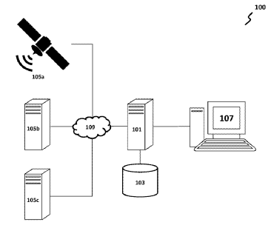
Publication number (Kind Code):
WO2018204316A1
Inventor(s):
CHEN R
Publication Date:
2018-11-08
Current IPC:
G01C 21/00; G01C 21/34; G01W 1/10; G06F 19/00; G06G 7/70
Abstract
Novelty
The method involves generating a new-convection object data record in an evolution database (103) by a user computer (107), where the new-convection object data record is associated with a new-convection object. Parameters associated with the new-convective object for each respective time step are stored into the new-convection object data record. A nowcast output is generated based upon a weather object data record received for time step intervals of the new-convective object and convective object data records for convective objects by the computer, where the nowcast output displays a geographic map indicating a nowcast weather image for a set of future time step intervals on a graphical user interface (GUI). The nowcast output is transmitted to user devices to display the nowcast output through the GUI.
Detailed Description:
An INDEPENDENT CLAIM is also included for a weather nowcasting system.
Use
Method for automatically modeling, recording and predicting convective weather for businesses.
Advantage
The method enables maintaining own input data needs based on proximity to data sources to minimize latency and maximize computational efficiency for generating nowcast weather projection products provided to user devices to assist time-critical operational decision-making. The method enables generating images dynamically for less frequently viewed weather projection fields, thus saving device memory space and minimizing processing time on an nowcasting server and a database by avoiding storing output images or different data plots for many weather projection fields at each weather projection time step. The method enables providing air traffic management and control (ATM/C) personnel with access to relevant weather information and capability to manage air traffic proactively by generating re-routing plans to circumvent weather-blocked airspace or by executing ground delay programs or ground stop programs to prevent burdening of reduced airspace capacity during a strategic stage.
Drawing Description
The drawing shows a schematic block diagram of a nowcasting system.
101 - Nowcasting server.
103 - Evolution database.
105a-105c - Source devices.
107 - User computer.
109 - Networks.

NASA |  | ! Indeterminate
Title DWPI:  Method for providing regional landslide hazard assessment, involves creating susceptibility map, which is divided into categories, and showing categories on susceptibility map on display of computer system using defining characteristic | 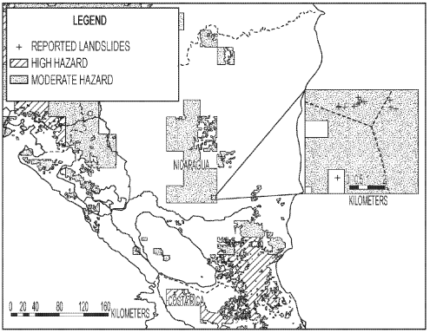
Publication number (Kind Code):
US20180045853A1
Inventor(s):
CAPPELAERE P; KIRSCHBAUM D; STANLEY T A
Publication Date:
2018-02-15
Current IPC:
G01W 1/06; G01C 21/00; G01W 1/14; G08B 21/10
Abstract
Novelty
The method involves retrieving geographic information from a database on a region. Satellite-based remote sensing data is retrieved from an external database (195) in real-time or near real-time from the region, where the external database is accessed by a computer system. A susceptibility map, which is divided into categories that represent relative susceptibility to landslides is created. The categories are shown on the map on a display of the system using a defining characteristic. A faults regional geographic dataset is combined with global slope, soils, and roads geographic datasets.
Detailed Description:
An INDEPENDENT CLAIM is also included for a non-transitory computer-accessible medium comprising a set of instructions for providing a landslide hazard assessment.
Use
Method for providing a regional landslide hazard assessment by using a computer system (claimed). Uses include but are not limited to personal computers (PCs), hand-held devices, multi-processor systems, microprocessor-based or programmable consumer electronics, network PCs, minicomputers, and mainframe computers.
Advantage
The method enables accurately resolving landslide nowcasts while minimizing overall number of alerts issued as relationship between rainfall, antecedent rainfall, susceptibility and landslide triggering is not linear. The method enables enhancing accuracy of the susceptibility map as the data retrieved from the databases by a program.
Drawing Description
The drawing shows a block diagram of a computing system for providing a regional landslide hazard assessment.
100 - Computing device.
160 - Storage device.
170 - Device output.
180 - Communications interface.
195 - External database.

SKY MOTION RES ULC |  | - Alive
Title DWPI:  Computer implemented method for outputting chronological succession of weather forecasts, involves receiving choice of time increment from user, with chosen time increment defining succession of specific times starting at given time | 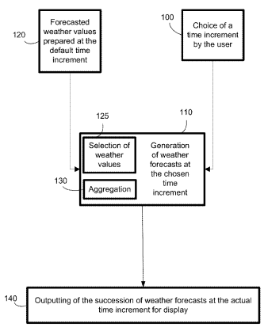
Publication number (Kind Code):
EP2981855A1
Inventor(s):
LEBLANC A
Publication Date:
2016-02-10
Current IPC:
G01W 1/10; G01C 21/36
Abstract
Novelty
The method involves receiving forecasted weather values prepared (120) by a weather value forecaster, with the values starting at given time and for subsequent times. A choice of a time increment is received (100) from a user, with increment defining a succession of specific times for times separated by the chosen time increment. The forecasted weather values are used at default time increment for generating a new succession of weather forecasts for intervals between specific times. The succession of weather forecasts is outputted (140) between specific times.
Detailed Description:
INDEPENDENT CLAIMS are included for the following:
a system for outputting a chronological succession of weather forecasts starting at a given time, over a given period, and for a given territory;
a device for outputting a chronological succession of weather forecasts starting at a given time, over a given period, and for a given territory; and
a non-transitory computer-readable medium storing instructions for outputting chronological succession of weather forecasts starting at a given time, over a given period, and for a given territory.
Use
Computer implemented method for outputting chronological succession of weather forecasts using laptop, desktop, portable computing device, or tablet.
Advantage
The time increment is enabled to be memorized, for later retrieving the memorized time increment instead of prompting the user for a choice, thus allowing using a time increment saved from a previous use of the method.
Drawing Description
The drawing shows a flowchart illustrating the method for outputting chronological succession of weather forecasts.
100 - Step for receiving choice of time increment.
110 - Step for generating weather forecasts.
125 - Step for selecting weather values.
140 - Step for outputting weather forecasts.
200 - Nowcaster.

METEOWISE RISK MAN SHENZHEN CO LTD |  | - Alive
Title DWPI:  Lattice site weather data based weather risk estimating method, involves performing weather risk evaluating process to evaluate risk level of various meteorological disasters in various regions according to basic database | N/A
Publication number (Kind Code):
CN107679167A
Inventor(s):
GAO H; LIU F; LUO F
Publication Date:
2018-02-09
Current IPC:
G06F 17/30; G06Q 10/04; G06Q 40/08; G06Q 50/26; G08B 21/10
Abstract
Novelty
The method involves combining lattice site meteorological data and historical weather data to form a complete set of weather data. An original layout is detected according to certain distribution density data. Meteorological data verification process is performed to obtain a closest real-time numerical value. A basic database is established, where the lattice site meteorological data is included with year and geographic area information. Weather risk evaluating process is performed to evaluate risk level of various meteorological disasters in various regions according to the basic database.
Detailed Description:
An INDEPENDENT CLAIM is also included for a lattice site weather data based weather risk analyzing and pre-warning platform.
Use
Lattice site weather data based weather risk estimating method.
Advantage
The method enables integrating current weather forecast data into a weather risk evaluation model to realize real-time meteorological disaster broadcasting operation, and evaluating risk level of target meteorological disaster in accurate manner.
Drawing Description
The drawing shows a flowchart illustrating a lattice site weather data based weather risk estimating method. '(Drawing includes non-English language text)'

ANHUI JINKUN ELECTRONIC TECH CO LTD |  | - Alive
Title DWPI:  Weather forecasting evaluation system, has timing module connected with service platform and for determining time period of monitoring module, and service station for receiving processed monitoring data to obtain weather prediction result | N/A
Publication number (Kind Code):
CN106501875A
Inventor(s):
QIU K; ZHOU R
Publication Date:
2017-03-15
Current IPC:
G01W 1/02; G01W 1/06
Abstract
Novelty
The system has a service platform fixed in a control room and for receiving transmission information. A rainfall monitoring module is fixed in a distribution region to measure and obtain rainfall information of a monitoring point and transmits the rainfall information to the service platform. A timing module is connected with the service platform and determines data transmission time period of a monitoring module. A data processing module is connected with the service platform. A service station receives processed monitoring data to obtain a weather prediction result.
Detailed Description:
The timing module is specified as a timer. The service platform is specified as a mainframe computer.
Use
Weather forecasting evaluation system.
Advantage
The system is convenient to use, and realizes centralized processing to obtain maintenance data, and can effectively obtain a result of the weather prediction, and improves accuracy of the service platform.
Drawing Description
The drawing shows a block diagram of a weather forecasting evaluation system. '(Drawing includes non-English language text)'

Floods, flash floods, debris flow and landslides
In order to get a rough result of the patent analysis of this result, the research has been performed starting from 2009 up to day.
The query used to obtain a patent dataset referring to forecast and simulation of floods, flash floods, debris flow and landslides is “(((*floods OR (debris ADJ flow) OR landslides) AND (monitor* OR forecast OR simulat*)))”.
The query results in a total of 1064 patents selected (corresponding to 753 INPADOC families). As it can be noticed from the following graphs in the last 10 years (2009-2019) there’s been a positive temporal trend showing a peak of interest in 2016. In particular, there has been great interest towards patent applications from countries as China, US and Europe. Main players are Go science LTD, University Chengdu Technology and Korea Institute Geoscience and Minera who submitted 34, 24 and 16 patents respectively.
In the following the main results of the scenario analysis it has been reported.

Figure 19: Patent temporal trend (2009-2018)

Figure 20: Patent Publication Countries

Figure 21: Trend of the main applicants

Tables below provide the most relevant patents analyzed.

GERMAN AEROSPACE CENTER (DEUTSCHES ZENTRUM FUR LUFT-UND RAUMFAHRT) |  | Alive
Title DWPI:  System for warning local flood events on part of earth's surface, has warning unit for producing warning output when value of water level distribution exceeds threshold value, and transmitting device for exchanging data | N/A
Publication number (Kind Code):
DE102015109208A1
Inventor(s):
FISCHER P; KRAUSS T; TAUBENBOECK H; WURM M
Publication Date:
2016-12-15
Current IPC:
G06F 17/50; G06F 19/00; G06Q 10/04; G08B 31/00
Abstract
Novelty
The system has an interface or a data storage unit (101) for providing a digital 3D-terrain model of a part of earth's surface. A precipitation prognosis unit or a computer simulation model (102) predicts temporal progression of two-dimensional distribution of rain quantities located on the part of the surface. A computer (103) determines time course of planar water level distribution on the part of the surface based on the 3D-terrain model. A warning unit (104) produces warning output when value of the water level distribution exceeds threshold value. A transmitting device exchanges data.
Detailed Description:
An INDEPENDENT CLAIM is also included for a method for warning local flood events on a part of earth's surface.
Use
System for warning local flood events on a part of earth's surface.
Advantage
The warning unit produces warning output, thus warning local flood events on the part of the earth's surface in a simple manner.
Drawing Description
The drawing shows a block diagram of a system for warning local flood events on a part of earth's surface.
101 - Data storage unit.
102 - Computer simulation model.
103 - Computer.
104 - Warning unit.

NANJING KANGTENG BIOTECH CO LTD |  | ! Indeterminate
Title DWPI:  Debris flow monitoring evacuation alarm system, has disaster prevention center monitoring host platform for judging whether sensor is in alarm state based on time series and judging whether to perform debris flow evacuation alarm | N/A
Publication number (Kind Code):
WO2018228301A1
Inventor(s):
QIN H; QIN S; QIN Z
Publication Date:
2018-12-20
Current IPC:
G08B 21/10; G08B 31/00
Abstract
Novelty
The system has a sensor module paved into a monitored area according to an Esther matrix. A signal receiver wirelessly receives state change information, sensor real-time state information and low-voltage alarm information of the monitored area detected by a sensor using an internet communication protocol (LPWA). The signal receiver transmits the state change information, the sensor real-time state information and the low-voltage alarm information to a disaster prevention center monitoring host platform through a wireless or wired network. The disaster prevention center monitoring host platform judges whether the sensor is in an alarm state according to a time series and judges whether to perform debris flow evacuation alarm.
Detailed Description:
An INDEPENDENT CLAIM is also included for a debris flow disaster prevention monitoring method.
Use
Debris flow monitoring evacuation alarm system.
Drawing Description
The drawing shows a schematic view of a debris flow monitoring evacuation alarm system. '(Drawing includes non-English language text)'

Storm surges
In order to get a rough result of the patent analysis of this result, the research has been performed starting from 2009 up to day.
The query used to obtain a patent dataset referring to forecast and monitoring of storm surges is “(((storm ADJ surge) AND (monitor* OR forecast)))”.
The query results in a total of 39 patents selected (corresponding to 28 INPADOC families). As it can be noticed from the following graphs in the last 10 years (2009-2019) there’s been a positive temporal trend until 2012, when there was a decline that lasted until 2015. In particular, there has been great interest towards patent applications from countries as China, Korea and US. Main players are University Shangai Ocean, University Kyungsung and Han Jin Ind & Constr who submitted 7, 4 and 4 patents respectively.
In the following the main results of the scenario analysis it has been reported.

Figure 22: Patent temporal trend (2009-2018)

Figure 23: Patent Publication Countries

Figure 24: Trend of the main applicants

Tables below provide the most relevant patents analyzed.

UNIV CHEJU NAT IND ACADEMIC COOP FOUND |  | - Dead
Title DWPI:  Method for predicting Korean peninsula sea storm surge intensity change, includes forecasting future typhoon by intensity change prediction server, and basing intensity change of storm surge on storm surge simulation | 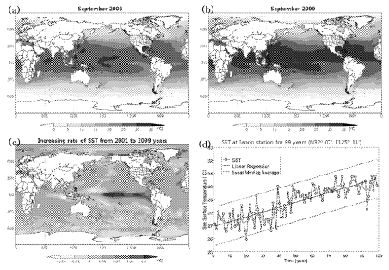
Publication number (Kind Code):
KR1172317B1
Inventor(s):
JU M I; MOON I J; MYEONG O S; OH S M
Publication Date:
2012-08-14
Current IPC:
G01W 1/02; G01W 1/10
Abstract
Novelty
The Korean peninsula sea storm surge intensity change predicting method comprises forecasting future typhoon by intensity change prediction server (100), basing intensity change of storm surge on storm surge simulation (130), calculating future typhoon of Korean peninsula sea by estimator (140), using weather research and forecasting model base on heating surround of warming configuration part (110), and applying actual time tide and surge model base on warming surround of typhoon simulation (120).
Use
Method used for predicting Korean peninsula sea storm surge intensity change.
Advantage
The intensity change of storm surge and correct typhoon activity is predicted.
Drawing Description
The drawing shows a block diagram of Korean peninsula sea storm surge intensity change predicting method (Drawing includes non-English language text).
100 - Intensity change prediction server.
110 - Warming configuration part.
120 - Typhoon simulation.
130 - Storm surge simulation.
140 - Estimator.

SBIS LTD |  | ! Indeterminate
Title DWPI:  System for forecasting storm surge, has storm surge index calculating unit which produces storm surge index and transmit unit transmits generated storm surge forecast data from storm surge forecaster generating unit | N/A
Publication number (Kind Code):
KR2015089191A
Inventor(s):
JHYEON P H; JONG H KU M I; MOON I J; MYEONG O S; OH S M
Publication Date:
2015-08-05
Current IPC:
G06F 19/00
Abstract
Novelty
The system (100) has an atmosphere model information database (1) which stores the atmosphere model information. A storm surge model information database (2) stores the position Fargo changing. A digital elevation model (DEM) (3) stores the position DEM information. A standardization section (4) confirms the standardization grid structure unit set up. A storm surge index calculating unit (6) produces the storm surge index. A storm surge forecaster generating unit (8) produces the storm surge forecaster. A transmit unit (9) transmits the generated storm surge forecast data.
Use
System for forecasting storm surge.
Advantage
The damage of human life and property are prevented.
Drawing Description
The drawing shows a configuration view of the system for forecasting storm surge.
1 - Atmosphere model information database.
2 - Storm surge model information database.
3 - DEM.
4 - Standardization section.
6 - Storm surge index calculating unit.
8 - Transmit unit.
100 - System.

TIANJIN UNIVERSITY |  | - Alive
Title DWPI:  Storm surge prediction model based data analysis and visual management system, has storm knowledge module connected with water-increasing prediction module through visual final tidal information management module | N/A
Publication number (Kind Code):
CN106327020A
Inventor(s):
FAN R; MA X; NIE H; WANG R; ZHAO W
Publication Date:
2017-01-11
Current IPC:
G06Q 10/04
Abstract
Novelty
The system has a storm knowledge module integrated with a user interface base assembly. A data pattern analyzer is connected with a data cluster through a based on graphical user interface (GUI) design of MATLAB (RTM: numerical computing environment and programming language). An analysis tool is contained with multiple drawing modes and connected with a visual management terminal. The storm knowledge module is connected with a water-increasing prediction module through a visual final tidal information management module.
Use
Storm surge prediction model based data analysis and visual management system.
Drawing Description
The drawing shows a block diagram of a storm surge prediction model based data analysis and visual management system. '(Drawing includes non-English language text)'

BAIDU INC |  | - Alive
Title DWPI:  Storm surge forecasting method, involves establishing storm water database, collecting occurrence time data of astronomical tide peak level of meteorological monitoring station and storm, and establishing storm happening time database | N/A
Publication number (Kind Code):
CN108732647A
Inventor(s):
QI C; ZHANG H
Publication Date:
2018-11-02
Current IPC:
G01W 1/10
Abstract
Novelty
The method involves collecting tidewater level data of a meteorological monitoring station corresponding to wind speed data of a windward side of the meteorological monitoring station. A storm water database is established, where the storm water database includes average wind speed, maximum wind speed and storm water time of the meteorological monitoring station. Occurrence time data of astronomical tide peak level of the meteorological monitoring station and storm are collected. A storm happening time database is established, where the storm happening time database includes the occurrence time data of astronomical tide peak level and the storm.
Use
Storm surge forecasting method.
Advantage
The method enables predicting the occurrence time of the storm within 24 hours or longer so as to provide guidance for countermeasures before arriving the storm.

Heatwaves and weather induced health impacts
A patent analysis has been performed starting from 2009 up to day and using a generic query referring to monitoring and forecast of heatwaves and weather induced health impacts. In particular the query used to obtain a patent dataset is “(((heatwave) AND (monitor* OR forecast)))”.
The query results in a total of 6 patents selected (corresponding to 3 INPADOC families). As it can be noticed from the following graphs in the last 10 years (2009-2019), the patent temporal trend started in 2014 showing a peak of interest in 2017. In particular, there has been great interest towards patent applications from countries as Europe and US. The main player is the North-eastern University who submitted 5 patents.
In the following the main results of the scenario analysis it’s been reported.

Figure 25: Patent temporal trend (2009-2018)

Figure 26: Patent Publication Countries

Figure 27: Trend of the main applicants
Table below provide the most relevant patent analyzed.

INST AGRO FOOD SCI & TECHNOLOGY CHINESE |  | - Alive
Title DWPI:  Experimental device for measuring effects of heat wave climate and castration on grassland ecosystems, has soil carbon flux automatic measurement system and detection unit of soil moisture velocity measuring instrument set in soil | N/A
Publication number (Kind Code):
CN108353676A
Inventor(s):
CHEN J; DONG G; QU L; SHAO Z
Publication Date:
2018-08-03
Current IPC:
A01G 7/06; A01G 22/00; G01D 21/02
Abstract
Novelty
The device has a transparent plastic cloth (2) that is placed on the outside of a simulated heat wave bracket (1). A heater (3) is placed on the inner side of the simulated heat wave bracket. A temperature tester is arranged on the inner side of the simulated heat wave bracket. An analog castration device is provided horizontally in the simulated heat wave bracket. A soil carbon flux automatic measuring system (5) and a soil moisture measuring instrument (6) are arranged on the outer side of the simulated heat wave bracket. The soil carbon flux automatic measurement system and the detection unit of the soil moisture velocity measuring instrument are set in the soil inside the simulated heat wave stent.
Use
Experimental device for measuring effects of heat wave climate and castration on grassland ecosystems.
Advantage
The device is provided with simple structure and reasonable design. The device can simulate the heat wave climate of the grassland in the test area at any time. The vegetation in the test area can be simulated and casted. The carbon flux and water flux of the soil can be monitored and recorded in real time. The device simulates the maximum degree of cutting that the grassland ecosystem in the experimental area can withstand in a heat wave climate. The device can effectively serve the local grass cutting and grazing activities such as reducing vegetation.
Drawing Description
The drawing shows a schematic view of the experimental device for measuring effects of heat wave climate and castration on grassland ecosystems.
1 - Simulated heat wave bracket.
2 - Transparent plastic cloth.
3 - Heater.
5 - Soil carbon flux automatic measuring system.
6 - Soil moisture measuring instrument.

Weather induced forest fires
A patent analysis has been performed starting from 2009 up to day and using a generic query referring to tools able to monitor and forecast weather induced forest fire. In particular the query used to obtain a patent dataset is “(((forest ADJ fire) AND ((monitor* ADJ tool) OR forecast OR *warning)))”.
The query results in a total of 549 patents selected (corresponding to 460 INPADOC families). As it can be noticed from the following graphs in the last 10 years (2009-2019) there’s been a positive temporal trend showing a peak of interest in 2017. In particular, there has been great interest towards patent applications from countries as China and Korea. Main players are State Grid Corp China and Sony Corporation who submitted 31 and 30 patents respectively.
In the following the main results of the scenario analysis it has been reported.

Figure 28: Patent temporal trend (2009-2018)

Figure 29: Patent Publication Countries

Figure 30: Trend of the main applicants
Tables below provide the most relevant patents analyzed.

JINYANG IND CO LTD |  | - Alive
Title DWPI:  System for early warning forest fire has control server for transmitting emergency signal when sensed humidity and temperature value is greater than preset threshold value and is confirmed using automatic flying object | 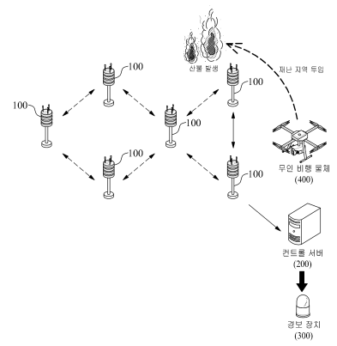
Publication number (Kind Code):
KR1532055B1
Inventor(s):
HAN Y
Publication Date:
2015-07-17
Current IPC:
G08B 17/06; G08B 25/10
Abstract
Novelty
The system has multiple unit observation apparatus (100) for sensing the temperature and humidity in air inside the forest in real-time. The sensed information is transmitted to a control server (200) which analyzes the received data for determining whether the sensed humidity and temperature values are within the predetermined threshold value or not. The emergency signal is outputted when the temperature is greater than the predetermined threshold. The automatic flying object (400) flies over the detected area and obtain visual data for conforming the fire hazard.
Use
System for early warning forest fire.
Advantage
The spreading of the forest fire is prevented. The accuracy of the emergency signal is enhanced by using automatic flying object which provides visual data of the fire hazard detected area. The damage caused is minimized by providing quick fire extinguishing process.
Drawing Description
The drawing shows a configuration view of system for early warning forest fire. (Drawing includes non-English language text)
100 - Unit observation apparatus.
200 - Control server.
300 - Alarm.
400 - Automatic flying object.
500 - Information transmitting apparatus.

KOREA FORESTRY ADMIN FORESTRY RES |  | - Alive
Title DWPI:  Method for forecasting forest fire danger rating, involves extracting topography danger index from geographic information, and unit lattice weather danger index is extracted from weather information | N/A
Publication number (Kind Code):
KR1106957B1
Inventor(s):
BO L M; LEE M B; SU W M; WON M S
Publication Date:
2012-01-25
Current IPC:
G07B 17/00; G06Q 50/00; G06Q 50/10
Abstract
Novelty
The method involves extracting a topography danger index from geographic information. A unit lattice weather danger index is extracted from weather information. A clinical danger index is extracted from clinical information. The weather danger index is extracted according to conditions such as temperature, humidity and the speed of wind.
Detailed Description
An INDEPENDENT CLAIM is also included for a forest fire danger rating forecasting system.
Use
Method for forecasting forest fire danger rating.
Advantage
The method involves extracting a topography danger index from geographic information, where a unit lattice weather danger index is extracted from weather information, and thus ensures fast and efficient forest fire danger rating forecasting method.
Drawing Description
The drawing shows a schematic block diagram of a forest fire danger rating forecasting system. (Drawing includes non-English language text).
11 - Weather information providing server.
12 - Geographic information providing server.
13 - Clinical information providing server.
20 - Forest fire danger prediction server.
40 - User terminal.

HK ELECTRONICS CO LTD |  | - Alive
Title DWPI:  Method for forecasting forest fire danger rating, involves extracting topography danger index from geographic information, and unit lattice weather danger index is extracted from weather information | N/A
Publication number (Kind Code):
KR1076734B1
Inventor(s):
BU H; GI W N; HAE G C; JUNG H J; YONG H L
Publication Date:
2011-10-26
Current IPC:
G08B 17/00; G01W 1/02; G08B 25/00
Abstract
Novelty
The apparatus has a sensor data gathering unit periodically collecting meteorological sense data about a monitoring forest fire spot and humidity and speed of wind. A forecaster gathering unit periodically collects meteorological forecast data about a watching point from an external database. An accumulation data gathering unit collects meteorological accumulation data about the watching point from the external database. A CPU receives value of weather observation data collected by using the accumulation data gathering unit.
Detailed Description
An INDEPENDENT CLAIM is also included for an information analysis type monitoring forest fire method.
Use
Information analysis type forest fire monitoring apparatus.
Advantage
The apparatus utilizes an observation sensor to analyze forest fire in an accurate manner. The apparatus can automatically generate a warning tone, so that a forest fire location is accurately recognized by an administrator, thus reducing damage caused due to forest fire.
Drawing Description
The drawing shows a block diagram of an information analysis type forest fire monitoring apparatus.'(Drawing includes non-English language text)'

CHENGZI SOFTWARE NANTONG CO LTD |  | - Alive
Title DWPI:  Forest fire warning system arrangement method, involves analyzing and processing alarming information and pre-planned fire protection measures, and tracking fire condition by scene monitoring terminal in real time | N/A
Publication number (Kind Code):
CN108765840A
Inventor(s):
WANG K
Publication Date:
2018-11-06
Current IPC:
G08B 17/00; G08B 17/06; G08B 17/10; G08B 17/12
Abstract
Novelty
The method involves collecting environment information around a monitoring point. Environment information and monitoring point position information are sent to a remote monitoring center. Forest fire protection data is analyzed and processed by a monitoring database server and a monitoring software platform. A pre-set forest fire alarm model is established by the monitoring database server. Environment information of the monitoring point received by the monitoring database server is read by the monitoring software platform. Alarming information and pre-planned fire protection measures are analyzed and processed by a related managing staff and a forest fire protection center. Fire condition is tracked by a scene monitoring terminal in real time.
Use
Forest fire warning system arrangement method.
Advantage
The method enables realizing rational design, low cost, stable operation and reliable monitoring.

WUXI NUIST WEATHER SENSOR NETWORK TECHNOLOGY CO LTD |  | - Alive
Title DWPI:  Forest fire weather early warning system, has data receiving module connected with geographical monitoring module, serial switch connected with storing circuit, and detector protection circuit is connected with level conversion module | N/A
Publication number (Kind Code):
CN106373065A
Inventor(s):
YU S
Publication Date:
2017-02-01
Current IPC:
G06Q 50/26; G01W 1/02
Abstract
Novelty
The system has a weather monitoring module and a geographical monitoring module connected with a data receiving module, respectively. The data receiving module, a forest fire weather index calculation module, a forest fire pre-warning information generating module and a pre-warning information sending module are connected together. The weather monitoring module receives geographical information by a monitoring module. A serial switch and a level conversion module are bidirectionally connected with a storing circuit. A detector protection circuit is connected with the level conversion module.
Use
Forest fire weather early warning system.
Advantage
The system realizes real time monitoring, processing and analysis function, which effectively realizes forest fire early warning function and saves manpower and material resources.
Technology Focus
INDUSTRIAL STANDARDS- A communication device is provided with a GPRS module or a 3G module.

STATE GRID CORP OF CHINA |  | - Dead
Title DWPI:  Forest fire hazardous weather early warning system, has weather data receive terminal receiving weather index information from weather station, and early warning information module sending pre-warning information to user terminal | N/A
Publication number (Kind Code):
CN103823953A
Inventor(s):
GUO J; GUO Y; GUO Z; WANG K; ZHANG Y
Publication Date:
2014-05-28
Current IPC:
G06F 19/00
Abstract
Novelty
The system has a weather station connected with a weather data receive terminal and a forest fire hazard weather index calculation module. The weather data receiving terminal receives weather index information from the weather station. An early warning information module sends pre-warning information to a user terminal. The data receiving terminal is connected with a data analysis module and a recording window. A database stores weather data information of the weather station. The data analysis module sends data package information to the recording window.
Detailed Description
An INDEPENDENT CLAIM is also included for a forest fire hazardous weather early warning method.
Use
Forest fire hazardous weather early warning system.
Drawing Description
The drawing shows a flow diagram illustrating a forest fire hazardous weather early warning system.'(Drawing includes non-English language text)'

Droughts
A patent analysis has been performed starting from 2009 up to day and using a generic query referring to tools for monitoring and forecast droughts. In particular the query used to obtain a patent dataset is (((drought NEAR (precipitation OR soil)) AND ((monitor* ADJ tool) OR forecast OR *warning))).
The query results in a total of 8 patents selected (corresponding to 6 INPADOC families). As it can be noticed from the following graphs in the last 10 years (2009-2019) the patent temporal trend started in 2012 showing a peak of interest in 2017. In particular, there has been interest towards patent applications only from China. Main players are State Grid Corp of China, Fujian Shuikou Power Generation and the Wuhan University who submitted 2 patents.
In the following the main results of the scenario analysis it has been reported.

Figure 31: Patent temporal trend (2009-2018)

Figure 32: Patent Publication Countries

Figure 33: Trend of the main applicants
Table below provide the most relevant patent analyzed.

SHANDONG AGRIC SUSTAINABLE DEV RES INST |  | - Alive
Title DWPI:  Agricultural drought monitoring and early-warning method, involves representing square image blocks are by column vectors that are collected to generate high resolution training image block | N/A
Publication number (Kind Code):
CN107451522A
Inventor(s):
HOU X; LIANG S; LIU T; WANG M; WANG S; YAO H; ZHU Z
Publication Date:
2017-12-08
Current IPC:
G06K 9/00; G06T 3/40; G06T 7/90
Abstract
Novelty
The method involves analyzing temperature-vegetation index and a passive microwave data soil water inversion mechanism. The spectral data of crops is analyzed in different growing period. The remote identification crop growth model is established. The farmland inversion of soil moisture data and crop growth information are combined to determine the crop growing field drought. The high resolution training images are set as inter-overlapped square image block. The square image blocks are represented by column vectors that are collected to generate the high resolution training image block.
Use
Agricultural drought monitoring and early-warning method.
Advantage
The method can accurately judge the drought soil moisture condition and reflect the actual farmland drought.

Convective storms, severe winds
A patent analysis has been performed starting from 2009 up to day and using a generic query referring to tools able to monitor and forecast convective storms and severe winds. In particular the query used to obtain a patent dataset is “((((convective ADJ storm) OR (severe ADJ wind)) AND ((monitor* ADJ tool) OR forecast OR probability)))”.
The query results in a total of 8 patents selected (corresponding to 7 INPADOC families). As it can be noticed from the following graphs in the last 10 years (2009-2019) there’s been a wavy temporal trend showing a peak of interest in 2017. In particular, there has been great interest towards patent applications only from China and US. Main players are WSI Corp, Ningbo Haivision Intelligence System and Jiangsu Meteorologic Observatory who submitted 2, 2 and 1 patents respectively.
In the following the main results of the scenario analysis it has been reported.

Figure 34: Patent temporal trend (2009-2018)

Figure 35: Patent Publication Countries

Figure 36: Trend of the main applicants
Table below provide the most relevant patent analyzed.

JIANGSU METEOROLOGIC OBSERVATORY |  | - Alive
Title DWPI:  Heat convection storm prediction concept evolution model establishing method, involves creating quantitative conceptual model, and establishing qualitative conceptual model through configuration relationship temperature and humidity fields | 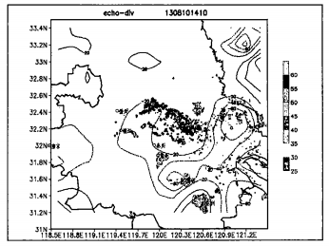
Publication number (Kind Code):
CN107436987A
Inventor(s):
WANG X
Publication Date:
2017-12-05
Current IPC:
G06F 19/00
Abstract
Novelty
The method involves creating a quantitative conceptual model. Feature statistic is changed. A qualitative conceptual model is established. Ground physical quantity is calculated. Evolution process of configuration relationship is researching and analyzed between storm and ground physical quantity. Convective storm is triggered when entire historical life storms are disappeared for dying variation characteristics. The qualitative conceptual model is established through configuration relationship between a temperature field, a humidity field and a divergence field.
Use
Heat convection storm prediction concept evolution model establishing method.
Advantage
The method enables researching heat convection, establishing visual concept model according to a statistical analysis result, and developing design of the concept evolution model.
Drawing Description
The drawing shows a schematic view of a heat convection storm prediction concept evolution model. '(Drawing includes non-English language text)'

Snowfall
A patent analysis has been performed starting from 2009 up to day and using a generic query referring to tools able to monitor or forecast snow precipitation and accumulation. In particular the query used to obtain a patent dataset is “(((snow* NEAR (precipitation OR accumulation)) AND ((monitor* ADJ tool) OR forecast OR probability OR simulation)))”.
The query results in a total of 19 patents selected (corresponding to 16 INPADOC families). As it can be noticed from the following graphs in the last 10 years (2009-2019) there’s been a wavy temporal trend showing a peak of interest in 2018. In particular, there has been great interest towards patent applications from countries as China and Korea. Main players are Korea Electronics Technology Inst and Accuweather Inc who submitted 3 and 2 patents respectively.
In the following the main results of the scenario analysis it has been reported.

Figure 37: Patent temporal trend (2009-2018)

Figure 38: Patent Publication Countries

Figure 39: Trend of the main applicants
Table below provide the most relevant patent analyzed.

ACCUWEATHER INC |  | ! Indeterminate
Title DWPI:  Method for forecasting snowfall accumulation range by using personal computing device, involves determining snowfall accumulation probability in predicted location over predicted time period, and outputting snowfall probability forecast | 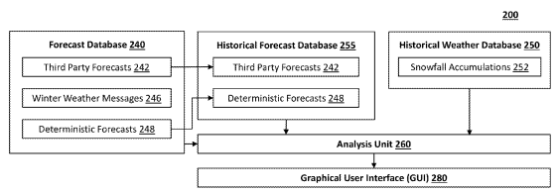
Publication number (Kind Code):
US20180284322A1
Inventor(s):
DEPODWIN D; PORTER J; ROOT M R
Publication Date:
2018-10-04
Current IPC:
G01W 1/10; G06N 5/04; G06N 7/00
Abstract
Novelty
The method involves calculating a probability density function representing likelihood of snowfall accumulation amounts based on an ensemble histogram. A snowfall probability distribution is determined (314) based on the probability density function, where snowfall probability distribution includes most likely snowfall accumulation range and probability that snowfall accumulation in a predicted location. A snowfall probability forecast is generated (320). A snowfall accumulation probability is determined in a predicted location over predicted time period within a most likely snowfall accumulation range. The snowfall probability forecast is output (322).
Detailed Description:
INDEPENDENT CLAIMS are also included for the following:
a system for forecasting snowfall accumulation range
a non-transitory computer readable storage medium for storing a set of instructions for forecasting snowfall accumulation range.
Use
Method for forecasting snowfall accumulation range by using a personal computing device. Uses include but are not limited to desktop computer, notebook computer, tablet and smartphone.
Advantage
The method enables determining snowfall probability distributions to avoid confusing users and determining forecast future snowfall accumulation in an accurate manner.
Drawing Description
The drawing shows a flow diagram illustrating a snowfall probability distribution generating method.
312 - Step for determining forecasted snowfall accumulation of third party weather forecast.
314 - Step for generating probability distribution.
316 - Step for determining shift probability distribution.
320 - Step for generating snowfall probability forecast.
322 - Step for outputting snowfall probability forecast.

- Insights from Business Model and Business Plan activities
This chapter aims to summarize information already provided in the deliverable D7.2 Business Plan Report by Market Segment (B2G,B2B, B2B2C). Main results of that deliverable are reported inside this document in order to facilitate the reader on the understanding of the general exploitation contest.
The business model design of the ANYWHERE Platform is organized with the following steps. Addressing the market segment of weather-induced impact prevention, the consortium has to face up a much-fragmented market in which there is a large community of end users and experts, and different organizational methods. These methods range from very basic office tools like spreadsheets and emails, to more or less constructed IT platforms, but that generally are designed solely by the suppliers and have difficulties to perfectly adapt to the processes and needs of emergencies.
The PPDR operators typically spend a lot of time to find relevant information related to prevention, preparedness, protection, detection, response and recovery, and regularly need to combine mentally information available on a wide range of sources, heavily impacting their response time and prevention on vulnerable location, in case that the actually can do anything on a short notice.
This section is presenting the end-users and providers concerns in order to highlight possible proposal and businesses model providing added value and solutions to the common place problems, leading towards a new operational paradigm. To approach this case, it is practical to use the Business Model Canvas tool created by Alex Osterwalder (https://hbr.org/2013/05/a-better-way-to-think-about-yo), that is regarded as the most comprehensive template to build up a Business Theory, being an organized way to lay out the assumptions about the key resources and activities of the value chain, including the value proposition, channels, customer segments, cost structures, revenue streams and customer relationships on a format with nine sections to visualize in a frame the complete proposition.

ANYWHERE Business Model Canvas
The business models have been detailed by segment according to the end users. In particular, B2B2C or Business-to-Many or B2M is a marketing term for a business that sells their goods or services to other businesses as well as to consumers.
In the ANYWHERE project, such B2M business model is suitable to reach both civilian population and commercial companies in order to reduce their vulnerability to extreme weather event, enabling further services.
The exploitation scenario linked to this type of business model is those related to the direct informational services to citizens and companies, which can enable on the tools for self-preparedness and self-protection developed within the project.
The ANYWHERE business models considered – B2G, B2B and B2B2C – have been analysed through the Business Model Canvas methodology that consists on nine conceptual blocks which allow making explicit the most relevant aspects for the business solution.
A brief description and meaning of the different blocks of the Canvas are reported in Annex A.49, along with an explanation of their relation to the rest of the Canvas blocks.

ANYWHERE Unique Value Proposition
A unique value proposition (UVP) is a carefully-crafted concept that explains the benefits of using the proposed products or services, including and the problems they solve towards the target audience. The statement outlines the advantages of proposed solutions and describes what makes the Supplier as unique and superior to alternatives. The goal is not to create an empty selling slogan but rather to exercise and test its conceptual feasibility on a sentence, that can be trialed internally or externally.
The UVP commonly is a single sentence, being neither a tag-line nor a positioning statement, although it’s related to both, explaining how the product or service is unique, being this proposal the most difficult part.
A value proposition is designed to be used externally and may determine if a potential customer responds to the pitch or not, or else stays on a website to read more or goes on to browse for other options.
A generally accepted template for UVP would fulfil:
FOR: (The target audience)
WHO: (Declaration of Need or Opportunity)
OUR: (Product or Service Name)
IS: (Product category)
Due to the broad scope of ANYWHERE, it is difficult to consolidate the complete offer on a single UVP, so they will be split into the three identified market segments: B2G, B2B and B2B2C, that will be presented on each of their proposed Business Models.
However, a general concept overview is feasible, and it should include some general terms:
Target audience: per-Se, not an actual “customer”, the ultimate benefited audience would be the civilian population. The users of the ANYWHERE technical and informational solutions would be integrators, either from within the supplying body, the ANYWHERE Foundation, or externally from within the ANYWHERE platform ecosystem, being either public or commercial entities.
Product or Service: the particular solutions could adopt different types of implementation forms, with more or less scope, depending on the particular solution that is being addressed, but in general terms that would include, being the basis of the UVPs:
- ANYWHERE’s Multi-Hazard Early Warning System: an Artificial Intelligence-aided emergency management engine compiling more than three hundred forecasting algorithms.
- A4EU Platform Ecosystem: a unifying emergency DSS operational platform, able to integrate scattered and mixed data sources, to be used at different levels including European, Member State, Regional and City, with potentiality for worldwide use.
- Applied Impact Forecasting: by combining the available local data and high-resolution sensors with the broader scope forecasting products, an accurate and pragmatic impact forecast can be achieved, that allow operational authorities and industrial operators to prepare in advance the strategies and resources to reduce the potential damages on the detected vulnerabilities and exposed focal points.
- User-Driven and Field Tested developments: the Co-Creation environment within ANYWHERE joins the technical capacity of the technology suppliers seamlessly with the stakeholder needs, producing solutions that are not only state-of-the-art, but also are simple and useful to be used on the daily basis operations, and such concept and development robustness is tested by a year-long pan-European approach to validate both intrinsically and externally.
The ANYWHERE Consortium have also formally expressed their expectations and particularly the external stakeholders are primarily looking forward for the ANYWHERE outputs, regarded as high and manifold.
There is a great need for usable tools, where the A4EU Platform should be useful, reliable, easy-to-use for different types of users, provide visualization and aggregate results to a presentable form. Also was expected that A4EU will have a modular structure and is compatible with existing operational systems and reporting schemes.
Some stakeholders did not expect any less than A4EU becoming in future the one place to go for hazard management.
Often it was highlighted that ANYWHERE products should not only improve the effectiveness and efficiency of disaster risk management but also risk communication to the general public. In doing so, A4EU will have to comply with the One Voice Principle.

Achieving Break-Even
In order to be able to plan the self-sustainability of ANYWHERE during the Operational phase, it is critical to understand the Vendor Entity break-even point. The Consortium should be able to know how much they need to achieve in sales (contracts) to reach a profit. A break-even analysis involves estimating the sales revenue, fixed and variable costs, and the retribution margin. The goal of knowing the break-even point is to help managers to adjust the decisions to achieve the baseline operations and beyond.

Fixed and Variable costs
Fixed costs constitute the minimal expenses that the Vendor Entity needs to cover just to exist and that do not increase due to an up-scale in production or commercial activity. Common fixed costs include interest paid on debt, insurance expenses, and salaries paid to full-time workers. Particularly for the MH-EWS and A4EU/A4U Platforms the fixed costs of the core operation include the Data Streams from the European Centre for Meteorological Weather Forecast (ECMWF), and the OPERA Pan-European Radar Precipitation Composite, Server hosting and Maintenance Staff, Baseline administration and supporting staff among others, plus yearly license-fees aimed towards the Developer partners of the Consortium to give access to the Forecasting Algorithms, as well as the A4EU and A4U Platform rights of use.
Variable costs, on the other hand, increase as the of total contracted amount or unit number of sales within the Vendor Entity increase. Examples of variable costs include sales commissions, customization expenses, and wages of part-time and employees and sub-contractors. In this particular area, the different versions of platforms associated to each end-user sector, namely Region, City and Spot dimensions in the case of the A4EU platform and customization of the forecasting products to a particular region have different levels of impact into the variable costs, and this should be clearly reflected on the economic forecast of the Break-even analysis, in order to better choose the starting markets that should be served to secure survival of the venture.

Stages towards Self-Supportive Operation
There are three main stages to be considered towards achieving a self-supportive operation:
- Start-up. On this initial phase, the total cost of operation are higher that the capacity to contract services that would cover the expenses, therefore it is a critical period that can span one or two years, where the Partners participating on the Vendor Entity must fund this operation, either by funding directly economically, or by supplying staff or services that are part of the operation or else, to withdraw of gaining any feeds coming from the licenses of use of their operation. This initial support can be taken into account as the required initial funding.
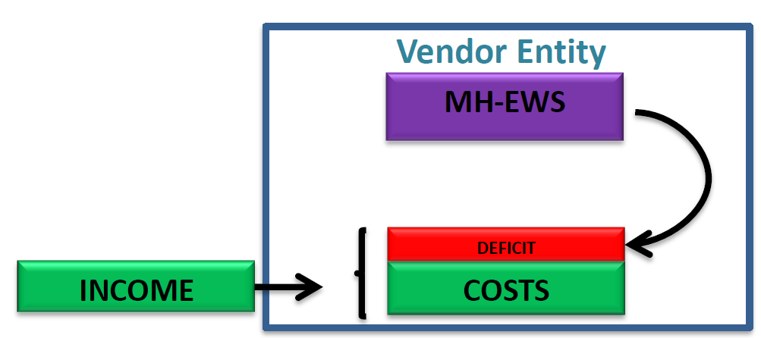
Figure 40: Stage 1 of Operation - Start-Up. The Income is less than the total operational costs. The Vendor Entity must face the Deficit by funding it economically or by holding profit gains.
- Break-Even Point. This second phase sees the moment where the funding Partners can stop giving support towards the operation, as it is already self-sustainable. However, it is also delicate as there is no profit that could be used to advance on the developments or fixing unforeseen issues, so in that case, their support will still be needed.
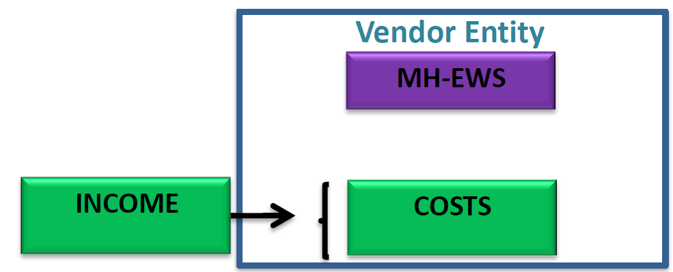
Figure 41: Stage 2 of Operation - Break-Even Point. The Income is equal to the total operational costs. The Vendor Entity records no gains but the partners stop funding the operation.
- Profit. Just when the Vendor Entity has been able to have a big-enough user base and contracts that reaches over the point of obtaining gains clearing out the costs, the operation would be finally self-supportive. In the case of ANYWHERE, due to the nature of its initial funding and Partners, the Vendor Entity is to be a Non-Profit Foundation, so the Profits are to be always re-used by either improvement of the tools that have presented some issues and are demanded, or in order to add new capabilities that the Client entities request. In either case, the destination of the gains will be managed through the Revenue Sharing System and the Foundation Directing board will oversee the good use of them, based on the situation of the environment and the business ecosystem at any given time.
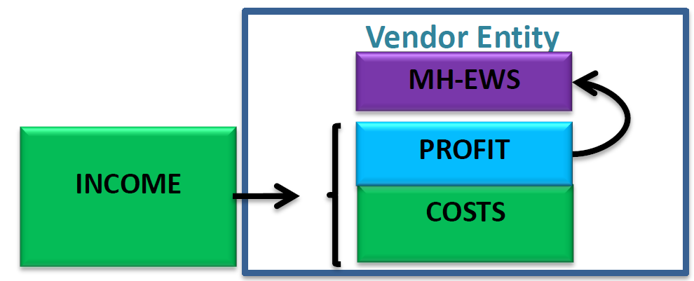
Figure 42: Stage 3 of Operation - Profit. The Income is superior to the total operational costs. The Vendor Entity records shares the gains towards the developer that must be reinvested into new solution, fixes and dissemination, but at the end should be a not-for-profit operation.

Business Models for the ANYWHERE Foundation market segments
Since the ANYWHERE Foundation as a standalone entity needs to be economically sustainable by itself, several business models are explored and discuss taking into account the previous consideration. For each model, it will be assumed that the Vendor Entity will be the proposed concept of ANYWHERE Foundation, that would be required still to be negotiated and set-up.
The business models envisioned can be easily grouped into an overall Hybrid Business Model, that permits to visualize the different feasible Revenue Stream that would take part on any of the market segments and products at any given moment.
The possible scenarios, include revenue coming from a combination of streams that not necessarily need to be all-inclusive, but can be concurrent, depending of the particular supply scenario, customer, call, etc., including:
- SaaS: Software-as-a-Service is a relatively new business model type that literally could not exist without the internet and has the particularity of being piece of software hosted on a cloud infrastructure and Clients pay a recurring fee to get access to this software and information. It is needed a major technological breakthrough in order to really make a SaaS product worthwhile, such as is the case of the ANYWHERE Platforms and tools. The main concept of a SaaS businesses model is that hosted in the cloud, removing the need for an end user license to activate the software and any infrastructure to host the software, so through a membership, the Client just has to log into their account and they get full access.
- SaaP: Alternatively, and mainly due to Security concerns of the Clients, the ANYWHERE solutions could be delivered as custom Software-as-a-Product on a more traditional way, being installed into their own Servers, so a license fee and probably the related support and maintenance feeds should be needed to be associated.
- Platform Ecosystem. Considering the different exploitable results available for ANYWHERE activities, the ecosystem is made up by the range of partner entities functioning as a unit and interacting with a shared market for solutions and services, which relationships are underpinned by a common technological platform, the A4EU/A4U environments and the MH-EWS Forecasting engine, operating through the exchange of information, resources, and services.
- Ancillary Revenue Streams: Completing the hybrid business model, there will be always activities that will support either main revenue option, being SaaS, SaaP and activities from within the Platform Ecosystem, and these include Reselling, Consultancy, Customization, Technical Support and Maintenance, affecting the Scientific Knowledge, System Integration, Commercial Activities, Hardware operation, etc., alike. These revenue streams can be addresses by the Ecosystem Leader, the ANYWHERE Foundation, or particularly by any of its participants as is seen best fitting, case by case.
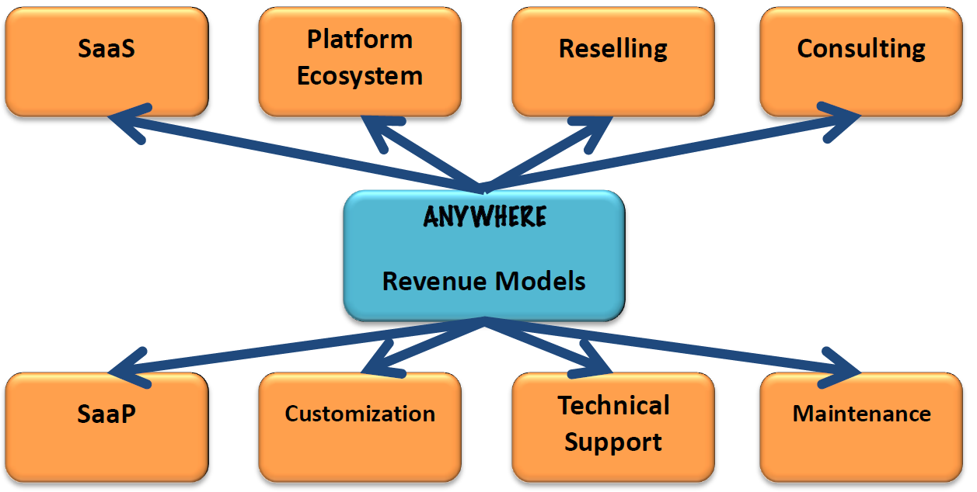
Figure 43: Hybrid Business Model for the ANYWHERE Foundation including the possible Revenue Streams. Adjusted from Karl Popp, 2010.
The following chapters illustrates the Business Model Canvas, summarizing all the key information related to the different blocks described above which represents main components of the B2G, B2B and B2B2C Business Models. Details about each block of the Business Model Canvas are reported in the deliverable D7.2 Business Plan Report by Market Segment (B2G, B2B, B2B2C).

Business Models for the B2G market segment

B2G Value Proposition
The innovation content of the self-protection info and services tools mainly consists on the combination of information from MH-EWS and others meteorological tools that improves and expands existing systems (either applied for crisis management or designed for different contexts of use like enterprise resource planning, fleet management, etc.). These existing systems will be adapted so that they can interact with the products provided by the platform. The platform provides value added through the provision and access of informational services in terms of hazard indications improving decision-making and response planning.
The decision support will provide early warning products and locally customizable decision support services adaptable to different types of needs. The result will be an easily adaptable tool meeting the constraints and needs of the emergency responders’ institutions, as well as the public and private managers of critical infrastructures and networks at the local and regional level. The platform will contribute significantly to the environmental risk impact reduction through providing tools for a better assessment of the risk.
The platform will be continuously upgraded, serviced and guaranteed (for commercial companies) being an updated and reliable source of information to final users. One of the main value propositions of this business model is to propose accessibility to the
ANYWHERE content to the customer segments.
It is reducing cost and risk for end-users and experts by having access to:
- the description of the products (data-sheet, presentation, video, etc.) because the technology and tools watch is available on the platform
- the detail of provider more comprehensive information
- the ANYWHERE platform to have advice and generally exchange information with the community.
Below, some examples of the Value proposal matrix are reported.

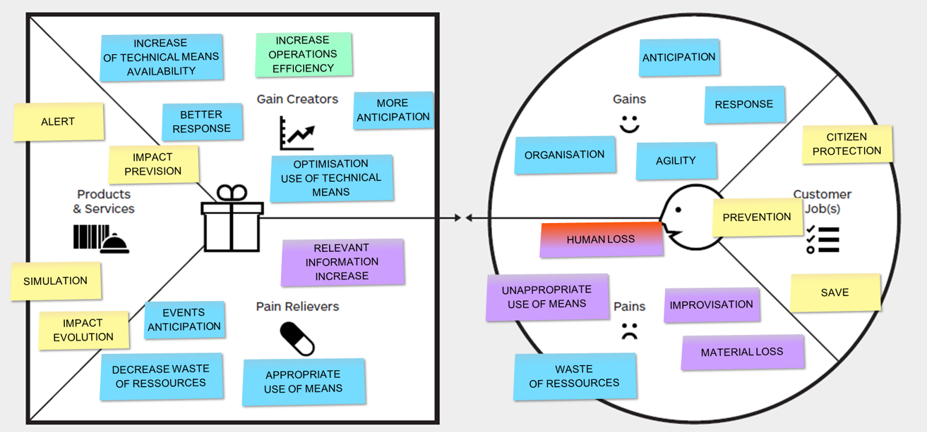
Figure 44: B2G - Public Protection and Disaster Relief
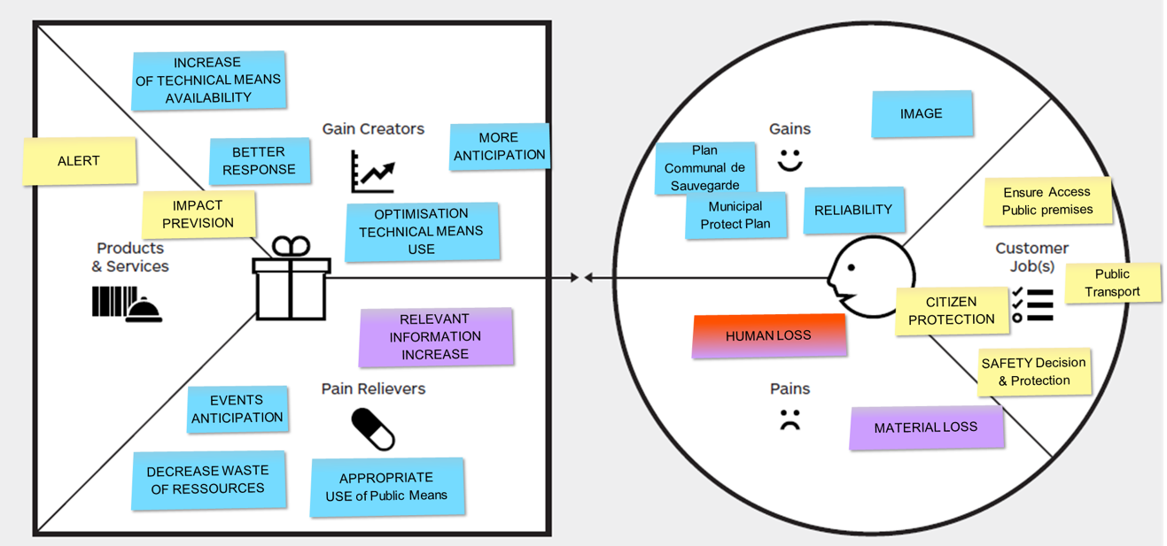
Figure 45: B2G for Small and Medium Municipalities
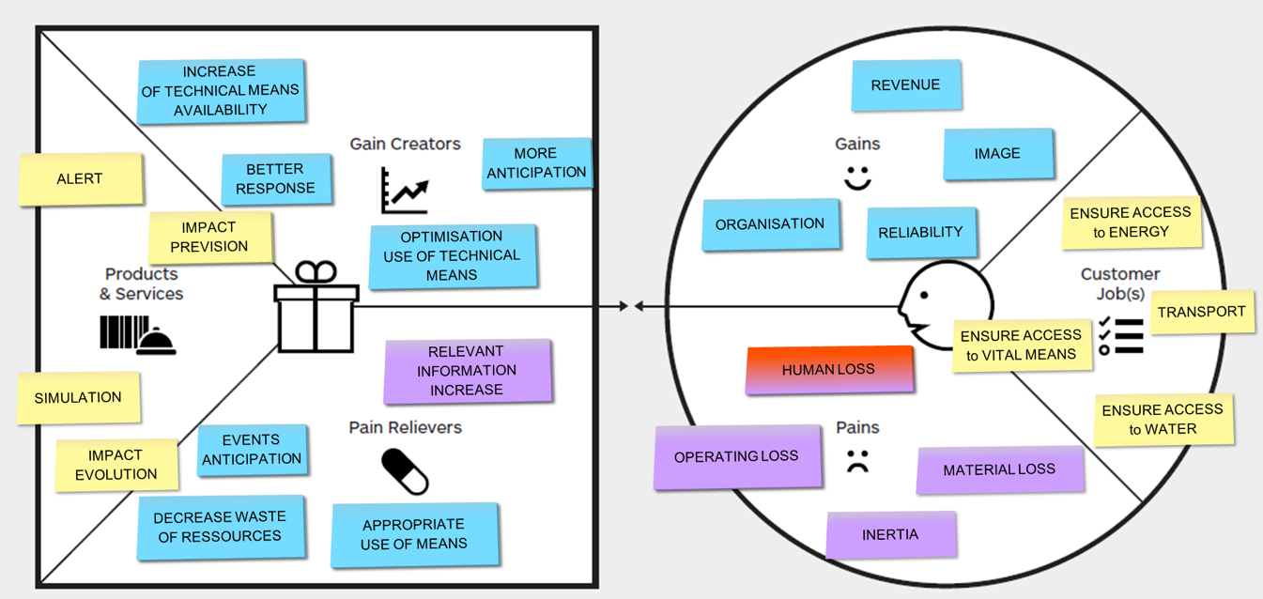
Figure 46: B2G for Governmental strategic provider and Operator of Strategic Sites
The main value proposition of this B2G business model is to sale an entry ticket that allows to a full access to the ANYWHERE content, as a result:
- Customers can access to the description of the products (data-sheet, presentation, video, etc.), to the detail of provider more comprehensive information and to the ANYWHERE Forum to have advice and generally exchange information with the community.
PROS | Rapid beginning of the business to have organization as end-user accepting to pay
CONS | No sustainability ensured, possible “fire and forget” - No Subscription
- Providers of Algorithm and Products (Universities, etc…) can present their products to future customers, and have the opportunity to be seen by people in the security and especially WEATHER IMPACT PREVENTION and crisis management.
PROS | Turnkey solution for the End users, without legacy system. Regular revenue for the platform access (probably from suppliers at the beginning). Interesting for Supplier whether they are sure the End-users regularly connected.
CONS | It is difficult at the beginning of the business to have organization as end user accepting to pay. The content should be interesting and it will not be the case at the beginning. Subscription Periodic membership fees or ‘life time’ membership. It envisioned having a “Free trial” Membership for individuals or ‘organization.
This business model is proposed to be implemented first because it guaranties economically sustainability.

B2G Business Model Canvas
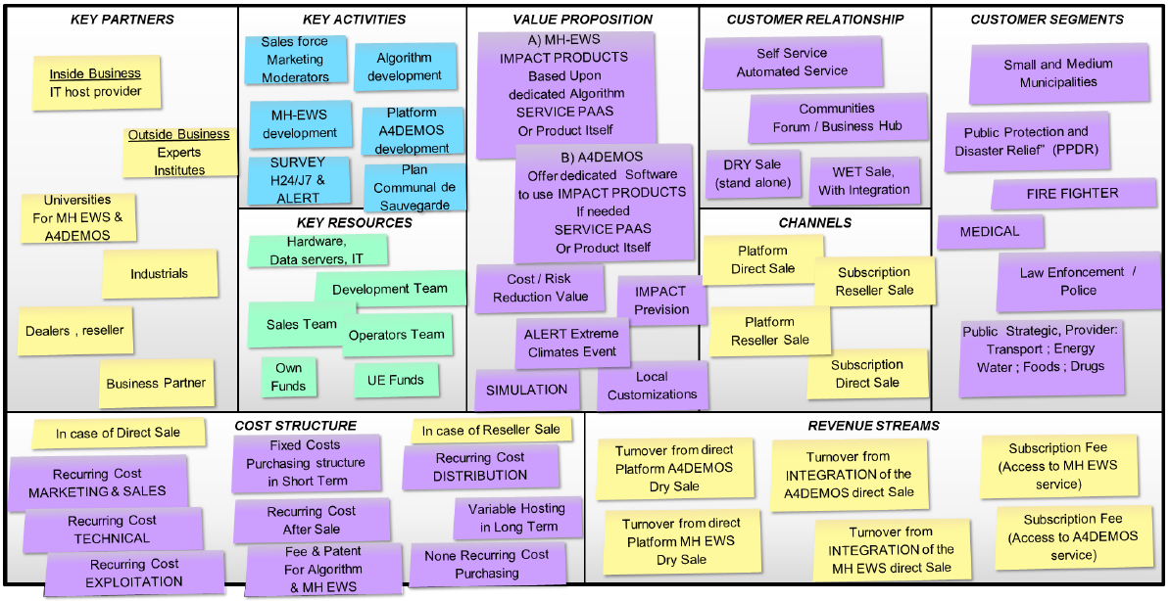
Figure 47: B2G Business Model Canvas

Business Models for the B2B market segment
The B2B Business Model proposal targets towards expanding the ANYWHERE Foundation outreach into novel markets where strategic business are already working or can use the exploitable results to create new solutions that the Foundation alone could not do, to be able to indirectly serve industries, public services and civilian population. However, interactions can be made to use the A4EU/A4U platforms and MH-EWS as is or customized in a dealership or reseller form, through consultancy or other types or dissemination that allow market expansion.

B2B Unique Value Proposition
The B2B Unique Value Proposition is an aggregation of the benefits that the ANYWHERE Foundation offers towards the Enterprise customers. Following the already commented template for UVP:
FOR: (The target audience)
WHO: (Declaration of Need or Opportunity)
OUR: (Product or Service Name)
IS: (Product category)
The UVP will be proposed as “For the Technology and Solution provider companies, who are primarily serving the emergency-related markets, our ANYWHERE Multi-Hazard Early Warning System and the A4EU Operational Platform ecosystem is solving the easy integration of state-of-the-art forecasting algorithms into Impact Forecasting solutions that can be exploited commercially into novel applications.
As added values, users will obtain the recognition of collaboration with a strong pan-European brand, ANYWHERE, backed up by a Consortium with leader industries and institutions and exploiting solutions that were thoroughly tested by emergency services on different pilot sites, with direct communication with the science and technology providers, availability for customization and a correct price schedule.”

B2B Business Model Canvas
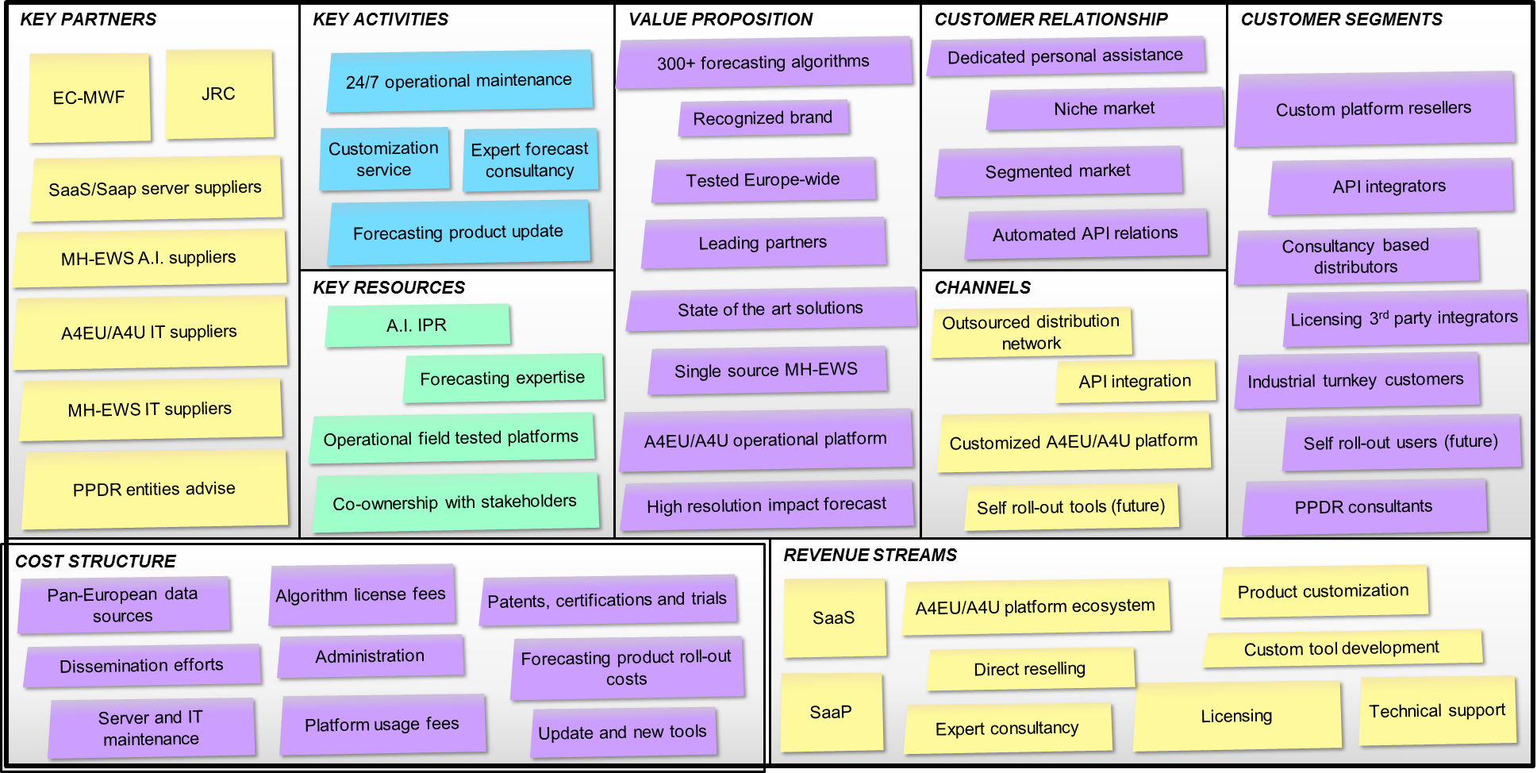
Figure 48: B2B Business Model Canvas

Business Models for the B2B2C market segment
A natural consequence of the existence of the different exploitation scenarios is the necessity to develop a sustainable business model intended to cope with such multifaceted exploitation perspective. The business models will be detailed by segment according to the end users.
In particular, B2B2C is a marketing term for a business that sells their goods or services to other businesses as well as to consumers. In the ANYWHERE project, such B2B2C business model is suitable to reach both civilian population and commercial companies in order to reduce their vulnerability to extreme weather event, enabling further services.
The exploitation scenario linked to this type of business model is those related to the direct informational services to citizens and companies which can enable on the tools for self-preparedness and self-protection developed within the project. The added value provided by this exploitation scenario is specified in the chapter.

B2B2C Value proposition
The innovation content of the self-protection info and services tools mainly consists on the combination of information from MH-EWS and others meteorological tools that improves and expands existing systems (either applied for crisis management or designed for different contexts of use like enterprise resource planning, fleet management, etc.). These existing systems will be adapted so that they can interact with the products provided by the platform.
The platform provides value added through the provision and access of informational services in terms of hazard indications improving decision-making and response planning.
The decision support will provide early warning products and locally customizable decision support services adaptable to different types of needs. The result will be an easily adaptable tool meeting the constraints and needs of the emergency responders’ institutions, as well as the public and private managers of critical infrastructures and networks at the local and regional level.
The platform will contribute significantly to the environmental risk impact reduction through providing tools for a better assessment of the risk. It will be continuously upgraded, serviced and guaranteed to provide an updated and reliable source of information to final users.
One of the main value propositions of this business model is to propose accessibility to the ANYWHERE content to the customer segments. It is reducing cost and risk for end-users and experts by having access to:
      - the description of products and tools (datasheet, presentation, video, etc.) together with their technology is available on the platform
      - the detail of provider more comprehensive information
      - the ANYWHERE platform to have advices and generally exchange information with the community

B2B2C Business Model Canvas
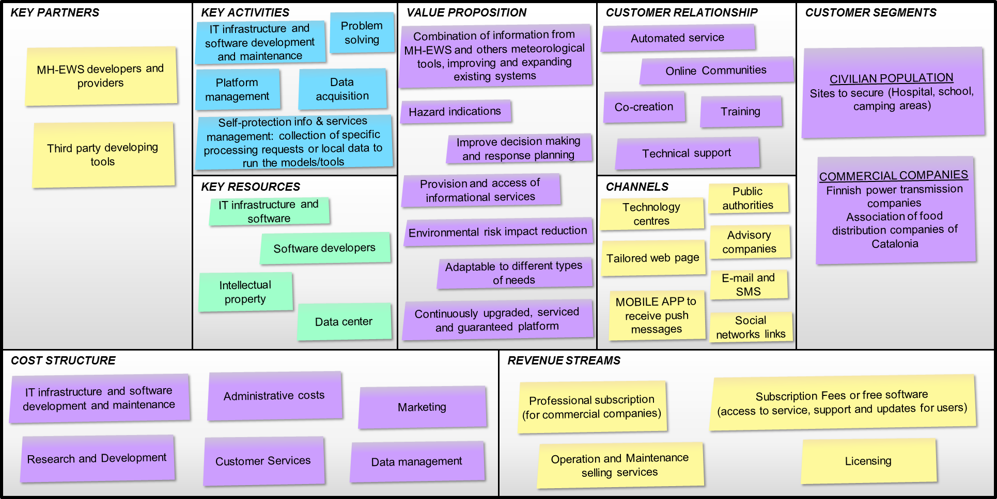
Figure 49: B2B2C Business Model Canvas

- Conclusions
The present document aimed at providing the analysis of the exploitation potential of the most promising results and outcomes of the ANYWHERE project, constituting the final version of the Exploitation Plan, in the framework of D7.4 “Innovation Exploitation plan”.
The update of the preliminary version of the Exploitation Plan (M7.6 “Intermediate report of the Innovation Exploitation Plan”) has been carried on with respect to the characterization tables of each Key Exploitable Result, their prioritization and the development of the final exploitation strategy.
The most promising result (namely the ANYWHERE A4EU) has been identified as the result that better allows considering and following a holistic approach for the exploitation, as it involved almost all the partners in its development and constitutes the integration of all the different KERs identified.
The potential exploitation routes have been detailed, both at partner and at project level. In particular, the exploitation strategy at project level corresponded to the ANYWHERE A4EU exploitation strategy. With this respect, mainly one option has been envisaged, according to the potential creation of a foundation.
Different business models based on the consortium level exploitation of the result have been proposed and described. In addition, insights from the business plan report are provided. More details on business plan can be found in D7.2 “Business plan report by market segment (B2G, B2B, B2B2C)”.
Finally, yet importantly, an overview of the main provisions related to intellectual property rights, use and dissemination of the results generated by the ANYWHERE project has been included.

- ANNEX A.1
CHARACTERIZATION TABLE OF KER #1

KER #1 - Drought forecasts: Standardized Indices
ER Short Description | Drought as departure from median (in number of standard deviations) for: 5 km grid precipitation (SPIx) evaporation (SPEIx, climate water balance); 5 km grid groundwater (SGIx); 5 km grid runoff (SRIx)  Lead times: 1, 2, 3 until 7 months  Accumulation periods x: 1, 3, 6 and 12 months.  The SRI12 with a 7-month lead time provides the forecasted runoff 7 months ahead, which is accumulated over the past 12 months (e.g. the forecasted SRI12 for July done in January gives a forecast of the runoff over the period August (previous year) – July (current year).
Innovation content | Standardized drought indices are well known in the literature. Scripts are new (i.e. fully written for the ANYWHERE project).
Type of Result | Algorithm | Model | Process | Method | Software | Knowledge
Type of Result | ✓ | No | No | ✓ | ✓ | Yes
Type of Result | Other (specify): all scripts are written in IDL
Owner of Result | Wageningen University and Research Centre (WUR)
Other Partners involved | No
Joint ownership? | Yes |  |  | No
To be integrated in ANYWHERE MH-EWS | ✓  (Encapsulated) |  |  | No
To be integrated on A4EU versions | Yes |  |  | No  (connected via MH-EWS)
Standalone result? | Yes |  |  | No  (scripts are driven by ECMWF seasonal weather forecasts, connected to MH-EWS)
Target Market | B2G |  | B2B |  | B2B2C
Target Market | ✓ |  | No |  | ✓
Potential customer | Water Agencies, Water Boards, Environmental Agencies, Forecasting Businesses, National Hydro meteorological Services, European Organizations
Benefit to customers | Improved preparation for potential upcoming drought (monthly, sub-seasonal, seasonal forecasts), in particular hydrological drought (groundwater, reservoirs)
Exploitation claims | Consultancy service |  | Academic exploitation |  | Commercial exploitation (e.g. selling licenses)
Exploitation claims | No |  | ✓ |  | No
Estimated maintenance cost (yearly) | ca. €8053,00
Estimated yearly selling price | ca. €8859,00

- ANNEX A.2
CHARACTERIZATION TABLE OF KER #2

KER #2 - Drought forecasts: Threshold Indices
ER Short description | Drought as deviation from pre-defined threshold for: 5 km grid precipitation; 5 km grid soil moisture; 5 km grid groundwater; 5 km grid runoff; discharge on river network .  The following drought characteristics are forecasted up to 7 months ahead for each of the above-mentioned variables: duration, deficit volume, onset and termination/recovery.
Innovation content | Threshold drought indices are well known in the literature. Scripts are new (i.e. fully written for the ANYWHERE project).
Type of Result | Algorithm | Model | Process |  | Method |  | Software |  | Knowledge
Type of Result | ✓ | No | No |  | ✓ |  | ✓ |  | Yes
Type of Result | Other (specify): all scripts are written in IDL
Owner of Result | Wageningen University and Research Centre (WUR)
Other Partners involved | No
Joint ownership? | Yes |  |  |  |  | No
To be integrated in ANYWHERE MH-EWS | ✓  (Encapsulated) |  |  |  |  | No
To be integrated on A4EU versions | Yes |  |  |  |  | No  (connected via MH-EWS)
Standalone result? | Yes |  |  |  |  | No  (scripts are driven by ECMWF seasonal weather forecasts, connected to MH-EWS)
Target Market | B2G |  |  | B2B |  |  |  | B2B2C
Target Market | ✓ |  |  | No |  |  |  | ✓
Potential customer | Water Agencies, Water Boards, Environmental Agencies, Forecasting Businesses, National Hydro meteorological Services, European Organizations
Benefit to customers | Improved preparation for potential upcoming drought (monthly, sub-seasonal, seasonal forecasts), in particular hydrological drought (groundwater, reservoirs).
Exploitation claims | Consultancy service |  |  | Academic exploitation |  |  |  | Commercial exploitation (e.g. selling licenses)
Exploitation claims | No |  |  | ✓ |  |  |  | No
Estimated maintenance cost (yearly) | ca. €8053,00
Estimated yearly selling price | ca. €8859,00

- ANNEX A.3
CHARACTERIZATION TABLE OF KER #3

KER #3 - MH-EWS
ER Short description | Platform to integrate (connect or encapsulate) forecast and impact algorithms for different hazards, run them in real time, and provide the produced outputs through a set of standard services.  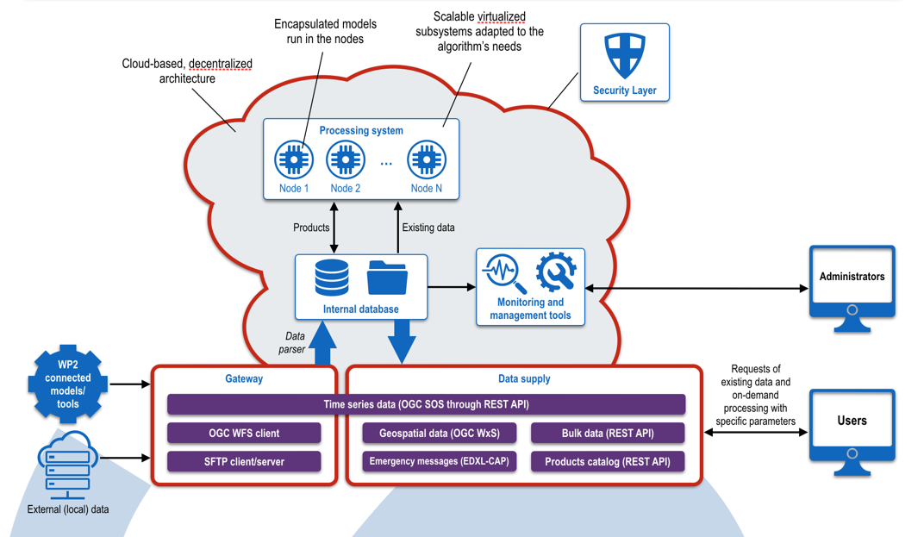
Innovation content | Dissemination of the information through a set of standard services.  Engine able to connect different sources of data and to run multi hazard algorithms in a single platform providing the right product/service to the right user.
Type of Result | Algorithm | Model | Process | Method | Software | Knowledge
Type of Result | No | No | No | No | ✓ | No
Type of Result | Other (specify): -
Owner(s) of Result | HYDS
Other Partners involved | CIMA (if Dewetra Data Server is used)  All partners developing algorithms (FMI, UPC, CFR, UoR, CIMA, WUR, JRC)  Data providers (ECMWF, FMI, EUMETNET, etc.)
Joint ownership? | Yes |  |  | No
To be integrated in ANYWHERE MH-EWS | - |  |  | -
To be integrated on A4EU versions | Yes |  |  | No
Standalone result? | ✓ |  |  | No  (needs different algorithms integrated)
Target Market | B2G |  | B2B |  | B2B2C
Target Market | ✓ |  | ✓ |  | ✓
Potential customer | Companies that use MH-EWS related information to build further services. Companies developing Early Warning Systems and Decision Support Tools. Companies that directly use MH-EWS information (data, algorithms): Water Agencies, Meteorological Services.
Benefit to customers | Gateway to obtain forecast and impact products  Single access points  Enabling further business  Multiple hazards in one single point that can be further tailored
Exploitation claim | Consultancy service |  | Academic exploitation |  | Commercial exploitation (e.g. selling licenses)
Exploitation claim | ✓ |  | No |  | ✓
Estimated maintenance cost (yearly) | - IT Part: ~200.000€  - Data part: N/A  - Algorithms part: N/A
Estimated yearly selling price | To be defined by all partners involved.

- ANNEX A.4
CHARACTERIZATION TABLE OF KER #4

KER #4 - A4FIN
ER Short Description | A4FIN is the implementation of the A4EU platform for South Savo region (Finland). It is a decision-tool based on weather and impact data adapted to the specific needs and requirements of ISTIKE, which is a joint situation and coordination centre in eastern Finland. A4FIN is an IMPACT Platform As A Service of MH EWS products and locals tools gathered and displayed in one single place that all authorities can use gross the country and also Europe.
Innovation content | Support tool for decision making. A4Finn provides the capacity of early-warning detection and proactive decision-making when facing extreme weather-related emergencies. This allows the ISTIKE to better manage such events, minimizing losses and saving lives.  Some of it is major operational capabilities are:  - Connection to different sources of local hazard information in real time.  - Capacity to cross the hazard impact forecasting products served by the ANYWHERE Multi-Hazard Early Warning System (MH-EWS) with high-resolution impact models.  - Combination with regional layers of exposure and vulnerability for flooding areas and critical elements for floods and forest fires.
Type of Result | Algorithm | Model | Process | Method | Software | Knowledge
Type of Result | No | No | ✓ | ✓ | ✓ | ✓
Type of Result | Other (specify):
Owner(s) of Result | AIRBUS
Other Partners involved | FMI, FMol
Joint ownership? | Yes |  |  | No
To be integrated in ANYWHERE MH-EWS | Yes |  |  | No
To be integrated on A4EU versions | Yes |  |  | No
Standalone result? | Yes |  |  | No  (need for MH-EWS connection)
Target Market | B2G |  | B2B |  | B2B2C
Target Market | ✓ |  | No |  | No
Potential customer | End users: Public Protection and disaster relief  Municipalities  Utilities Providers
Benefit to customers | Impact driven results  Prevention / anticipation  Risk mitigation
Exploitation claim | Consultancy service |  | Academic exploitation |  | Commercial exploitation (e.g.selling licenses)
Exploitation claim | ✓ |  | No |  | ✓
Estimated maintenance cost | N/A
Estimated yearly selling price | N/A

- ANNEX A.5
CHARACTERIZATION TABLE OF KER #5

KER #5 - A4ALPS
ER Short Description | A4Alps is the implementation of the A4EU platform for Canton Bern (Switzerland). This tool has been locally adapted to the specific needs and requirements of Volkswirtschaftsdirektion Kanton Bern (VOLBE). A4ALPS is an IMPACT Platform As A Service of MH EWS products and locals tools gathered and displayed in one single place that all authorities can use gross the country and also Europe.
Innovation content | A4Alps provides the capacity of early-warning detection and proactive decision-making when facing extreme weather-related emergencies. This allows the VOLBE to better manage such events, minimizing losses and saving lives.  Some of it is major operational capabilities are:  - Connection to different sources of local hazard information in real time.  - Capacity to cross the hazard impact forecasting products served by the ANYWHERE Multi-Hazard Early Warning System (MH-EWS) with high-resolution impact models.  - Combination with regional layers of exposure and vulnerability for flooding areas and critical elements for floods and forest fires.
Type of Result | Algorithm | Model | Process | Method | Software | Knowledge
Type of Result | No | No | ✓ | ✓ | ✓ | ✓
Type of Result | Other (specify):
Owner(s) of Result | AIRBUS
Other Partners involved | VOLBE
Joint ownership? | Yes |  |  | No
To be integrated in ANYWHERE MH-EWS | Yes |  |  | No
To be integrated on A4EU versions | Yes |  |  | No
Standalone result? | Yes |  |  | No  (need for MH-EWS connection)
Target Market | B2G |  | B2B |  | B2B2C
Target Market | ✓ |  | No |  | No
Potential customer | End users: Public Protection and disaster relief  Municipalities  Utilities Providers
Benefit to customers | Impact driven results  Prevention / anticipation  Risk mitigation
Exploitation claim | Consultancy service |  | Academic exploitation |  | Commercial exploitation (e.g.selling licenses)
Exploitation claim | ✓ |  | No |  | ✓
Estimated maintenance cost | N/A
Estimated yearly selling price | N/A

- ANNEX A.6
CHARACTERIZATION TABLE OF KER #6

KER #6 - A4NOR
ER Short Description | A4NOR is the implementation of the A4EU platform for Rogaland region (Norway). It is a decision-tool based on weather and impact data adapted to the specific needs and requirements of HSHU, which is managing the rescue centre in Rogaland. A4NOR is an IMPACT Platform As A Service of MH EWS products and locals tools gathered and displayed in one single place that all authorities can use gross the country and also Europe.
Innovation content | Support tool for decision making. A4NOR provides the capacity of early-warning detection and proactive decision-making when facing extreme weather-related emergencies. This allows the HSHU to better manage such events, minimizing losses and saving lives.  Some of it is major operational capabilities are:  - Connection to different sources of local hazard information in real time.  - Capacity to cross the hazard impact forecasting products served by the ANYWHERE Multi-Hazard Early Warning System (MH-EWS) with high-resolution impact models.  - Combination with regional layers of exposure and vulnerability for flooding areas and critical elements for floods.
Type of Result | Algorithm | Model | Process | Method | Software | Knowledge
Type of Result | No | No | ✓ | ✓ | ✓ | ✓
Type of Result | Other (specify):
Owner(s) of Result | AIRBUS
Other Partners involved | HSHU, SINTEF
Joint ownership? | Yes |  |  | No
To be integrated in ANYWHERE MH-EWS | Yes |  |  | No
To be integrated on A4EU versions | Yes |  |  | No
Standalone result? | Yes |  |  | No  (need for MH-EWS connection)
Target Market | B2G |  | B2B |  | B2B2C
Target Market | ✓ |  | No |  | No
Potential customer | End users: Public Protection and disaster relief  Municipalities  Utilities Providers
Benefit to customers | Impact driven results  Prevention / anticipation  Risk mitigation
Exploitation claim | Consultancy service |  | Academic exploitation |  | Commercial exploitation (e.g.selling licenses)
Exploitation claim | ✓ |  | No |  | ✓
Estimated maintenance cost | N/A
Estimated yearly selling price | N/A

- ANNEX A.7
CHARACTERIZATION TABLE OF KER #7

KER #7 - A4CAT
ER Short description | A4CAT is the implementation of the A4EU platform for Catalonia. This tool has been locally adapted to the specific needs and requirements of the Catalan civil protection system, emphasizing the risk of floods, forest fires, windstorms and snowfall. A4CAT provides the capacity of early-warning detection and proactive decision-making when facing extreme weather-related emergencies. This allows the CECAT (Catalunya Civil Protection Emergency Centre) to better manage such events, minimizing losses and saving lives.
Innovation content | The platform is flexible to integrate different sources of information (both from the Anywhere MH-EWS and local) and cross them with available vulnerability information. It is web-based with an intuitive interface. Real time impact calculation of vulnerability information provided by clients.  Some of it is major operational capabilities are:  - Connection to different sources of local hazard information in real time.  - Capacity to cross the hazard impact forecasting products served by the ANYWHERE Multi-Hazard Early Warning System (MH-EWS) with high-resolution impact models.  - Combination with regional layers of exposure and vulnerability for flooding areas and critical elements for floods, forest fires and snow.
Type of Result | Algorithm | Model | Process | Method | Software | Knowledge
Type of Result | ✓ | No | No | No | ✓ | ✓
Type of Result | Other (specify): -
Owner(s) of Result | HYDS
Other Partners involved | Partners involved in Data pool providers and Local Vulnerability information providers. DINT.
Joint ownership? | Yes |  |  | No
To be integrated in ANYWHERE MH-EWS | ✓ |  |  | No
To be integrated on A2EU versions | Yes |  |  | No
Standalone result? | ✓  (Could work with local products) |  |  | No  (currently uses MH-EWS products)
Target Market | B2G |  | B2B |  | B2B2C
Target Market | ✓ |  | ✓ |  | ✓
Potential customer | Public Protection and Disaster Relief organizations  Water agencies, Weather services and other agencies  Municipalities and other administrations  Large industry (i.e. infrastructure maintenance, electrical companies, aeronautical enterprises such as Vueling, etc.)
Benefit to customers | Early Warning and impact anticipation  Risk mitigation  Decision Support – Information provided from the platform can enable better in decision making
Exploitation claim | Consultancy service |  | Academic exploitation |  | Commercial exploitation (e.g. selling licenses)
Exploitation claim | ✓ |  | No |  | ✓  (SaaS – pay a fee to connect)
Estimated maintenance cost (yearly) | - IT Part: ~150.000€ (depending on the number of implementations)  - Data part: depends on coverage and on MH-EWS prices
Estimated yearly selling price | ~50.000€ for a region-size user

- ANNEX A.8
CHARACTERIZATION TABLE OF KER #8

KER #8 - A4LIG
ER Short Description | A4Lig is the implementation of the A4EU platform for Liguria. This tool is based on the DEWETRA technology operationally developed for and used by the Italian Civil Protection Department. A4Lig provides the capacity of early-warning detection and proactive decision-making when facing extreme weather-related emergencies. This allows the CDG (Comune di Genova) and ARPAL (Agenzia Regionale per la Protezione dell’Ambiente Ligure) to better manage such events, minimizing losses and saving lives. A4LIG allows a customization of the data required by clients. It can manage data based on observation. Its main function is the weather monitoring to be able to alert citizens in case of danger. It can be considered a prevention and early warning system supporting the decision making.
Innovation content | Some of it is major operational capabilities are:  - Connection to data available from different sources (from local to European).  - Capacity to cross the hazard impact forecasting products served by the ANYWHERE Multi-Hazard Early Warning System (MH-EWS) with high-resolution impact models.  - Combination with regional layers of exposure and vulnerability.
Type of Result | Algorithm | Model | Process | Method | Software | Knowledge
Type of Result | No | No | No | No | ✓ | No
Type of Result | Other (specify):
Owner(s) of Result | CIMA
Other Partners involved | -
Joint ownership? | ✓ |  |  | No
To be integrated in ANYWHERE MH-EWS | ✓ |  |  | No
To be integrated on A4EU versions | ✓ |  |  | No
Standalone result? | ✓ |  |  | No
Target Market | B2G |  | B2B |  | B2B2C
Target Market | ✓ |  | ✓ |  | No
Potential customer | B2G: Ministries (agreement between civil protection in different countries)  B2B: Large industrial energetic entities (e.g. ERG)
Benefit to customers | Real time monitoring and forecasts
Exploitation claim | Consultancy service |  | Academic exploitation |  | Commercial exploitation (e.g.selling licenses)
Exploitation claim | ✓ |  | ✓ |  | ✓
Estimated maintenance cost | 30-40 000 €/year depending on the services offered.
Estimated yearly selling price | Installation and customization cost (2 years working): 180 000 €

Further information
A4LIG cannot be commercialized but it can be implemented in other countries if they request it.
Potential competitors are some institution such as ARPAL that is a legal entity. Italian civil protection, in fact, bases their weather forecast on the ARPAL data. On the contrary, in other countries, there are some national public services (e.g. meteoFrance) able to provide competitive data.

- ANNEX A.9
CHARACTERIZATION TABLE OF KER #9

KER #9 - Rainbow risk-based decision machine
ER Short description | A resilient risk-based decision support system which give advice on weather induced risk-levels on local assets based on a combination of qualitative multi-attribute decision models (DEXI) and machine-learning (ML).
Innovation content | Use of available weather prognoses from MH-EWS and combine this with local knowledge and sensors to produce more accurate advice to local decision makers using Dexi and ML.
Type of Result | Algorithm | Model | Process | Method | Software | Knowledge
Type of Result | ✓ | No | ✓ | ✓ | ✓ | ✓
Type of Result | Other (specify): No
Owner(s) of Result | SINTEF AS
Other Partners involved | No
Joint ownership? | Yes |  |  | No
To be integrated in ANYWHERE MH-EWS | Yes |  |  | No
To be integrated on A4EU versions | ✓ |  |  | No
Standalone result? | ✓ |  |  | No
Target Market | B2G |  | B2B |  | B2B2C
Target Market | ✓ |  | No |  | ✓
Potential customer | - Decision making companies  - Fire departments  - Infrastructure owners
Benefit to customers | - Better decisions making in emergency situations
Exploitation claim | Consultancy service |  | Academic exploitation |  | Commercial exploitation (e.g. selling licenses)
Exploitation claim | It is early to say yes or no (potentially yes); it will be decided in a next phase of the project |  | ✓ |  | ✓
Estimated maintenance cost (yearly) | N/A
Estimated yearly selling price | N/A
Further information
- When is the expected date of achievement in the project? When is the time to market?
It is early to say something about this information. The timing is not estimated yet.
- Who are the main competitors of this result?
Product local decision-making in Norway but not in an actively way. The competitive solutions are based on manual processes.
- Which are the main sectors of application?
Transport, public services and infrastructure sectors.
- Are there any legal, normative/ethical requirements (need for authorization, compliance to standard, etc.)?
The result need to be implemented in a security way. There are business criteria from the security point of view.

- ANNEX A.10
CHARACTERIZATION TABLE OF KER #10

KER #10 - Decision support tool on logistic aspects and crisis management
ER Short description | Emergency management involves the implementation of actions immediately prior to, during, and immediately after an emergency/disaster in order to ensure that the effects are minimized. Any decision is taken on a evaluation of current status and effects, better the comprehension, more effective the actions. The DTS aims driving the user in the situation comprehension and decision taken via a questionnaire, preload rules and inputs coming from external services (weather forecast) and impacts on the road network.
Innovation content | The foremost objective is to support the Emergency Operator in coordinating and operating logistics efforts to delivery assistance to emergency response team. The tool allows to provide support to the operator according to the current situation and helps him/her in the coordination of the emergency also by taking into account the weather forecast and impacts on the road network.  The innovation content is associated to the fact that the tool is designed to be integrated in the already available “procedure-in-use” at the operation center and it implements the latest weather forecast and impact estimation on the road network (coming from MH-EWS and UPC tool).
Type of Result | Algorithm | Model | Process | Method | Software | Knowledge
Type of Result | No | No | No | No | ✓ | ✓
Type of Result | Other (specify):
Owner(s) of Result | RINA Consulting
Other Partners involved | Municipalità di Genova and CIMA for A4LIG;  Catalunia Civil Protection and UPC for A4CAT.
Joint ownership? | Yes |  |  | No
To be integrated in ANYWHERE MH-EWS | Yes |  |  | No
To be integrated on A4EU versions | ✓  (A4LIG e A4CAT) |  |  | No
Standalone result? | ✓ |  |  | No
Target Market | B2G |  | B2B |  | B2B2C
Target Market | ✓ |  | No |  | ✓
Potential customer | Civil Protection and any body that manages crisis and emergences.  In the case of A4CAT it should be evaluated by private food companies. This market is much more difficult because it prefer a standalone product more than long term cooperation that currently it is considered necessary for product customization.
Benefit to customers | Organization and follow up of the situation awareness and decision taking. Integration of additional forecast information of road network availability and status according to weather forecast and impact models (KER #13)
Exploitation claim | Consultancy service |  | Academic exploitation |  | Commercial exploitation (e.g. selling licenses)
Exploitation claim | ✓ |  | No |  | ✓
Estimated maintenance cost (yearly) | Considering that, the tool has to be properly adapted to the current needs of the customer (very variable and dependable on the circumstances), and it is designed for government bodies, the maintenance costs will be strictly dependent on the customization services that will be activated year by year. The price for this will be similar to other engineering management services.
Estimated yearly selling price | The possibility to sell the tool as a self-standing platform has not been evaluated yet. Currently it is foreseen to provide it within a consultancy services for emergency management optimization.

- ANNEX A.11
CHARACTERIZATION TABLE OF KER #11

KER #11 - A4Campsite
ER Short description | A4Campsite is a flood-oriented Early Warning System specifically targeted at raising self-protection in campsites located in flood zones in Catalonia. It is currently implemented and being tested in 14 campsites in the delta of the Tordera River Basin, an area where floods represent a significant natural hazard. It is proposed as a Software As A Service (SaaS) and it targeted other activities close to river and potentially subjected to flood area.
Innovation content | The platform integrates Anywhere MH-EWS products, local products (local implementations of MH-EWS products, local sensors: rain gauges, river gauges, official warnings, etc.) and specific site auto protection information (auto protection plans, evacuation maps, etc.). A4Campsite shows real-time meteorological information, local data from river gauges and forecasts of rainfall and flash flood hazards that can affect campsites located in flood-prone areas. In case of warnings, it shows specific self-protection actions to be done, allowing the campsite operators to better manage such events.
Type of Result | Algorithm | Model | Process | Method | Software | Knowledge
Type of Result | No | No | No | No | ✓ | No
Type of Result | Other (specify):
Owner(s) of Result | HYDS
Other Partners involved | -
Joint ownership? | Yes |  |  | No
To be integrated in ANYWHERE MH-EWS | Yes |  |  | No (user of MH-EWS)
To be integrated on A2EU versions | Yes |  |  | No
Standalone result? | ✓  (Could work with local products) |  |  | No
Target Market | B2G |  | B2C |  | B2B2C
Target Market | ✓(e.g. Municipalities) |  | ✓ |  | ✓
Potential customer | Camping sites (B2C), Municipalities and local administration (B2G), Sensor providers (B2B2C), Associations of campsite, Other activities that take place under areas at flood risk.
Benefit to customers | Risk mitigation (for municipalities and campsite entities), achieve direct information from official warning (campsite users), achieve wide number of potential new users (sensor providers)
Exploitation claim | Consultancy service |  | Academic exploitation |  | Commercial exploitation (e.g. selling licenses)
Exploitation claim | No (but it could be) |  | No |  | ✓
Estimated maintenance cost (yearly) | - IT Part: ~100.000€  - Data part: depends on MH-EWS prices
Estimated yearly selling price | ~15.000€ for a local association of users

Further information
- Most campsite do not have any tool to manage flooding emergencies. According to HYDS knowledge, there is no tool in the market that integrates sensors in place, radar data and warning levels together with self-protection plans and official warnings. There are sensors in the market that comes with its own software and warning levels.
- Up to now, there are not restrictions to commercial activities. According to EU directive for flood, if a flood happens for some years nobody can go to the Campsite.
- A4Campsite is a standalone result; therefore, it can work without MH-EWS products. The MH-EWS can enhance the early side of the warning system.
Current state of art  (Tools already used on the market) | Added value beyond the state of art  (Innovative elements of your tool respect to the current state of art)
Sensor with warning levels | - Integration of sensors data, official warnings and self-protection plans.  - Use of advanced radar-based products in terms of return period (river warning, rain warning)  - Direct access to self-protection plans, evacuation maps.  - Real-time connection with official warnings from administration.  - Real-time access to several sensors (river gauges, rain gauges)

- ANNEX A.12
CHARACTERIZATION TABLE OF KER #12

KER #12 - Social network & broadcasting tool
ER Short Description | Situational awareness derived about the extreme weather events derived from social networks. Crowdsourcing platform to collect surveys citizens surveys on extreme weather events (desktop & mobile). Social media analytics and social sensing able to analyse information on different social network (e.g. Twitter)
Innovation content | New knowledge for experts in the field of emergency/disaster and social media thanks to the outcomes from the trained artificial networks and big data analytics over the different scenarios experienced. – It helps to connect emergency/crisis people and social experts to talk the same language.
Type of Result | Algorithm | Model | Process | Method | Software | Knowledge
Type of Result | ✓ | ✓ | No | No | ✓ | ✓
Type of Result | Other (specify):
Owner(s) of Result | KAJO
Other Partners involved | -
Joint ownership? | Yes |  |  | No
To be integrated in ANYWHERE MH-EWS | ✓ |  |  | No
To be integrated on A4EU versions | ✓ |  |  | No
Standalone result? | ✓ |  |  | No
Target Market | B2G |  | B2B |  | B2B2C
Target Market | ✓ |  | ✓ |  | ✓
Potential customer | Civil Protection (Emergency management) – European and International Agencies (government and institutions from high level to local administration)  Private: Insurance, transport companies (i.e. logistics), private organization involved in disaster/emergency management
Benefit to customers | Better situational awareness
Exploitation claim | Consultancy service |  | Academic exploitation |  | Commercial exploitation (e.g.selling licenses)
Exploitation claim | ✓ |  | ✓ |  | ✓
Estimated maintenance cost | 2000 €/year
Estimated yearly selling price | KAJO would like to keep it free to ANYWHERE subscribers. Extra fees to be charged in case of specific requirements (language & local information or new hazard type) and for hosted and managed solutions (hosting the solution and managing the campaigns).

- ANNEX A.13
CHARACTERIZATION TABLE OF KER #13

KER #13 - Weather-based Macroscale transport chain planner
ER Short Description | A web service tool using weather-based information such as snow/rain accumulation to calculate the impact on road network capacity in terms of traffic and other relevant logistics-related information (costs, routes, queues, velocity, etc.);
Innovation content | Translating weather observations and forecasts to the impact on road and traffic conditions customized to the needs of the end-user (e.g. food distribution logistics platforms)
Type of Result | Algorithm | Model | Process | Method | Software | Knowledge
Type of Result | ✓ | ✓ | ✓ | ✓ | ✓ | ✓
Type of Result | Other (specify):
Owner(s) of Result | RINA-C
Other Partners involved | UPC-CRAHI
Joint ownership? | Yes |  |  | No
To be integrated in ANYWHERE MH-EWS | Yes |  |  | No
To be integrated on A4EU versions | Yes |  |  | No
Standalone result? | ✓ |  |  | No
Target Market | B2G |  | B2B |  | B2B2C
Target Market | No |  | ✓ |  | ✓
Potential customer | Logistics platforms in charge of coordinating the distribution of fresh food or perishable goods. In general, any institution with activities affected by road performance and traffic conditions. Alternative customers might be municipalities (for mobility and urban planning tasks)
Benefit to customers | Improved decision making incorporating the effect of weather conditions (particularly snow) on the road and traffic conditions
Exploitation claim | Consultancy service |  | Academic exploitation |  | Commercial exploitation (e.g.selling licenses)
Exploitation claim | ✓ |  | No |  | ✓
Estimated maintenance cost | N/A: the main commercial route is consultancy service, the cost depends on the complexity and level of details of each customer case.
Estimated yearly selling price | N/A: the main commercial route is consultancy service, the cost depends on the complexity and level of details of each customer case.

- ANNEX A.14
CHARACTERIZATION TABLE OF KER #14

KER #14 - Nowcasting of snowfall limit
ER Short Description | Optimal nowcasting of the snowfall limit on high spacial resolution (100m*100 m)
Innovation content | More accurate snowfall limit estimation based on micro rain radar (MRR) and better spatial resolution as state of the art
Type of Result | Algorithm | Model | Process | Method | Software | Knowledge
Type of Result | ✓ | ✓ | No | No | ✓ | ✓
Type of Result | Other (specify): No
Owner(s) of Result | METEODAT + UNIGE
Other Partners involved | No
Joint ownership? | ✓ |  |  | No
To be integrated in ANYWHERE MH-EWS | Yes |  |  | No
To be integrated on A4EU versions | ✓  Integrated in A4ALPS |  |  | No
Standalone result? | ✓ |  |  | No
Target Market | B2G |  | B2B |  | B2B2C
Target Market | ✓  no concrete requirements or customers |  | ✓ |  | ✓  no concrete requirements or customers
Potential customer | - Companies interested because they could use the product for road security  - Private customers or companies (road, airports..) interested in this context
Benefit to customers | - Better estimation of snowfall limit for road, rail and air traffic optimization  - Incorporation in Early Warning System can improve (flash) flood warnings
Exploitation claim | Consultancy service |  | Academic exploitation |  | Commercial exploitation (e.g.selling licenses)
Exploitation claim | No  but they are open if someone would be interested |  | ✓ |  | No  but they are open if someone would be interested
Estimated maintenance cost | 4000 Euro
Estimated yearly selling price | 20000 Euro

Further information
- Is there a joint ownership between METEODAT and UNIGE?
They need to define all the legal contexts for their relationship. They are working in a colloquial context. The ownership of rights on this result will depend on who will be really interested in its development.
- Can the result work even if not connected to a platform?
This is a standalone results but it depends on data. However, in general, it does not require of connections to other platforms
- Who are the main competitors of this result?
Some products such as similar forecasts by weather services exist but our result is more innovative. There is some competition but the result will be innovative on the market.
- Which are the main sectors of application?
One of the main sector of application are the official early warning centre as there are several in Europe. In addition, potential customers could be private companies and consultancy services interested in this product.
Current state of art | Added value beyond the state of art
- Snowfall limit estimation based on air temperature interpolation | - More accurate snowfall limit estimation based on micro rain radar (MRR)  - Better spatial resolution as the state of the art

- ANNEX A.15
CHARACTERIZATION TABLE OF KER #15

KER #15 - Optimal convective index for heavy precipitation
ER Short Description | New combined optimal index for the forecast of convective heavy precipitation for mountainous regions
Innovation content | New combined optimal index much better adapted for mountainous regions than state of the art. Expert level giving insight how probability of extreme precipitation is calculated
Type of Result | Algorithm | Model | Process | Method | Software | Knowledge
Type of Result | ✓ | ✓ | No | No | ✓ | ✓
Type of Result | Other (specify): No
Owner(s) of Result | METEODAT + UNIGE
Other Partners involved | No
Joint ownership? | ✓ |  |  | No
To be integrated in ANYWHERE MH-EWS | Yes |  |  | No
To be integrated on A4EU versions | ✓  Integrated in A4ALPS |  |  | No
Standalone result? | ✓ |  |  | No
Target Market | B2G |  | B2B |  | B2B2C
Target Market | ✓ |  | ✓ |  | ✓
Potential customer | - Companies interested because they could use the product for road security  - Private customers or companies (road, airports..) interested in this context  - Federal and regional Early warning centres
Benefit to customers | Better estimation of risk of heavy precipitation events in mountainous regions
Exploitation claim | Consultancy service |  | Academic exploitation |  | Commercial exploitation (e.g.selling licenses)
Exploitation claim | ✓ |  | ✓ |  | ✓
Estimated maintenance cost | 4000 Euro
Estimated yearly selling price | 20000 Euro

Further information
- Is there a joint ownership between METEODAT and UNIGE?
They need to define all the legal contexts for their relationship. They are working in a colloquial context. The ownership of rights on this result will depend on who will be really interested in its development.
- Can the result work even if not connected to a platform?
This is a standalone results but it depends on data. However, in general, it does not require of connections to other platforms
- Who are the main competitors of this result?
Some products such as weather services exist but the result is more innovative. There is some competition, but the result is innovative on the market. The forecast module that characterizes the result is more innovative that the state of the art.
- Which are the main sectors of application?
One of the main sectors of application are the official early warning centres that are several in Europe. In addition, potential customers could be private companies, and bodies officially responsible for air and road traffic, as well as private consultancy firms interested in this product.
Current state of art | Added value beyond the state of art
- Convective indices of operational weather forecast models (e.g. CAPE) are not optimal for mountainous areas | - New combined index much better adapted for mountainous regions than state of the art products.  - Expert level giving insight how probability of extreme precipitation is calculated

- ANNEX A.16
CHARACTERIZATION TABLE OF KER #16

KER #16 - Downscaling of numerical forecast models for mountainous regions
ER Short Description | Output of global weather forecast models is downscaled and bias corrected to a resolution of 2*2 km
Innovation content | Statistical downscaling based on local (precipitation) stations to a finer spatial resolution than operational weather forecast models, resp. state of the art.  Correction of biases of the operational weather forecasting models
Type of Result | Algorithm | Model | Process | Method | Software | Knowledge
Type of Result | ✓ | ✓ | No | No | ✓ | ✓
Type of Result | Other (specify): No
Owner(s) of Result | METEODAT + UNIGE
Other Partners involved | No
Joint ownership? | ✓ |  |  | No
To be integrated in ANYWHERE MH-EWS | Yes |  |  | No
To be integrated on A4EU versions | ✓  Integrated in A4ALPS |  |  | No
Standalone result? | ✓ |  |  | No
Target Market | B2G |  | B2B |  | B2B2C
Target Market | ✓  no concrete requirements or customers |  | ✓ |  | ✓  no concrete requirements or customers
Potential customer | - Companies interested because they could use the product for road security  - Private customers or companies (road, airports..) interested in this context  - Federal or regional Early Warning Centers
Benefit to customers | - better special resolution of the forecast  - correction of the inherent biases of the operational weather forecast models
Exploitation claim | Consultancy service |  | Academic exploitation |  | Commercial exploitation (e.g.selling licenses)
Exploitation claim | No  but they are open if someone would be interested |  | ✓ |  | No  but they are open if someone would be interested
Estimated maintenance cost | 4000 Euro
Estimated yearly selling price | 20000 Euro

Further information
- Is there a joint ownership between METEODAT and UNIGE?
They need to define all the legal contexts for their relationship. They are working in a colloquial context. The ownership of rights on this result will depend on who will be really interested in its development.
- Can the result work even if not connected to a platform?
This is a standalone results but it depends on data. However, in general, it does not require of connections to other platforms
- Who are the main competitors of this result?
Some products such as weather services exist but the result is more innovative. There is some competitions but the result is innovative on the market.
- Which are the main sectors of application?
One of the main sector of application is the official early warning community present in Europe. In addition, potential customers could be private companies and consultancy services interested in this product.
Current state of art | Added value beyond the state of art
- Resolution of global weather forecasts remains coarse in mountainous regions  - Global models tend to overestimate small precipitation events and tend to underestimate extreme precipitation events | - Statistical downscaling based on local precipitation stations to a finer spatial resolution as the operational global forecast models  - Correction of the inherent biases of the operational forecast models

- ANNEX A.17
CHARACTERIZATION TABLE OF KER #17

KER #17 - Disposition Model for Shallow Landslides
ER Short description | Based on the actual hydro meteorological situation and its development in the next days the disposition is evaluated using a next neighbourhood approach on earlier events
Innovation content | Shallow landslides are very complex due to spatial heterogeneity of soil and subsurface hydrology. Hence, deterministic forecasts based on precipitation thresholds show a strong bias. Using a nearest neighbourhood approach to compare the actual state with the conditions of former events this complexity can be taken into account.
Type of Result | Algorithm | Model | Process | Method | Software | Knowledge
Type of Result | ✓ | ✓ | No | ✓ | ✓ | ✓
Type of Result | Other (specify): No
Owner(s) of Result | GEO7 AG
Other Partners involved | Amt für Wald des Kantons Bern, Abteilung Naturgefahren VOLBE  Swiss federal institute of forest snow and landscape research
Joint ownership? | Yes |  |  | No
To be integrated in ANYWHERE MH-EWS | Yes |  |  | No
To be integrated on A4EU versions | ✓ |  |  | No
Standalone result? | ✓ |  |  | No
Target Market | B2G |  | B2B |  | B2B2C
Target Market | ✓ |  | No |  | No
Potential customer | - Cantonal and federal authorities in Switzerland  - Authorities in other countries
Benefit to customers | Regional differentiated forecast of the disposition (probability) for shallow landslides
Exploitation claim | Consultancy service |  | Academic exploitation |  | Commercial exploitation (e.g. selling licenses)
Exploitation claim | ✓ |  | No |  | ✓
Estimated maintenance cost (yearly) | N/A
Estimated yearly selling price | N/A
Further information
- Who are the main competitors of this result?
We do not know any comparable tool for shallow landslide warning, neither operational nor in development.
- Which are the main sectors of application?
Regional warning against shallow landslides. Natural hazard specialists in authorities.
- Are there any legal, normative/ethical requirements (need for authorization, compliance to standard, etc.)?
For Switzerland, the results should be published in the 5 official danger levels.
Current state of art | Added value beyond the state of art
Up to now hazard indication maps show where a disposition for shallow landslides exists. In addition, there exist regional precipitation thresholds for triggering shallow landslides. Shallow landslides are a quit common but complex process. They are affected for examples by soil parameters and the actual soil water content. For both the current state typically is unknown. | Using a nearest neighborhood approach the actual and forecasted precipitation parameters (sum, intensity, duration) are compared with the records in a database which contains more than 1,8000 events of shallow landslides including the precipitation information of the events. From this an assessment of the susceptibility that shallow landslides will occur can be de-rived.

- ANNEX A.18
CHARACTERIZATION TABLE OF KER #18

KER #18 - Disposition Model Permafrost Degradation Process Chains
ER Short description | Modelling actual state of permafrost bodies (active layer) based on measured meteorological parameters and forecast of development based on mid/long term temperature and precipitation forecast.
Innovation content | Permafrost exhibits a complex thermal behaviour due to precipitation, temperature and radiation (energy fluxes) and snow cover (isolation). Up to now only measurements at some points provided information about the actual state of permafrost bodies. With the developed tool, information can be made available also for places without permanent measurements. Furthermore, an ensemble based forecast will be provided.
Type of Result | Algorithm | Model | Process | Method | Software | Knowledge
Type of Result | No | ✓ | No | ✓ | ✓ | ✓
Type of Result | Other (specify): No
Owner(s) of Result | GEO7 AG
Other Partners involved | Swiss federal institute of forest snow and landscape research WSL  WSL Institute for Snow and Avalanche Research SLF
Joint ownership? | Yes |  |  | No
To be integrated in ANYWHERE MH-EWS | Yes |  |  | No
To be integrated on A4EU versions | ✓ |  |  | No
Standalone result? | ✓ |  |  | No
Target Market | B2G |  | B2B |  | B2B2C
Target Market | ✓ |  | No |  | No
Potential customer | - Cantonal and federal authorities in Switzerland  - Authorities in other countries
Benefit to customers | Transient information about actual and forecasted state of typical permafrost bodies/settings and the disposition for debris flows from permafrost areas.
Exploitation claim | Consultancy service |  | Academic exploitation |  | Commercial exploitation (e.g. selling licenses)
Exploitation claim | ✓ |  | No |  | ✓
Estimated maintenance cost (yearly) | N/A
Estimated yearly selling price | N/A

Further information
- Who are the main competitors of this result?
We do not know any comparable tool for permanent permafrost simulation.
- Which are the main sectors of application?
Regional warning against shallow debris flows and rock fall. Natural hazard specialists in authorities.
- Are there any legal, normative/ethical requirements (need for authorization, compliance to standard, etc.)?
For Switzerland, the results should be published in the 5 official danger levels.
Current state of art | Added value beyond the state of art
A permafrost indication map over the alpine area in Europe was elaborated. Furthermore at some places in the Alps temperature measurements in boreholes exists. From this, the past and actual thawing depth in the permafrost body, which is an important parameter for triggering debris flows, can be derived. | Using the 1D Snowpack model developed at the SLF Davos the conditions in permafrost bodies (temperature, thawing depth, water content) are simulated over time, based on measured meteorological parameters. In addition, a forecast of the further development of the permafrost bodies is simulated, based on the ensemble midrange weather forecast from ECMWF.

- ANNEX A.19
CHARACTERIZATION TABLE OF KER #19

KER #19 - PREDICT Support decision making services
ER Short Description | Support decision making to cope with weather hazards (e.g. fire, snow, wind, storm, flood, etc.). This is a platform that communicate with manager and major on the magnitude of risk and forecast safety levels. Then it will be checked with physical response of the environment (sea level station, flood station).
Innovation content | Everything is new and innovative
Type of Result | Algorithm | Model | Process | Method | Software | Knowledge
Type of Result | No | No | ✓ | ✓ | ✓ | ✓
Type of Result | Other (specify):
Owner(s) of Result | PREDICT services
Other Partners involved | -
Joint ownership? | Yes |  |  | No
To be integrated in ANYWHERE MH-EWS | ✓ |  |  | No
To be integrated on A4EU versions | ✓  (A4CORSICA) |  |  | No
Standalone result? | ✓  (it depends on the data provided up to know) |  |  | No
Target Market | B2G |  | B2B |  | B2B2C
Target Market | ✓ |  | ✓ |  | ✓
Potential customer | Partnership with insurance companies  Cities  Industrial sites
Benefit to customers | Support decision making services
Exploitation claim | Consultancy service |  | Academic exploitation |  | Commercial exploitation (e.g.selling licenses)
Exploitation claim | ✓ |  | No |  | ✓
Estimated maintenance cost | To be determined with the partners whose data / algorithms would be used.
Estimated yearly selling price | To be determined with the partners whose data / algorithms would be used.

- ANNEX A.20
CHARACTERIZATION TABLE OF KER #20

KER #20 - Resilience tool ORI (DSS)
ER Short Description | The Operational resilience assessment tool has been developed by UNS and belongs to the category of Decision support system tool. The main aims of the Operational resilience assessment tool is to produce a specified resilience index, under the format of Resilience Index maps, which represent the operational resilience at building/block scale of the urban system toward high climatic events. The Operational resilience gathers a set of data, requiring hazard maps, urban function and urban component and fluxes as input, and applies a methodology, which was first developed specifically for flood Through Flood Resilience Index (Batica and Gourbesville, 2016) and adapted here. Operational resilience allows entities such as people and operational systems, to adapt to changing patterns.
Innovation content | Aim, is to compute the Operational resilience index at building/block scale. This relative index allow the user to capture the resilience of the urban system toward a given hazard. Thus, the power of the approach for decision support lies in the fact that once the ORI has been computed by the trained users, it brings to him a synthetic vision on the critical aspects of the urban system, allowing him to take decisions accordingly. Moreover, the possibility to update the urban system according to taken decision allow the user to foresee the impact of decision taken on the resilience of the urban system toward a climatic hazard.
Type of Result | Algorithm | Model | Process | Method | Software | Knowledge
Type of Result | ✓ | ✓ | No | No | ✓ | ✓
Type of Result | Other (specify):
Owner(s) of Result | UNS
Other Partners involved | -
Joint ownership? | No |  |  | Yes
To be integrated in ANYWHERE MH-EWS | No |  |  | Yes
To be integrated on A4EU versions | ✓  (Only in A4COR and A4LIG) |  |  | No
Standalone result? | ✓ |  |  | No
Target Market | B2G |  | B2B |  | B2B2C
Target Market | ✓ |  | ✓ |  | ✓
Potential customer | Municipalities  Insurance companies  Emergency operators
Benefit to customers | Able to foresee the impact of decision taken on the resilience of the urban system toward a climatic hazard.
Exploitation claim | Consultancy service |  | Academic exploitation |  | Commercial exploitation (e.g.selling licenses)
Exploitation claim | ✓ |  | No |  | ✓
Estimated maintenance cost | 5,000-10,000
Estimated yearly selling price | 30,000 - 50,000

- ANNEX A.21
CHARACTERIZATION TABLE OF KER #21

KER #21 - RISICO & Propagator (fire danger rating system)
ER Short Description | RISICO is a model within the ANYWHERE MH-EWS that provides fire dangers alerts on a European level based on specific evaluations. The propagator is an on demand model implemented within the A4EU versions; this is a system to be used in an emergency case. Data are collected in a repository and historic data are available.
Innovation content | Based on the identification of the fire area and on the wind level, the system provides the probability of the flame front.  Real-time simulation of the fire evolution with high reliability.
Type of Result | Algorithm | Model | Process | Method | Software | Knowledge
Type of Result | ✓ | ✓ | No | No | ✓ | ✓
Type of Result | Other (specify):
Owner(s) of Result | CIMA
Other Partners involved | -
Joint ownership? | Yes |  |  | No
To be integrated in ANYWHERE MH-EWS | ✓   (only RISICO) |  |  | No
To be integrated on A4EU versions | ✓   (only Propagator) |  |  | No
Standalone result? | ✓   (only for Propagator) |  |  | No  (RISICO needs a meteorological model as input – provided by ECMWF)
Target Market | B2G |  | B2B |  | B2B2C
Target Market | ✓(only RISICO) |  | ✓ |  | ✓(only for Propagator)
Potential customer | Public Authorities (municipalities)  Firefighters
Benefit to customers | Fire danger areas provided
Exploitation claim | Consultancy service |  | Academic exploitation |  | Commercial exploitation (e.g.selling licenses)
Exploitation claim | ✓ |  | ✓ |  | ✓
Estimated maintenance cost | Maintenance costs are highly variable depending on the customer needs and requirements.  The product is not for sale alone but it is provided as a part of the systems (e.g. MyDewetra) which CIMA is providing to several Civil Protections and Disaster Risk Reduction key actors in different areas of the world.
Estimated yearly selling price | Selling price is highly variable depending on the customer needs and requirements.  The product is not for sale alone but it is provided as a part of the systems (e.g. MyDewetra) which CIMA is providing to several Civil Protections and Disaster Risk Reduction key actors in different areas of the world.

- ANNEX A.22
CHARACTERIZATION TABLE OF KER #22

KER #22 - FloodPROOF algorithm
ER Short Description | This European model provides flood alerts based on the river control. The Italian version of it is the EFAS model. It is able to forecast the flow of a specific area. The analysis is based on the level of precipitation and it is empirical.
Innovation content | Not only precipitation and empirical  Improvement in resolution  Offered also access to historical data (repository)
Type of Result | Algorithm | Model | Process | Method | Software | Knowledge
Type of Result | ✓ | ✓ | No | No | ✓ | ✓
Type of Result | Other (specify):
Owner(s) of Result | CIMA
Other Partners involved | -
Joint ownership? | Yes |  |  | No
To be integrated in ANYWHERE MH-EWS | ✓ |  |  | No
To be integrated on A4EU versions | ✓  (only for A4LIG) |  |  | No
Standalone result? | Yes |  |  | No
Target Market | B2G |  | B2B |  | B2B2C
Target Market | ✓ |  | ✓ |  | No
Potential customer | Public Authorities (municipalities)  Utilities
Benefit to customers | Flood danger alerts
Exploitation claim | Consultancy service |  | Academic exploitation |  | Commercial exploitation (e.g.selling licenses)
Exploitation claim | ✓ |  | ✓ |  | ✓
Estimated maintenance cost | Maintenance costs are highly variable depending on the customer needs and requirements.  The product is not for sale alone but it is provided as a part of the systems (e.g. MyDewetra) which CIMA is providing to several Civil Protections and Disaster Risk Reduction key actors in different areas of the world.
Estimated yearly selling price | Selling price is highly variable depending on the customer needs and requirements.  The product is not for sale alone but it is provided as a part of the systems (e.g. MyDewetra) which CIMA is providing to several Civil Protections and Disaster Risk Reduction key actors in different areas of the world.

- ANNEX A.23
CHARACTERIZATION TABLE OF KER #23

KER #23 - Now cast model - PhaSt
ER Short Description | Model providing short term forecast (3 hours) of precipitation scenarios based on the evolution of the precipitation field. This is based on the analysis of images coming from a radar signal developed by the civil protection (CIMA and ARPAL in ANYWHERE).
Innovation content | It can be used to perform hydrological forecast.  Real-time simulations.
Type of Result | Algorithm | Model | Process | Method | Software | Knowledge
Type of Result | ✓ | ✓ | No | No | ✓ | ✓
Type of Result | Other (specify):
Owner(s) of Result | CIMA
Other Partners involved | -
Joint ownership? | Yes |  |  | No
To be integrated in ANYWHERE MH-EWS | ✓ |  |  | No
To be integrated on A4EU versions | ✓  (only for A4LIG) |  |  | No
Standalone result? | Yes |  |  | No (need of radar images)
Target Market | B2G |  | B2B |  | B2B2C
Target Market | ✓ |  | ✓ |  | ✓
Potential customer | Municipalities  Utilities  Companies (B2B2C)
Benefit to customers | The reliability of the model allows improving a danger situation in real-time
Exploitation claim | Consultancy service |  | Academic exploitation |  | Commercial exploitation (e.g.selling licenses)
Exploitation claim | ✓ |  | ✓ |  | ✓
Estimated maintenance cost | Maintenance costs are highly variable depending on the customer needs and requirements.  The product is not for sale alone but it is provided as a part of the systems (e.g. MyDewetra) which CIMA is providing to several Civil Protections and Disaster Risk Reduction key actors in different areas of the world.
Estimated yearly selling price | Selling price is highly variable depending on the customer needs and requirements.  The product is not for sale alone but it is provided as a part of the systems (e.g. MyDewetra) which CIMA is providing to several Civil Protections and Disaster Risk Reduction key actors in different areas of the world.

- ANNEX A.24
CHARACTERIZATION TABLE OF KER #24

KER #24 - A4SCHOOL
ER Short Description | A4School is a service based on Telegram specifically developed to increase self-awareness and self-protection in front of flooding risk in schools all over the Municipality of Genoa city. It has been tested in a full-scale exercise in May 2018 and it is currently available for all schools in the area.
Innovation content | A4Schools standardizes and improves the communication protocols between schools and emergency managers, but is also able to provide customized information to the parents about the impact of the weather conditions on the schools by suggesting them the safer behavior to protect their children and themselves.
Type of Result | Algorithm | Model | Process | Method | Software | Knowledge
Type of Result | No | No | ✓ | ✓ | ✓ | No
Type of Result | Other (specify):
Owner(s) of Result | CIMA
Other Partners involved | CDG, ARPAL
Joint ownership? | ✓ |  |  | No
To be integrated in ANYWHERE MH-EWS | Yes |  |  | No
To be integrated on A4EU versions | Yes |  |  | No
Standalone result? | ✓ |  |  | No
Target Market | B2G |  | B2B |  | B2B2C
Target Market | ✓ |  | No |  | ✓
Potential customer | Schools (head teachers, teachers), civil society (parents) and the Municipality of Genoa city
Benefit to customers | CDG: wider awareness and minor reaction time  SCHOOLS: Wider event protection and awareness
Exploitation claim | Consultancy service |  | Academic exploitation |  | Commercial exploitation (e.g.selling licenses)
Exploitation claim | ✓ |  | No |  | ✓
Estimated maintenance cost | Very limited
Estimated yearly selling price | COST: no additional cost of development  Only personnel cost.

- ANNEX A.25
CHARACTERIZATION TABLE OF KER #25

KER #25 - RIVERTRACK
ER Short Description | Community based flood alerting and forecasting
Innovation content | Hyper-local community based alerting for flooding, vising IoT low cost sensors and LoRa communication protocols
Type of Result | Algorithm | Model | Process | Method | Software | Knowledge
Type of Result | No | ✓ | ✓ | ✓ | ✓ | ✓
Type of Result | Other (specify): Product
Owner(s) of Result | RAB CONSULTANTS
Other Partners involved | RIVERTRACK LTD, WATERNUMBERS LIMITED
Joint ownership? | ✓ |  |  | No
To be integrated in ANYWHERE MH-EWS | ✓ |  |  | No
To be integrated on A4EU versions | ✓ |  |  | No
Standalone result? | ✓ |  |  | No
Target Market | B2G |  | B2B |  | B2B2C
Target Market | ✓ |  | ✓ |  | ✓
Potential customer | - Campsites  - Citizens  - Communities
Benefit to customers | Raised self-preparedness and self-protection of citizens and communities through the availability of hyper-local data and forecasts along with the knowledge to use them. The innovation is providing flood alerting and consequently improved flood resilience to those not served for more formal / national flood warning services.
Exploitation claim | Consultancy service |  | Academic exploitation |  | Commercial exploitation (e.g.selling licenses)
Exploitation claim | ✓ |  | No |  | ✓
Estimated maintenance cost | This depends on the scale of the application and exploitation of the innovation.  However typically for a small application then the maintenance would be lower than 1000 Euros (< 1000 Euros)
Estimated yearly selling price | < 1000 Euros

Further information
- Is the joint ownership between RAB, RIVERTRACK and WATERNUMBERS? In which way do you intend to proceed once the product is developed?
Yes. There is a clear split in the ownership of the different components used to generate the exploitable result, which is the basis of ongoing discussions.
Whilst our contribution to the ANYWHERE program is very much a joint initiative and collaboration, there are initial elements, which are individually owned/have retained IPR. Further exploitation of our solution / innovation will depend on who is involved. Apologies this is not a clear Yes or No.
- Which are the main sectors of application? Who are the main competitors of this result?
Communities, individuals or businesses at risk of flooding. A number of environmental sensing and consultancy companies.
- Are there any legal, normative/ethical requirements (need for authorization, compliance to standard, etc.)?
Permission is generally needed by relevant authorities to install the devices but this is not unique to RiverTrack.
Current state of art | Added value beyond the state of art
“Watch and warn” systems reporting local data back to a central server which issues warnings | Robust local distribution of data using LoRa communications protocol. Separate display with (audible) alarm in the property giving more reliable dissemination of warnings. Warning are evaluated onsite and can be set by users. Significantly cheaper observation costs due to advanced IoT sensor technologies.
Initial attempts at simplified forecasting to compliment “watch and warn” systems (e.g. https://www.hydro-logic.co.uk/media/wysiwyg/Case_studies/St_Blazey_UK_150310.pdf) | Proven low cost forecasting techniques which can be used generically and many sites and make use of multiple data sources (e.g. radar as well as gauge data)
Community flood action groups, possibly supported/assisted by local government or national agencies, developing local knowledge and resilience strategies. | Work with these groups to provide information to empower them to take proactive, preventative actions at the local level. Increased ‘localization’ of the early warning process.

- ANNEX A.26
CHARACTERIZATION TABLE OF KER #26

KER #26 - CONVECTIVE CELL CLASSIFICATION ALGORITHM FOR ELECTRICITY PROVIDERS (PDR-161)
ER Short Description | It identifies convective cells and classifies them based on the estimated severity
Innovation content | It classifies impact data and weather data with the aim to give information about economic losses. It is useful for example for electricity companies, civil protection, etc.
Type of Result | Algorithm | Model | Process | Method | Software | Knowledge
Type of Result | ✓ | No | No | No | ✓ | No
Type of Result | Other (specify):
Owner(s) of Result | FMI
Other Partners involved | -
Joint ownership? | ✓ |  |  | No
To be integrated in ANYWHERE MH-EWS | ✓ * |  |  | No
To be integrated on A4EU versions | Yes |  |  | No
Standalone result? | ✓ |  |  | No
Target Market | B2G |  | B2B |  | B2B2C
Target Market | No |  | No |  | ✓
Potential customer | Electricity companies, but it is open to any type of customer that may be affected by convective storm.  Insurance companies, but it is open to other applications.
Benefit to customers | Understanding the impact on their infrastructure (estimation of economic loss, electricity distribution interruptions, amount of customer of electricity, estimation of loss of KW/hour during power break).  Severity class of convective cell, route estimation of convective cell.
Exploitation claim | Consultancy service |  | Academic exploitation |  | Commercial exploitation (e.g.selling licenses)
Exploitation claim | ✓ (Training) |  | ✓ |  | No
Estimated maintenance cost | N/A
Estimated yearly selling price | N/A

* The algorithm for the convective cell is within the MH-EWS (at European level) but the translate in local impact (i.e. economic loss in electricity company) is external to MH-EWS.

Further information
The ownership of the result is FMI that has the right to manage the tool.
They have an agreement with electricity companies that are not allowed to sell the tool without the FMI knowledge.
FMI is a public entity: they are 40% financed by government and 60% financed by most research projects.
Current state of art | Added value beyond the state of art
There is no similar tools in Finland. Something similar can be found in US. | Convective cells are developed at national scale but can be used at European level (by EFFAS) but they are the only one with input from historical data from companies.

- ANNEX A.27
CHARACTERIZATION TABLE OF KER #27

KER #27 - SCENARIO TECHNIQUE TOOL (AST)
ER Short Description | Tool for decision support and scenario analysis of potential customer demands, market and technology developments
Innovation content | Process and data model implemented in software, to be used either standalone (DIY approach) or as part of consultancy service  The ANYWHERE Scenario Tool (AST) allows individual strategic planning by deriving future scenarios. Therefore, both method and data are provided therein. The process model is implemented within the software, allowing an iterative approach towards scenario development. The AST contains a set of generic influence factors which can be used as a first input for the scenarios. Relevant underlying statistical data is provided. The set of influence factors can be adapted individually. Also, methods and data for a semi-automatized consistency assessment to reduce the effort for scenario-technique is provided within the AST.
Type of Result | Algorithm | Model | Process | Method | Software | Knowledge
Type of Result | No | No | No | ✓ | ✓ | No
Type of Result | Other (specify):
Owner(s) of Result | UPB
Other Partners involved | -
Joint ownership? | Yes |  |  | No
To be integrated in ANYWHERE MH-EWS | Yes |  |  | No
To be integrated on A4EU versions | Yes |  |  | No
Standalone result? | ✓
Target Market | B2G |  | B2B |  | B2B2C
Target Market | No |  | ✓ |  | ✓
Potential customer | Enterprises willing/interested in building (self-p*) services/tools using ANYWHERE components
Benefit to customers | Do-it-yourself approach for strategic planning of innovative services and tools based on A4EU and MH-EWS components is offered by the AST. By using it, users are enabled to develop scenarios for market, customer demands and technological aspects in a DIY-manner. All relevant knowledge for applying scenario-technique within the domain of innovative services based on ANYWHERE components is contained within the AST.
Exploitation claim | Consultancy service |  | Academic exploitation |  | Commercial exploitation (e.g.selling licenses)
Exploitation claim | ✓ |  | ✓ |  | ✓
Estimated maintenance cost | Costs for updating influence factors, software implementation and updating, hosting of an online-platform (approximately 250 €/month)
Estimated yearly selling price | N/A

- ANNEX A.28
CHARACTERIZATION TABLE OF KER #28

KER #28 - European storm surge model
ER Short description | The algorithm provides waves, storm surge level, total water level and storm surge hazard level forecast at pan-European scale.
Innovation content | For the first time, a coastal hazard forecast system tool has been developed at pan-European scale. The algorithm provides a more accurate forecast of the storm surge level, accounting for all the phenomena that contribute to the sea level rise during marine storm (wind, sea level pressure, waves and tide). The system offers not only the magnitude of sea level rise and waves, but also the inherent hazard level. Useful information about where, when, and for how long the hazardous conditions will occur is provided to support real time emergency coordination.
Type of Result | Algorithm | Model | Process | Method | Software | Knowledge
Type of Result | No | ✓ | No | ✓ | No | ✓
Type of Result | Other (specify): No
Owner(s) of Result | CFR + JRC
Other Partners involved | EU-Joint Research Centre
Joint ownership? | ✓ |  |  | No
To be integrated in ANYWHERE MH-EWS | ✓ |  |  | No
To be integrated on A4EU versions | ✓  Integrated in A4NOR and A4CENEM |  |  | No
Standalone result? | ✓ |  |  | No
Target Market | B2G |  | B2B |  | B2B2C
Target Market | ✓ |  | ✓ |  | No
Potential customer | - Public authorities  - Civil protection agencies  - Water boards  - Consultancy companies
Benefit to customers | - Access to impact forecast  - Decrease of direct losses  - Efficiency of the Emergency response
Exploitation claim | Consultancy service |  | Academic exploitation |  | Commercial exploitation (e.g. selling licenses)
Exploitation claim | ✓ |  | ✓ |  | No
Estimated maintenance cost (yearly) | A reasonable estimate for maintaining the 3 products (European storm surge model, local inundation-erosion model, regional storm surge model algorithm) is in the order of a minimum of 24000 euros a year, which is the minimum salary of a research assistant in Italy. Thus, for each product the cost is 8000 euros a year. In addition the cost for computing machines amounts to approximately 5.7212 €/day
Estimated yearly selling price | The selling price depends on the services offered. It is not quantifiable. There is only a consultancy price that depends on the offered services.

Further information
- What is the state of the art?
Apart from global and regional storm surge forecast system at a specific location, there is a lack of storm surge forecasting system at continental scales. Such forecast system is usually dedicated only to the storm surge, sea level rise or to the wind wave forecasting. Very often, the waves and storm surge phenomena occur simultaneously during the marine storm and in case of extreme event the concomitance of the high waves and extreme high water levels causes flooding and erosion damage in coastal areas. On the other hand, the current storm surge and wave forecasting system operating beyond regional scales provide only information about the magnitude of the sea level rise or waves. However, emergency manager demands a more precise information about how hazardous are the forecasted marine storm conditions.
- What is the target market?
The product can be provided to companies involved in the development of similar solutions to be applied into the market. Since JRC is a public entity cannot sells products.
Current state of art | Added value beyond the state of art
ECMWF global wave forecast | Coupling wave and circulation model
- Global Copernicus sea surface height forecast  - Regional Copernicus sea surface height forecast | Coupling effect of tide, wave and wind in a single model. It provides storm surge hazard level

- ANNEX A.29
CHARACTERIZATION TABLE OF KER #29

KER #29 - Local inundation-erosion model
ERShort description | High-resolution local scale hazard maps of inundation and erosion at local scale.
Innovation content | Potentially the developed system can provide information about the impact caused by the flooding and erosion hazards. This information includes the expected damage and the infrastructure disruption in the coastal areas. The developed tool affords guidance, assisting emergency managers in making decisions about resource deployment and evacuation
Type of Result | Algorithm | Model | Process | Method | Software | Knowledge
Type of Result | No | ✓ | No | ✓ | No | ✓
Type of Result | Other (specify): No
Owner(s) of Result | CFR
Other Partners involved | No
Joint ownership? | Yes |  |  | No
To be integrated in ANYWHERE MH-EWS | ✓ |  |  | No
To be integrated on A4EU versions | Yes |  |  | No
Standalone result? | ✓ |  |  | No
Target Market | B2G |  | B2B |  | B2B2C
Target Market | ✓ |  | ✓ |  | No
Potential customer | - Coastal manager  - Local civil protection  - Consultancy companies
Benefit to customers | High resolution local scale assessment of goods to be inundated during floods
Exploitation claim | Consultancy service |  | Academic exploitation |  | Commercial exploitation (e.g. selling licenses)
Exploitation claim | ✓ |  | ✓ |  | No
Estimated maintenance cost (yearly) | A reasonable estimate for maintaining the 3 products (European storm surge model, local inundation-erosion model, regional storm surge model algorithm) is in the order of a minimum of 24000 euros a year, which is the minimum salary of a research assistant in Italy. Thus, for each product the cost is 8000 euros a year. In addition the cost for computing machines amounts to approximately 5.7212 €/day.
Estimated yearly selling price | The selling price depends on the services offered. It is not quantifiable. There is only a consultancy price that depends on the offered services

Further information
- When is the time to market?
The result have to be ready by the end of the project. Experimental products, on the contrary, are not ready for the market. From the date in which an order for this type of result arrives, there are almost 6 months to be waited.
- Who are the main competitors of this result?
Some companies that could developed this product exist but a similar service does not exist on the market. A similar product at local level could be developed by SINTEF.
- What is the state of the art?
Local inundation and erosion forecast system already available are limited to forecast the magnitude and extension of the erosion and inundation. There is not similar erosion-inundation forecasting system similar with the exception of the EW system developed in the Emilia-Romagna coast (Italy).

- ANNEX A.30
CHARACTERIZATION TABLE OF KER #30

KER #30 - Regional storm surge model
ER Short description | High-resolution waves, storm surge level and total water level forecast at regional scale. In particular, it provides an accurate forecast of the storm surge level, accounting for all the phenomena that contribute to the sea level rise during marine storm (wind, sea level pressure, waves and tide). The system delivers useful information about where, when, and for how long the hazardous conditions will occur to support the real time emergency coordination.
Innovation content | The regional forecast system operates separately for the storm surge, sea level rise or to the wind wave forecasting. Very often, waves and storm surge phenomena occur simultaneously during the marine storm, and in case of extreme event the concomitance of the high waves and extreme high water levels causes flooding and erosion damage in coastal areas. The regional model operates at medium resolution typically an order of kilometres. This resolution imposes limitations for a robust forecast in complex coastal areas like fiords or estuaries.
Type of Result | Algorithm | Model | Process | Method | Software | Knowledge
Type of Result | No | ✓ | No | ✓ | No | ✓
Type of Result | Other (specify): No
Owner(s) of Result | CFR
Other Partners involved | No
Joint ownership? | Yes |  |  | No
To be integrated in ANYWHERE MH-EWS | ✓ |  |  | No
To be integrated on A4EU versions | ✓  It could be integrated in A4EU |  |  | No
Standalone result? | ✓ |  |  | No
Target Market | B2G |  | B2B |  | B2B2C
Target Market | ✓ |  | ✓ |  | No
Potential customer | - Coastal manager  - Consultancy services
Benefit to customers | Local wave and surge forecast
Exploitation claim | Consultancy service |  | Academic exploitation |  | Commercial exploitation (e.g. selling licenses)
Exploitation claim | ✓ |  | ✓ |  | No
Estimated maintenance cost (yearly) | A reasonable estimate for maintaining the 3 products (European storm surge model, local inundation-erosion model, regional storm surge model algorithm) is in the order of a minimum of 24000 euros a year, which is the minimum salary of a research assistant in Italy. Thus, for each product the cost is 8000 euros a year. In addition the cost for computing machines amounts to approximately 5.7212 €/day.
Estimated yearly selling price | The selling price depends on the services offered. It is not quantifiable. There is only a consultancy price that depends on the offered services

Current state of art | Added value beyond the state of art
- Meteorological institute  - Regional Copernicus sea surface height forecast | Coupling effect of tide and waves at high resolution

- ANNEX A.31
CHARACTERIZATION TABLE OF KER #31

KER #31 - WILDFIRE products at European scale
ER Short description | Various fire danger indices e.g. Fire Weather Index (FWI)  The product is operational and already maintained by ECMWF
Innovation content | Fire danger is quantified and calibrated for countries (and ad-hoc areas).  Useful to issue alerts
Type of Result | Algorithm | Model | Process | Method | Software | Knowledge
Type of Result | No | No | No | No | No | No
Type of Result | Other (specify): Data
Owner(s) of Result | ECMWF
Other Partners involved | Copernicus Emergency Management Services + JRC
Joint ownership? | ✓ |  |  | No
To be integrated in ANYWHERE MH-EWS | Yes |  |  | No  The algorithm is connected
To be integrated on A4EU versions | ✓  Fire danger products are integrated in A4CAT, A4LIG and A4CENEM. |  |  | No
Standalone result? | ✓ |  |  | No
Target Market | B2G |  | B2B |  | B2B2C
Target Market | ✓ |  | ✓  Not completely sure |  | ✓
Potential customer | - Forestry agencies  - First responders  - Civil protection agencies
Benefit to customers | Getting fire danger information calculated in consistent way across Europe
Exploitation claim | Consultancy service |  | Academic exploitation |  | Commercial exploitation (e.g. selling licenses)
Exploitation claim | No |  | ✓ |  | No
Estimated maintenance cost (yearly) | In terms of Data license, this is free if the source is acknowledged (they could depend on the data provided, e.g. modules). In terms of maintenance, ECMWF maintains the service regardless of ANYWHERE, therefore there should be no maintenance costs but there might be data handling costs. Costs related to the platform maintenance and A4EU should to be estimated by ANYWHERE.
Estimated yearly selling price | ECMWF is not involved in marketing activities. They are not involved in the estimation of the selling price. Archived data are available for free through Copernicus.

Further information
Since ECMWF is a public entity, they are not allowed to have income.

- ANNEX A.32
CHARACTERIZATION TABLE OF KER #32

KER #32 - Meteorological product – probability of precipitation type
ER Short description | The product is operational and already maintained by ECMWF
Innovation content | Type of precipitation is potentially very useful for predicting hazardous winter conditions, for example snow and freezing rain.
Type of Result | Algorithm | Model | Process | Method | Software | Knowledge
Type of Result | No | No | No | No | No | ✓
Type of Result | Other (specify): Data
Owner(s) of Result | ECMWF
Other Partners involved | No
Joint ownership? | Yes |  |  | No
To be integrated in ANYWHERE MH-EWS | Yes |  |  | No  connected
To be integrated on A4EU versions | Yes |  |  | No
Standalone result? | ✓ |  |  | No
Target Market | B2G |  | B2B |  | B2B2C
Target Market | ✓ |  | ✓ |  | ✓
Potential customer | - Forecasters and met-services  - Traffic controllers  - Civil protection agencies
Benefit to customers | Getting information on precipitation type
Exploitation claim | Consultancy service |  | Academic exploitation |  | Commercial exploitation (e.g. selling licenses)
Exploitation claim | No |  | ✓ |  | No
Estimated maintenance cost (yearly) | Costs relate to Data licensing and depend on the data provided (e.g. modules)  168.000 Euro
Estimated yearly selling price | ECMWF is not involved in marketing activities. They are not involved in the estimation of the selling price

- ANNEX A.33
CHARACTERIZATION TABLE OF KER #33

KER #33 - HEATWAVE INDEX (UTCI)
ER Short description | Universal thermal climate index (UTCI). Parameter describing the thermal stress perceived by the human body and due to the surrounding environmental parameter
Innovation content | First pan-European forecast product of human thermal stress
Type of Result | Algorithm | Model | Process | Method | Software | Knowledge
Type of Result | ✓ | No | No | No | No | No
Type of Result | Other (specify): No
Owner(s) of Result | UOR - ECMWF
Other Partners involved | No
Joint ownership? | ✓ |  |  | No
To be integrated in ANYWHERE MH-EWS | Yes |  |  | No  connected to MH-EWS
To be integrated on A4EU versions | Yes |  |  | No
Standalone result? | ✓ |  |  | No
Target Market | B2G |  | B2B |  | B2B2C
Target Market | ✓ |  | No |  | No
Potential customer | - Weather services  - Health services
Benefit to customers | Prediction of thermal conditions that are stressful to humans
Exploitation claim | Consultancy service |  | Academic exploitation |  | Commercial exploitation (e.g. selling licenses)
Exploitation claim | No |  | ✓ |  | No
Estimated maintenance cost (yearly) | 168000 GBP/year
Estimated yearly selling price | 168000 GBP/year

Current state of art | Added value beyond the state of art
Current heat health watch forecast systems are based on temperature or on a combination of temperature and humidity. Furthermore, do not directly consider the stress these environmental parameters force on the human body. | The ANYWHERE heat health watch forecast system is the first system of this type that consider multiple environmental parameters – air temperature, humidity, wind, radiation – and predicts the thermal stress they induce on the physiology on the human body.  It is also the first system of this type at the pan-European level.

- ANNEX A.34
CHARACTERIZATION TABLE OF KER #34

KER #34 - Site specific database mechanistic flood forecasts
ER Short Description | Software tools and underlying IP to develop and operationally deploy forecasting models for water level or discharge at gauged locations using physically consistent time series models. Forecasts generation make use of real-time assimilation of water level or discharge and one or both of observed and forecast meteorology, such as the products in the MH-EWS.
Innovation content | Traditional forecasting techniques have either been based on models covering a large domain (e.g. national level models or EFAS) or been developed, generally by consultancies using conceptual hydrological models. Tools developed can be used by non-experts to develop models for predicting future river levels or discharges at gauged locations. Given the availability of the gauge data the models can be easily deployed to provide forecasts in near real time at very low cost. Ability for the cheap and accurate forecasting of observed water level in many locations.
Type of Result | Algorithm | Model | Process | Method | Software | Knowledge
Type of Result | ✓ | ✓ | No | No | ✓ | ✓
Type of Result | Other (specify): No
Owner(s) of Result | WATERNUMBERS
Other Partners involved | Variable depending on data providers
Joint ownership? | Yes |  |  | No
To be integrated in ANYWHERE MH-EWS | It could be integrated in MH-EWS (to be decided) |  |  | No
To be integrated on A4EU versions | Yes |  |  | No
Standalone result? | ✓ |  |  | No
Target Market | B2G |  | B2B |  | B2B2C
Target Market | ✓ |  | ✓ |  | ✓
Potential customer | Customers are different depending on the solution provided.  - Software tools for model development  - Business and Government agencies  - Possible public use  - Forecasts  - Communities  - Businesses and individuals at risk of flooding  - Local hydro power producers
Benefit to customers | Local site-specific forecasts with outputs that can be tailored to their requirements.
Exploitation claim | Consultancy service |  | Academic exploitation |  | Commercial exploitation (e.g.selling licenses)
Exploitation claim | ✓ |  | ✓ |  | ✓
Estimated maintenance cost | Variable depending on meteorological forecast cost and amount of data processing (e.g. ISO +yearly costs)
Estimated yearly selling price | The selling price of software tools depends upon usage  The selling price of forecast products with basic tailored warnings amounts to <50 euro/user

Further information
- Who are the main competitors of this result?
National forecasting systems, numerous websites showing observed, but not forecast water levels, consultancies moving to provide local forecasting capabilities.
- Which are the main sectors of application?
B2B2C for consumption of forecasts based on either public or licensed data.
B2B or B2G for use of tools for model development
Current state of art | Added value beyond the state of art
Initial attempts at simplified forecasting to compliment “watch and warn” systems e.g. https://www.hydro-logic.co.uk/media/wysiwyg/Case_studies/St_Blazey_UK_150310.pdf | Proven low cost forecasting techniques which can be used generically and many sites and make use of multiple data sources (e.g. radar as well as gauge data)
Forecasting systems based on conceptual, physically based catchment models set up by ‘experts’ | Non-experts are able to develop models – democratizes the generation of flood forecasts  Significantly lower computational and data resources for both set-up and forecast generation
Forecasts for future discharge or water level issued by responsible authorities | Forecasts are typically more specific then the public summaries currently provided. Fully probabilistic forecasting system giving quantities forecast uncertainty.

- ANNEX A.35
CHARACTERIZATION TABLE OF KER #35

KER #35 - Calibrated meteorological forecasts
ER Short description | Software tools and underlying IP to calibrate meteorological forecasts to better predict observed station data
Innovation content | Provision of calibrated forecasts cheaply and on a broad scale
Type of Result | Algorithm | Model | Process | Method | Software | Knowledge
Type of Result | ✓ | ✓ | No | No | ✓ | ✓
Type of Result | Other (specify): No
Owner(s) of Result | WATERNUMBERS
Other Partners involved | Variable depending on data providers
Joint ownership? | Yes |  |  | No
To be integrated in ANYWHERE MH-EWS | Yes |  |  | No
To be integrated on A4EU versions | Yes |  |  | No
Standalone result? | ✓ |  |  | No
Target Market | B2G |  | B2B |  | B2B2C
Target Market | ✓ |  | ✓ |  | ✓
Potential customer | - Owners of weather stations  - Whether commercial or personal
Benefit to customers | Better forecasts calibrated to local data
Exploitation claim | Consultancy service |  | Academic exploitation |  | Commercial exploitation (e.g. selling licenses)
Exploitation claim | ✓ |  | ✓ |  | ✓
Estimated maintenance cost (yearly) | Variable depending on forecast cost and amount of data processing (e.g. ISO +yearly costs)
Estimated yearly selling price | Variable depending on forecast cost and amount of data processing (e.g. ISO +yearly costs). Basic calibration using user supplied data and public weather service data <50 euro/user

Further information
- Who are the main competitors of this result?
B2B – National Meteorological Services and consultancies offering bespoke calibrated products.
B2C – limited overlap with activities of services sharing open ‘crowd sourced’ weather data.
- Which are the main sectors of application?
B2C - personal interest and usage
B2B – for forward planning purposes
Current state of art | Added value beyond the state of art
Various calibration methodologies exist but are generally used by consultancies or national meteorological services to tailor forecasts for specific users. | Ability for users to calibrate one or more forecast variables on demand.

- ANNEX A.36
CHARACTERIZATION TABLE OF KER #36

KER #36 - COMMON INFORMATION SPACE (CIS)
ER Short Description | The Anywhere Common Information Space (CIS) is a tool to attract attention and support potential customer, IT provider to assist the whole development process for creating new self-preparedness and self-protection tools but also to give citizen, enterprises and emergency services advice for self-preparedness and self-protection activities.
Innovation content | The CIS allows role-based access to information, covering various topics of self-preparedness and self-protection.
Type of Result | Algorithm | Model | Process | Method | Software | Knowledge
Type of Result | No | No | No | ✓ | ✓ | ✓
Type of Result | Other (specify):
Owner(s) of Result | UPB
Other Partners involved | WP5 partners in the building of content of guidelines and recommendations
Joint ownership? | Yes |  |  | No
To be integrated in ANYWHERE MH-EWS | Yes |  |  | No
To be integrated on A4EU versions | Yes |  |  | No
Standalone result? | ✓ |  |  | No
Target Market | B2G |  | B2B |  | B2B2C
Target Market | ✓ |  | ✓ |  | ✓
Potential customer | Potential customers are divided into IT providers, enterprises, citizens and emergency services.
Benefit to customers | The CIS is a platform for the distribution of recommendations and guidelines to increase self-protection and self-preparedness in extreme weather situations.
Exploitation claim | Consultancy service |  | Academic exploitation |  | Commercial exploitation (e.g.selling licenses)
Exploitation claim | No |  | ✓ |  | No
Estimated maintenance cost | Costs for maintenance of web domain, SharePoint and workload for updates etc. (approximately 200€/month)
Estimated yearly selling price | 0

- ANNEX A.37
CHARACTERIZATION TABLE OF KER #37

KER #37 - GUIDELINES, RECOMMENDATIONS, GOOD PRACTICES
ER Short Description | Guidelines to support third parties to develop new tools to enhance self-preparedness and self-protection
Innovation content | With regard to the guidelines individual support will be provided to develop new tools for self-preparedness and self-protection.  Here relevant topics are:  - Communication and Crowd Sourcing  - Data Protection  - Ethics and Human Rights  - User Perspectives  - Business Models and Regulations
Type of Result | Algorithm | Model | Process | Method | Software | Knowledge
Type of Result | No | No | No | No | No | ✓
Type of Result | Other (specify):
Owner(s) of Result | UPB, SSSA, CNRS, … (potentially all WP5 partners)
Other Partners involved | WP5 partners
Joint ownership? | ✓ |  |  | No
To be integrated in ANYWHERE MH-EWS | Yes |  |  | No
To be integrated on A4EU versions | Yes |  |  | No
Standalone result? | ✓ |  |  | No
Target Market | B2G |  | B2B |  | B2B2C
Target Market | ✓ |  | ✓ |  | ✓
Potential customer | Potential customers are divided into IT providers, enterprises, citizens and emergency services.
Benefit to customers | IT providers will be enabled to develop new tools to open up new market segments. Emergency services are supported by recommendations to promote citizens’ self-protection and self-preparedness. Citizens become self-protected and self-protected with simple and clear recommendations for action. As with citizens, enterprises receive clear and simple recommendations for self-preparedness and self-protection in extreme weather situations. In particular, the characteristics in the business environment are dealt with.
Exploitation claim | Consultancy service |  | Academic exploitation |  | Commercial exploitation (e.g.selling licenses)
Exploitation claim | No |  | ✓ |  | No
Estimated maintenance cost | 100€/month
Estimated yearly selling price | 0

- ANNEX A.38
CHARACTERIZATION TABLE OF KER #38

KER #38 - Rainfall now casting model
ER Short Description | Algorithm for nowcasting precipitation at high resolution based on the observations of weather radars.
Innovation content | Adapted to nowcasting precipitation based on radar observations at regional, national and continental scale for up to a few hours
Type of Result | Algorithm | Model | Process | Method | Software | Knowledge
Type of Result | ✓ | No | No | ✓ | ✓ | No
Type of Result | Other (specify):
Owner(s) of Result | UPC-CRAHI
Other Partners involved | -
Joint ownership? | Yes |  |  | No
To be integrated in ANYWHERE MH-EWS | ✓ |  |  | No
To be integrated on A4EU versions | ✓ |  |  | No
Standalone result? | ✓ |  |  | No
Target Market | B2G |  | B2B |  | B2B2C
Target Market | ✓ |  | ✓ |  | ✓
Potential customer | Multiple, from public institutions (such as Water Agencies or Civil Protection authorities) to private companies with activities affected by heavy rainfall)
Benefit to customers | High-resolution precipitation observations and nowcasts for monitoring the evolution of rainfall situations.
Exploitation claim | Consultancy service |  | Academic exploitation |  | Commercial exploitation (e.g.selling licenses)
Exploitation claim | ✓ |  | ✓ |  | ✓
Estimated maintenance cost | 5,000 €
Estimated yearly selling price | 10,000 €

Current state of art  (Tools already used on the market) | Added value beyond the state of art  (Innovative elements of your tool respect to the current state of art)
Different applications of precipitation nowcasting systems for up to a few hours | First application at European scale

- ANNEX A.39
CHARACTERIZATION TABLE OF KER #39

KER #39 - Flash flood FF-EWS algorithm
ER Short Description | Algorithm for forecasting the flash flood hazard in real time at regional scale based on high-resolution precipitation observations and nowcasts
Innovation content | Regional, national or continental coverage with resolution adapted to the application scale.
Type of Result | Algorithm | Model | Process | Method | Software | Knowledge
Type of Result | ✓ | No | No | ✓ | ✓ | No
Type of Result | Other (specify):
Owner(s) of Result | UPC-CRAHI
Other Partners involved | -
Joint ownership? | Yes |  |  | No
To be integrated in ANYWHERE MH-EWS | ✓ |  |  | No
To be integrated on A4EU versions | ✓ |  |  | No
Standalone result? | ✓ |  |  | No
Target Market | B2G |  | B2B |  | B2B2C
Target Market | ✓ |  | ✓ |  | ✓
Potential customer | Multiple, from public institutions (such as Water Agencies or Civil Protection authorities) to private companies with activities potentially affected by river overflows
Benefit to customers | Advanced assessment of the potential hazard due to flash floods
Exploitation claim | Consultancy service |  | Academic exploitation |  | Commercial exploitation (e.g.selling licenses)
Exploitation claim | ✓ |  | No |  | ✓
Estimated maintenance cost | 5,000 €
Estimated yearly selling price | 10,000 €

Current state of art  (Tools already used on the market) | Added value beyond the state of art  (Innovative elements of your tool respect to the current state of art)
- Different alternatives based on rainfall-runoff models in gauged catchments.  - Few large scale applications. | - Based on the catchment-aggregated rainfall.  - Applied for flash flood hazard assessment and nowcasting at scales from regional to Continental.  - Adapted to the use of different precipitation data sets and resolutions at regional, national and continental scale

- ANNEX A.40
CHARACTERIZATION TABLE OF KER #40

KER #40 - Flash flood impact estimation algorithm
ER Short Description | The flash flood hazard model (see ANYWHERE product FF-EWS algorithm) is considered in real time with exposure and vulnerability
Innovation content | Real-time high-resolution description of the potential impacts caused by flash floods
Type of Result | Algorithm | Model | Process | Method | Software | Knowledge
Type of Result | ✓ | ✓ | No | ✓ | ✓ | No
Type of Result | Other (specify):
Owner(s) of Result | UPC-CRAHI
Other Partners involved | -
Joint ownership? | Yes |  |  | No
To be integrated in ANYWHERE MH-EWS | Yes |  |  | No
To be integrated on A4EU versions | Yes |  |  | No
Standalone result? | ✓ |  |  | No
Target Market | B2G |  | B2B |  | B2B2C
Target Market | ✓ |  | ✓ |  | ✓
Potential customer | Multiple, from public institutions (such as Water Agencies or Civil Protection authorities) to private companies with activities potentially affected by river overflows
Benefit to customers | Description of the potential impacts caused by forecasted flash floods
Exploitation claim | Consultancy service |  | Academic exploitation |  | Commercial exploitation (e.g.selling licenses)
Exploitation claim | ✓ |  | No |  | ✓
Estimated maintenance cost | 3,000 €
Estimated yearly selling price | 5,000 €

Current state of art | Added value beyond the state of art
- Connected to the algorithms for high-resolution rainfall nowcasting and flash flood hazard forecasting
- Combining information

- ANNEX A.41
CHARACTERIZATION TABLE OF KER #41

KER #41 - Landslide now casting algorithm
ER Short Description | Algorithm for forecasting the landslide and debris flow hazard based on radar-based rainfall observations and nowcasts
Innovation content | Applied at regional scale by combining regional information of landslide susceptibility and real-time high-resolution rainfall observations and nowcasts
Type of Result | Algorithm | Model | Process | Method | Software | Knowledge
Type of Result | ✓ | No | No | No | ✓ | No
Type of Result | Other (specify):
Owner(s) of Result | UPC-CRAHI
Other Partners involved | -
Joint ownership? | Yes |  |  | No
To be integrated in ANYWHERE MH-EWS | ✓ |  |  | No
To be integrated on A4EU versions | ✓ |  |  | No
Standalone result? | ✓ |  |  | No
Target Market | B2G |  | B2B |  | B2B2C
Target Market | ✓ |  | ✓ |  | ✓
Potential customer | Multiple, from public institutions (such as Water Agencies or Civil Protection authorities) to private companies with activities potentially affected by shallow landslides and debris flows
Benefit to customers | High-resolution forecasts of areas potentially affected by landslides and debris flows triggered by heavy rainfall
Exploitation claim | Consultancy service |  | Academic exploitation |  | Commercial exploitation (e.g.selling licenses)
Exploitation claim | ✓ |  | No |  | ✓
Estimated maintenance cost | 3,000 €
Estimated yearly selling price | 5,000 €

Current state of art | Added value beyond the state of art
- Real time local early warning systems  - Based on rain gauge observations | - Adapted to real time conditions  - Based on weather radar observations and nowcasts  - At regional scale combining rainfall products with information of vulnerability and exposure

- ANNEX A.42
CHARACTERIZATION TABLE OF KER #42

KER #42 - Road conditions forecasting module
ER Short Description | Real time module to forecast the evolution of road and traffic conditions due to high-impact weather (specifically snowfall) events
Innovation content | Translating weather observations and forecasts to the impact on road and traffic conditions customized to the needs of the end-user (e.g. food distribution logistics platforms)
Type of Result | Algorithm | Model | Process | Method | Software | Knowledge
Type of Result | ✓ | No | No | No | ✓ | No
Type of Result | Other (specify):
Owner(s) of Result | UPC-CRAHI
Other Partners involved | -
Joint ownership? | Yes |  |  | No
To be integrated in ANYWHERE MH-EWS | ✓ |  |  | No
To be integrated on A4EU versions | ✓ |  |  | No
Standalone result? | ✓ |  |  | No
Target Market | B2G |  | B2B |  | B2B2C
Target Market | No |  | ✓ |  | ✓
Potential customer | Logistics platforms in charge of coordinating the distribution of fresh food or perishable goods. In general, any institution with activities affected by road performance and traffic conditions.
Benefit to customers | Improved decision making incorporating the effect of weather conditions (particularly snow) on the road and traffic conditions
Exploitation claim | Consultancy service |  | Academic exploitation |  | Commercial exploitation (e.g.selling licenses)
Exploitation claim | ✓ |  | No |  | ✓
Estimated maintenance cost | 5,000 €
Estimated yearly selling price | 10,000 €

Current state of art | Added value beyond the state of art
- Several snowfall forecasting systems based on NWP models  - Some applications for predicting road surface conditions based on modeling the energy fluxes at the ground surface with a 1D model using NWP forecasts | - 1D energy balance model combining observations and NWP forecasts  - Adapted to the characterization of the impacts on road and traffic conditions  - Adapted to the needs of the end user

- ANNEX A.43
CHARACTERIZATION TABLE OF KER #43

KER #43 - Performance assessment of the meteorological forecasts and nowcasts products
ER Short Description | Verification of ECMWF’s weather-related forecasts in the test sites
Innovation content | Site-specific evaluation of the forecasts
Type of Result | Algorithm | Model | Process | Method | Software | Knowledge
Type of Result | No | No | No | No | No | ✓
Type of Result | Other (specify): Data
Owner(s) of Result | ECMWF
Other Partners involved | No
Joint ownership? | Yes |  |  | No
To be integrated in ANYWHERE MH-EWS | Yes |  |  | No
To be integrated on A4EU versions | Yes |  |  | No
Standalone result? | ✓ |  |  | No
Target Market | B2G |  | B2B |  | B2B2C
Target Market | ✓ |  | ✓ |  | ✓
Potential customer | - Forecasters and met-services  - Traffic controllers  - Civil protection agencies
Benefit to customers | Better understanding of the quality of the forecasts, can be useful for cost/loss scenarios
Exploitation claim | Consultancy service |  | Academic exploitation |  | Commercial exploitation (e.g.selling licenses)
Exploitation claim | No |  | ✓ |  | No
Estimated maintenance cost | Not applicable, one-off product that will be available for the anyone
Estimated yearly selling price | Not applicable, will be available for free

Further information
Since the result consists in a performance assessment, it is only something to provide not to sell. Hence, there is not a real selling price.

- ANNEX A.44
CHARACTERIZATION TABLE OF KER #44

KER #44 - Flood products (e.g. EFAS/LisFlood layers)
ER Short description | Stream flows are forecasted across Europe. The product is already operational. It is owned/managed by Copernicus + JRC and ECMWF is the computational centre
Innovation content | Comparable stream flow predictions across Europe for floods and flash floods.  It provides partners with “notifications” on predicted floods that fulfil certain criteria.
Type of Result | Algorithm | Model | Process | Method | Software | Knowledge
Type of Result | ✓ | ✓ | No | No | No | No
Type of Result | Other (specify): No
Owner(s) of Result | JRC + Copernicus
Other Partners involved | ECMWF
Joint ownership? | Yes |  |  | No
To be integrated in ANYWHERE MH-EWS | Yes |  |  | No
To be integrated on A4EU versions | Yes |  |  | No
Standalone result? | ✓ |  |  | No
Target Market | B2G |  | B2B |  | B2B2C
Target Market | No |  | No |  | No
Potential customer | - Civil protection agencies  - River agencies get reliable and consistent forecasts across Europe
Benefit to customers | Access to European-wide probabilistic discharge forecasts including a wide range of forecast products
Exploitation claim | Consultancy service |  | Academic exploitation |  | Commercial exploitation (e.g. selling licenses)
Exploitation claim | No |  | ✓ |  | No
Estimated maintenance cost (yearly) | €1M for maintenance, operational running and development. This cost is estimated based on the framework contract with JRC. Note that it does not include costs for the other EFAS centres.
Estimated yearly selling price | Available for free for partners. You can only become partner if you have the authority to issue flood warnings on national, regional or local level. Archived output from EFAS is available for free.

Further information
The estimated cost for EFAS is based on the contract the computational centre has with JRC. Note that it does not include the cost for the other centres.
Note that EFAS data has potential commercial value, but since the forecasts are not open for the public, they are currently not commercially interesting. If the data was to be open in the future, this would change.

- ANNEX A.45
CHARACTERIZATION TABLE OF KER #45

KER #45 - Air quality and health products (Regional Air Quality, RAQ)
ER Short Description | Pan-European maps of the main atmospheric pollutants’ concentrations as forecast by the regional air quality (RAQ) models of the Copernicus Atmosphere Monitoring Service (CAMS)
Innovation content | Integration to a multi-hazard platform
Type of Result | Algorithm | Model | Process | Method | Software | Knowledge
Type of Result | ✓ | No | No | No | No | No
Type of Result | Other (specify): No
Owner(s) of Result | UOR
Other Partners involved | No
Joint ownership? | Yes |  |  | No
To be integrated in ANYWHERE MH-EWS | Yes |  |  | No
To be integrated on A4EU versions | Yes |  |  | No
Standalone result? | ✓ |  |  | No
Target Market | B2G |  | B2B |  | B2B2C
Target Market | ✓ |  | No |  | No
Potential customer | - Weather services  - Health services
Benefit to customers | Prediction of air pollution levels dangerous to health
Exploitation claim | Consultancy service |  | Academic exploitation |  | Commercial exploitation (e.g.selling licenses)
Exploitation claim | No |  | ✓ |  | No
Estimated maintenance cost | RAQ products can be obtained for free via data web services in NetCDF or GRIB Edition2 format on the condition that CAMS data license is accepted.
Estimated yearly selling price | RAQ products can be obtained for free via data web services in NetCDF or GRIB Edition2 format on the condition that CAMS data license is accepted.

Further information
RAQ products are pushed to the ANYWHERE MH-EWS via HYDS (Xavi Llort, xavi.llort@hyds.es). He might be the person to ask to about maintenance costs and selling prices.
Current state of art | Added value beyond the state of art
Copernicus Atmosphere Monitoring Service (CAMS) | Integration to a multi-hazard platform.

- ANNEX A.46
CHARACTERIZATION TABLE OF KER #46

KER #46 - Debris flows and landslide algorithm
ER Short Description | Algorithm for forecasting debris flows and landslides in real time at regional scale based on high-resolution precipitation observations and nowcasts
Innovation content | Regional or local coverage with resolution adapted to the application scale.
Type of Result | Algorithm | Model | Process | Method | Software | Knowledge
Type of Result | ✓ | No | No | ✓ | ✓ | No
Type of Result | Other (specify):
Owner(s) of Result | UPC-CRAHI
Other Partners involved | -
Joint ownership? | Yes |  |  | No
To be integrated in ANYWHERE MH-EWS | ✓ |  |  | No
To be integrated on A4EU versions | ✓ |  |  | No
Standalone result? | ✓ |  |  | No
Target Market | B2G |  | B2B |  | B2B2C
Target Market | ✓ |  | ✓ |  | ✓
Potential customer | Multiple, from public institutions (such as Water Agencies or Civil Protection authorities) to private companies with activities potentially affected by river overflows
Benefit to customers | Advanced assessment of the potential hazard due to flash floods
Exploitation claim | Consultancy service |  | Academic exploitation |  | Commercial exploitation (e.g.selling licenses)
Exploitation claim | ✓ |  | No |  | ✓
Estimated maintenance cost | 5,000 €
Estimated yearly selling price | 10,000 €

Current state of art  (Tools already used on the market) | Added value beyond the state of art  (Innovative elements of your tool respect to the current state of art)
- Different alternatives based susceptibility available data and radar rainfall QPE and QPF availability. | - Based on the dynamic cross of high-resolution precipitation forecasts and nowcasts and information about land cover and soil properties to infer susceptibility.  - Applied for debris flow and landslide hazard assessment and nowcasting at scales from regional to local.

- ANNEX A.47
CHARACTERIZATION TABLE OF KER #47

KER #47 - A4CENEM
ER Short description | A4CENEM is the implementation of the A4EU platform for Spain at National level. This tool has been adapted to the specific needs and requirements of the Spanish National Centre of Emergency Coordination (CENEM) of the Spanish Civil Protection. A4CENEM provides the capacity of early-warning detection and proactive decision-making when facing extreme weather-related emergencies. This allows the CENEM to better manage such events, minimizing losses and saving lives.
Innovation content | The platform is flexible to integrate different sources of information (both from the ANYWHERE MH-EWS and local) and cross them with available vulnerability information. It is web-based with an intuitive interface. Real time impact calculation of vulnerability information provided by clients.  Some of it is major operational capabilities are:  - Connection to different sources of local hazard information in real time.  - Capacity to cross the hazard impact forecasting products served by the ANYWHERE Multi-Hazard Early Warning System (MH-EWS) with high-resolution impact models.  - Combination with regional layers of exposure and vulnerability for flooding areas and critical elements for floods, forest fires and snow.
Type of Result | Algorithm | Model | Process | Method | Software | Knowledge
Type of Result | ✓ | No | No | No | ✓ | ✓
Type of Result | Other (specify): -
Owner(s) of Result | HYDS
Other Partners involved | Partners involved in Data pool providers and Local Vulnerability information providers. DGPCE.
Joint ownership? | Yes |  |  | No
To be integrated in ANYWHERE MH-EWS | ✓ |  |  | No
To be integrated on A2EU versions | Yes |  |  | No
Standalone result? | ✓  (Could work with local products) |  |  | No  (currently uses MH-EWS products)
Target Market | B2G |  | B2B |  | B2B2C
Target Market | ✓ |  | ✓ |  | ✓
Potential customer | Public Protection and Disaster Relief organizations  Water agencies, Weather services and other agencies  Municipalities and other administrations  Large industry (i.e. infrastructure maintenance, electrical companies, aeronautical enterprises such as Vueling, etc.)
Benefit to customers | Early Warning and impact anticipation  Risk mitigation  Decision Support – Information provided from the platform can enable better in decision making
Exploitation claim | Consultancy service |  | Academic exploitation |  | Commercial exploitation (e.g. selling licenses)
Exploitation claim | ✓ |  | No |  | ✓  (SaaS – pay a fee to connect)
Estimated maintenance cost (yearly) | - IT Part: ~150.000€ (depending on the number of implementations)  - Data part: depends on coverage and on MH-EWS prices
Estimated yearly selling price | ~50.000€ for a region-size user

- ANNEX A.48
CHARACTERIZATION TABLE OF KER #48

KER #48 - A4COR
ER Short Description | A4Cor is the implementation of the A4EU platform for Corsica. This tool is based on the well-stablished platform of PREDICT Services, enriched by ANYWHERE layers and algorithms that counts with a multichannel communication system to ensure a continuous information service on hydro meteorological risks. A4Cor provides the capacity of early-warning detection and proactive decision-making when facing extreme weather-related emergencies. The platform has been locally adapted to the specific needs and requirements of the Service Incendie et Secours de Corse (SIS2B), emphasizing the risk of floods, forest fires, meteorological forecasts and heatwaves. This allows the SIS2B to better manage such events, minimizing losses and saving lives.
Innovation content | A real time decision-support system in order to implement safety plans and the analysis of the damages resulting from natural hazards.  Some of it is major operational capabilities are:  - Connection to different sources of local hazard information in real time.  - Capacity to cross the hazard impact forecasting products served by the ANYWHERE Multi-Hazard Early Warning System (MH-EWS) with high-resolution impact models.  - Combination with regional layers of exposure and vulnerability for flooding areas and critical elements for floods and forest fires.
Type of Result | Algorithm | Model | Process | Method | Software | Knowledge
Type of Result | No | No | ✓ | ✓ | ✓ | No
Type of Result | Other (specify):
Owner(s) of Result | PREDICT Services
Other Partners involved | CIMA, HYDS, UPC, KAJO and UNS
Joint ownership? | Yes |  |  | No
To be integrated in ANYWHERE MH-EWS | Yes |  |  | No  (user of MH-EWS)
To be integrated on A4EU versions | ✓ |  |  | No
Standalone result? | ✓ (could work with local products) |  |  | No
Target Market | B2G |  | B2B |  | B2B2C
Target Market | ✓(e.g. Municipalities) |  | ✓(i.e. firefighters) |  | ✓(i.e. sensor providers)
Potential customer | Municipalities Industries and other activities that take place under areas at flood risk.
Benefit to customers | Risk mitigation (for municipalities, HSE site managers, citizens, firefighters) to achieve direct information and to cope with natural hazards.
Exploitation claim | Consultancy service |  | Academic exploitation |  | Commercial exploitation (e.g.selling licenses)
Exploitation claim | ✓ |  | No |  | ✓
Estimated maintenance cost | N/A
Estimated yearly selling price | N/A

- ANNEX A.49
DESCRIPTION OF THE BUSINESS MODEL CANVAS

There are different definitions of “Business Model”, in terms of both structure and contents, but in general, a “business model” represents a plan implemented by a Company to create a value proposition for the targeted customers, to make it and to gain a part of the economic value generated.
A business model can be articulated in conceptual blocks that allow making explicit the most relevant phenomena for the management of a company. This formalism – also known as “Business Model Canvas” – was proposed for the first time by Alexander Osterwalder in his work “Business Model Ontology (2004)” and afterwards developed in cooperation with Yves Pigneur and Alan Smith and a community of 470 experts in 45 countries and published in “Business Model Generation (2009)”.
The Business Model Canvas is a complete and systemic method that allows reducing the complexity of the business modelling activity, representing in effective manner all the parts and internal/external dynamics that are within a Business Model, using a visual language (visual thinking logic).
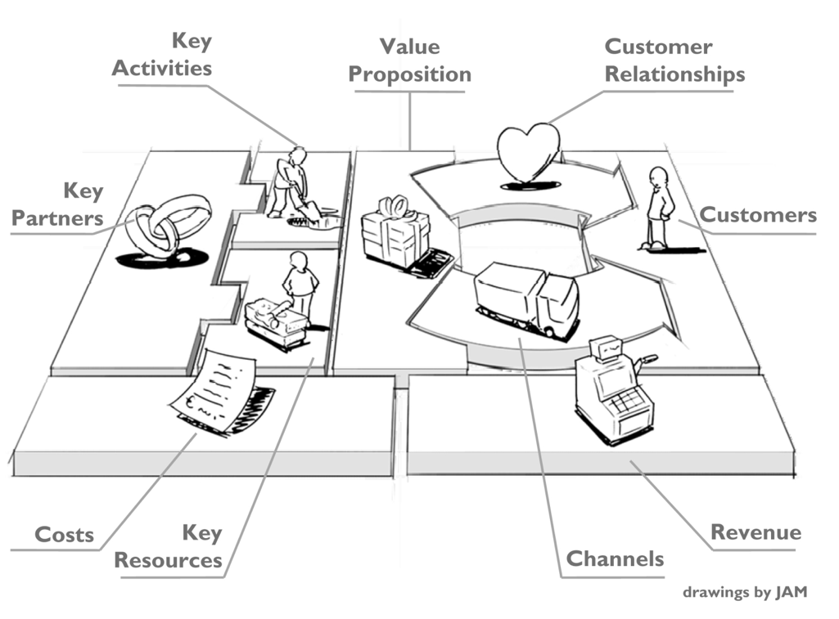
Business Model Canvas
Therefore, the ANYWHERE business models considered – B2B, B2C and B2M – will be analysed through the Business Model Canvas methodology (A. Osterwalder concept) that consists on nine conceptual blocks which allow making explicit the most relevant aspects for the business solution.
In Table 58.1 a brief description and meaning of the different blocks of the Canvas are presented, along with an explanation of their relation to the rest of the Canvas blocks.

Business Model Canvas building blocks
 | BM Canvas block - Key Question | Description
#1 Value proposition | 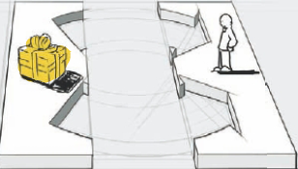  - What do we offer our customers?  - What value do we create for our customers?  - Which needs do we cover? | Description of the characteristics of the products/services offered, underlining the problems solved and the benefits expected that can be related to different aspects such as:  - new needs satisfaction  - performances  - customized solution  - reliability  - novel design  - risks and costs reduction  - competitive price  - accessibility  - usability
#2 Customer Segments | 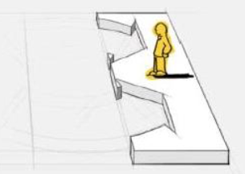  - Who are your customers?  - What are their needs? | Identification of the clients segments based on their needs/benefits guaranteed. The Customer Segments represents the core of the BM.  A company serves one or several customer segments (mass market, niche market, segmented, diversified, multi-sided)
#3 Channels | 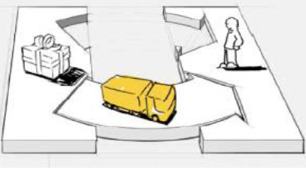  - Through what channels do we reach our customers?  - Through what channels do we deliver our products/services? | How a company communicates with and reaches its Customer Segments to deliver a Value Proposition. Channels are the company’s interface with the customer, thus they play a relevant role in the customer experience.  Channels can be physical (e.g. shops) or virtual (e.g. e-commerce/ selling platforms/ own website), direct (own shop) or indirect (franchising, wholesaler, distributors).
#4 Customer Relationships | 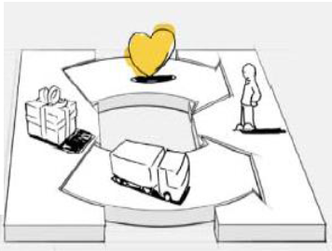  - How do we build and maintain good customer relationships? | Identification of the type of relationship the partnership has to establish and maintain with each specific customer segment. Different assistance means are recognized as effective customer relationships as:  - Personal assistance based on human interaction  - Self-service: the customer should receive all the info needed in order to help himself  - Automated services: it mixes a more sophisticated form of customer self-service with automated processes offering customized services based on the customer profile and need  - Communities: increasingly, companies are utilizing user communities to become more involved with customers/prospects and to facilitate connections between community members.  - Co-creation: more companies are going beyond the traditional customer-vendor relationship to co-create value with customers.
#5 Revenue Streams | 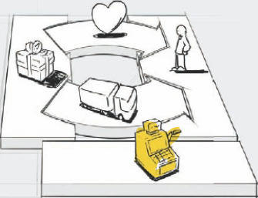  - How do we create revenues?  - What value are our customers really willing to pay for?  - How would they prefer to pay? | Identification of the revenues model and product/service pricing model. It represents the cash flow that a company generates from each Customer Segment. Revenue streams result from value propositions successfully offered to customers (depend type of contract).  Revenues can be derived from different sources: physical (e.g. direct selling, fee proportional to the use), virtual (use of app for selling), grants and crowd funding. There are different ways to generate revenues, such as:  - Asset sale. The most widely understood Revenue Stream derives from selling ownership rights of a physical product.  - Usage fee. This is generated by the use of a particular service. The more a service is used, the more the customer pays.  - Subscription fees. This is generated by selling continuous access to a service.  - Lending/Renting/Leasing. This is created by temporarily granting someone the exclusive right to use a particular asset for a fixed period in return for a fee.  - Licensing. This is generated by giving customers permission to use protected intellectual property in exchange for licensing fees. Licensing allows rights holders to generate revenues from their property without having to manufacture a product or commercialize a service  - Brokerage fees. This derives from intermediation services performed on behalf of two or more parties.  - Advertising. This results from fees for advertising a particular product, service, or brand.
#6 Key resources | 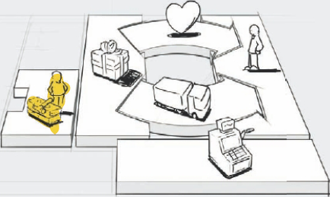  - What key resources do we need to fulfil:  - our value proposition?  - our distribution channels?  - customer relationships?  - revenue streams? | Identification of Key Resources required for operating successfully. Key resources are the assets required to offer and deliver the Value Proposition to Customers.  Key resources can be owned or leased by the company or acquired from key partners. Key resources can be classified as:  - Physical assets such as manufacturing facilities, buildings, vehicles, machines, systems, point-of-sales systems and distribution networks  - Intellectual resources such as brands, proprietary knowledge, patents and copyrights, partnerships, and customer databases  - Human resources  - Financial resources and/or financial guarantees, such as cash, lines of credit, or a stock option pool for hiring key employees.
#7 Key Activities | 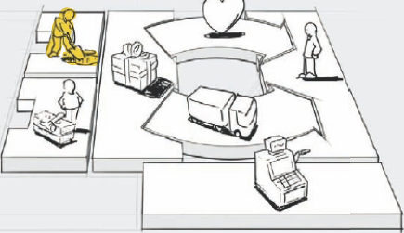  - Which key activities must we perform to deliver our value proposition? | Identification of the most important actions a company must take to operate successfully. They are required to create and offer a Value Proposition, reach markets, maintain Customer Relationships, and earn revenues. Key activities can be related to:  - Production: designing, making, and delivering a product in substantial quantities and/or of superior quality.  - Problem solving: coming up with new solutions to individual customer problems.  - Platform/network: networks, match making platforms, software, and even brands can function as a platform
#8 Key Partnership | 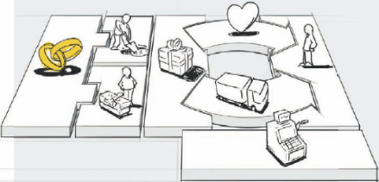  - Which partners and suppliers do we work with to deliver our value proposition? | Identification of the Key Partnership describeing the network of suppliers and partners that make the business model work. Companies create alliances to optimize their business models, reduce risk, or acquire resources. Some activities are outsourced and some resources are acquired outside the enterprise.  We can distinguish between four different types of partnerships:  - Strategic alliances between non-competitors  - Strategic partnerships between competitors  - Joint ventures to develop new businesses  - Buyer-supplier relationships to assure reliable supplies.
#9 Costs structure | 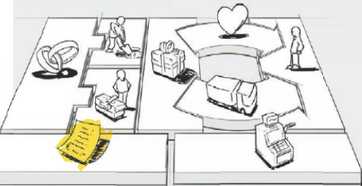  - What types of costs do we have to operate our business model and deliver our value proposition? | The Cost Structure describes all costs incurred to operate a business model. It can be useful to distinguish between two broad classes of business model Cost Structures:  - Cost-driven focus on minimizing costs wherever possible. This approach aims at creating and maintaining the leanest possible Cost Structure, using low price Value Propositions, maximum automation, and extensive outsourcing;  - Value-driven focus on premium Value Propositions and a high degree of personalized service  The categories of cost that interact with a business model may be:  - Fixed costs: costs that remain the same despite the volume of goods or services produced such as salaries, rents, and physical manufacturing facilities;  - Variable costs: costs that vary proportionally with the volume of goods or services produced;  - Economies of scale: cost advantages that a business enjoys as its output expands;  - Economies of scope: cost advantages that a business enjoys due to a larger scope of operations.

https://www.who.int/hac/techguidance/preparedness/emergency_preparedness_eng.pdf
“B” for the IPR on background information (Information, excluding foreground information, brought to the project from existing knowledge, owned or controlled by project partners in the same or related fields of the work carried out in the research project)
“F” for the IPR on foreground information (Information including all kind of exploitable results generated by the project partners or 3rd parties working for them in the implementation of the research project.)
U. Suthersanen, Incremental Inventions in Europe: A Legal and Economic Appraisal of Second Tier Patents, in Journal of Business Law, 2001, 319 ff
https://yourstory.com/2015/07/what-is-industrial-design-protectiontheir-designs/
http://www.hec.unil.ch/aosterwa/PhD/Osterwalder_PhD_BM_Ontology.pdf
https://core.ac.uk/download/pdf/15567621.pdf

