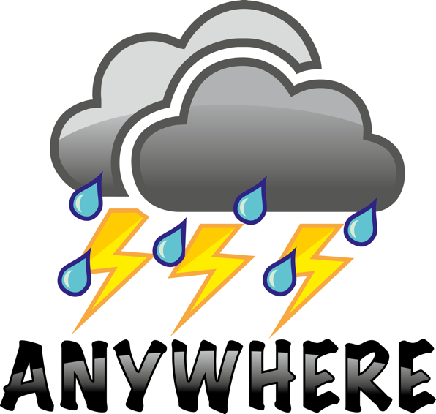

Project Number 700099
Call: H2020-DRS-01-2015

Project Title:
ANYWHERE
EnhANcing emergencY management and response to extreme
WeatHER and climate Events

Subject:
Deliverable 4.1:
A4DEMOS specifications: interfaces, processes, tools, RI design report

Dissemination Level:
CO | Confidential, only for members of the consortium (including the Commission Services)

Delivery date: 26th APRIL 2018
Month: Month 23
Organisation name of lead contractor for this deliverable: UNS


This project has received funding from the European Union’s H2020 Programme under the topic of potential of current and new measures and technologies to respond to extreme weather and climate events under grant agreement no. 700099.
This document reflects only the authors’ views and not those of the European Community. The information in this document is provided “as is” and no guarantee or warranty is given that the information is fit for any particular purpose. The user thereof uses the information at its sole risk and neither the European Community nor any member of the Consortium is liable for any use that may be made of the information.

Document Information
Title | A4DEMOS specifications: interfaces, processes, tools, RI design report
Lead Author | Morgan Abily(UNS)
Contributors | Philippe Gourbesville (UNS)  Jelena Batica (UNS)  Paolo Campanella (CIMA)  Ivan Tesfai (RINA)  Xavier Gautron (AIRBUS)  Bernardo Espinosa (HYDS)  Daniel Sempere-Torres (UPC-CRAHI)  Alvaro Rodriguez (HYDS)  Xavier Llort (HYDS)  Milan Kalas (KAJO)  Valentina De Santis (HSUH)
Distribution | CONFIDENTIAL
Document Reference

Document History:
Date | Revision | Prepared by | Organisation | Approved by
22.11.2017 | Rev_1_0 | Abily Morgan | UNS | Philippe Gourbesville
27.11. 2017 | Rev_2 | All WP4.1 partners | WP4.1 partners | Airbus
01.12.2017 | Rev_3 | All WP4.1 partners | UNS | UPC
30.12.2017 | Rev_4 | Daniel Sempere-Torres | UPC-CRAHI | Bernardo Espinosa
18.01.2018 | Rev_5 | Abily Morgan | UNS | Daniel Sempere-Torres
15.02.2018 | Rev_6 | All WP4.1 partners | WP4.1 partners | Daniel Sempere-Torres
04.04.2018 | Rev_7 | Bernardo Espinosa | UPC-CRAHI | Daniel Sempere-Torres
26.04.2018 | Rev_7.1 | Daniel Sempere-Torres | UPC-CRAHI | Abily Morgan

Related Documents:
This report and others are available from the ANYWHERE Project Website at: http://www.anywhere-h2020.eu/

© Members of the ANYWHERE Consortium

Summary
The main goal of the ANYWHERE Work Package 4 (WP4) is to develop an operational implementation of the ANYWHERE system For Decision support in Emergency Management Operation Services (A4DEMOS). The main aim being to make available the products and services provided by the ANYWHERE Multi-Hazard Early Warning System (MH-EWS) to any emergency management command centre to support decision making during weather-induced emergencies.
The purpose of the A4DEMOS is that it could be used “anywhere” in the EU with Pan-European tools, and to gather direct PPDR Users feedback from different perspectives and emergency scenarios caused by various phenomena, the project will develop several prototypes, in close collaboration of the PPDR Partners, to demonstrate in six regions located around 6 Pilot sites representing different climatic regional scenarios in Europe: Liguria (Italy), Catalonia (Spain), Bern Canton (Swiss Alps), South Savo (Finland), Rogaland (Norway) and Corsica (France).
One main requisite specified in the DoA is that the A4DEMOS system should be designed to be locally customizable and proactively targeted to the needs and requirements of the users and designed to maximize the exploitation and market uptake potential of the results of the ANYWHERE innovation action.
Thus, this D4.1 report gathers information for the A4DEMOS system development based on the analysis of the users’ expectations. Information on A4DEMOS concept, functional specifications, interfaces and process are provided, along with a description of the bottom up approach employed to define them.
The standardized method developed to assess pilot's diagnosis, requirements and functional specification is detailed. As well as the outcomes of its application to the six A4DEMOS implementation sites based on the visits and discussions with the managers of the emergency command centres of the six pilot sites. This process has led to the proposed system concept, seen as a highly customizable and localizable tool able to be easily adapted to new locations besides of the selected pilot sites.

Table of Contents
Document Information i
Document History: i
Related Documents: i
Summary ii
Table of Contents iii
List of acronyms and abbreviations v
List of figures vi
List of tables vii
1 Introduction 1
2 General overview of the A4DEMOS decision support system concept 4
2.1 Context and A4DEMOS general requirements (from GA Annex 1 PART B) 7
2.1.1 A4DEMOS tools to support the implementation of the system to new locations and new users 8
2.2 Overview of the process which lead to A4DEMOS conceptualization and specifications 8
3 From pilots site diagnosis to functional specifications for A4DEMOS implementation 10
3.1 Standardized bottom up approach to reach functional specifications 10
3.1.1 Matrix presentation 11
3.1.2 Pilot visits 16
3.1.3 From Use-case elaboration to requirements and functional specifications formalization 16
4 Standard approach applied to the six ANYWHERE implementation sites 19
4.1 Liguria region (Italy) pilot site 19
4.1.1 Liguria Use-case summary 19
4.1.2 General requirements of Liguria Use-case 21
4.1.3 Functional specification 22
4.2 Catalonia (Spain) pilot site 24
4.2.1 Catalonia Use-case summary 24
4.2.2 Catalonia pilot requirements generalization 25
4.2.3 Functional specifications 26
4.3 South Savo (Finland) pilot site 28
4.3.1 South Savo pilot Use-case summary 28
4.3.2 General requirements of South Savo pilot 29
4.3.3 Functional specification 30
4.4 Canton Bern (Switzerland) Pilot site 32
4.4.1 Canton Bern pilot Use-cases summary 32
4.4.2 Canton Bern pilot requirements generalization 34
4.4.3 Functional specifications 35
4.5 Rogaland (Norway) implementation site 37
4.5.1 Rogaland (Norway) Use-cases summary 37
4.5.2 Rogaland (Norway) requirements generalization 38
4.5.3 Functional specifications 39
4.6 Corsica (France) implementation site 41
4.6.1 Corsica (France) Use-cases summary 41
4.6.2 Corsica (France) requirements generalization 41
4.6.4 Functional specifications 43
4.7 Summary of the requirements and functional specifications per pilots 45
5 A4DEMOS Crowdsourcing and communication component 48
5.1.1 Administration Component 51
5.1.2 Crowdsourcing component 51
5.1.3 Social media component 52
5.1.4 Federation and processing component 53
5.1.5 Social Media & Crowd component implementation 53
6 Optional extra tools specifications 55
6.1 Operational resilience assessment tool (UNS) 55
6.2 DTS for logistic (RINA) 59
6.3 Risk assessment tool (SINTEF) 61
7 References 64
Annexes 65
Annex 1. Use-case description template provided to Pilot site Users 66
Annex 2. Genoa UC-01. 67
Annex 3. Genoa UC-02. 68
Annex 4. Finland UC-01. 69
Annex 5. Switzerland UC-01 71
Annex 6. Switzerland UC-02 73
Annex 7. Switzerland UC-03 75
Annex 8. Switzerland UC-04 77
Annex 9. Catalonia UC-01 78
Annex 10. Catalonia UC-02 83
Annex 11. Rogaland (Norway) Implementation site UC 86
Annex 12. SM & Crowd sourcing Use-cases and HMI details. 88

List of acronyms and abbreviations
A4DEMOS | ANYWHERE system For Decision support in Emergency Management Operation Services
ACA | Water Agency of Catalonia
ARPAL  B2B  B2C  B2B2C  B2G | Agenzia Regional per la Protezione dell'Ambiante Ligure  Business to Business  Business to Client  Business to Business to Client  Business to Government
CECAT | Emergency Management Center of Catalonia
CIMA | Fondazione Centro Internazionale in Monitoraggio Ambientale
Copernicus EMS | Copernicus Emergency Management Service
F | Functions
FMI | FMI - Finnish Meteorological Institute
FMoI | FMoI Finnish Ministry of the Interior
FOCP | Swiss Federal Office for Civil Protection
IGCC | Institute of Geography and Cartography of Catalonia
INTC | Department of Interior- Generalitat de Catalunya
ISTIKE | East and South-East Finland Rescue Services Joint Situation and Coordination Center
MH-EWS | ANYWHERE Multi-Hazard Early Warning System
ORI  PPDR | Operational Resilience Index  Public Protection and Disaster Relief organisations
R | Requirement
SMC | Meteorological Service of Catalonia
UC | User Case
UNIGE | University of Genova
UNS | University of Nice Sophia Antipolis

List of figures
Figure 2: General vision of ANYWHERE, including the interactions between the products and services provided by MH-EWS pan-European platform and the three ways to address the three typologies of users, B2G, B2B and B2B2C. In the case of A4DEMOS (developed in WP4) the targeted users are Public (PPDR), and 6 prototypes will be developed to be operationally tested in the pilot sites during ANYWHERE demonstrations. 5
Figure 1: General vision of ANYWHERE A4DEMOS 6 prototypes to be implemented in the pilot sites. The developer partner for Corsica pilot sites has been changed by the General Assembly in April 2018, but should be confirmed once the SME PREDICT Services become new partner of ANYWHERE. 6
Figure 3: Overview of the standardized approach for A4DEMOS customization/versioning. 10
Figure 4: Extract of the matrix for pilot diagnosis: part 1/3 display. 12
Figure 5: Extract of the matrix for pilot diagnosis: part 2/3 display. 13
Figure 6: Extract of the matrix for pilot diagnosis: part 3/3 display. 15
Figure 7: Design flow for A4DEMOS pilots' functional specification. 17
Figure 8: Functional specification of A4Lig (A4DEMOS for Liguria). 22
Figure 9: Functional specification of A4Lig with local enhancement of A4DEMOS functions. 23
Figure 10: Functional specification of A4Cat (A4DEMOS prototype for Catalonia pilot) 26
Figure 11: Functional specification of A4Cat with local enhancement of A4DEMOS functions 27
Figure 12: Functional specification of A4Finn, the A4DEMOS prototype for South Savo pilot. 30
Figure 13: Functional specification of A4Finn with enhancement of A4DEMOS functions. 31
Figure 14: Functional specification of A4Alps (A4DEMOS prototype for Canton Bern pilot). 35
Figure 15: Functional specification of A4Alps with enhancement of A4DEMOS functions. 36
Figure 16: Functional specification of A4DEMOS prototype for Rogaland (Norway) implementation site. 39
Figure 17: Functional specification of A4EU for Rogaland (Norway) with enhancement of A4DEMOS functions. 40
Figure 18: Functional specification of A4DEMOS prototype for Corsica (France) implementation site. 43
Figure 19: Functional specification of A4EU prototype for Corsica (France) with enhancement of A4DEMOS functions. 44
Figure 20: Schematic view of the SM & Crowd component. 48
Figure 21: Following table summarizes the general flow of the SM & Crowd application. 49
Figure 22: Indicative development and implementation planning (P=functional prototype). 54

List of tables
Table 1: Outlook of the functionalities that A4DEMOS will provide. 17
Table 2: List and classification of actors for the Liguria pilot site 19
Table 3: Liguria Use-case scenario UC-01. 20
Table 4: Liguria Use-case scenario UC-02. 20
Table 5: Expression of the general requirements for the Liguria pilot. 21
Table 6: List and classification of actors for the Catalonia pilot. 24
Table 7: List of requirements for the Catalonia Pilot. 25
Table 8: List and classification of actors for the South Savo pilot. 28
Table 9: South Savo pilot Use-case scenario UC-01. 28
Table 10: Expression of the general requirements for the South Savo pilot. 29
Table 11: List and classification of actors for the Switzerland pilot. 32
Table 12: Summary and listing of the four Use-cases requirements per UC, born from the analyse of UC- description for the Canton Bern pilot. 32
Table 13: Expression of the general requirements for the Canton Bern pilot. 34
Table 14: List and classification of actors for the Rogaland implementation site. 37
Table 15: Expression of the general requirements for Rogaland implementation site. 38
Table 16: List and classification of actors for the Corsica implementation site. 41
Table 17: Expression of the general requirements for Corsica (France) implementation site. 41
Table 18: Liguria requirements in the context of A4DEMOS functionalities 45
Table 19: Catalonia pilot requirements in the context of A4DEMOS functionalities 45
Table 20: South Savo pilot requirements in the context of A4DEMOS functionalities 46
Table 21: Canton Bern pilot requirements in the context of A4DEMOS functionalities 46
Table 22: Rogaland pilot requirements in the context of A4DEMOS functionalities 47
Table 22: Corsica pilot requirements in the context of A4DEMOS functionalities 47

Introduction
The main goal of the ANYWHERE Work Package 4 (WP4) is to design a common ANYWHERE system For Decision support in Emergency Management Operation Services (A4DEMOS) that could be a general solution for providing support to any emergency management centre in Europe, and at the same time be able to be easily customizable to the local needs, and adaptable to the local data availability with the purpose of being a powerful support tool in the decision-making process during weather induced emergencies.
The proposed strategy is to develop 6 operational prototypes of the A4DEMOS concept which will have the same basic objectives:
- Enable integration of forecasts and hazard impact indicators provided by the MH-EWS service pan-european platform (WP3) with local layers of information including risk and vulnerability analyses, open and commercial data, local sensor data, crowdsourced data and social media information, for monitoring and decision-support during emergency management.
- Propose adapted solutions to the local requirements, being able to build on or to interface with the present legacy systems through standardized interface layers and through offering specific “plug-ins” and toolkits to support integration and sharing of data.
- Be able to cope the local and high-resolution information available at the responder/user site, and to interconnect them with the MH-EWS to allow it to run specific high-resolution versions of the forecasting algorithms using this local information on demand.
- Be able to provide the products of the MH-EWS to any emergency management command centre to support decision making during weather-induced emergencies “anywhere” in Europe. To that end, the lessons learnt in the implementation and demonstration in the pilot sites will be used to ensure by construction that all six prototypes will be able to be implemented lately in any other emergency control centre in Europe, providing efficient support to the decision makers during weather induced emergencies independently of their location.
Moreover, the A4DEMOS system will include a set of “built-in” decision support tools able to be used operationally to support decision making during weather induced emergencies, as well as to collect data from the field and social networks.
Therefore, WP4 will implement a prototype of the A4DEMOS system for any of the six pilot sites of the WP6, adapted to the requirements defined by the users in D4.1 and validated by them after pre-operational tests ready for the trainings and for the operational pilot demonstrations required in WP6.
To achieve this, the ANYWHERE project has identified as main strategy to design all the project developments (including A4DEMOS) under the commitment of serving the users’ needs. In the project, this is identified as the ANYWHERE co-creation and co-ownership framework to which the entire WP1 (development of a framework for co-ownership and co-evaluation to ensure the successful implementation of the project) is devoted.
To ensure this co-creation framework, the A4DEMOS users that have been appointed to define the needs and requirements of the system and to guide the design process and implementation works during the project are the partners/authorities commanding the 6 control centres of the 6 implementation sites in which the project demonstrations will be carried out. In Liguria: CDG and ARPAL, in Catalonia: INTC and ACA, in Canton Bern: VOLBE, in South Savo: FMoI (and specifically South Savo Civil protection ISTIKE), in Rogaland: HSUH, and in Corsica: SDIS2B.
These partners are thus the core partners to define the “A4DEMOS specifications: interfaces, processes and tools” that are the aim of the present report. Being translated by the developing partners (AIRBUS, HYDS, CIMA and UNS) and the rest of the technical partners participating in WP4 into the IT specifications that could define the concept of the A4DEMOS system and the 6 prototypes that should be implemented for their operation during the ANYWHERE demonstrations (to be operationally running by June 2018).
WP4 Task 4.1 (Compilation of requirements for A4DEMOS decision support system and specific customized systems: specifications, interfaces and internal processes), is the one translating the collected needs and requirements into specifications for the interfaces, processes of A4DEMOS, and to describe the tools that are to be specifically developed in the other tasks of WP4. The main output is this report, D4.1: A4DEMOS specifications: interfaces, processes, tools, RI design report.
These T4.1 methodological and descriptive aspects are hence main objects of the present deliverable (D4.1) report which is organized in the next 5 main Sections.
Section 2: Aims at providing a global formalization of the general A4DEMOS concept before moving forward to the specification for interface, process and tool task. Reminders are given on A4DEMOS context and background. Details are provided on the process which lead to A4DEMOS conceptualization.
Section 3: Details the approach and process which has been conducted by ANYWHERE consortium to gather information regarding the maturity of the pilots, their needs and gaps from the state-of-the-art. Explanations on how this process leads to the formal establishment of requirement and functional specification are provided. The approach has been standardized and the elaborated process is applied for each of the ANYWHERE pilot sites that include the six locations initially foreseen in the DoA: Liguria (Italy), Catalonia (Spain), Bern Canton (Switzerland), South Savo (Finland), Rogaland (Norway) and Corsica (France).
Section 4: Focuses on feedback from the pilots’ high-level requirements and functional specification which consolidate, in a reverse engineering way, a global definition of A4DEMOS as a general concept able to be customized and localized to the user’s needs, executed by iterations to fine-tune the developments on real-world operations.
The lessons learnt during this process will be generalised identifying the commonalities of the different prototypes and identifying the best strategies for adapting the general structure to the particular needs. This effort will be shared between the different developers to achieve the objective of developing a common A4DEMOS concept that could be easily adaptable to new locations and new users’ needs, designed to maximize the exploitation and market uptake potential of the results of the ANYWHERE innovation.
Section 5: Describes the A4DEMOS Crowd-sourcing and communication component that provides an additional information channel to collect and disseminate information in different stages of the disaster management cycle. This component uses and analyses available Crowd-sourcing data as supporting information to improve the impact assessment to be included in all A4DEMOS prototypes (a specific Task in WP4 is dedicated to that purpose).
Finally, Section 6 describes the A4DEMOS optional tools to support resilience, detailed risk, and logistic risk assessment if required. Additional work to identify how they can contribute to respond to the users identified needs should be done during the implementation of the A4DEMOS prototypes.

General overview of the A4DEMOS decision support system concept
The target of this section is to provide the context for the design of A4DEMOS system For Decision support in Emergency Management Operation Services in ANYWHERE.
The core of the ANYWHERE Project is the integration of a number of meteorological forecasts and advanced algorithms to transform them into impact forecasting inside the MH-EWS pan-European platform. The products and services generated by the MH-EWS are the key to provide anticipation and to support more effective response during emergency events. ANYWHERE will offer these products and services to three typologies of users through three commercialization/distribution schemes:
- Public Protection and Disaster Relief organizations (PPDR), and specifically emergency control and command centres (usually regional Civil Protections, but also municipal Civil Protections in some cases) coordinating first responders and issuing alerts and warnings during emergencies. The purpose being to support decision making during weather-induced emergencies. The way to connect with them is through the A4DEMOS prototypes developed in WP4. This falls into the B2G market classification that will be fully described on the Business Plans of WP7.
- End-Users: i.e. Citizens and enterprises with activities located in risk areas. For them ANYWHERE will develop a variety of self-protection tools in WP5 providing services to support the implementation of self-protection risk plans pre-defined by the End-Users. This falls into the B2B2C market classification that will be detailed on the Business Plans of WP7.
- Third-Parties: Implementing Partners (associated enterprises) that collaborate with the ANYWHERE consortium in the commercialization of MH-EWS products in additional markets. The MH-EWS (WP3) will prepare and define the protocols to connect with them in order to reach additional markets. This falls into the B2B market classification which is be detailed on the Business Plans of WP7.
Figure 2 illustrates the interactions between the components of ANYWHERE system and the position of A4DEMOS within these interactions between the MH-EWS and its foreseen users. It details the interactions between the products and services provided by MH-EWS pan-European platform and the three ways to address the three typologies of users, B2G, B2B and B2B2C.
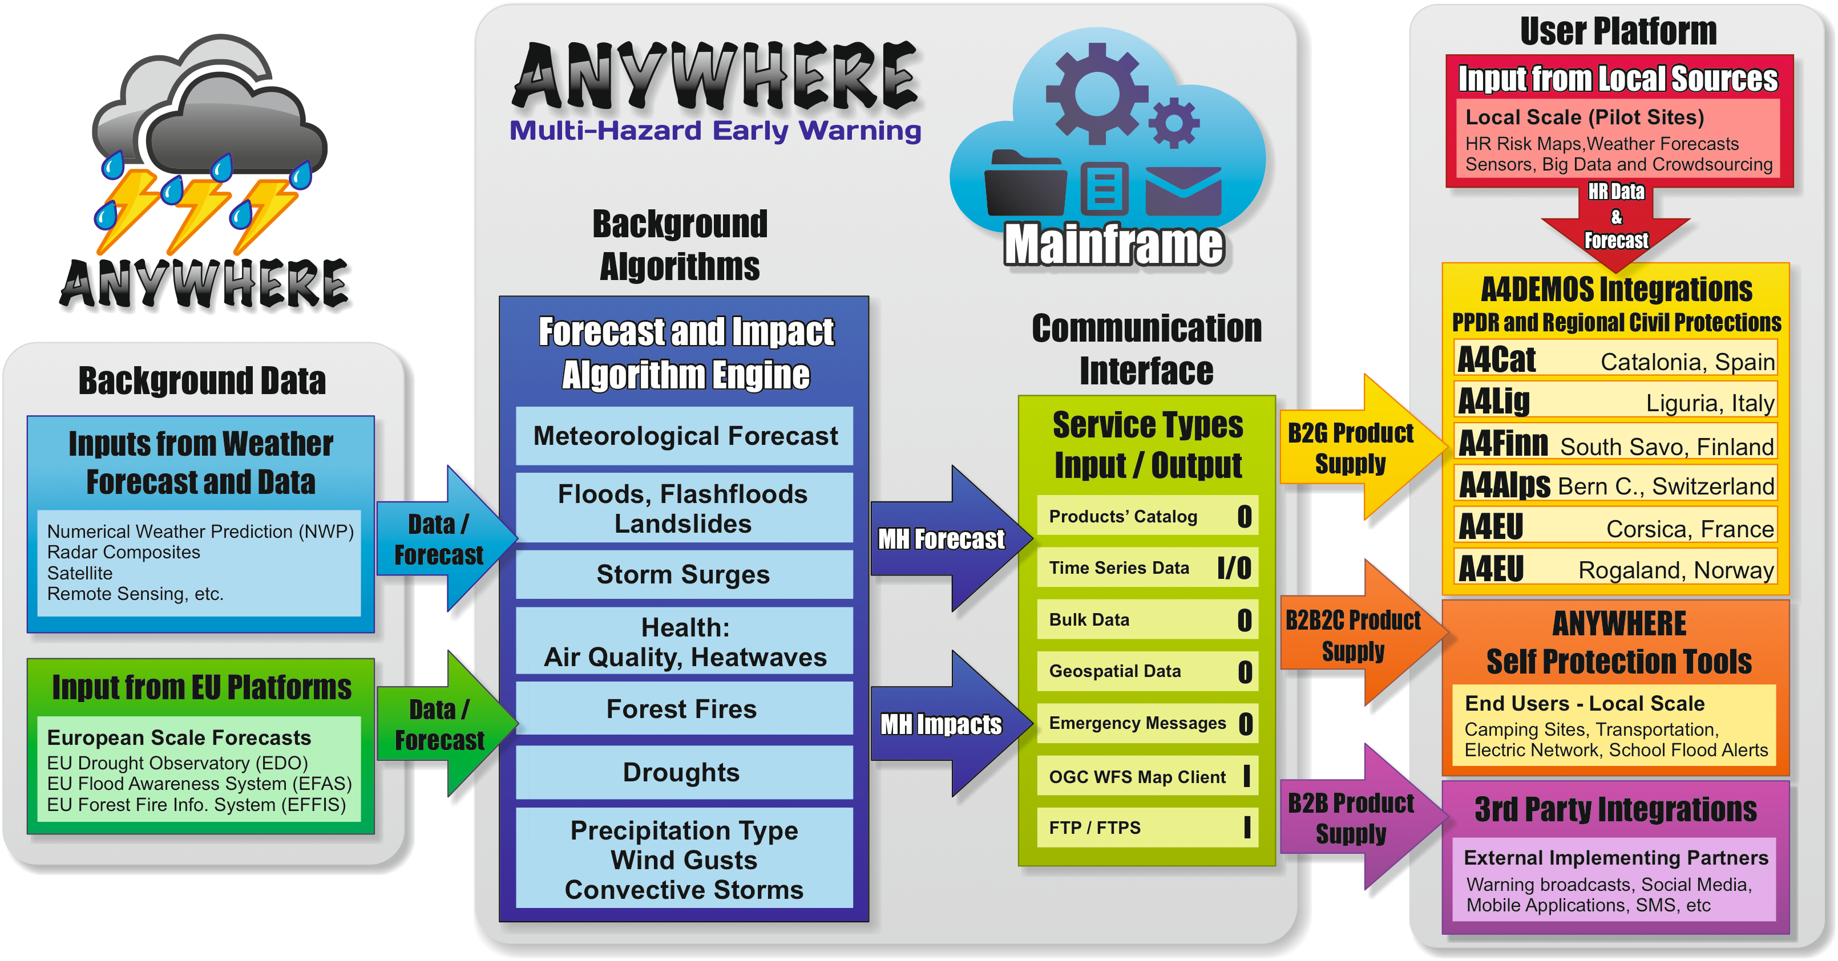
Figure 2: General vision of ANYWHERE, including the interactions between the products and services provided by MH-EWS pan-European platform and the three ways to address the three typologies of users, B2G, B2B and B2B2C. In the case of A4DEMOS (developed in WP4) the targeted users are Public (PPDR), and 6 prototypes will be developed to be operationally tested in the pilot sites during ANYWHERE demonstrations.
In the case of A4DEMOS (developed in WP4) the targeted users are Public (PPDR), and 6 prototypes will be developed and implemented to be operationally tested in the pilot sites during ANYWHERE demonstrations: Liguria (A4Lig, developed by CIMA), Catalonia (A4Cat, developed by HYDS), Canton Bern (A4Alps, developed by AIRBUS), South Savo (A4Finn, developed by AIRBUS), Rogaland (A4EU for Norway, developed by AIRBUS) and Corsica (A4EU for Corsica to be developed by a new partner).
This multiple development and implementation work has been adopted to solve the problems encountered during the A4DEMOS design and development phase with the purpose of increasing the efficiency in the implementations and maximizing the success expectation while ensuring the minimal delay in the start of the demonstrations (initially foreseen to start in June 2018).
Moreover, it is worth noting that all the developers (AIRBUS, HYDS and CIMA, together with other partners that could be able to join the consortium later, as PREDICT) will design their prototypes in a way that allow them to be implemented lately in any other emergency control centre in Europe (ensured by construction) with low adaptation efforts. This capacity to use any of the developed prototypes to supply the MH-EWS forecasts and impact assessment products to any PPDR User (internal and external to the project), is seen as an opportunity to provide different options to the project to promote a successful market uptake of the ANYWHERE developments in the B2G Market sector (see Figure 2), which implementation and roll-out strategy will be fully detailed on the Business Plans of WP7.
Thus, all the 6 prototypes will integrate the same ANYWHERE MH-EWS products and capabilities to cross them with local layer of information providing support to the decision makers during weather induced emergencies but allowing different versions able to customized the user experience and the interaction with the decision procedures tailored to the needs of the pilot site users. The lessons learnt in the implementation and demonstration of these pilot sites will be used to gather experience and feedback to better design the B2G model for Market Uptake.
This framework has to be kept in mind during the reading of this deliverable.

Figure 1: General vision of ANYWHERE A4DEMOS 6 prototypes to be implemented in the pilot sites. The developer partner for Corsica pilot sites has been changed by the General Assembly in April 2018, but should be confirmed once the SME PREDICT Services become new partner of ANYWHERE.

Context and A4DEMOS general requirements (from GA Annex 1 PART B)
The A4DEMOS decision support system is a solution to be developed in ANYWHERE project to connect the products and services offered by the Multi-Hazard Early Warning System (MH-EWS) to any emergency management command center in EU to support decision making during weather-induced emergencies. Additionally, the system must be able to cope the local and high-resolution information available at the responder/user site and interconnect them with the MH-EWS to allow it to run specific high-resolution versions of the forecasting algorithms using this local information on demand (section 1.3.1, page 12, Annex 1 Part B of GA).
To achieve these objectives, A4DEMOS system will integrate the following specific skills, that will be activated or not depending on the needs expressed in the different pilot sites implementations (section 1.3.1, page 13, Annex 1 Part B of GA):
- Capacity to adapt multi-hazard impact assessment products generated by the MH-EWS to a specific environment including specific user needs.
- Capacity to interact and adapt with the response protocols (procedures & SOPs) of a specific user or managing institution.
- Capacity to incorporate sensors and local sources of information (including crowd-sourcing).
- Capacity to handle detailed cartographies and local vulnerability and risk maps.
- Capacity to share information and interconnect various responders and operators (including regional and national CPs, local responders, hospitals, fire brigades, etc.).
- Advanced Geospatial Web Services capabilities to facilitate third parties Web services and Application Programming Interfaces (APIs).
- Capacity to support shorter reaction times and higher efficiency of reactions.
- Improved coordination of emergency and pro-active reactions in the field during the emergency management operation.
- Enhanced social media communication skills based on social studies on the effectiveness of the emergency warnings.
- Capacity to disseminate publicly available online now- and fore-casting hazard assessment for disasters triggered by extreme and high-impact weather and climate events.
Finally, WP4 will also support the development of complementary tools to add field emergency management operation capabilities, including 3rd-Party plug-is (through APIs) and WP5 will develop tailored products and services oriented to raise self-preparedness and self-protection of the population and the institutions with activities affected by the weather and climate events.
The A4DEMOS system design approach developed in WP4 should meet these objectives and requirements and provide a standardized methodology that must be implemented in each demonstration site to ensure its achievement.

A4DEMOS tools to support the implementation of the system to new locations and new users
Being ANYWHERE an Innovation Action, an additional objective of WP4 is to ensure that theA4DEMOS system can be commercially exploited at the end of the project.
Initially this objective was thought to be addressed including a suite of tools (Tool-Box) to support the adaptation of A4DEMOS to new locations and new users’ needs, designed to maximize the exploitation and market uptake potential of the results of the ANYWHERE innovation action (section 1.3.1, page 11, Annex 1 Part B of GA).
However, after a number of discussions, the initial idea expressed in the DoA as “toolkit” to support the implementation of the system to new locations has been changed in order to incorporate the same concept and the same basic functionalities in all the prototypes of A4DEMOS. These functionalities include the capacity to integrate and cross the MH-EWS products with local layer of information “anywhere” in Europe to automatically provide support to the decision makers during weather induced emergencies independently of the location of the control center.
So, all A4DEMOS 6 prototypes will be developed, implemented and tested in a way that ensures their capacity to be implemented lately in any other emergency control centre in Europe (ensured by construction) with low adaptation efforts.

Overview of the process which lead to A4DEMOS conceptualization and specifications
For the A4DEMOS conceptualization and interface specification strategy, the objective is to make sure that A4DEMOS will:
(i) match with the PPDR (B2G) end-user’s expectations;
(ii) be flexible enough to encompass the various type of information available from different Pilot sites (WP6) and products from MH-EWS pan-European platform (WP3 outputs).
Consequently, a bottom-up approach was set up to gather information on local specificities and level of maturity of pilot sites, existing Information Systems. Objective being to aggregate the expressed needs under a functional approach. Target of this approach is to assess the end-user/pilot needs and to compile them at a high level to formalize:
- needs and gaps versus the state-of-the-art.;
- Use-cases, requirements and functional specification;
- level of maturity regarding the proposed solution for a given function.
The A4DEMOS system specifications approach has been planned as followed:
- Elaboration of a Matrix to collect relevant information on the different pilots, to perform a first diagnosis on expectations, available information and existing systems (done in the period from M04 to M07).
- Collection of Pilot's needs and gaps with the different pilot sites leaders, and aggregation of the pilots’ sites input under the form of (i) requirement and (ii) Use-cases (done in the period from M08 to M12).
- Analyse phase and specifications reporting (done in the period from M10 to deliverable submission).

From pilots site diagnosis to functional specifications for A4DEMOS implementation

Standardized bottom up approach to reach functional specifications
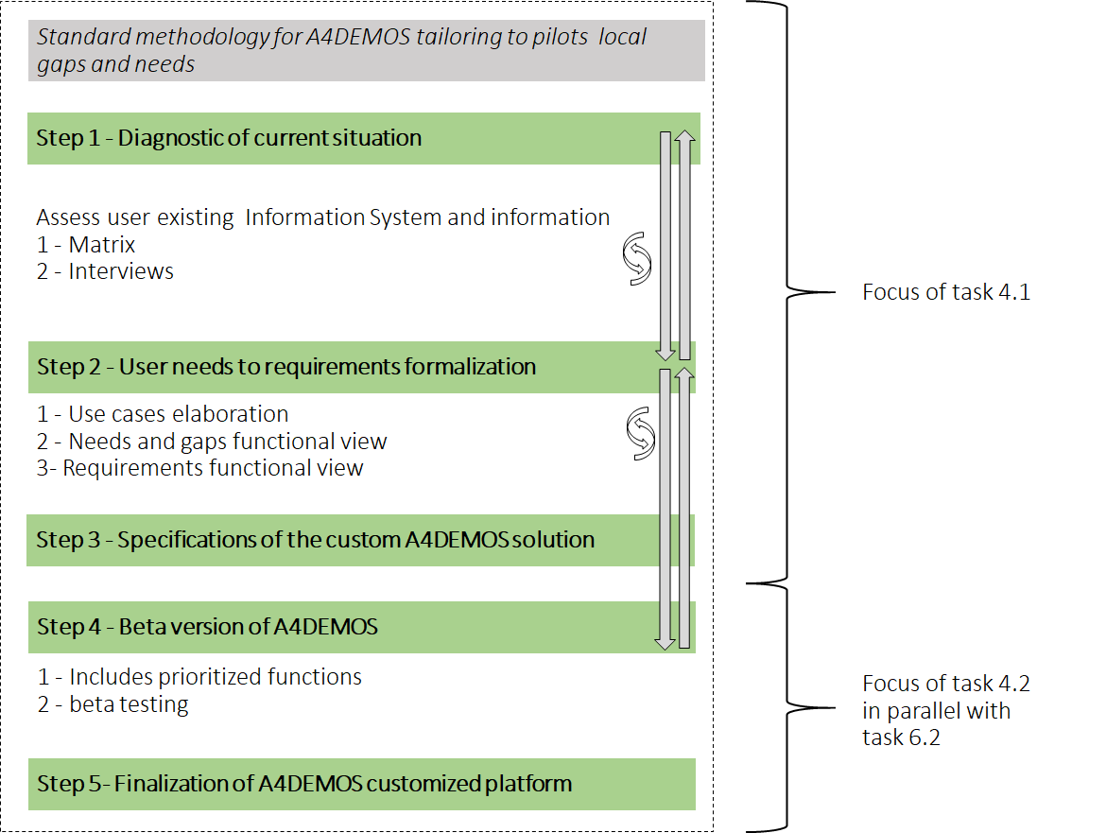
Figure 3: Overview of the standardized approach for A4DEMOS customization/versioning.
Developed standardized methodology, applied to reach specifications of the custom A4DEMOS system for the six implementation sites, is composed of three main steps: steps 1 to step 3, enhanced here in Figure 3. Two more steps, step 4 and step 5, which are not detailed here. Indeed, they are part of WP4, T4.2 and of WP6, regarding the development and finalization of the A4DEMOS prototype for each pilot based on the specifications. However, based on the results of testing the beta version, small changes and refinements will be made on requirements and specifications receiving Users (in this case PPDR Entities) first feedbacks on the beta versions.
This section details the processed step 1 to 3, presenting the material and approach used to reach the specifications which are detailed in Section 4.

Matrix presentation
The matrix aims to provide a relevant material to establish a standardized diagnosis of pilot site current situation and expectations. Objectives of this diagnosis of the pilot sites are:
- (i) to better understand the situation and the detailed needs of the pilots, aiming to help for assessment of level of maturity of pilots' existing system (before ANYWHERE) in order to design framework for requirements formulation;
- (ii) to provide and archive a first series of technical knowledge of the pilot sites as a supportive material to be reused by A4DEMOS developers during implementation phase;
- (iii) to help for a global organizational and technical conceptualization of A4DEMOS.
The process of establishing the matrix template was first tested with one given pilot site (Liguria-Genoa), with the help of Genoa municipality (Commune Di Genova, CDG) and the Liguria region (Agenzia Regional per la Protezione dell'Ambiante Ligure, ARPAL). Matrix was also tested for feedback with a Stakeholder Board member (Nice Metropolis, France) to have an "extra" feedback on the matrix from a potential end-user from outside the project.
Following this elaboration process, the matrix was provided to pilots. The process of filling the matrix was performed by WP6 partners using series of indication to fill the matrix fields and allowing room for open comments during the matrix filling process.
The structure of the matrix is detailed here. The Matrix is divided in three parts:
- Part 1, notably for information regarding pilot extent, risk to be assessed, existing system;
- Part 2, to compile information on existing IS and used/usable datasets and sensors;
- Part 3, to ask, which of WP2/3 products should be included.
Part 1. of the matrix gather information regarding the pilot specificities such as spatial extent, risk to be assessed, existing system, and main information on decision chain and communication from the future ANYWHERE A4DEMOS DSS user perspective (see Figure 4).
Moreover, regarding the field "Risks to be assessed in the pilot", complementary questions for each risk are included in extra columns of the matrix part 1 (not displayed in the Figure 4 for clarity sake). The required complementary information is under the form of following questions to be answered for each line of the matrix:
- is risk already addressed (partially/fully) or it assessment starts from scratch? If yes, precise what are the implemented solutions resources;
- rank level of confidence (1 -low- to 5 -high-) you have on your existing assessment system to support the decision-making process.
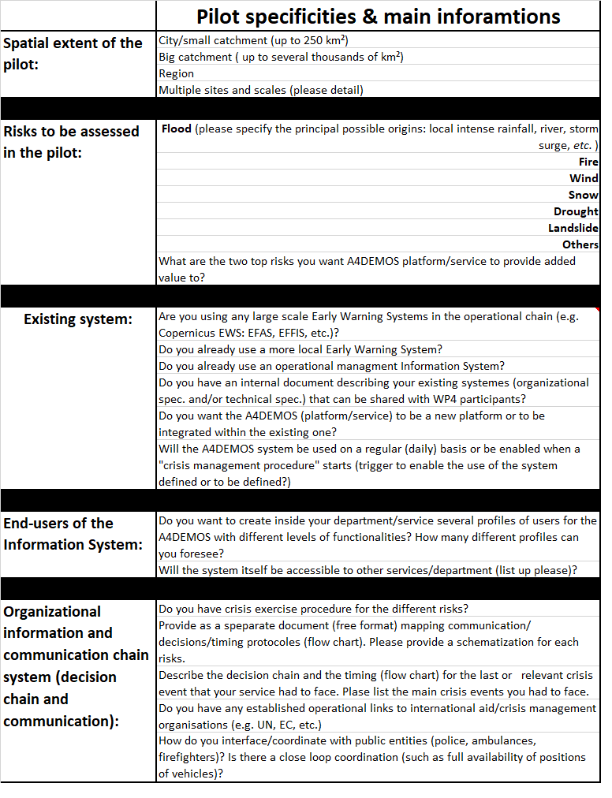
Figure 4: Extract of the matrix for pilot diagnosis: part 1/3 display.
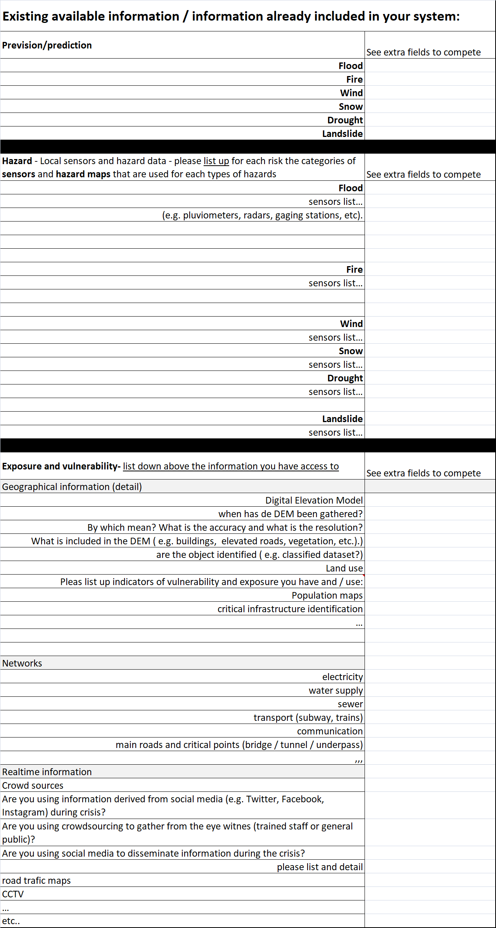
Figure 5: Extract of the matrix for pilot diagnosis: part 2/3 display.
Part 2. of the matrix aims to compile information on existing IS and data of pilots (see Figure 5). Moreover, information on data and IS properties regarding risks prevision, sensors, exposure and vulnerability of the pilot for each risk considered is to be filled.
For each section of this part, the matrix encompasses specific questions to gather a complete picture.
For the forecasting section:
- Specify and detail nature and source of what you are using right now for forecasting
- Format of the information and temporal update of the flux of information in your system
- Temporal horizon of the prevision
- Please, explain how you use this data? (e.g. use it to run a model, use it to start a decision process?)
For the hazard sensors section:
- Source: (1) local and handled by your service / (2) local and provided by another operator (cite source)/ (3) data provided at a broader scale (e.g. national flood maps, (cite source.)
- Nature of the variable
- Format of the data
- Already included in your existing Information system?
- Temporal update of the flux of information in your system
- Data storage protocol
- Connection/communication protocol (e.g. wifi, satellite, wire…)
- Starting date of the data acquisition
- Energy supply of the sensor (electric network, batteries...)
- Use of the sensor (continuous or only activated in a crisis situation)
- Number of sensors
- Scheme of the sensor network (detail here for one variable the different components (e.g. 10 over 60 using wifi, 50 over 60 uses …)
- Foreseen development of the network
- Virtual sensors
- Reference and brand of the sensor
Exposure and vulnerability section:
- Already included/available but not included in your information system yet
- Source (local and handled by your service /local and provided by another service (cite source)/upper scale information (coming from regional/national level)
- Is the information shared/ operated and updated by other services?
- Is the information open source?
- Temporal update of the flux of information in your system
- Data storage protocol
- Connection/communication protocol (e.g. wifi, satellite, wire…)
- Starting date of the data acquisition
- Is there an existing survey to update the data?
Part 3. of the Matrix target diagnosis of pilots by asking to Pilots users, which of MH-EWS products is wanted to be included the developed prototype of A4DEMOS. To express so, a catalogue of WP3 product output has been provided as an annex of the matrix when provided to users, in order for them to make their selection.
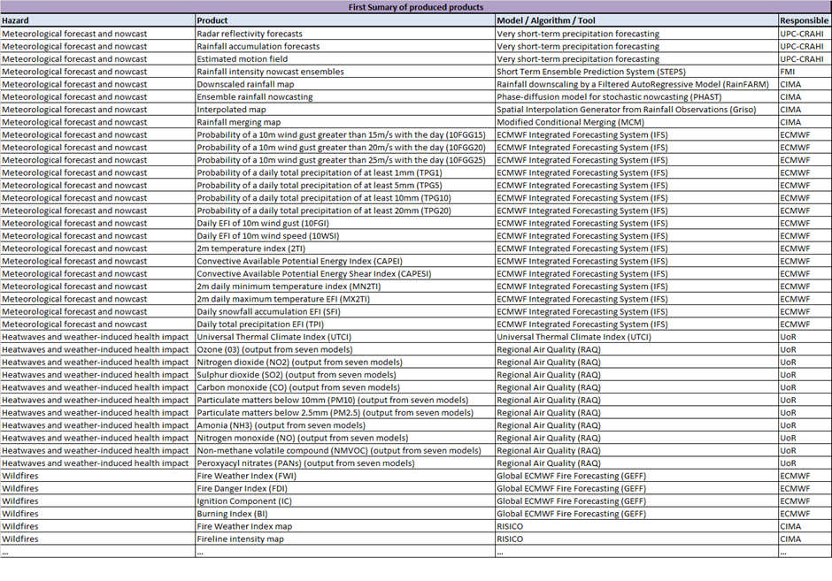
Figure 6: Extract of the matrix for pilot diagnosis: part 3/3 display.
The list of products used here was extracted from ANYWHERE Deliverable D3.1 (Sancho et al., 2017). As reminded in the text of this deliverable, the list of products was continuously evolving until M19. Moreover, MH-EWS list of algorithms will continue to evolve until the end of the project. Hence, the list provided to pilots at the period of the Matrix filling process (M4-M7) should not be taken as the final list of products offered by the MH-EWS. The list of products will be updated in the Matrix annex on a regular basis to cope with evolutions of MH-EWS list of products.

Pilot visits
From the perspective of Task 4.1 (WP4) perspective the objective of the pilot visits was to get a crucial complement of the matrix for diagnosis assessment of the pilot needs, gaps to be filled and expectations. This part of the process was performed to fully understand the users requirements in terms of what they expect from A4DEMOS (Accordingly with the definitions proposed in WP5, see deliverable D5.1 -Scholle et al., 2017-, the users of A4DEMOS will be the personnel or the authority in charge of the emergency center where the system will be used. Thus in ANYWHERE, the concept of end-users will be reserved for citizens or enterprises with activities at risk). The visits helped to formalize the identification of gaps and needs of the pilot in a standardized A4DEMOS framework. The synthesis of these pilot visit is the core of ANYWHERE deliverable D1.2 (Müller et al., 2017).
Indeed, gaps and needs expressions are key milestones used by WP4 partners to secure a reliable conversion of these information into requirements expression. More specifically, during pilot visits, WP4 partners aimed to address Pilots Use-cases and requirement analysis, through actions listed above:
- sending a generic template to pilots’ leaders before the visit;
- performing a series of interviews with each pilot leader, discussing Use-cases under the form of Use-case scenario description.
The initiated approach uses as starting point during meeting between users and developers, the Use-case description from the template (see Annex 1). This template has been sent to pilots before the visits. Objective was to achieve a common understanding during interview/visit, allowing afterward to create and formalize Use-cases material to be used afterward as a support for requirements and functional specification elaboration.

From Use-case elaboration to requirements and functional specifications formalization
As mentioned in previous sections, process to elaborate pilots’ requirements, and to build a formal functional specifications formulation (see Figure 7), is based on as first step of diagnosis elaboration performed through Matrix elaboration and pilots site visits. Then, in a second step, the Use-case template revision after pilots visits specific interviews, and the diagnosis knowledge allows:
- to build up Use-case scenario summary and table listing of actors to classify them;
- to clearly formulate the general requirement per pilots;
- to build up functional specifications per pilot site and to link them with A4DEMOS concept in terms of functional description.
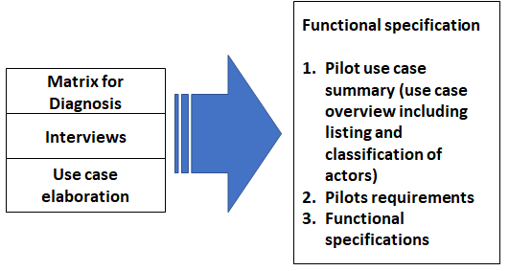
Figure 7: Design flow for A4DEMOS pilots' functional specification.
Six functionalities (F1-6) defined in fig.1 and summarized in Table 1, result from the aggregation of both the original A4DEMOS concept definition from the grant agreement (recalled in section 1.1) combined with the feedback of the interviews with the pilot sites future users of A4DEMOS.

Table 1: Outlook of the functionalities that A4DEMOS will provide.

Information integration layer | F1- Integration of MH-EWS products (compulsory) | The functionalities F1 to F3 correspond to the data to be used by a user and by A4DEMOS second layer of functionalities (F4 to F6), to provide an analysis for the high impact climatic event crisis management.  From F1 to F3, the input data is becoming more localized in terms of spatial scale, and tends to go respectively from prevision/prevention type to a more exposure/vulnerability type of information.  In other words, from F1 to F3, nature of the information is shifting from forecasting to local measurements or local information inclusion. Note that some of the regional information might be provided/included in the MH-EWS products.
Information integration layer | F2- Regional information
Information integration layer | F3- Use of local information
Information System Layer with analysis and ICT enhancement | F4- Inclusion of new modules of tools (toolkits) | This functionality means that A4DEMOS leaves the room for integration of extra tools in Pilots. It can be seen as the possibility to integrate in ADEMOS different modules of tools which will provide extra information/analysis for the assessment of the risk and impacts for the Pilots.
Information System Layer with analysis and ICT enhancement | F5- Visualization and display for decision support enhancement | This functionality regroups the displays in terms of: standardization of the representations for inclusion of the other functions and in terms of options for prioritization of the visualization (depending on profile or nature of hazard).
Information System Layer with analysis and ICT enhancement | F6- Communication module | This function regroups the ruling for the communication: internal/external & uni/multidirectional and the SOP of communication.

Standard approach applied to the six ANYWHERE implementation sites
The process applied here to provide functional specifications is standardized as much as possible, according to description in Section 3.1.3 (see Figure 7). However, it has to be recalled that external factors might lead, to the margin, to slight deviations in the process.
The set of diagnosis matrix is stored under numeric format in ANYWHERE Basecamp workspace. This section presents for each implementation site (Liguria (Italy), Catalonia (Spain), Bern Canton (Switzerland), South Savo (Finland), Rogaland (Norway) and Corsica (France)) the outcomes of the process. Outcomes consists first in the production of one (or several depending on the pilot) Use-case(s) summary. Then the requirements are generalized. The requirements listed for each of the pilots are high level requirements. Lastly functional specifications are presented for each of the pilots and an emphasis is done to show the parallelism between the functionalities to be developed in each pilots A4DEMOS custom version with respects to the general A4DEMOS functionalities as defined in Table 1.

Liguria region (Italy) pilot site

Liguria Use-case summary
Table 2: List and classification of actors for the Liguria pilot site

Actors
General | Detailed listing
Information/data provider | MH-EWS
Information/data provider | DEWETRA
Information/data provider | RASOR
User | ARPAL
User | Municipality of Genoa (CDG)
The A4DEMOS prototype for Liguria pilot site will be called A4Lig and will be developed and implemented by partner CIMA. A4Lig will provide access to the MH-EWS products and use DEWETRA for visualization/information managing purposes. The MH-EWS is set to become the central source of information, to create a seamless scenario of workflow along with the local Data and Systems. An extra documentation/reporting on the started implementation of A4Lig (outside of the scope of this deliverable) has been produced by CIMA and has been made available to the coordinator and to the consortium.
For the Liguria pilot, the municipality of Genoa was selected by WP6 Pilot leader (CIMA), as representative of the Liguria pilot site for the design of: Use-cases, requirements, needs and specification. The municipality of Genoa is already using the operational system DEWETRA, for real time monitoring (http://www.cimafoundation.org/en/cima-foundation/dewetra/) and Rasor, for impact scenario calculation (http://www.rasor-project.eu/rasor-platform/). The users expressed a high-level need that can be considered more like a User scenario or very high level Use-case, regarding the integration of the two systems, with the specific need to access ANYWHERE MH-EWS seamlessly. Users specified that they want to be able to access information on the developed system to: (i) visualize impact forecast, through mapping processes; (ii) analyze impact forecast through clickable sections producing charts where indicators can be customized.
Here the Use-case has been described following CIMA standard procedure/template (Annexes 2 and 3), to elaborate two Use-cases scenarios. Tables 3 and 4 present these two Use-case scenarios summarized under the CIMA foundation template form.
Table 3: Liguria Use-case scenario UC-01.
Use-case | View Impact Forecast
Primary Actor | User
Scenario | - The user selects the "Forecast menu";  - The user selects the Impact Maps model;  - The system shows by default the last available model and shows the population map with the medium probability: the map shows all the considered exposure with for each information about affected people;  - The user can click on the exposure of the map to see detailed information;  - The user can change the layer options;  - The user can choose the indicator to see on the map (population, internal damage, external damage, etc.);  - The user can choose the statistical scenario (safest, medium, worst);  - The user can update the layer;  - The system shows the new map of the selected indicator in the selected scenario.

Table 4: Liguria Use-case scenario UC-02.
Use-case | Analyze Impact Forecast
Primary Actor | User
Scenario | - The user selects the Forecast menu;  - The user selects the Impact Sections Model;  - The system shows by default the last available model and shows a marker for each section of the driver hydro model;  - The user can click on a section of the hydro model;  - The system shows a chart with the forecast of the section;  - The user can change the variable of the chart;  - The user can choose one of Impact Scenario Distribution chart, available for each indicator;  - The system shows a distribution chart of the impact scenarios;  - The user can click on a peak of the chart;  - The system opens the map related to that indicator and scenario.

General requirements of Liguria Use-case
Table 5: Expression of the general requirements for the Liguria pilot.
R-1 | System should be accessed by login through web service
R-2 | System should centralize hazard and exposure information to provide impact information
R-3 | System will allow exposure information to be updated by user
R-4 | System will allow two types of approach regarding impact visualization: Impact maps and charts of impact forecast
R-5 | System will allow to parameterize impact map visualization and charts of forecast
R-6 | System will allow to parameterize the variable of the charts

Functional specification
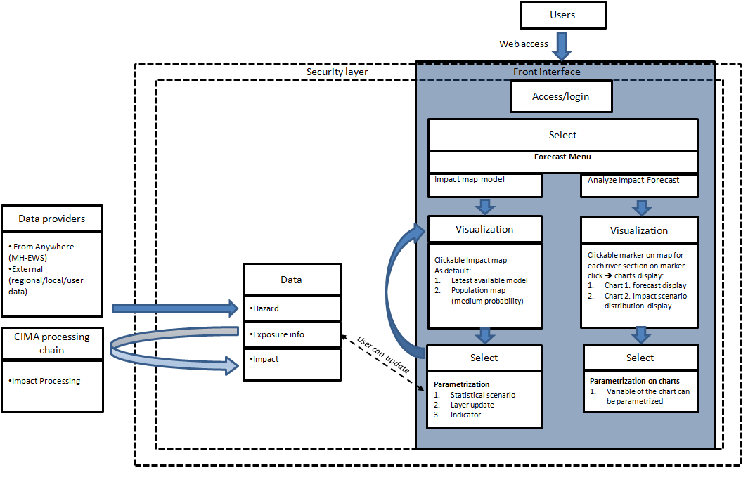

Figure 8: Functional specification of A4Lig (A4DEMOS for Liguria).
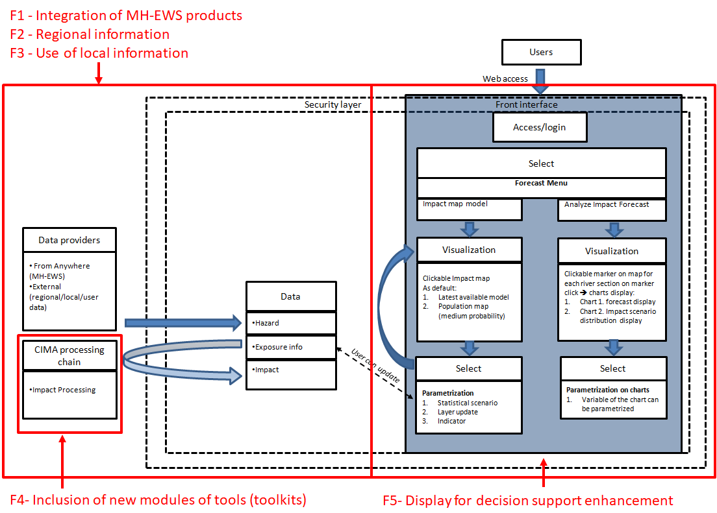
Figure 9: Functional specification of A4Lig with local enhancement of A4DEMOS functions.

Catalonia (Spain) pilot site

Catalonia Use-case summary
Table 6: List and classification of actors for the Catalonia pilot.
Actors
General | Detailed listing
Information/data provider | MH-EWS
Information/data provider | Catalonia Weather Services (SMC)
Information/data provider | Spanish Meteorological Agency (AEMET)
Information/data provider | Catalonia Water Agency (ACA)
Information/data provider | Ebro river basin (CHE)
Information/data provider | Jucar river basin
Information/data provider | Riskhydro
Information/data provider | Meteologica
Information/data provider | Catalonia Agriculture Department
Information/data provider | Catalonia Cartographical services (IGCC)
User | SICECAT2
User | INTC

Two Use-cases were produced to describe the Catalonia customization of A4DEMOS, named A4Cat that is developed by partner HYDS (detailed in Annexes 9 and 10). The two Use-cases can be summarized as follow:
- UC CAT-01: Common system to visualize and cross information from different sources: The objective of this Use-case is to have a single-entry point where all the hazard and impact data used by the Civil Protection of Catalonia (INTC) is available and inter-related. This will allow a more efficient way to analyze all the available data (currently spread in many sources) in case of current or potential risks appear.
- UC CAT-02 Integration of the impact models into the SICECAT2 platform: The objective of this Use-case is to integrate the most relevant products offered by the ANYWHERE MH-EWS into the SICECAT2 platform used by the Catalonia Civil Protection to track activities.
For the reader information, an extra documentation/reporting on the started implementation of A4Cat (outside of the scope of this deliverable) has been produced by HYDS and has been made available to the coordinator and to the consortium.

Catalonia pilot requirements generalization
Based on the Use-cases and on the previously described methodology, requirements for Catalonia pilot have been generalized in Table 7.

Table 7: List of requirements for the Catalonia Pilot.
 | Requirement
R-1 | System will be a service accessed and secured through login on SICECAT2
R-2 | System will centralize visualization of data from several sources (private/public/owned), and allow their mapping
R-3 | System will allow update of the mapped information with a refreshment compatible and adapted to the different data sources
R-4 | System will provide an interface allowing visualization of information adjustment to the scale (spatial and temporal) of hazards information (forecasting, now casting & measurement), to operational requirements and to data properties facilitating user analysis
R-5 | System will provide impact products for the different hazards based on vulnerability and hazard data combination

Functional specifications
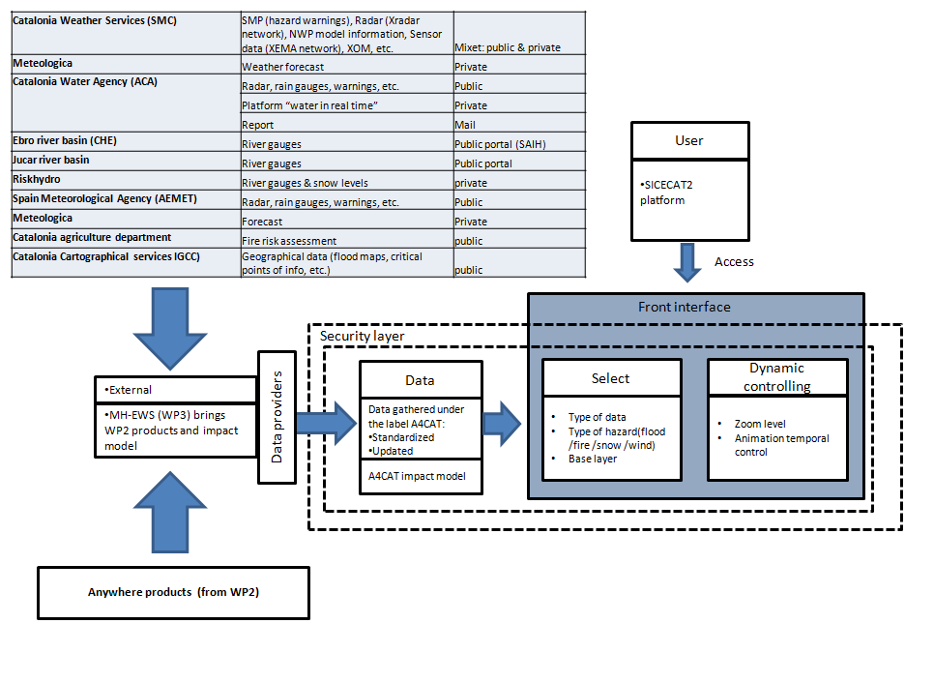
Figure 10: Functional specification of A4Cat (A4DEMOS prototype for Catalonia pilot)
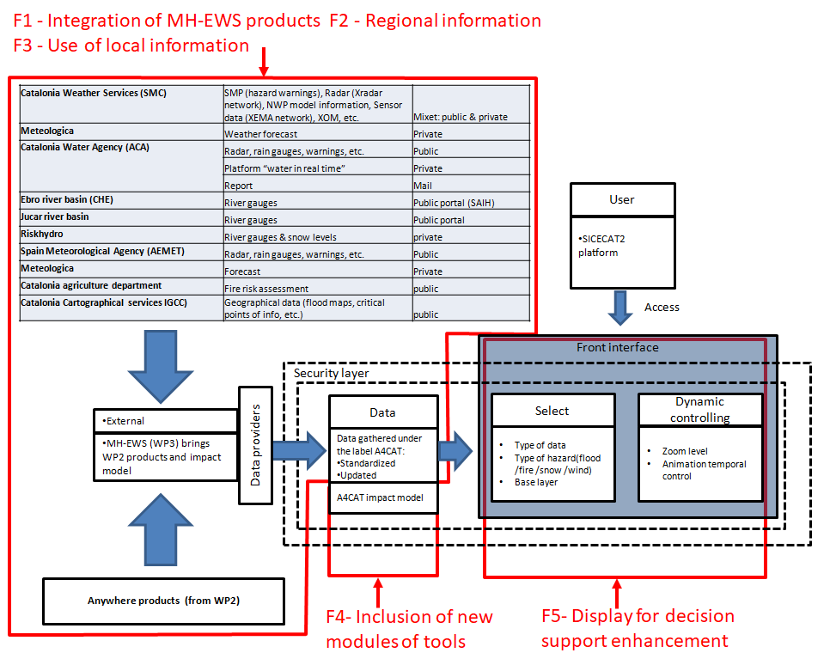
Figure 11: Functional specification of A4Cat with local enhancement of A4DEMOS functions

South Savo (Finland) pilot site

South Savo pilot Use-case summary
Table 8: List and classification of actors for the South Savo pilot.
Actors
General | Detailed listing
Information/data provider | MH-EWS
Information/data provider | FMI
Information/data provider | ISTIKE
User | ISTIKE
User | KRIVAT System

In accordance with WP6, the South Savo region in Finland has been selected for the A4DEMOS customization procedure. The local version will be called A4Finn and will be developed by the partner AIRBUS.
As all other A4DEMOS prototypes, A4Finn will allow the retrieving of products of MH-EWS for the users. The main need identified by the end-user, namely here the East and South-East Finland Rescue Services Joint Situation and Coordination Center ISTIKE, is to automate and centralize the Finnish Monitoring Center of Natural Disasters Alert Bulletin (LUOVA Alert Bulletin) analysis by the different civil protection agencies. As a first step, the ISTEKE semi-automatic analysis procedure will be used to develop the first implementation of the customized version of A4DEMOS: A4Finn.
A4Finn will allow flexibility to be to include procedures of other agencies for the analysis of the LUOVA bulletins in its analysis tools. Outputs will be centralized in KRIVAT System. The Use-case scenario presented in Table 9 has been jointly elaborated by users and developers using as a support document (extract from the full Use-case description in Annex 4).
Table 9: South Savo pilot Use-case scenario UC-01.
Use-case | Analyze Impact Forecast
Primary Actor | User
Scenario | - Objective of the Use-case is to allow a centralized and automated interpretation of the standardized FMI alert bulletin (LUOVA).  - This bulletin shall be accessible by users of the system (ISTIKE and potential others departments using the system) to provide automatic support to their analysis.  - The ISTIKE analysis procedure to be developed and used as is a semi-automate decision tree under excel format based on the LUOVA bulletin (traffic light management).  - The bulletin and users should access the system through a secured manner.  - The output of the fully automated bulletin alert analysis procedure should be sent through secured channel to a formal receiver for centralization (KRIVAT system).

General requirements of South Savo pilot
Table 10: Expression of the general requirements for the South Savo pilot.
 | Requirements
R-1 | System must be accessed upon login
R-2 | System should centralize the MH-EWS products and LUOVA Bulletin which has to arrive in a standardized format
R-3 | System will allow ISTIKE process to automatically perform its analysis on the LUOVA bulletin
R-4 | System should allow ISTIKE to parameterize the analysis process
R-5 | System will securely and automatically forward the results of LUOVA/ISTIKE analysis to KRIVAT

Functional specification
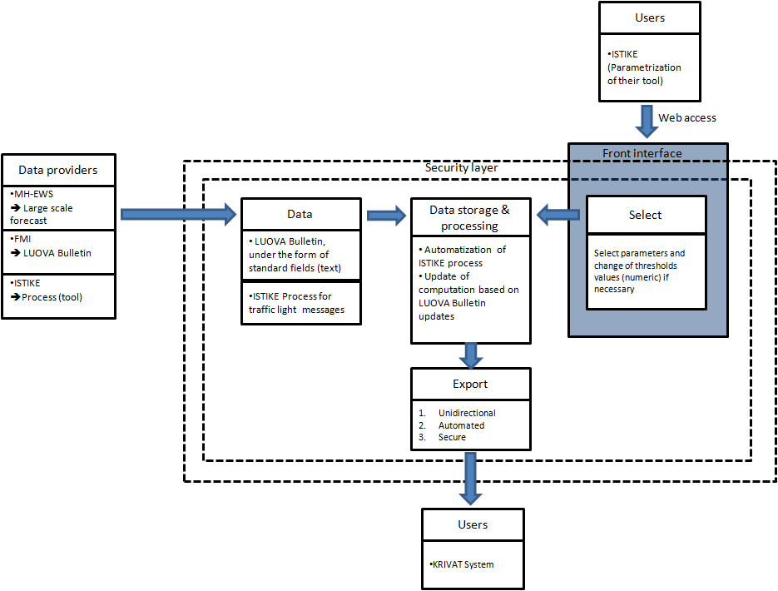
Figure 12: Functional specification of A4Finn, the A4DEMOS prototype for South Savo pilot.

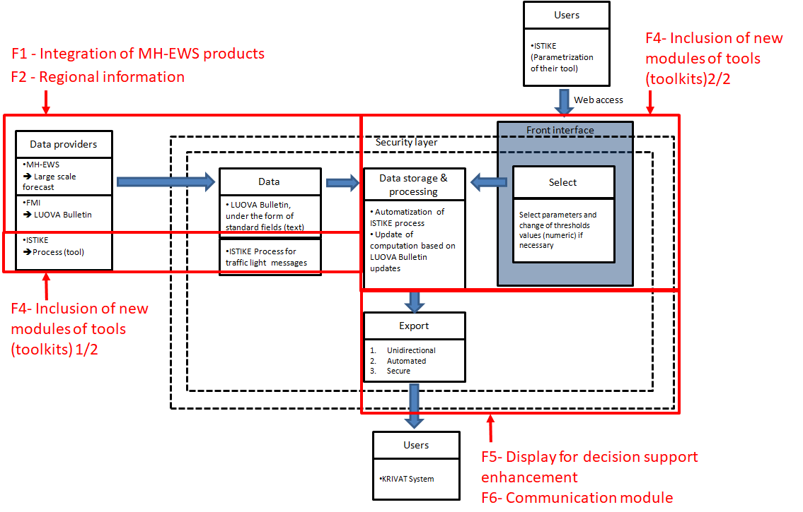
Figure 13: Functional specification of A4Finn with enhancement of A4DEMOS functions.

Canton Bern (Switzerland) Pilot site

Canton Bern pilot Use-cases summary
In accordance with WP6, the Canton Bern in Switzerland has been selected for the A4DEMOS customization procedure. The local version will be called A4Alps and will be developed by the partner AIRBUS. The purpose is that this version could be easily extended to other Alpine Cantons and regions presenting similar climatic and terrain characteristics.
Table 11: List and classification of actors for the Switzerland pilot.
Actors
General | Detailed listing
Information/data provider | MH-EWS
Information/data provider | UNIGE
Information/data provider | GEO7
Information/data provider | local info (Meteoswiss)
Information/data provider | local info (Cantonal water reg. office)
Admin | Administrator
User | Local organizations
User | Cantonal Expert

Canton Bern pilot consists in a set of four distinct Use-cases listed below.

- UC-01: Medium term Forecast.
- UC-02: Mass Movements.
- UC-03: Landslides.
- UC-04: Zug catchment Nowcasting.
These Use-cases are fully described in Annex 5 to 8 and here a summary of the different requirements per Use-case is presented in Table 12, to provide an overview of the scope of this pilot (as a summary) before expressing (see Table 13) the synthesis of these requirements for the whole pilot.

Table 12: Summary and listing of the four Use-cases requirements per UC, born from the analyse of UC- description for the Canton Bern pilot.
Switzerland Pilot
Use-case 1 to requirements | Use-case 2 to requirements | Use-case 3 to requirements | User case 4 to requirements
Medium Term Forecast | Mass Movements | Landslides | Zug catchment Now casting
UC-01 | UC-02 | UC-03 | UC-04
Primary actor: user | Primary actor: user | Primary actor: user | Primary actor: user
System must be accessed upon login | System must be accessed upon login | System must be accessed upon login | System must be accessed upon login
System must have several profiles configured (standard/expert) |  | System must configure several profiles (standard/expert) | System must configure several profiles (standard/expert)
System must show a clicking map of 5 regions | System must show a clicking map of 3 regions | System must show a clicking map of 5 regions colored upon risk level
System uses data from UNIGE through MH-EWS and from MeteoSwiss (Threshold levels) | System uses data from Geo7 through MH-EWS | System uses data from Geo7 through MH-EWS | System uses data from local data providers (Meteo Swiss & Cantonal Water Reg. Office)
System must display a chart of the highest risk level aside of the map when clicked | System must display 3 charts when a given region is clicked on | System must display a chart of risk level aside of the map when clicked on | System must display a chart
System must allow to click on the previous chart to display 5 more charts for experts |  | System must allow to click on the previous chart to display 5 more charts for experts | System must allow to click on the previous chart to display 2 more charts for experts
 |  |  | System must send SMS if threshold exceeded

Canton Bern pilot requirements generalization

Table 13: Expression of the general requirements for the Canton Bern pilot.
 | Requirements
R-1 | System must be accessed upon login
R-2 | System must have several profiles configured (standard/expert)
R-3 | System must have a local admin to attribute user rights and to manage diffusion list and threshold for SMS alerts
R-4 | System must have data provided from several sources MH-EWS, Local data, new developed tools
R-5 | System allow selection: Medium term forecast/Mass movement/ Landslide/Zug catchment Nowcasting
R-6 | System allows visualization of maps and charts which can be clickable
R-7 | System should send alert through SMS

Functional specifications
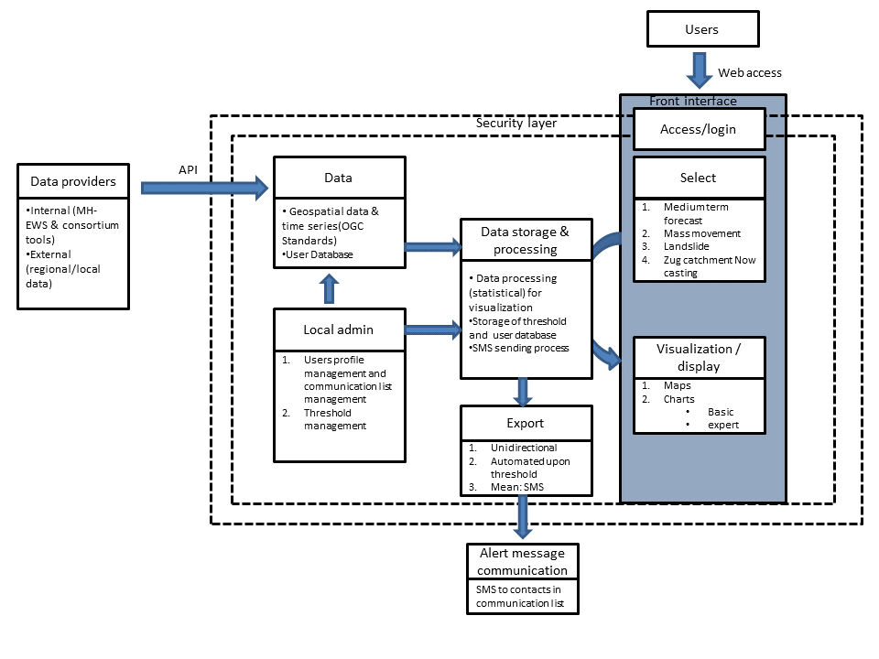
Figure 14: Functional specification of A4Alps (A4DEMOS prototype for Canton Bern pilot).
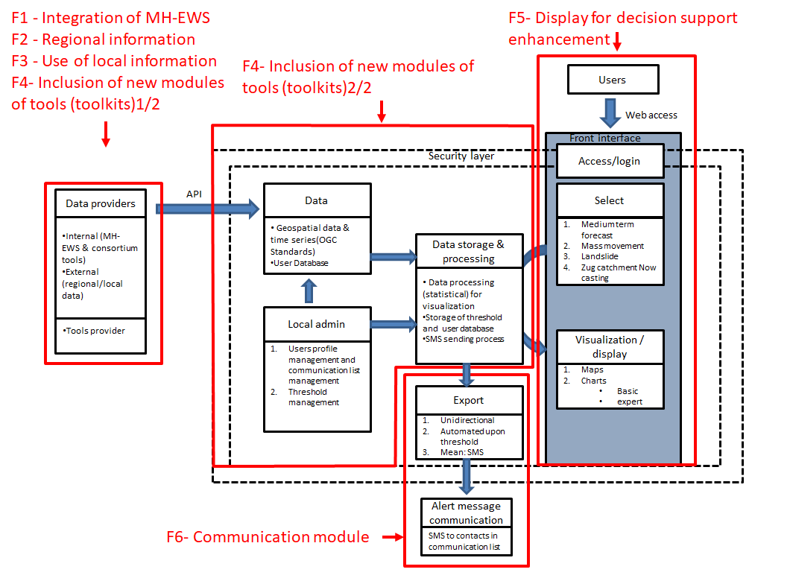
Figure 15: Functional specification of A4Alps with enhancement of A4DEMOS functions.

Rogaland (Norway) implementation site
The Rogaland region (Norway) implementation site includes two municipalities which will test A4DEMOS implementation in Norway: Stavanger and Sauda municipalities.

Rogaland (Norway) Use-cases summary

Table 14: List and classification of actors for the Rogaland implementation site.
Actors
General | Detailed listing
Information/data provider | MH-EWS
Information/data provider | Halo: Weather services from Norwegian Meteorological Institute
Information/data provider | NVE: Norwegian water resources and energy directorate
Information/data provider | Varsom.no: for the identification of the risk level for flood, snow melting and avalanches
Information/data provider | Yr.no: weather forecast website
Information/data provider | Kartverket.no: Norwegian Mapping Authority
Information/data provider | Senorge.no : webservice
User | Municipality crisis response team (Stavanger and Sauda)
 | Road Authorities
 | Hydro electric power station operator

Stavanger and Sauda (Norway) cities expressed as a main need, to have the possibility to use the ANYWHERE MH-EWS products, combined with local information regarding weather forecasts and measurements (gauging, traffic conditions, etc.). Moreover, will to inclusion of the specific tool "risk based decision support tool" outcomes in their prototype has been expressed.
For this A4DEMOS implementation site, it is wanted to achieve:
(1) To combine these sources of information to feed a risk based decision support tool (developed by SINTEF).
(2) To provide a system for visualization of forecast, measurement and risk based decision support tool outcomes, with three different types of User Interface (Map based, Chatbot and augmented reality User Interface.
(3) To communicate/export through UMS system (which send SMS) and through an existing app to public.

It has to be noted that the approach to express requirements and functional specifications of Stavanger city results from the same approach as the other pilot sites (Use-Case description in Annex 11). However, interviews were conducted here under the form of a workshop among Norwegian partners, and the outcome of this workshop is included in a report produced by HSUH (RAKOS) (Annex 11). The workshop completed information from the Use-Case description and illustrates that the Stavanger city has the same needs as Sauda city in Norway. Thus, requirements and specifications of Stavanger city can be transposed to Sauda city and deployment of A4DEMOS for Sauda will be a practical test of its capacity to be implemented in new places.

Rogaland (Norway) requirements generalization
Table 15: Expression of the general requirements for Rogaland implementation site.
 | Requirements
R-1 | System must be accessed upon login
R-2 | System must have several profiles configured
R-3 | System must collect and gather inputs from MH-EWS, regional and local information
R-4 | System should include in its core a risk-based decision support tool based on a decision support model (developed by SINTEF) composed of DEXi and CIM models
R-5 | System allows visualization through three types of user interfaces: Map based, Chatbot and augmented reality user interface
R-6 | System should be linked with the UMS communication currently used in Rogaland

Functional specifications

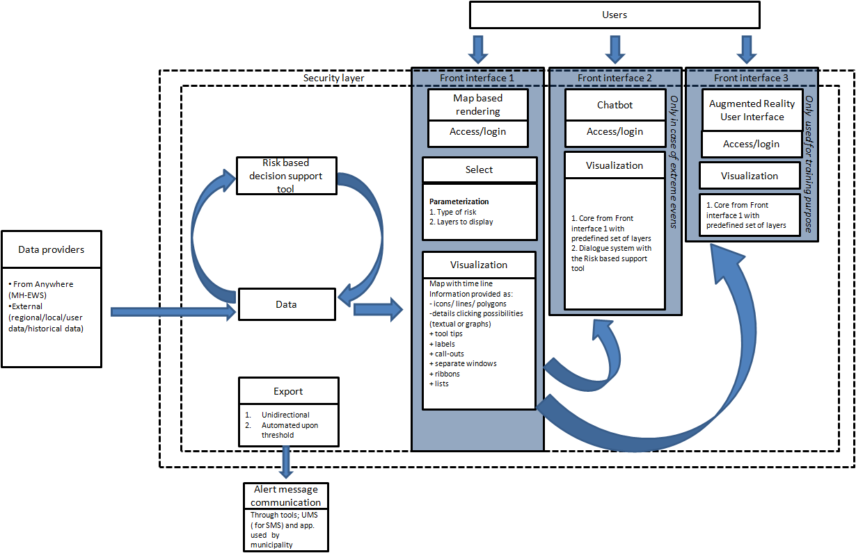
Figure 16: Functional specification of A4DEMOS prototype for Rogaland (Norway) implementation site.

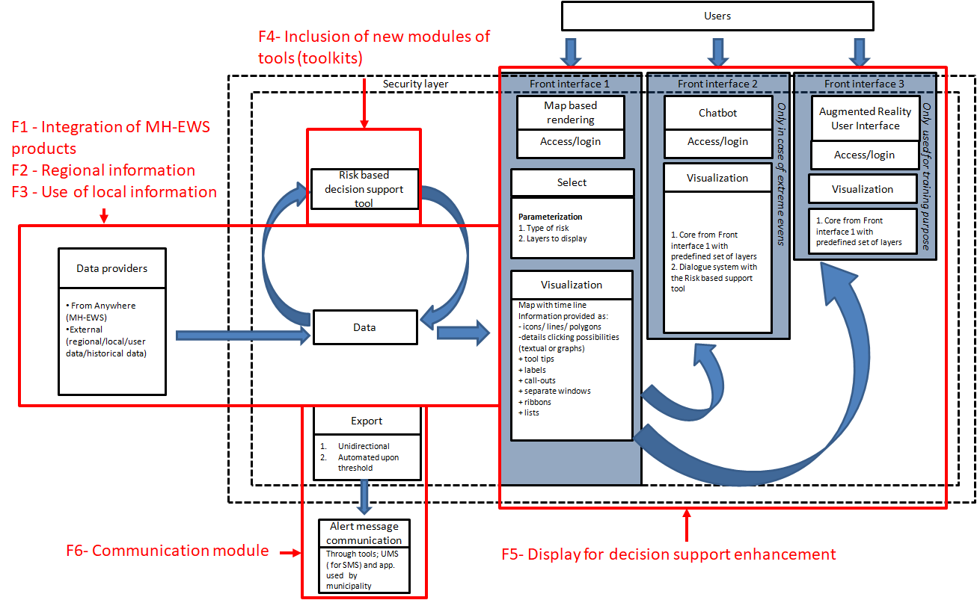
Figure 17: Functional specification of A4EU for Rogaland (Norway) with enhancement of A4DEMOS functions.

Corsica (France) implementation site

Corsica (France) Use-cases summary

Table 16: List and classification of actors for the Corsica implementation site.
Actors
General | Detailed listing
Information/data provider | MH-EWS
Information/data provider | Corsica Services
User | Administration
 | ICS
 | Operator

In Corsica, the Biguglia implementation site is prone to two major risks which are flash floods and wildfires. Moreover, floods are related here to local intense rainfall events and impacts are mainly mitigated by operation of a key infrastructure (bridge). Thus flood impact are notably related to manual barrier operation at a key bridge location.
The objectives of this implementation site is to provide to the SDIS2B users access to the MH-EWS products and local monitoring custom visualization for three different types of levels:
- ADMIN LEVEL (Implementation GIS, sensors, preparedness scenario operations & training)
- ICS LEVEL (Real time visual, operation and anticipation)
- OPERATOR LEVEL (real time operations following & coordination)
In depth studies are on-going to assess the levels of operation of the bridge. A modelling tool is currently developed locally under by SDIS2B coordination, and specific instrumentation of the catchment is ongoing. This simulation tool will be part of the A4DEMOS prototype for Corsica, receiving the data from MH-EWS and local data as inputs, and feeding the visualization part of A4EU for Corsica prototype by its outputs.

Corsica (France) requirements generalization
Table 17: Expression of the general requirements for Corsica (France) implementation site.
 | Requirements
R-1 | System must be accessed upon login
R-2 | System must have several profiles configured
R-3 | System must collect and gather inputs from MH-EWS, regional and local information
R-4 | System should include in its core a Corsica simulation and operation modeling tool
R-5 | System allows customizable Map based visualization
R-6 | System should be linked with the PREDICT services provided to municipalities

Functional specifications
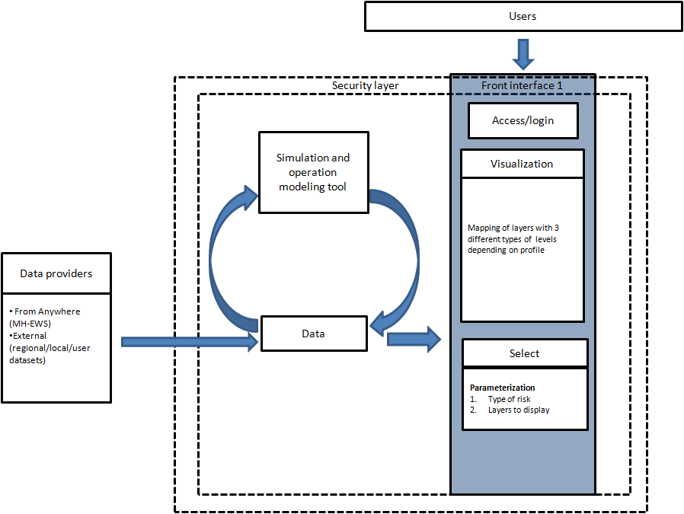
Figure 18: Functional specification of A4DEMOS prototype for Corsica (France) implementation site.
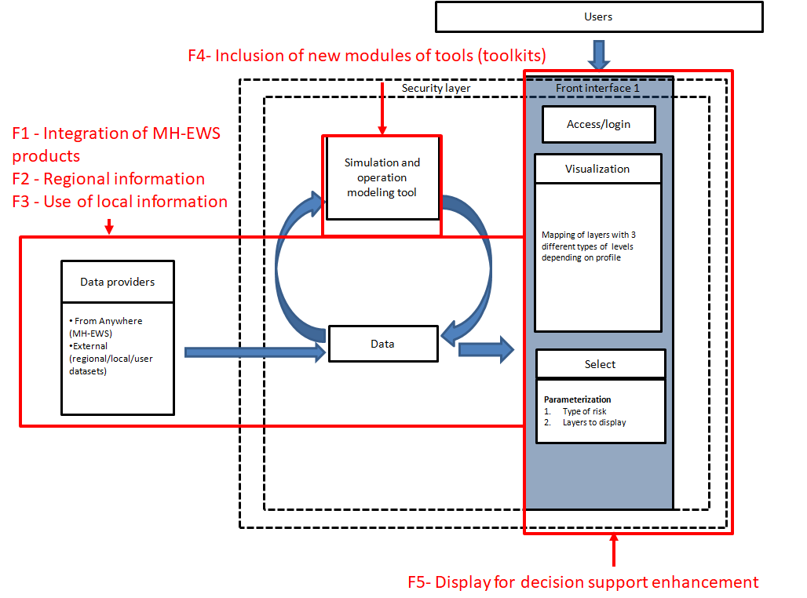
Figure 19: Functional specification of A4EU prototype for Corsica (France) with enhancement of A4DEMOS functions.

Summary of the requirements and functional specifications per pilots
This section summarizes the requirements identified in the 6 pilot sites and their parallelism with functions of the generic A4DEMOS functionalities. Thus, for each pilot a table highlights the parallelism between the pilot requirements and the A4DEMOS functions (Tables 18 to 21) respectively for Liguria, Catalonia South Savo, Canton Bern, Rogaland and Corsica implementations. This process helps to enhance the functional decomposition of the A4DEMOS generic system for each customized version.

Table 18: Liguria requirements in the context of A4DEMOS functionalities
 | Requirement | Parallelism with A4DEMOS functions
R-1 | System should be accessed by login through web service | Information integration layer: F1-F3
R-2 | System should centralize hazard and exposure information to provide impact information | Information integration layer: F1-F3
R-3 | System will allow exposure information to be updated by user | IS with analysis and ICT enhancement layer: F4-F5
R-4 | System will allow two types of approach regarding impact visualization: Impact maps and charts of impact forecast | IS with analysis and ICT enhancement layer: F4-F5
R-5 | System will allow to parameterize impact map visualization and charts of forecast | IS with analysis and ICT enhancement layer: F4-F5
R-6 | System will allow to parameterize the variable of the charts | IS with analysis and ICT enhancement layer: F4-F5

Table 19: Catalonia pilot requirements in the context of A4DEMOS functionalities
 | Requirement | Parallelism with A4DEMOS Functions
R-1 | System will be a service accessed and secured through login on SICECAT2 | Information integration layer: F1-F3
R-2 | System will centralize visualization of data from several sources (private/public/owned), and allow their mapping | Information integration layer: F1-F3
R-3 | System will allow update of the mapped information with a refreshment compatible and adapted to the different data sources | IS with analysis and ICT enhancement layer: F5
R-4 | System will provide an interface allowing visualization of information adjustment to the scale (spatial and temporal) of hazards information (forecasting, now casting & measurement), to operational requirements and to data properties facilitating user analysis | IS with analysis and ICT enhancement layer: F5
R-5 | System will provide impact products for the different hazards based on vulnerability and hazard data combination | IS with analysis and ICT enhancement layer: F4 & F5

Table 20: South Savo pilot requirements in the context of A4DEMOS functionalities
 | Requirement | Parallelism with A4DEMOS functions
R-1 | System must be accessed upon login | Information integration layer: F1 & F2
R-2 | System should centralize the MH-EWS products and the LUOVA Bulletin which has to arrive in a standardized format | Information integration layer: F1 & F2
R-3 | System will allow ISTIKE process to automatically perform its analysis on the LUOVA bulletin | IS with analysis and ICT enhancement layer:  F4 & F6
R-4 | System should allow ISTIKE to parameterize their process | IS with analysis and ICT enhancement layer:  F4 & F6
R-5 | System will securely and automatically forward the results of LUOVA/ISTIKE analysis to KRIVAT | IS with analysis and ICT enhancement layer:  F4 & F6

Table 21: Canton Bern pilot requirements in the context of A4DEMOS functionalities
 | Requirement | Parallelism with A4DEMOS Functions
R-1 | System must be accessed upon login | Information integration layer: F1-F3
R-2 | System must have several profiles configured (standard/expert) | Information integration layer: F1-F3
R-3 | System must have a local admin to attribute user rights and to manage diffusion list and threshold for SMS alerts | Information integration layer: F1-F3
R-4 | System must have data provided from several sources MH-EWS, Local data, new developed tools | Information integration layer: F1-F3
R-5 | System allow selection: Medium term forecast/Mass movement/ Landslide/Zug catchment Now casting | IS with analysis and ICT enhancement layer: F4 & F5
R-6 | System allows visualization of maps and charts which can be clickable | IS with analysis and ICT enhancement layer: F4 & F5
R-7 | System should send alert through SMS | IS with analysis and ICT enhancement layer: F6

Table 22: Rogaland pilot requirements in the context of A4DEMOS functionalities
 | Requirement | Parallelism with A4DEMOS Functions
R-1 | System must be accessed upon login | Information integration layer: F1-F3
R-2 | System must have several profiles configured (standard/expert) | Information integration layer: F1-F3
R-3 | System must collect and gather inputs from MH-EWS, regional and local information | Information integration layer: F1-F3
R-4 | System should include in its core a risk-based decision support tool based on a decision support model (developed by SINTEF) composed of DEXi and CIM models | IS with analysis and ICT enhancement layer: F4 & F5
R-5 | System allows visualization through three types of user interfaces: Map based, Chatbot and augmented reality user interface | IS with analysis and ICT enhancement layer: F4 & F5
R-6 | System should be linked with the UMS communication currently used by Rogaland | IS with analysis and ICT enhancement layer: F6

Table 22: Corsica pilot requirements in the context of A4DEMOS functionalities
 | Requirement | Parallelism with A4DEMOS Functions
R-1 | System must be accessed upon login | Information integration layer: F1-F3
R-2 | System must have several profiles configured (standard/expert) | Information integration layer: F1-F3
R-3 | System must collect and gather inputs from MH-EWS, regional and local information | Information integration layer: F1-F3
R-4 | System should include in its core a Corsica simulation and operation modeling tool | IS with analysis and ICT enhancement layer: F4 & F5
R-5 | System allows customizable Map based visualization | IS with analysis and ICT enhancement layer: F4 & F5
R-6 | System should be linked with the PREDICT services provided to municipalities | IS with analysis and ICT enhancement layer: F6

A4DEMOS Crowdsourcing and communication component
The main objective of the A4DEMOS Crowdsourcing (Crowd) and Social Media (SM) component is to provide additional information channel to collect and disseminate information in different stages of the disaster management cycle.
Following the initial state of the art analysis, interviews with different stakeholders and analysis of the existing emergency plans in the pilot sites, KAJO has defined the initial functionalities and basic use cases. These functionalities are explained in this section to give better idea of the proposed solution. A schematic view of Crowd and SM solution is introduced in Figure 21.
Main functional modules are:
- Administration component
- Crowdsourcing component
- Social media component
- Federating and processing component
- Dissemination component
Each of these modules are detailed in next subsections. Figure 22 summarizes the flow of SM& Crowd application. Full details on SM& Crowd sourcing Use-cases and HMI are provided in Annex12.
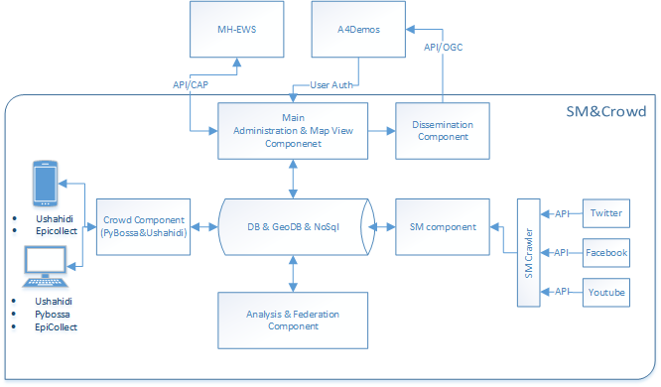
Figure 20: Schematic view of the SM & Crowd component.

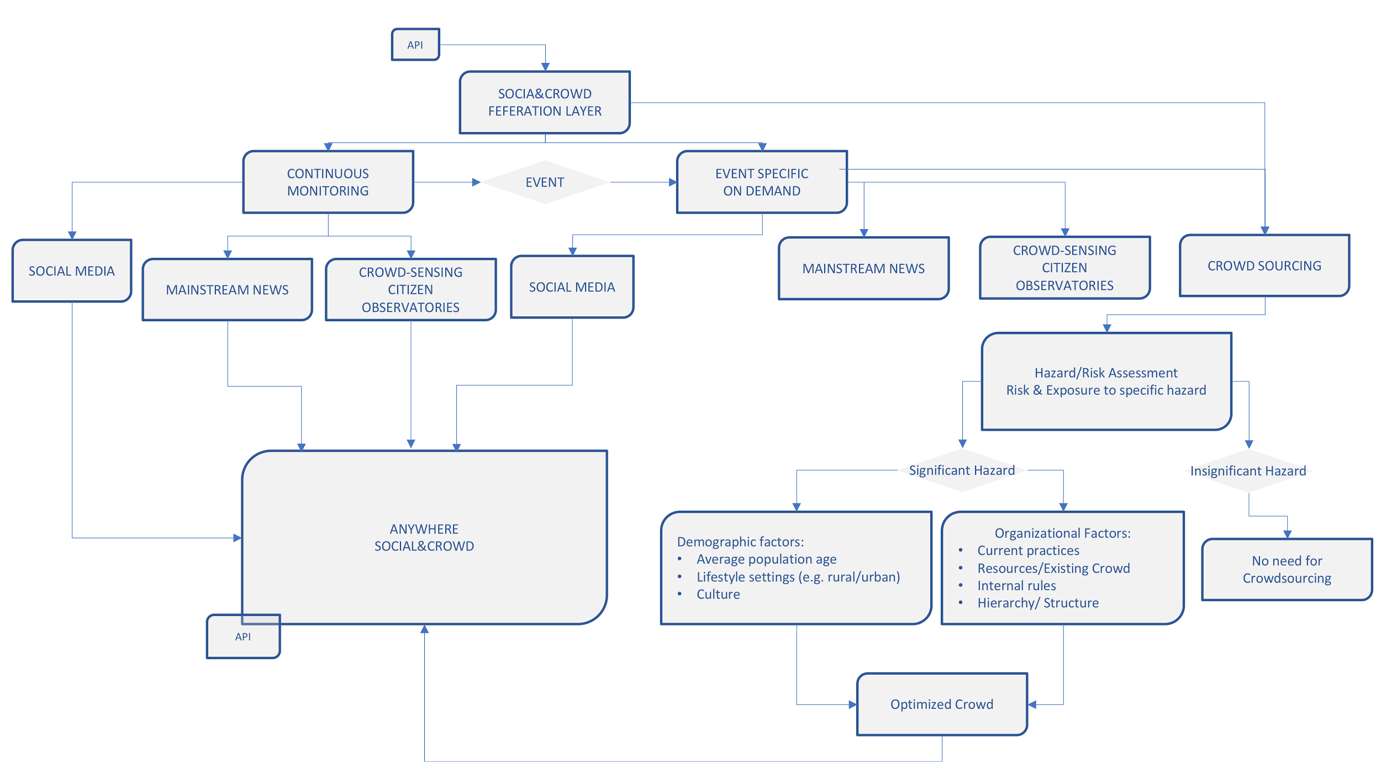
Figure 21: Following table summarizes the general flow of the SM & Crowd application.

Title / Overview: SM&CROWD

The objective of the social media and crowdsourcing tool (SM&Crowd) is to provide users improved situational awareness information, better (targeted) VGI data acquisition for hazard and risk modelling and impact assessment; and additional source of information for automated decision support system (e.g. plausibility check).

Use Case Description: (Context / Actors / Conditions / Task or Steps Decomposition / Alternate Steps)

1. User/Organization/Data/Dissemination management
2. Continuous streaming of SM
3. On-demand SM streaming (user, EWS triggered)
4. Automated crowdsourcing campaigns
5. User triggered crowdsourcing (institutionalized/moderated)

User can subscribe to hazard/risk forecasting systems (MH-EWS) and use the forecasted events stream (CAP) as a trigger of Social Media & Crowdsourcing campaigns, as well as dissemination of the warning/awareness/advice information using social media.
1, once event is identified by the forecasting system, dedicated Twitter streaming is launched and relevant tweets are collected. Tweets are passing automated classification algorithm, geo-location, and enrichment and are stored in the database. Tweets are aggregated in regular time intervals into final products (maps, lists, etc) which are disseminated according to defined dissemination rules (either explored within the A4DEMOS or dedicated OGC web-service (WMS, WFS, CAP)).
2, Similar to case 1, but the initial triggering comes from the user. Social media streaming is triggered either with specific set keywords to be monitored on Twitter or geographic bound box.
3, Crowdsourcing campaigns are created based on the automated trigger from hazard/risk forecasting systems (MH-EWS). Campaign is initialized from the preconfigured template and completed with information automatically derived from the forecasts. Crowdsourcing is distributed with user defined restrictions (restricted_to/public). The result of crowdsourcing can be explored via A4DEMOS as density maps of the responses (heatmaps) or single response with basic metadata (WFS, GeoJSON).
4, Similar to case 3, but the Crowdsourcing campaign is triggered and configured manually.

HMI (Human Machine Interface) requirements or needs:
Main web based administration interface (user authentication is inherited from the A4DEMOS, each user can add organizations involved in crises management or any other contact point relevant in information flow). Each user can customize their map view by adding OGC services (MH-EWS catalogue is loaded by default) and setting priority and overlays of different layers. Each user can subscribe to CAP alerts from MH-EWS or any other provider. CAPs could be configured as triggering mechanism for SM and Crowd components.

Crowd component has dedicated web interface where authorized user can create, execute and monitor crowdsourcing tasks. The main interface is based on widely used open-source project PyBossa. Pybossa was selected because huge number of users (existing crowds), tools provided are well known, respected and interoperable.
The second crowdsourcing interface for certain specific tasks which will be deployed is USHAHIDI. USHAHIDI will be used as the visualization front end for crowd sourcing campaigns as well as front end visualization of social media products.
There will be 2 mobile applications made available for crowdsourcing. Both apps are market leading open source products with huge user community. All campaigns created via Crowd web interface or launched automatically are instantly available via mobile apps.

SM component will have dedicated web interface where authorized user can create, execute and monitor crowdsourcing tasks. SM interface should contain dashboard to visualize the basic statistics from social media. Classified information amount over time, main users, keywords, hashtags, most frequently shared content, etc. Interface should allow to dig in the hierarchically organized information going from highly aggregated data to single messages/user/hashtag/geo-location.

Dissemination is done through standardized API interface as much as possible compliant with OGC standards.

Process and rules: (any specific requirements linked with domain: weather/emergency/etc.)

The tool is configurable based on the parameters reflecting actual operational procedures in different Pilot sites, but not limited to it. Our proposal is to use CAP alerts from MH-EWS where parameters like time of event, likelihood, severity, etc. well reflect all information used currently in the decision making or are defined in operational procedures during crisis management.

Most of the services are/will be deployed on KAJO’s infrastructure, stressing the need for scalability and load balancing of the solution.
Twitter API has restriction on the total traffic per user. KAJO is proposing and evaluating different approaches to overcome this limitation e.g. each user the SM has to provide for Twitter API credentials (free of charge).
Performances: (any requirements regarding performances or time constraints)
SM&Crowd is running as external service. Data layers for visualization are made available in regular intervals or on request as OGC compliant web-services. Visualization should be done respecting good user experience, within the ranges set for the other data layers.

Architecture and standards: (any software architecture requirements or standards to apply)
SM&Crowd will run as external service. Architecture based on load balanced Docker containers. Data services should be OGC compliant when possible.

Technologies: (any information regarding technologies to use or hardware or IT)
Python, Postgres, Apache Kafka, Apache Casandra, Mapserver, Geoserver, geo-catalog, Pybossa, Ushahidi, EpiCollect

I/O data and data format: (any information regarding inputs/outputs and data formats)
OGC compliant web services. SM&Crowd expects CAP alert from MH-EWS, all data created within are exposed as OGC web-services or JSON.

Administration Component
Administration component is designed to facilitate the user management, data management and should provide a way to define the information distribution list and criteria for triggering actions. This component contains the web frontend interface with mapping component, geo-database to provide access to any OGC compliant data service (all MH-EWS products, any other local data), mapping component can provide basic mapping functionalities, visualization geographic layers (e.g. MH-EWS products together with local data), layers manipulation (on/off, up/down). Administration component should load the MH-EWS products inventory and make them available in mapping interface. It should also inherit the user authentication (or at least get access to user database from A4DEMOS via API).
Administration component:
- User, organization management (users, offices, geo-coverage, access rights, responsibilities)
- Data management (data access points and interoperability, access rights, visualization styles)
- Request management (trading system, information flows, decision criteria, request matching and tracking)

Crowdsourcing component
Crowdsourcing component should allow users to submit different tasks to high number of workers. There tasks may vary in nature and complexity and also in the time available to complete them. Component should allow easy configuration, execution and monitoring of the task, as well as maximize the engagement of the different crowds and should provide straight-forward deployment of the completed tasks into practical application as well. The Crowd component should allow easy configuration of the new tasks based on predefined templates. Templates are designed in close collaboration with the pilot sites and should allow easy transferability to different places (e.g. task template to classify Tweets developed in one pilot can be readily used anywhere else). Novel approach for time-restricted, RUSH mode crowdsourcing campaigns is utilizing the availability of the early warning information from MH-EWS. The Crowd module will be subscribed to MH-EWS to collect latest EWS from user defined area in form of CAP (Common Alerting Protocol) and based on user defined settings of CAP standardized parameters (likelihood, severity, time of the event) will automatically pre-generate the available crowdsourcing tasks (templates). Then authorized user can set the target audience and access restrictions and publish the task. Results of the task are stored and disseminated as much as possible in OGC compliant format (e.g. HDX) to maximize the interoperability (e.g. direct streaming of the data to crisis rooms, or easy exchange with other crowdsourcing initiatives – e.g. VOST Europe, Standby Task Force).
Definition of the target audience is another innovation being proposed. Crowd component should benefit from a user defined hierarchical organizational structure (Administration module) which should reflect the official information distribution lists defined in disaster management plans. Each user can define such organizational hierarchy with all organizations and stakeholders involved, including spatial coverage of their responsibility (e.g. fire brigades responsible for different district) and each crowdsourcing campaign will have such distribution list defined. System will automatically disseminate the crowdsourcing task to all contact in the list respecting also their geographical responsibility (including user defined buffer). This way each authorized user has full control who can access or contribute to the crowdsourcing task.
Based on the phase of disaster:
- Rush mode (preparedness, response) – time to execute and complete the task is very restricted
- Non-Rush mode (preparedness, recovery, prevention) – typically continuous monitoring, or longer lasting campaigns
Type of information:
- Collect new information – system should allow easy way of collecting new information in form of easy questionnaires (e.g. do you see flood, do you see smoke, do you see electricity interruption), posting geo-referenced image and video content ()
- Validate existing information – system should allow easy way sharing small tasks of different complexity. Typically, these tasks are:
Classification of text/image/video content (e.g. does this Tweet mention flood?; Do you see flooded building on these image? Which grids cells on the image are burned?)
Translation of text (e.g. from official to local dialect or slang)
Geo-reference text/image/video content (Is this picture taken in Genova? Does this Tweet mention Interlaken?)

Social media component
Social media component is designed to collect information which is spontaneously being shared on the social networks. It was decided that the main focus will be on the Twitter, with the possibility to expand the solution to other main social networks (e.g. Facebook, Flickr, YouTube). Social media component should allow collections to run in two modes. The background collector is collecting information continuously based on predefined (user specific) set of keywords. The other mode of collection is running on-demand and is event-specific. In the event specific collection we rely on the early information about upcoming event from MH-EWS. Whenever MH-EWS detects a potential event (exceedance of critical severity & likelihood) system will collect necessary information available and trigger the on-demand collection. Novelty in this approach is that some additional keywords and geographic constraints for a specific forecasted event will be used to refine the search criteria for social media content. System should provide possibility to combine the strengths of both social media and crowdsourcing components and allow pushing social media content for further analysis via crowdsourcing component. Typical tasks foreseen are geo-tagging, text/image classification, content translation.
Types of social media tasks proposed:
- Background – running continuously with generic keywords. Anomalies in the signal are used to detect potential events
- On-demand –executed for a specific event:
EWS triggered – task is automatically configured and executed based on CAP message from MH-EWS
User triggered – authorized user can manually define and trigger a task via web interface

Federation and processing component
Federation and processing component is taking care of the internal process management, persistent data flows, campaigns versioning (e.g. user, event, language) and scalability. Processing module contains all algorithms used to data processing. This includes data more advanced content filtering and analysis, automated classification, geo-referencing, aggregation (e.g. time/space aggregation of hazard signal from social media) or data fusion with other data (e.g. validation of the forecasted hazard against signal derived from social media). Newly produces information is stored in the internal geo-database and/or no-sql database and exposed to other services (A4DEMOS or external) via standardized data services (mostly OGC).
Dissemination component serves the outgoing communication to any external users. This module should allow user to disseminate to predefined target audience either warnings itself or any self-protection advisory content (WP5). This component IS NOT the main dissemination tool. It should utilize the existing networks (identified from social media or existing crowds) to provide targeted information from Anywhere tools.

Social Media & Crowd component implementation
In the following section we summarize the tentative development and implementation plan for the Social Media & Crowd component. Due to complexity of the tasks and overall A4DEMOS system, it was decided to start developing single components as functional prototypes which could be tested and independently. These will be developed into fully functional stage, configured for selected pilots and opened to end users for testing. This early stage testing will allow close collaboration with the end users to identify the limitations and problems in proposed architecture and tune the overall user experience. It is also important to mention that this approach will eliminate delays in development due to delays in consecutive tasks.
The generic tools of the Social (text & language processing) will be developed not per pilot site, but for different language variations (English, Spanish, Italian, French). In the later stage we envisage the implementation of the on-demand (event based) collectors per pilot site. Following pilots were selected mostly because of the high maturity of the modelling tools and EWS (EFAS for A4DEMOS, A4Lig, A4Cat). The Crowd component will also be available and tested in A4EU for Rogaland. Figure 23 summarizes the planned timing of different task.

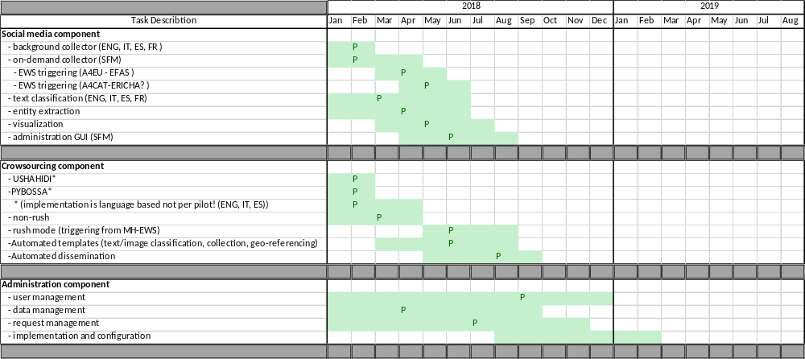
Figure 22: Indicative development and implementation planning (P=functional prototype).

Optional extra tools specifications
A number of optional extra tools for A4DEMOS are foreseen in WP4.They are decision support tools and they are presented in this section. They will be tested in different pilot sites of interest. They will be a part of A4DEMOS as tools which can potentially be deployed and applied on any pilot site upon request.

Operational resilience assessment tool (UNS)
Operational resilience assessment tool will be tested on A4Lig. Background of the tool is presented as follow.
Occurrence of high impact climatic events in complex environments such as urban systems requires, for users and decision makers an understanding and a synthesis of the flow of information which is available for them. Decision support tools exists but uses of tool specifically devoted to operational resilience assessment before, during and after a crisis using latest innovative methodology is lacking for practitioners (practitioners being here: crisis first responders, managers and decision makers).
Resilience as a new concept, is getting introduced and its application appearing in different sectors. On one hand, overall resilience is very difficult to define. On the other hand, specified resilience concept clearly defined and suitable for a more direct application. Specified resilience is defined as the resilience of what (e.g. flood, drought, etc.; in our case high impact climatic event), to what, and up to what level. For practical applications of resilience such as for ANYWHERE context, it is decided to focus on specified resilience concept.
Thus, Operational Resilience concept, is classified as a specific resilience type which applies for high climatic events on urban system at multilevel. Operational resilience gathers a set of different data and applies a methodology, which was first developed specifically for flood Through Flood Resilience Index (Batica and Gourbesville, 2016). Operational resilience allows entities such as people and operational systems, to adapt to changing patterns. This concept applies directly to networks, organizations, supply chains, critical infrastructure and even to the population. Operational resilience takes into consideration planning, integrating, executing and governing that will ensure that entity will:
- identify and mitigate operational risks - eliminating disruptions before they occur;
- prepare for responding to events - respond is controlled (prepared in advance);
- recover and restore - have an acceptable time frame.
Assessment of this concept is already applied to different frameworks considering only flood hazard. Setting the scene for operational resilience toward multi hazard aspects brings new lights within the existing framework. For anywhere the tool/method performs a mapping of an Operational Resilience Index (ORI) that is providing operational resilience level of an entity. The methodology is summarized in the Use-case presented below.

Title / Overview: (title + short introduction about purpose of the Use-case)

Operational resilience assessment tool
Application developed for evaluation of ORI is web-based and analyse the urban area with existing elements and networks. The area is mapped to its components and networks (fluxes). In addition, the dependencies between different components and networks are defined and included within the methodology. The tool provides analysis of a complex urban system taking into account all its components, connections and dependencies within the defined framework. The ORI for the concerned High impact weather event is calculated at micro- (building) or meso- ( district) scale and mapped over A4DEMOS system prototypes which includes F4 (Inclusion of new modules of tools and F5 (Display for decision support enhancement).

Use-case Description: (Context / Actors / Conditions / Task or Steps Decomposition / Alternate Steps)

Context:
To contextualise the methodology, the figure below presents the operational resilience assessment for different systems. It is applicable to urban systems since it is taking into account all physical system components that are recognized within operations presented in the framework. There are four different stages of the framework presented:
1) System analysis - the urban system with all his physical components is mapped and scaled to its attributes.
2) Characterisation of system disruption - definition of risk, risk assessment, setting the scenarios for analysis and with respect to event, integrates different scales for analysis and defines disaster parameters.
3) Operational resilience assessment - evaluation of Operational Resilience Index for all defined scenarios.
4) Decision-making stage - based on evaluated ORI.
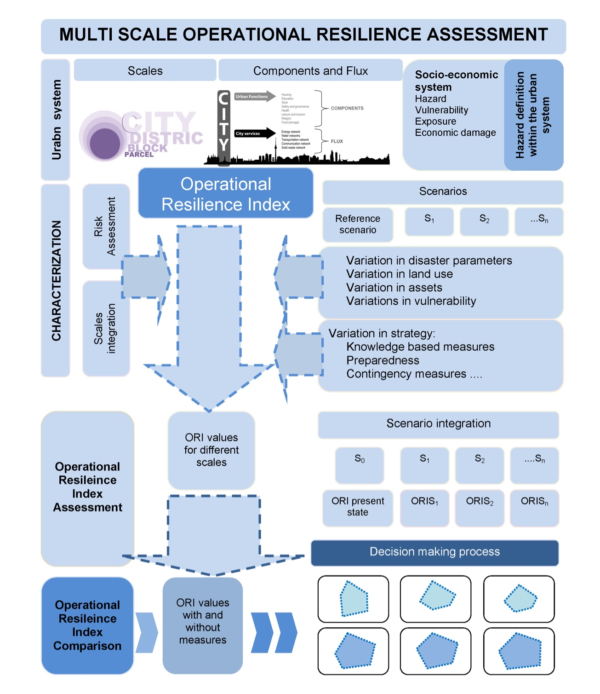

(1)

(2)

(3)

(4)

Actors:
User (crisis manager)
Conditions:
1) The user has to receive a short training before the use of the tool.
2)The vector dataset to be uploaded by User and used by the Operational Resilience Assessment tool follow the OGC standard, but a short formatting of the data by the user is necessary for the data to comply with the methodological framework

Step by step decomposition:
User will: 1) load initial GIS information (function and services layers; 2) Load event information hazard map 3) receive an initial ORI results map as polygon layer 4) has the possibility update ORI computation either by (i) reloading updated information from 1 and 2 or by Hovering on the result file and locally changing values for recompilation of ORI.

HMI (Human Machine Interface) requirements or needs:

A4DEMOS client should allow to display through A4DEMOS F4 and F5.
There are five parts (sketch below) in the visualization page which should be associated to F5.
(1) Part 1 is the menu of the operation buttons which are loading initial ORI button: loading Function, service and events map button, loading updated ORI button, removing map button and change value button.
(2) Part 2 is the zoom button. Users can adjust the resolution of the map by clicking it. Besides, User also can scroll the mouse middle button to zoom in/out the map.
(3) Part 3 is the main map which gets from the Open Street Map.
(4) Part 4 is the output ORI information box. After loading the ORI information, users can explorer the Polygons ( building or district’s information) by hovering on it.
(5) Part 5 is the legend of the map which denotes different building ORI values by different colors.
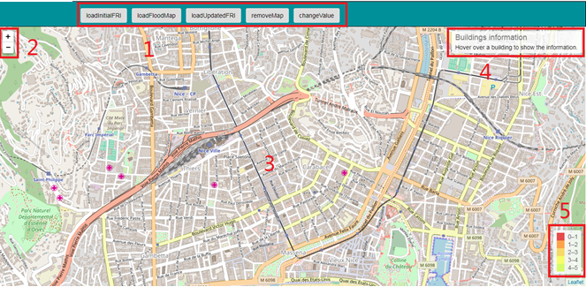

Process and rules: (any specific requirements linked with domain: weather/emergency/etc.)
No
Performances: (any requirements regarding performances or time constraints)
No constraints regarding performance or computation time constraint.

Architecture and standards: (any software architecture requirements or standards to apply)
Tool was developed using java framework, accessibly as web service and hosted on UNS server.

Technologies: (any information regarding technologies to use or hardware or IT)
Data are uploaded by user on the A4DEMOS customized system though interface.
A4DEMOS system will communicate with UNS server. RESTful API to implement the communication between client and server is considered. The communication message format is JavaScript Object Notation (JSON).

I/O data and data format: (any information regarding inputs/outputs and data formats)
Input data are OGC standards vector information. Inputs should be provided by the user. They encompass urban function data and hazard data.
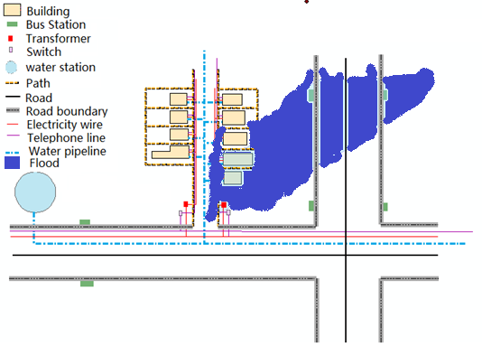
Sketch example of visualized vectorial information used for the urban function and a flood map to upload for the ORI computation

Output data are OGC standards vectorial informations (polygon) they will be displayed on the A4DEMOS customised prototype or can be loaded on any GIS system or WMS/WFS.
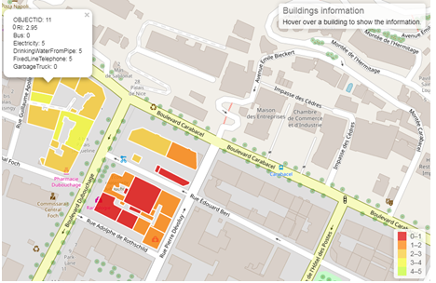
Mock up illustration of ORI and output visualisation at mapped at building scale.

DTS for logistic (RINA)
DTS tool (Decision support capabilities for crisis and emergency operations) will be tested in Catalonia and Liguria pilot sites.
Title / Overview: Decision support capabilities for crisis and emergency operations

The objective of this Use-case is the support of the user in the control room to carrying out the most relevant actions according the applicable procedures during the emergencies.

Use-case Description: (Context / Actors / Conditions / Task or Steps Decomposition / Alternate Steps)

The operator in the control room is focused in the understanding of the current situation and at the same time involved in a series of actions to activate the response of the personnel and resources available on the field. Such actions can be both based on call, automatic sending of SMS, e-mail, request of local feedback from the operator and/or sensors and coordination of the logistic movement of food and first responder team.
The user works in direct contact with different operators, each focused in its field. The availability of impact forecasting from the MH-EWS will allow the user in taking the decision with a higher effectiveness.
Graphical simplified representation of the Decision flow during the emergency management is shown in the following image. This represents the baseline for the tool that is going to be developed.
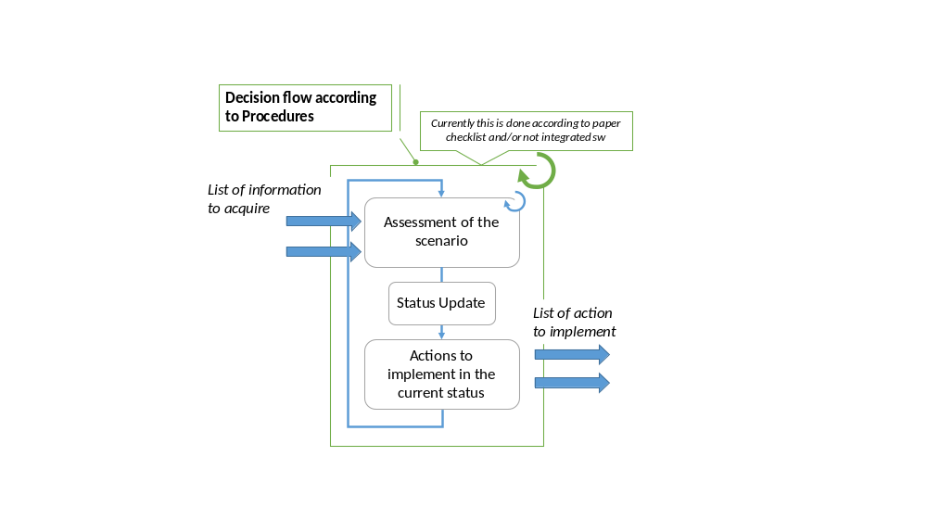
Simplified representation of the Decision flow during the emergency management

The list of actions as well as the inputs for the status assessment are based on questions that the user has to answer to assess the situation (the same that the user currently applies) by using the tools available in the control room and managed by different specialized users. In the future, it should be evaluated the possibility to extend the inputs of the software by automatic acquisition and data exchange modules. Regarding the output, in similarity with the inputs, in a first phase they will be composed of the procedure shown and suggestions, as currently implemented in the procedure. For future development, the integration with external software could be evaluated.

HMI (Human Machine Interface) requirements or needs:

The interaction should be through a web-based interface. The tool should take into consideration that the user can be subject to different procedures to be followed during the emergency management, so the tool has to be flexible and there should be the possibility to easily configure the questions and action to be done.
Process and rules: (any specific requirements linked with domain: weather/emergency/etc.)

The tool is based on the application of already defined and approved procedures. In other words, it allows the user to make an assessment and following monitoring of the situation by presenting him/her a series of questions driven by current decisional flow, and based on the answer, to propose action to be done in compliance to the emergency procedure in place.
There are several tools and checklists applied to guarantee the application of the procedures but currently they are not integrated and they are often just paper-based. The user does not have the overall visibility of the actions done/to be done so that he/she might need of reminders and/or suggestions to cover potential execution gaps. For example, if the user postpones the evaluation of a parameter and/or an action because the current situation does not allow it implementation, there is currently the risk that it will not do it later on, i.e. a reminder window would be very effective to avoid oversights. The procedures are based on the status of the current situation on the “street” and the “emergency” status according to forecast models and other inputs coming from different evaluation tools, currently in place. For this reason, the questions to be applied to the user should be based on actual status. The tool is flexible in order to guarantee the fitting with any decisional flow and emergency procedures in place (e.g. by hazard, by purpose such as logistics) at any customization degree, allowing the planning based on lessons learnt. The tool allows multi-access so it allows the collection of multiple user answers, aggregate results, management of multiple decisional flows, etc. Results, decisions/actions taken and data analytics could make them available for post analysis, training, identification of good practices, etc.
Performances: (any requirements regarding performances or time constraints)

The performance requirements in terms of response time are linked to the main objective of the tool, i.e. the response should be available in line with the decision flow during the emergency management.
Architecture and standards: (any software architecture requirements or standards to apply)

Informal talks brought to develop, at least in a first phase a new tool to be integrated in a second phase with the already existing tools (for example there is one tool that automatically send a message to a list of logistics companies to warn them about the weather forecast). The tool has to allow the user to browse the current procedures in an interactive, centralized and formalized way. No particular standards identified so far.
Technologies: (any information regarding technologies to use or hardware or IT)

Considering the requirements of the proposition of a web-based solution, there are no other specific requirements at the current status of the project. Information exchange with the user will be devoted in understanding the level of implementation and integration with potential (if any) legacy.
I/O data and data format: (any information regarding inputs/outputs and data formats)

The tool in a first phase will be used by the operator as a checklist and decision flow support in terms of question for the proper evaluation of the current scenario. The main interface (I/O data and information) will be directly with the user by simple Q/A windows of a web-page. To integrate the tool with the available data in the control room, it could be evaluated in the future the integration that could be done in terms of inputs to better and automatically asses the current operative scenario and the support the action implementation with trigger towards another emergency management system.

Risk assessment tool (SINTEF)
Risk assessment tool will be integrated in the Rogaland pilot site.
Title / Overview:
The SINTEF risk assessment tool helps actors to respond to risks faster and more accurately.
It automatically computes impact and risk assessments from various data sources such as weather forecast and sensors data using knowledge from the actors.
Use-case Description:
The Use-case takes place in Sauda, a municipality in Norway. The local crisis response team, the road authorities, and the owners of the Sauda hydro-electric power station must take the following decisions:
- If and when to close roads
- When and where to evacuate, if the dam breaks
- When and where to evacuate, if large amounts of precipitation occur during a short period of time
- When to regulate the amount of water in the river by adjusting the dam water level
- When and how to evacuate in case of a large forest fire
The most common and relevant incidents related to extreme weather in the Sauda municipality are:
- Flooding in the city center caused by large amounts of precipitation during a short period of time
- Closed main road due to a too strong waterfall next to the main road
- Availability of ambulances when roads are closed
- Outage of electrical supply
- Falling rocks
- Closed roads due to avalanches
- Slippery roads

HMI (Human Machine Interface) requirements or needs:
The HMI must provide a map view of the situation, with classic features such as icons, lines, polygons, tool-tips, and labels. The situation in the HMI should be updated automatically whenever the risk levels change. The HMI should remember the last known state by the system in case of network connectivity issues. It should inform the user that the state may not be relevant anymore if the last known state is too old.
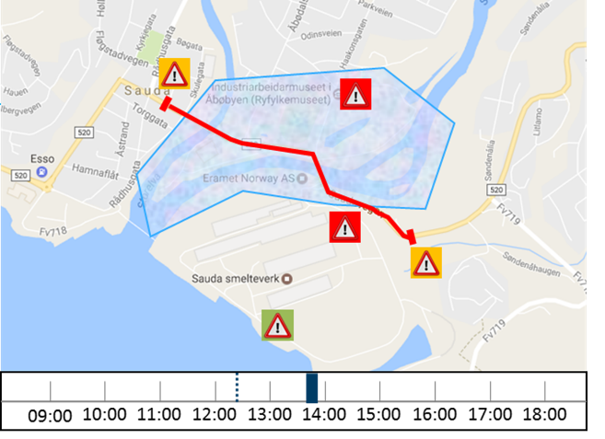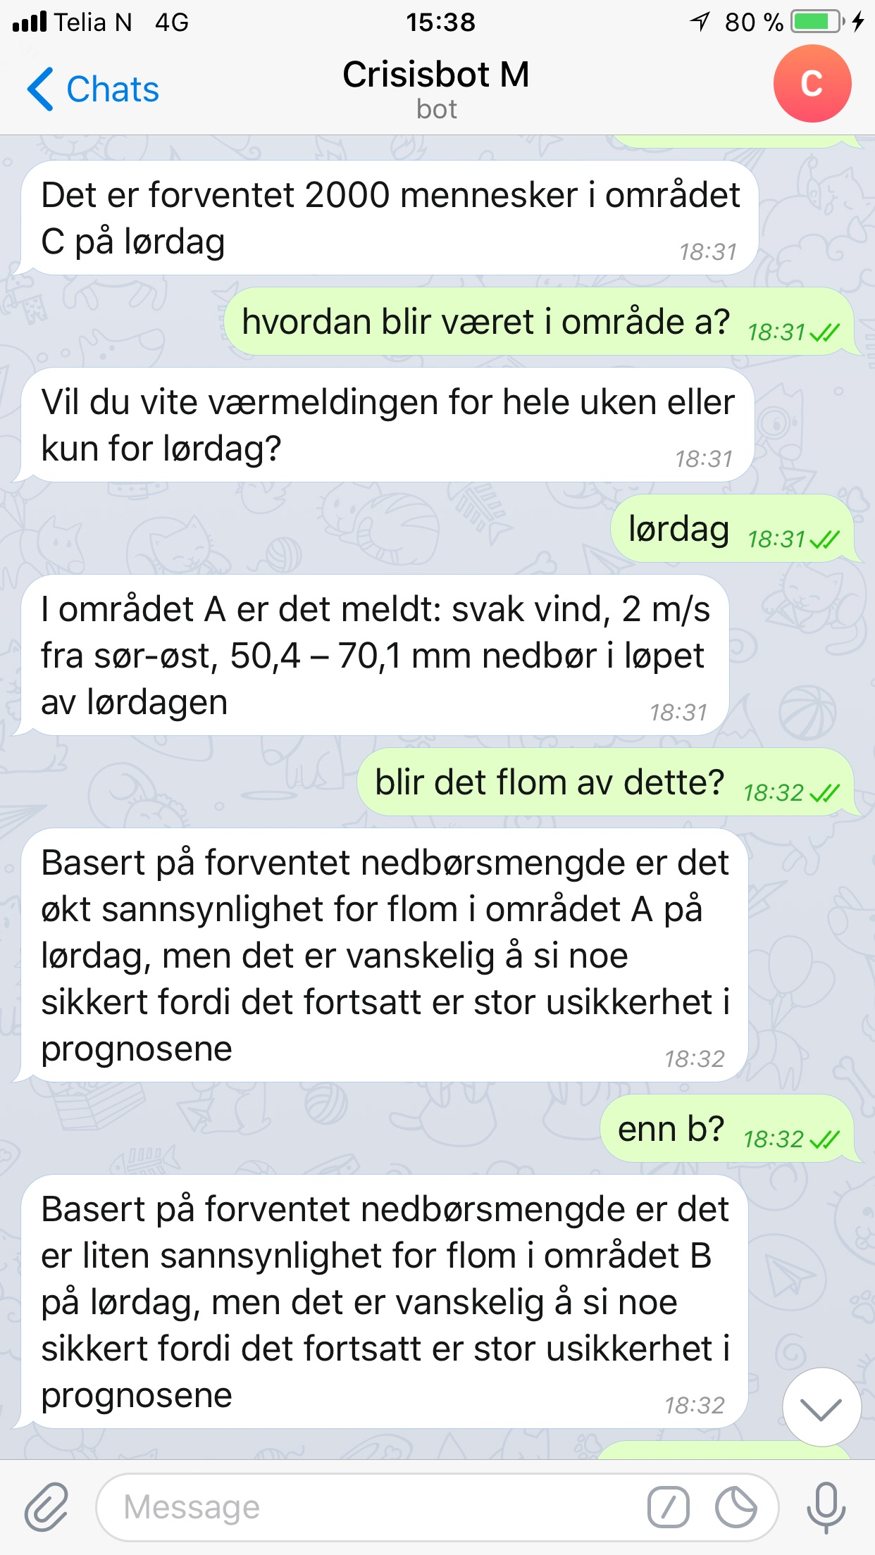
Mockups of the map view and of the chatbot.
A chatbot must be provided, allowing dialogs between actors and the risk assessment tool. The chatbot should emit warnings directly to the actors’ phones, but also to provide more information if needed. The actors may question the chatbot to understand a situation, a risk level, or a risk assessment. The chatbot may also ask actors about the current situation if an important sensor failed.
To test and build the risks assessment, the risk assessment tool should also provide a simple tool that could be used with all users without requiring them knowledge in information technology. Tangible hardwire HMI equipment may be needed.The risk assessment tool should have a strong focus on usability and simplicity.
Process and rules:
-

Performances:
Risks must be immediately assessed whenever new information is known by the system. Data processing, risk assessments computations, and network replications may take a few seconds. In worst cases, a delay up to one minute is tolerated by the users.
This risk assessment tool must operate in remote areas where high-bandwidth and low latency network connectivity are not necessarily available. Input data could be processed by system components in a cloud before being sent to the other components in the remote area, yet the system should continue to operate in a degraded mode if the connection between the cloud and the remote area is not available.
The HMI should support mobile and desktop devices with common technical specifications, such as recent tablets or desktops with graphical unit processing and up-to-date operating systems.
Architecture and standards:
The risk assessment tool must be resilient, as it is mainly used when unexpected events occur. It should always operate, possibly in a degraded mode.
It should be fault tolerant by design, using processing nodes physically located in different places. It should support the loss of network connectivity or electrical power gracefully.
Data sources may become unavailable and the risk assessment tool should operate on a best effort basis whenever this happens.
Technologies:
The risk assessment tool backend should be operated on common consumer grade hardware for computing, such as low-end ARM and x86-64 computers with TCP/IP Internet connectivity. It may be also available in various cloud providers such as Scaleway or OVH. The strategy for resilience is to have many small cheap nodes, instead of having a few large nodes.
The risk assessment tool backend components should run in software containers, such as Docker containers on GNU/Linux. These containers should be available for the x86-64 and ARMv7 architectures. The computation of risk levels may use DEXi, a tool for multi-attribute decision making. It may also use machine learning with multi layers neural networks using Tensorflow or similar frameworks. Data adapters, to process input data into the risk models, may use any kind of technologies required for processing a given input data. Node-RED is, however, the preferred framework to orchestrate the data workflows.
On the frontend side, a responsive web application supporting mobile and desktops devices must be provided. It should use HTML, CSS, Javascript, and WebSocket web technologies.
The chatbot should support communication through various channels and may rely on SMS using a GSM model when Internet connectivity is lost.
I/O data and data format:
The risk assessment tool should support integration with any kind of input data, with respect to the local constraints. Users will be provided a tool to develop, test, and deploy data adapters. SINTEF will provide data adapters for the Sauda Use-case. Data may be pushed to the risk assessment tool, through message brokers supporting the MQTT protocol. Alternatively, the risk assessment tool may pull data from various sources periodically. The risk assessment tool may push its analyzes to other systems, such as the CIM tool or other applications and systems. A GeoJSON output stream may be provided.
To facilitate data integration, common data formats such as JSON, XML, or CSV are preferred. MQTT and HTTPS REST are the preferred protocols to access and publish data.

References
Batica, J., & Gourbesville, P. (2016). Resilience in Flood Risk Management–A New Communication Tool. Procedia Engineering, 154, 811-817.
Müller et al., 2017: Report on needs and requirements from the users, including advises on how to address ethical, legal and environmental issues. ANYWHERE Internal Report, Leipzig, Germany.

Sancho et al. 2017: Design of the MH-EWS platform including products, services,
interfaces and tests. ANYWHERE Internal Report, Barcelona, Spain.

Scholle et al. 2017: Supporting innovation for self-preparedness and self-protection: Good practices, approaches, guidelines and constraints. ANYWHERE Deliverable D5.1, Paderborn, Germany.

Smith et al. 2017: Modules/tools requirements to be integrated into the MH-EWS.
ANYWHERE Internal Report, Reading, United Kingdom.

Annexes

Annex 1. Use-case description template provided to Pilot site Users

Title / Overview: (title + short introduction about purpose of the Use-case)

Use-case Description: (Context / Actors / Conditions / Task or Steps Decomposition / Alternate Steps)

HMI (Human Machine Interface) requirements or needs:

Process and rules: (any specific requirements linked with domain: weather/emergency/etc.)

Performances: (any requirements regarding performances or time constraints)

Architecture and standards: (any software architecture requirements or standards to apply)

Technologies: (any information regarding technologies to use or hardware or IT)

I/O data and data format: (any information regarding inputs/outputs and data formats)

Annex 2. Genoa UC-01.
Use-case | UC.ANY.070 – View Impact Forecast
Primary Actor | Operator
Goal in context
Preconditions
Trigger
Scenario | - The user selects the Forecast Menu;  - The user selects the Impact Maps Model;  - The system shows by default the last available model and shows the Population map with the medium probability: the map shows all the considered exposure with for each information about affected people;  - The user can click on the exposure of the map to see detailed information;  - The user can change the layer options;  - The user can choose the indicator to see on the map (population, internal damage, external damage…);  - The user can choose the statistical scenario (safest, medium, worst)  - The user can update the layer;  - The system shows the new map of the selected indicator in the selected scenario
Exceptions
Priority
When available | NA
Frequency of use | Alta
Channel to actor
Secondary actors | Nessuno
Channel to secondary actors | Nessuno
Open issues | D
Open issues | R
 | D
 | R
 | D
 | R

Annex 3. Genoa UC-02.
Use-case | UC.ANY.080 – Analyze Impact Forecast
Primary Actor | Operator
Goal in context
Preconditions
Trigger
Scenario | - The user selects the Forecast Menu;  - The user selects the Impact Sections Model;  - The system shows by default the last available model and shows a marker for each section of the driver hydro model;  - The user can click on a section of the hydro model;  - The system shows a chart with the forecast of the section;  - The user can change the variable of the chart;  - The user can choose one of Impact Sceario Distribution chart, available for each indicator;  - The system shows a distribution chart of the impact scenarios;  - The user can click on a peak of the chart;  - The system opens the map related to that indicator and scenario;
Exceptions
Priority
When available | NA
Frequency of use | Alta
Channel to actor
Secondary actors | Nessuno
Channel to secondary actors | Nessuno
Open issues | D
Open issues | R
 | D
 | R
 | D
 | R

Annex 4. Finland UC-01.
Title / Overview: Finland automated and secure alert information flow gathering

Objective is to automate and centralize the LUOVA Alert Bulletin analysis by the different civil protection agencies. ISTEKE semi-automatic analysis procedure is used as a proof of concept. The developed system will allow flexibility for other agencies analyse procedure to include their LUOVA analyse tools. Outputs are centralized in KRIVAT System
Use-case Description:
Actors
1 – Finland Ministry of Interior (FMoI)
2 – Finnish Meteorogical Institute (FMI)
3 – ISTIKE
6-– KRIVAT system

Objective of the Use-case is to allow a centralized and automated interpretation of the standardized FMI alert bulletin (LUOVA).
This bulletin shall be accessible by users of the system (ISTIKE and potential others departments using the system) to automatically perform their analysis.
The ISTIKS analysis used as a proof of concept is a semi-automate decision tree under excel format based on the LUOVA bulletin (traffic light management).
The bulletin and users should access the system through a secured manner.
The output of the fully automated bulletin alert analysis procedure should be sent through secured channel to a formal receiver for centralisation (KRIVAT system).
HMI (Human Machine Interface) requirements or needs:

Process and rules:

The global concept is described in this first graph:
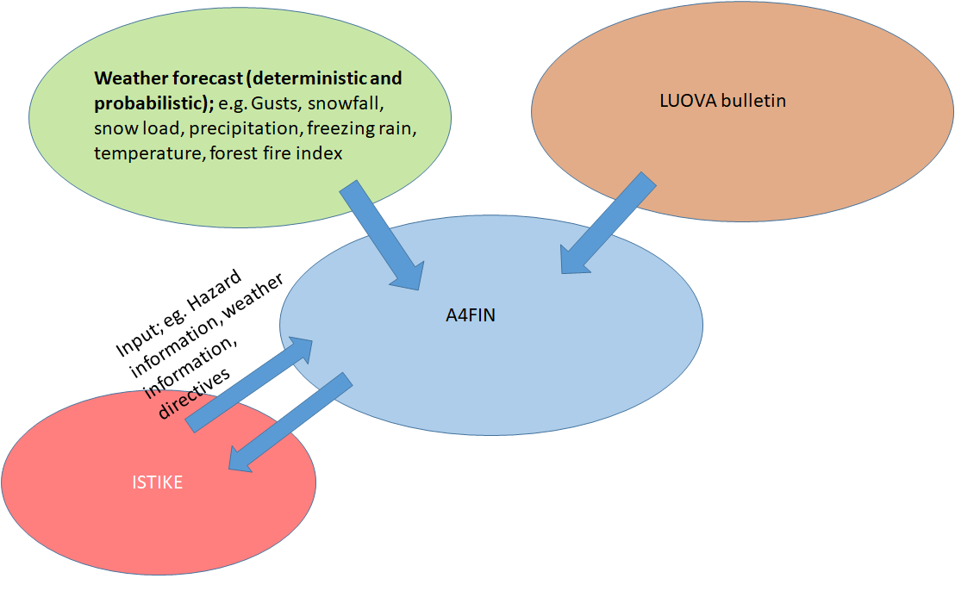
In more detail, the graph above helps to understand the process to put in place in this test case to formalize A4Finn:
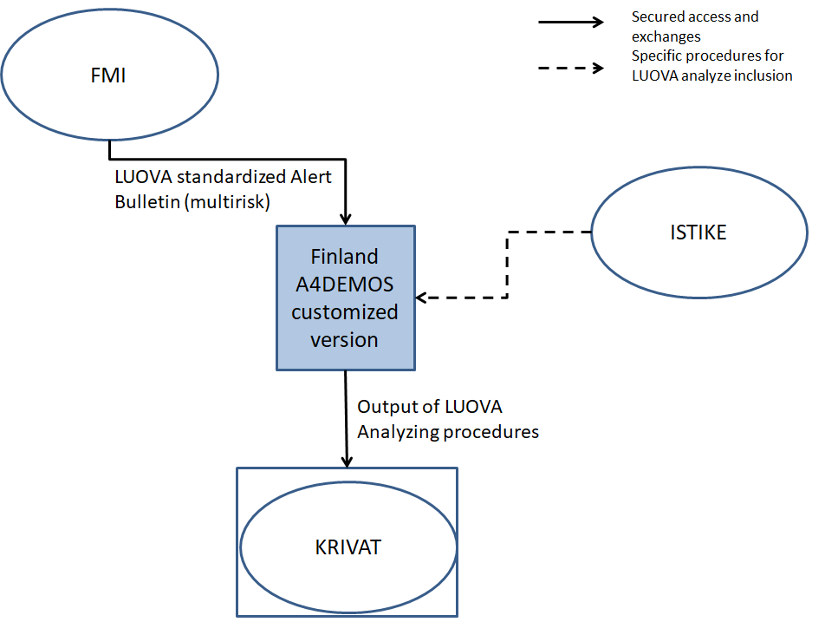

Performances:
Secure / Flexible

Architecture and standards:

Technologies:

I/O data and data format:

Annex 5. Switzerland UC-01
Title / Overview:

Medium Term Disposition Forecast for Natural Hazards:
- Avalanche
- Floods, debris Flows, Landslides
The objective of this Use-case is to provide to local organisations and experts some official warning levels considering two types of hazards, avalanches and debris flows (floods / landslides) for the five regions of Canton of Berne.

Use-case Description:

The users are local organisations (basic view) and regional and cantonal experts (extended/expert view). After being logged in the system, the user shall see the map of the five regions of the Canton of Berne, where he can click to select the region and the system shall display the basic view, and an option for the expert view. The views (charts below) are computed using two algorithms (provided by University of Geneva), one for avalanches (snowfall) and another one for floods/debris flows (rainfall). Some indicators regarding uncertainty should be provided (variance of the different weather forecast model). Models and charts are calculated once per day.
Warning levels correspond to official Swiss levels (1: low danger to 5: very high danger).

HMI (Human Machine Interface) requirements or needs:
The hazard levels should be displayed on a map per region (the user selects one of the five regions):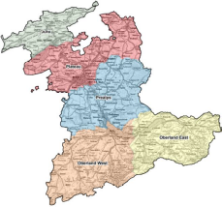

Two indicators shall be displayed, depending of the expertise level of the user:
- basic view: 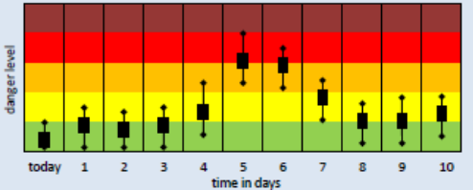

- expert view (5 charts):
1 chart for Probability of exceedance for a danger level: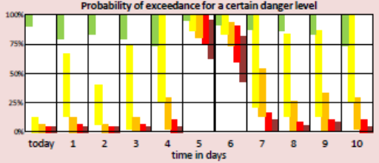
4 charts for Probability of exceedance per time (24h, 48h 72h) and per temperature (°C): 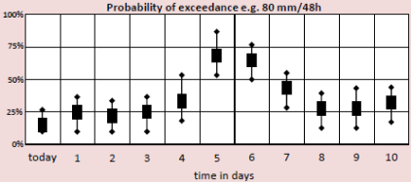

Process and rules:

Performances:

No specific constraints, as the algorithms are computed once a day, the results shall be displayed accordingly

Architecture and standards:

Technologies:

Web access

I/O data and data format:

Annex 6. Switzerland UC-02
Title / Overview:

Disposition of Mass Movements in Periglacial Areas:

The objective of this Use-case is to display information about the development of the thickness of the active layer and the snow cover for the three concerned regions of Canton of Berne.

Use-case Description:

The users are local organisations (basic view) and regional and cantonal experts (extended/expert view). After being logged in the system, the user shall see the map of the three south regions of the Canton of Berne, where he can click to select the region and the system shall display charts about thickness of the active layer and the snow cover. The views (charts below) are computed using algorithms (provided by Geo7 AG).

HMI (Human Machine Interface) requirements or needs:
The hazard levels should be displayed on a map per region (the user selects one of the three regions): 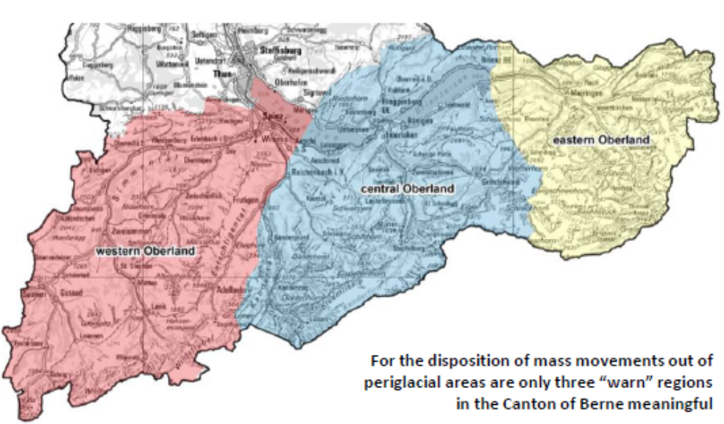

One chart per region and substrate types ( e.g. rock, coarse debris, fine debris): 3 regions and 3 substrates
Rock and Debris are over 10 days, Snow over months in a year
Expert views (no basic information, only for experts):
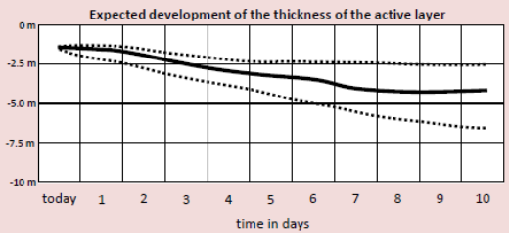 and 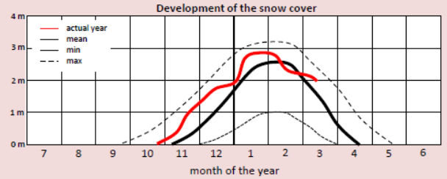

Process and rules:

Performances:

No specific constraints, as the algorithms are computed once a day, the results shall be displayed accordingly

Architecture and standards:

Technologies:

Web access

I/O data and data format:

Annex 7. Switzerland UC-03
Title / Overview:

Disposition Shallow Spontaneous Landslides:
- Avalanche
- Floods, debris Flows, Landslides
The objective of this Use-case is to provide to local organisations and experts some official warning levels considering the hazard of landslides for the five regions of Canton of Berne.

Use-case Description:

The users are local organisations (basic view) and regional and cantonal experts (extended/expert view). After being logged in the system, the user shall see the map of the five regions of the Canton of Berne, where he can click to select the region and the system shall display the basic view, and an option for the expert view. The views (charts below) are computed using algorithms (provided by Geo7 AG), to translate forecasted weather information into danger level based on events on the past.

HMI (Human Machine Interface) requirements or needs:
The hazard levels should be displayed on a map per region (the user selects one of the five regions):

Two indicators shall be displayed, depending of the expertise level of the user:
- basic view:
- Danger level 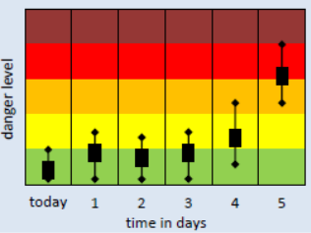
- Degree of similarity to past events 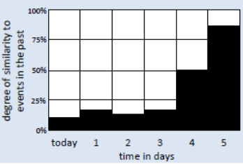

- expert view:
- List of the 10 events closest to the predicted weather situation: 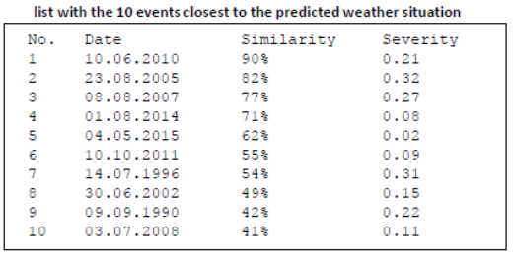

- Similarity of forecasted weather parameters with the range of weather in the past which caused landslides: 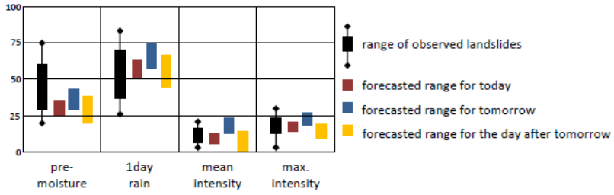
- Measured rainfall parameters of past shallow landslide event: 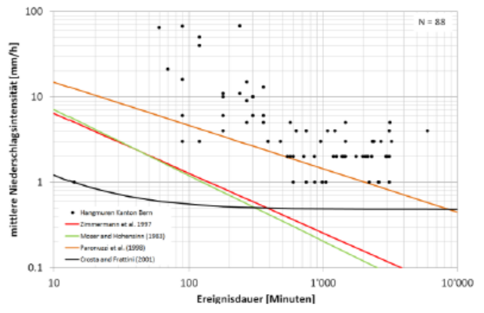

Process and rules:

Performances:

No specific constraints, as the algorithms are computed once a day, the results shall be displayed accordingly

Architecture and standards:

Technologies:

Web access

I/O data and data format:

Annex 8. Switzerland UC-04
Title / Overview:

Nowcasting in the Catchment of the River Zug:
- Flood
- Landslide
The objective of this Use-case is to provide to local organisations and experts some warning levels considering hazards of landslides and flood for the catchment of the river Zug.

Use-case Description:

The users are local organisations (basic view) and regional and cantonal experts (extended/expert view). After being logged in the system, the user can see the basic view, and an option for the expert view. The views (charts below) are computed using algorithms (provided by University of Geneva), and display information over hours. Some thresholds can be defined to send an alert (SMS or email) when they are exceeded.

HMI (Human Machine Interface) requirements or needs:

Two indicators shall be displayed, depending of the expertise level of the user:
- basic view: 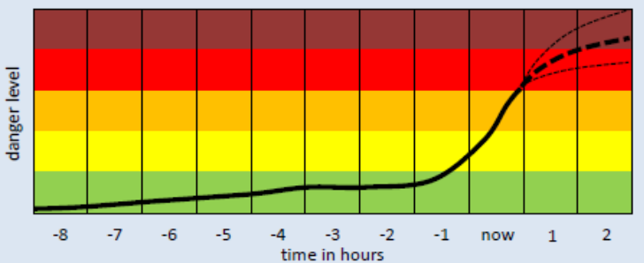

- expert view:
- rainfall: 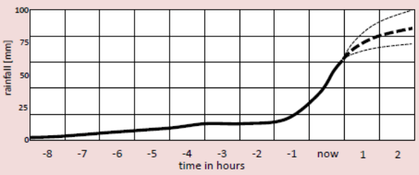

- other (TBD)

Process and rules:

Performances:

Due to hourly level of information, the system shall be able to compute every hour the results and display (refresh) accordingly.

Architecture and standards:

Technologies:

Web access

I/O data and data format:

Annex 9. Catalonia UC-01
Title / Overview: Common system to visualize and cross information from different sources

The objective of this Use-case is to have a single-entry point where all the hazard and impact data used by the Civil Protection of Catalonia (INTC) is available and inter-related. This will allow a more efficient way to analyze all the available data (currently spread in many sources) in case of current or potential risks appear.

Use-case Description: (Context / Actors / Conditions / Task or Steps Decomposition / Alternate Steps)

The Use-case covers the development of a visualization system where the different operators from INTC can analyze all the hazard and impact information, including the currently used sources of information and the new ones coming from Anywhere products.
Currently INTC uses the following dynamic information sources and systems to analyze a current or future risk:
- Catalonia Weather Service (SMC), providing information of:
- SMP (Situació Meteorològica de Perill). Hazard warnings based on all available information and human interpretation.
- Radar rainfall (XRAD radar network).
- NWP Model information.
- Sensor data (XEMA network of AWS).
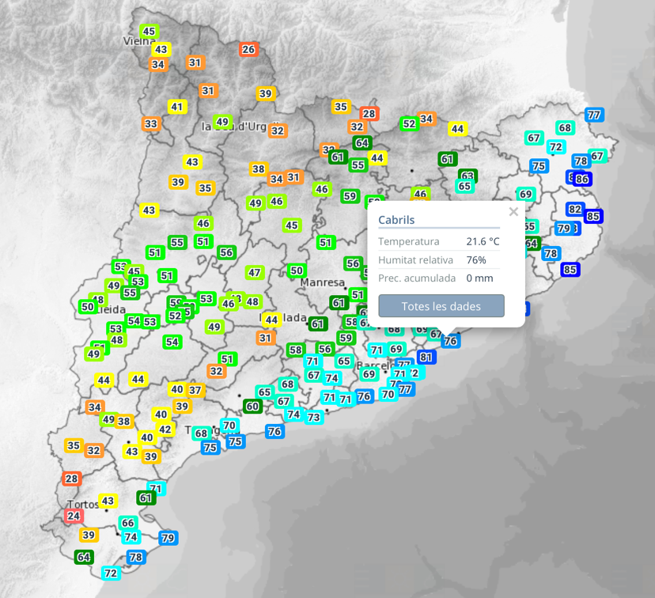

- Network of volunteers providing Meteorological Observations (XOM)
Some of the information is public available and other goes through private portals or services.
- Catalonia Water Agency (ACA), providing river warnings (issued using radar and rain gauges information) and sensor information (river gauges) through the “Water in real time” system. A new version updating functionalities and technologies is currently being developed (project will end in 12/2017).
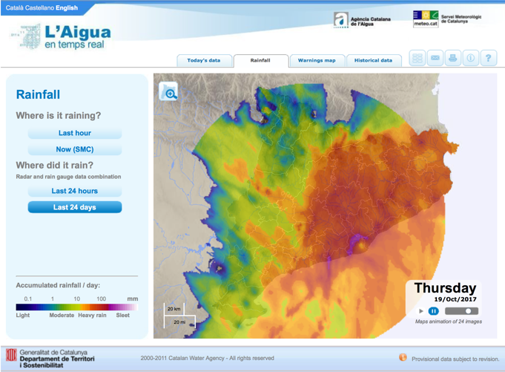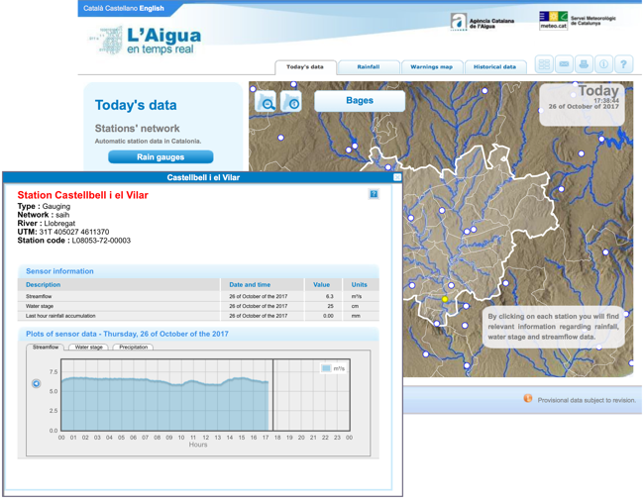
- Catalonia Water Agency (ACA), provides reports when an event is ongoing. The data from several sources (radar, rain gauges, river gauges, forecast from SMC, etc.) is analyzed by experts and summarized in a report sent by email to INTC.
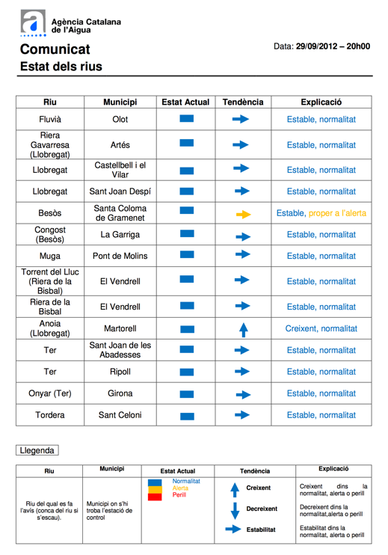
- Catalonia Water Agency (ACA), provides reports when there is an intervention in the rivers that might affect the river status. Those reports are currently sent by email.
- The Ebro river basin (CHE), providing through the Sistema Automática de Información Hidrológica (SAIH) portal river gauges’ information (public portal).
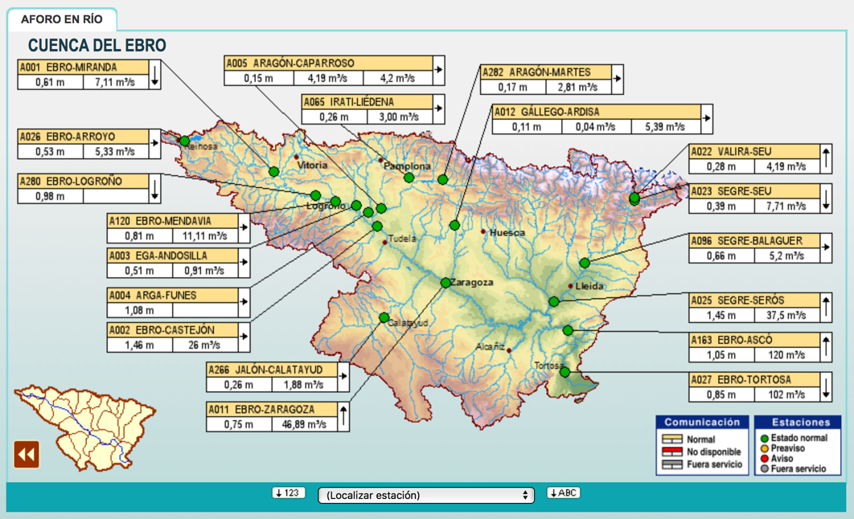

- The Jucar river basin (CHJ) –covering a very small area in the south-, providing also information of its river gauges (public portal).
- RiskHydro, a private service provided by Arantec Enginheria S.L. (member of ANYWHERE SICN Board) that provides river gauges’ measurements and snow level.
- Spain Meteorological Agency (AEMET), providing information of radar rainfall, NWP forecasts, rain gauges’ measurements, official warnings and fire risk assessment. INTC uses the public web information.
- Meteologica, a private company offering meteorological forecasts through its private services.
- The Catalonia agriculture department, providing fire risk assessment.

Static information used in emergency management and to be incorporated is:
- Geospatial information provided by the Catalonia Cartographical services (IGCC).
- Pre-calculated flooding and risk maps (according to Directive 2007/60/EC).
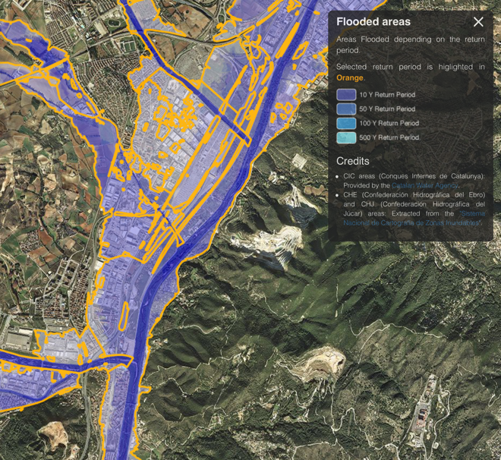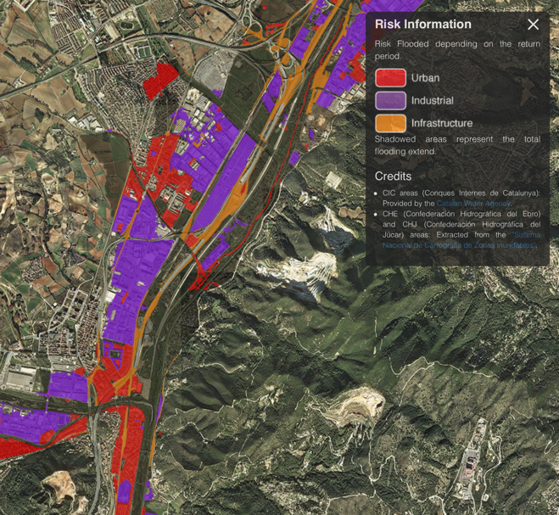

- Critical points information.
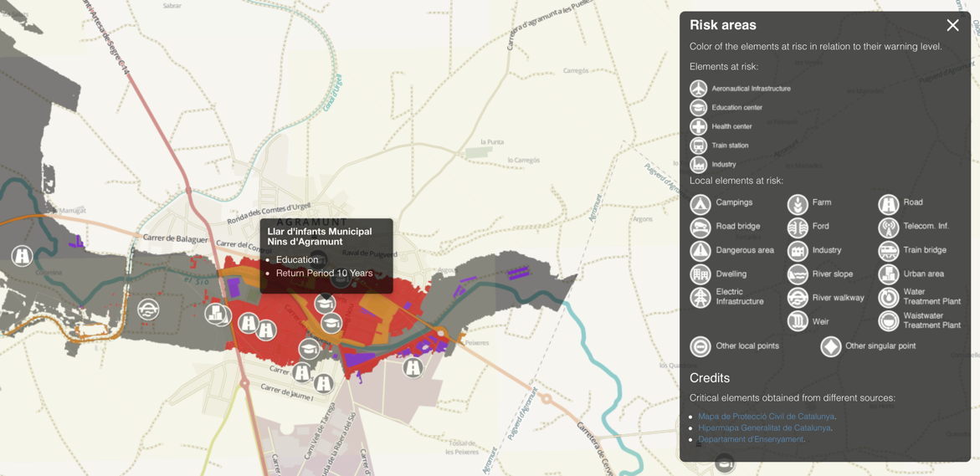

INTC operators must analyze various sources for each specific hazard. This Use-case covers the integration and cross relation of all this information in a specific portal, reducing the time spent by the operators analyzing an event through providing centralized and integrated information.
HMI (Human Machine Interface) requirements or needs:

The system will be a web application accessible also by mobile devices. It must provide a general overview, where each municipality is highlighted in case a warning is expected. In addition, it must be possible to analyze which municipalities are affected by a specific hazard in this overview.

The application must be able to analyze each product integrated in the system, together with the impact calculated for this product. It must also contain additional static layers, specific for each hazard.

Process and rules: (any specific requirements linked with domain: weather/emergency/etc.)

The information available for each hazard in the system, in combination with ANYWHERE products, will be:
Floods:
- Radar rainfall products, including identification of convective areas and short-term forecasting (Nowcasting)
- Rain gauges provided by different providers, with warnings based on several time accumulations.
- Official warnings provided by SMC (SMP warnings).
- River gauges measurements provided by ACA, CHE, CHJ and RiskHydro.

Fire:
- Fire risk assessment provided by AEMET and the Catalonia agriculture department.

Snow:
- Precipitation type provided by SMC.
- Official warnings provided by SMC.
- Snow level provided by Arantec.

Wind:
- Official warnings provided by SMC (SMP warnings).
- Wind gusts forecasts provided by SMC and Meteologica.

Information about vulnerability (maps or critical points) should be displayed in all hazards in combination with data and impact products.

Performances: (any requirements regarding performances or time constraints)

The data refresh should be as high as possible, in order that the system offers latest information to the operators as soon as it is available.

Architecture and standards: (any software architecture requirements or standards to apply)

Technologies: (any information regarding technologies to use or hardware or IT)

OpenLayers, Javascript, HTML5, CSS3, REST to get data, WxS,…
I/O data and data format: (any information regarding inputs/outputs and data formats)

All the ANYWHERE products will be acquired by the system from the MH-EWS, using its services and interfaces. These services and interfaces are defined in Deliverable D3.2.
Information of the other data sources will be acquired connecting to each data source individually.

Annex 10. Catalonia UC-02
Title / Overview: Integration of the impact models into the SICECAT2 system

The objective of this Use-case is to integrate the most relevant products offered by the ANYWHERE MH-EWS or A4Cat system into the SICECAT2 system used by the Catalonia Civil Protection to track activities.

Use-case Description: (Context / Actors / Conditions / Task or Steps Decomposition / Alternate Steps)

SICECAT2 is the tool used by the Catalonia Civil Protection to manage the emergencies. It covers the following features:
- Management of incidents, allowing to send SMS, emails and faxes to all the actors involved in an emergency. SICECAT records and keeps track of all the information sent and received.
- Keeps track of the activities of the protocols linked to the different risks.
- Register the activation of the different plans of the civil protection.
- Collect all the data from the municipalities, the agencies and others, used to solve an emergency.
- It includes GIS capabilities, to display all the geographical information.

The user is the SICECAT2 system, who will acquire impact products from the MH-EWS or information from the A4Cat prototype in a standardized way. This will be later exploded by SICECAT2, allowing to generate automatic reports that can be disseminated to different institutions.

HMI (Human Machine Interface) requirements or needs:
The interaction will be done through the SICECAT2, and no additional requirements are envisaged.
Process and rules: (any specific requirements linked with domain: weather/emergency/etc.)

The impact models integrated in SICECAT2 can be later used by the system to generate internal warnings or to be integrated in the different bulletins Civil Protection generates.
Performances: (any requirements regarding performances or time constraints)
-
Architecture and standards: (any software architecture requirements or standards to apply)

The following figure presents the general architecture of SICECAT2, including the available interfaces:

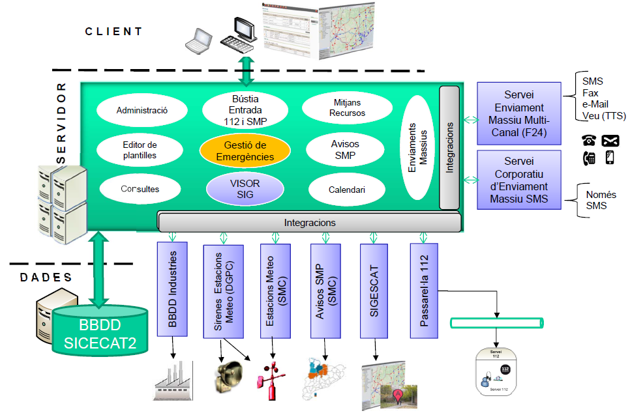

Adequate interface of SICECAT2 to incorporate the MH-EWS or A4Cat information has to be explored.
Technologies: (any information regarding technologies to use or hardware or IT)
-

I/O data and data format: (any information regarding inputs/outputs and data formats)

The impact models’ data will be integrated into SICECAT2 platform using the services and interfaces provided by the MH-EWS, and described in Deliverable D3.2. A4Cat information integration will be done through agreed interfaces.

The following figure presents the current interfaces provided by SICECAT2, and how different data providers connect with the platform.
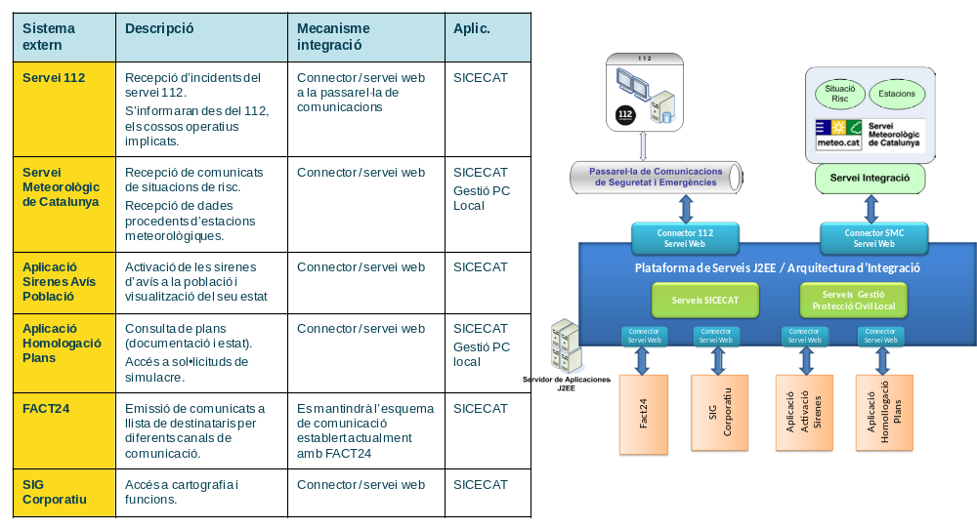

Annex 11. Rogaland (Norway) Implementation site UC
Title / Overview : (title + short introduction about purpose of the use case)
Risk-based decision support when responding to extreme weather incidents in Rogaland.

The use case shall help members of the crisis response team in Rogaland to act faster and more accurate to risks related to extreme weather.

Use Case Description : (Context / Actors / Conditions / Task or Steps Decomposition / Alternate Steps)

The relevant risk-based decisions for the crisis response team (main actor) in Rogaland are:

- When to notify resources
- When to notify and warn the public
- When to mobilize resources
- Which specialized types of resource to mobilize
- When and where to evacuate
- When should an extreme weather situation be declared as finished (and the situation goes back to normal)

The most common and relevant incidents related to extreme weather in Rogaland:
- Storm surge flooding parts of the city
- Large amounts of precipitation during a short period of time
+ Snow that causes closed roads
+ Rain that causes floods
- Strong winds may cause needs for evacuation
- Outage of electrical supply

HMI (Human Machine Interface) requirements or needs :

Sketch:

Map-based with time line.
Information provided as:
- icons/ lines/ polygons
- details clicking possibilities (textual or graphs)
+ tool tips
+ labels
+ call-outs
+ separate windows
+ ribbons
+ lists

Process and rules : (any specific requirements linked with domain : weather/emergency/etc.)

In addition to weather related information, the map should be able to visualize among others:
- Traffic (current and expected based on historical data)
- Critical infrastructure
- Results from analyses

Performances : (any requirements regarding performances or time constraints)

Information should be updated when the underlying information changes, unless this is too often. In this case changes every minute or so is OK.

Serious changes, for example changing certain risk levels should be presented as warnings to the users.

Architecture and standards : (any software architecture requirements or standards to apply)

Technologies : (any information regarding technologies to use or hardware or IT)

The DEXi tool for multi-attribute decision making will be used as part of the risk aggregation mechanisms.

Platforms:
- Desktop PCs
- Web based
- Mobile devices
- Virtual reality

I/O data and data format : (any information regarding inputs/outputs and data formats)

Import/export to the CIM tool will be considered.

Annex 12. SM & Crowd sourcing Use-cases and HMI details.

Use Case Description: (Context / Actors / Conditions / Task or Steps Decomposition / Alternate Steps)

User can login with credentials, or create account; manage personal details, their organization details, staff, and offices.
User detail is shared with A4DEMOS, so if user is registered within the A4DEMOS, they do not need to register again in the SM&Crowd application.

HMI (Human Machine Interface) requirements or needs:
Web GUI for User/Organization administration:
• Register/modify user
• Register/modify organization (location, type)
• Register/modify office (location, type)
• Register/modify personnel (contact, role)
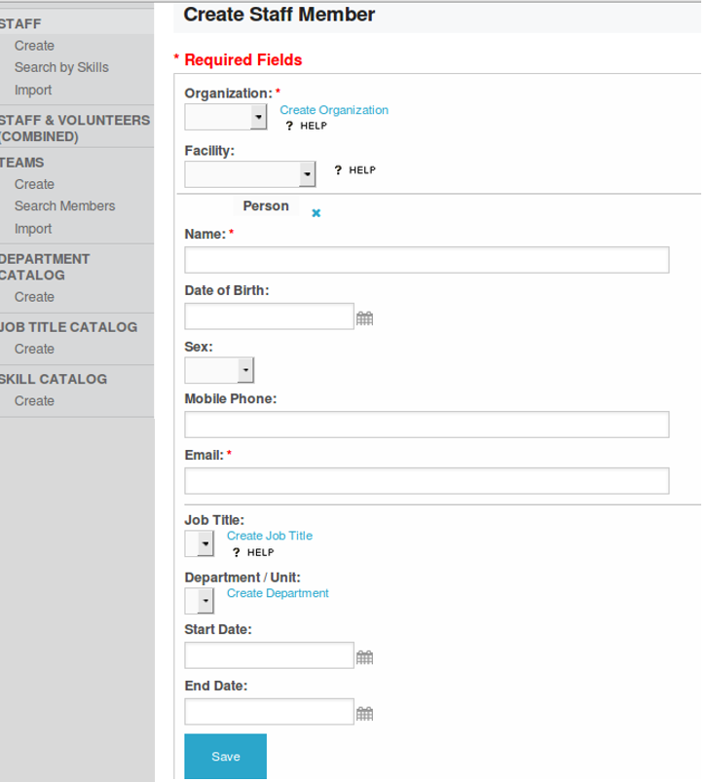
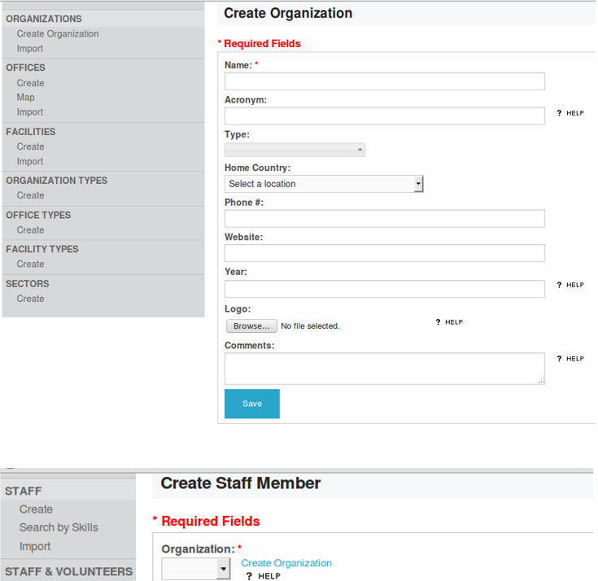

Use Case Description: (Context / Actors / Conditions / Task or Steps Decomposition / Alternate Steps)
Map/Data administration:
• User can import data catalogue from MH-EWS and/or any other OGC compliant web-service, create their own map views (moving layers, showing/hiding layers).
• User can subscribe to MH-EWS alerts in CAP format (or any other external CAP provider), visualize the CAP on the map.

HMI (Human Machine Interface) requirements or needs:
Web GU:
• Create/modify map configuration (controls the map viewer-projection/zoom level, map center)
• Import/Add/ modify layers (import OGC service, select rendering, and visibility on/off, position up/down)
• Change access right/distribution list of the map

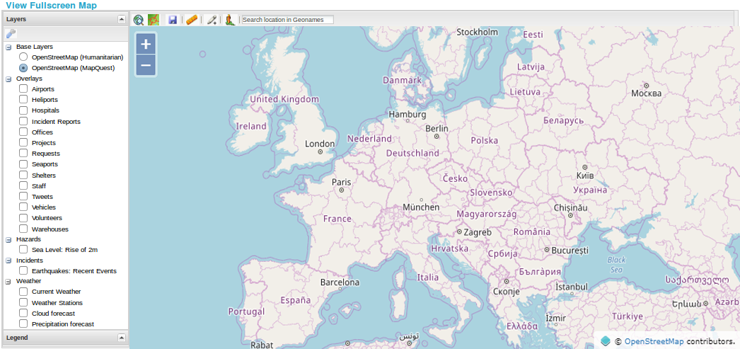

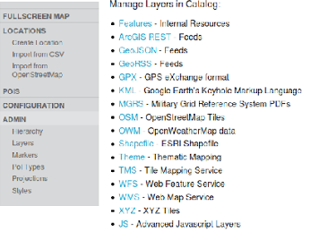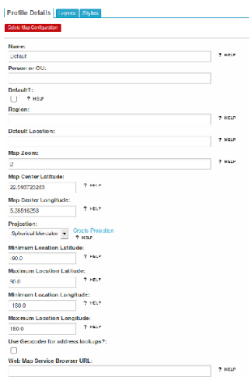

Use Case Description: (Context / Actors / Conditions / Task or Steps Decomposition / Alternate Steps)
User can create/list/modify requests (information, goods, services, any above mentioned crowdsourcing task), locate it on the map, share it to configurable list of responders
When creating new request, user can define different field types (text, selections, radio-buttons, pictures, videos, locations and time fields)
When new request is published, it is automatically available via dedicated web interface and mobile app (ushahidi, pybossa, epicollect) and users from configurable distribution list are automatically notified.
HMI (Human Machine Interface) requirements or needs:
Web GUI:
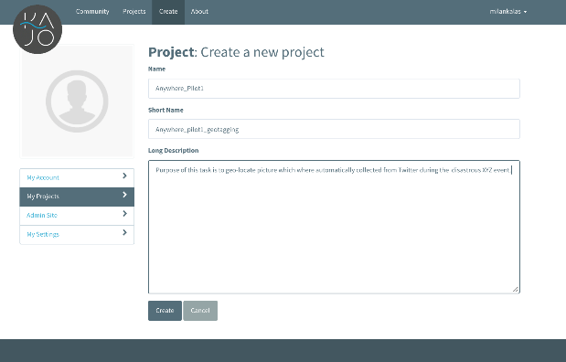
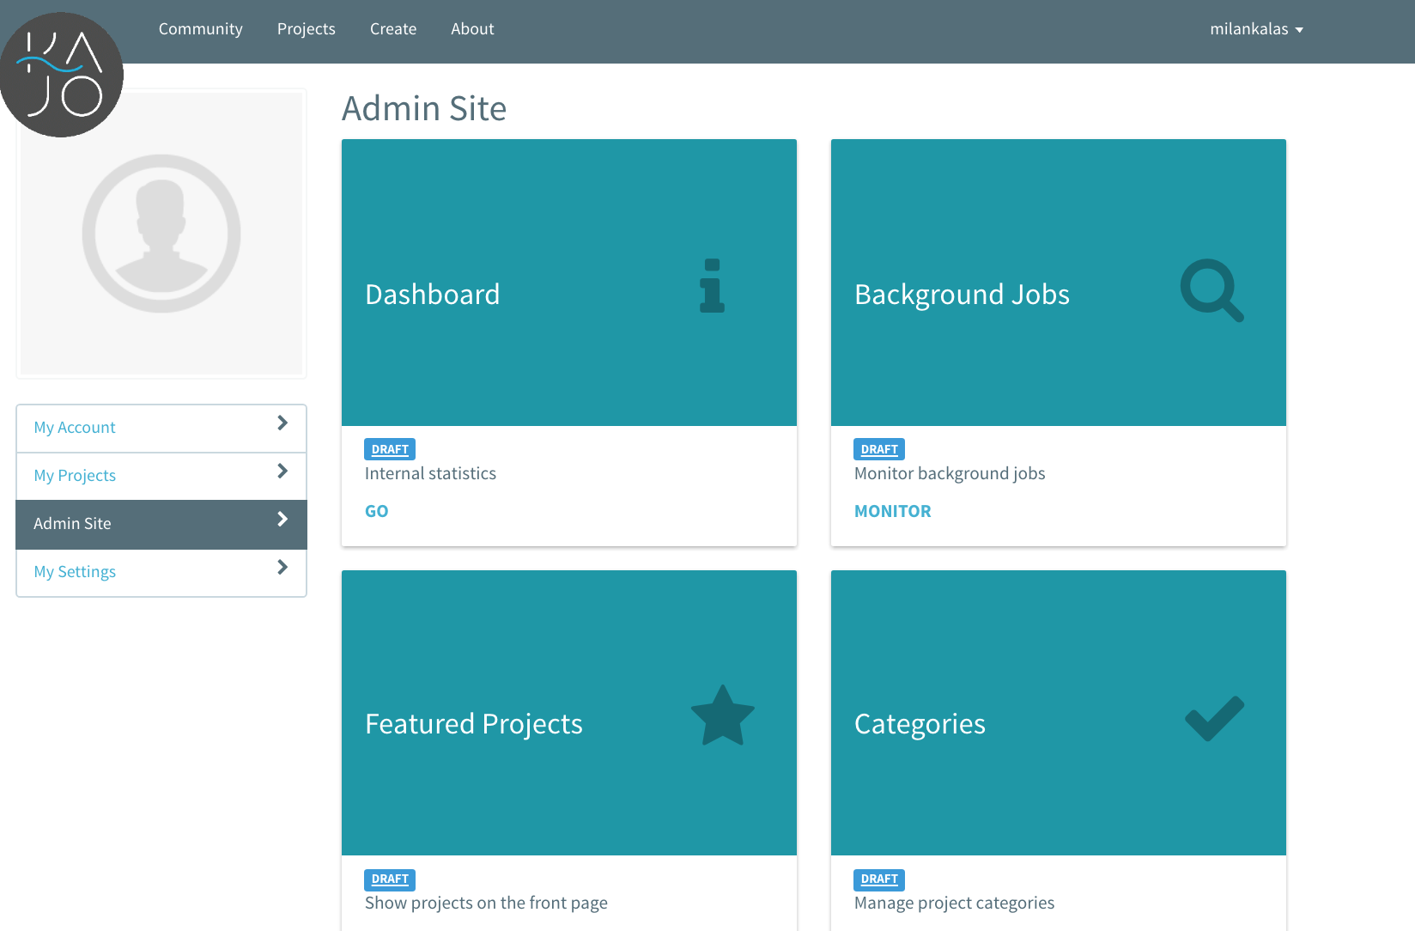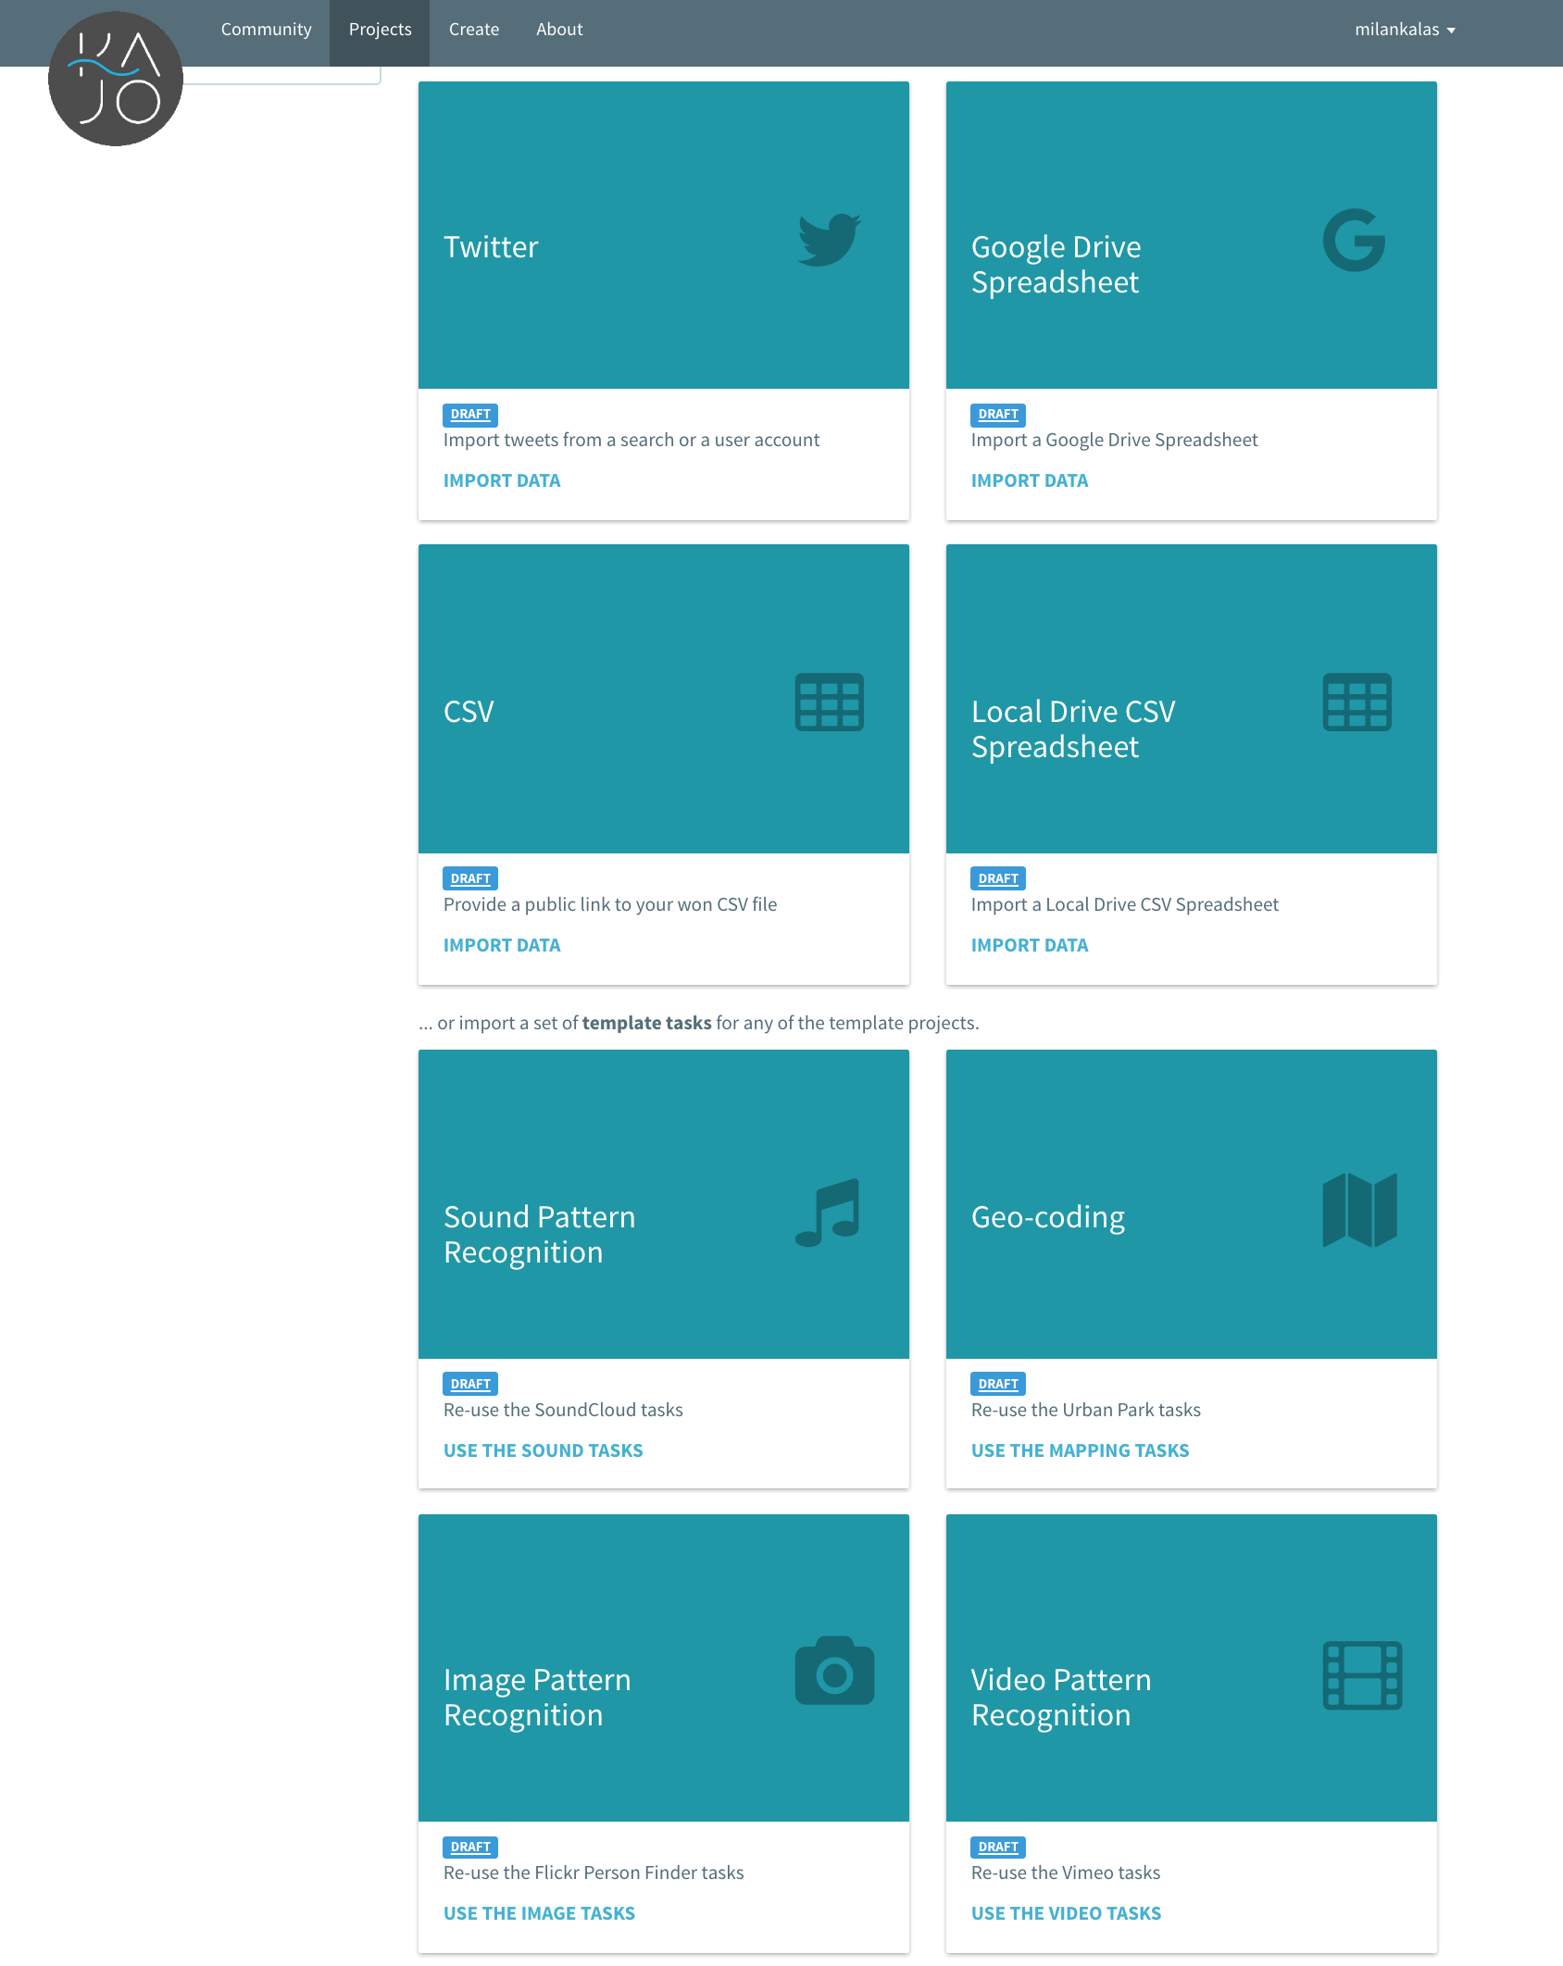
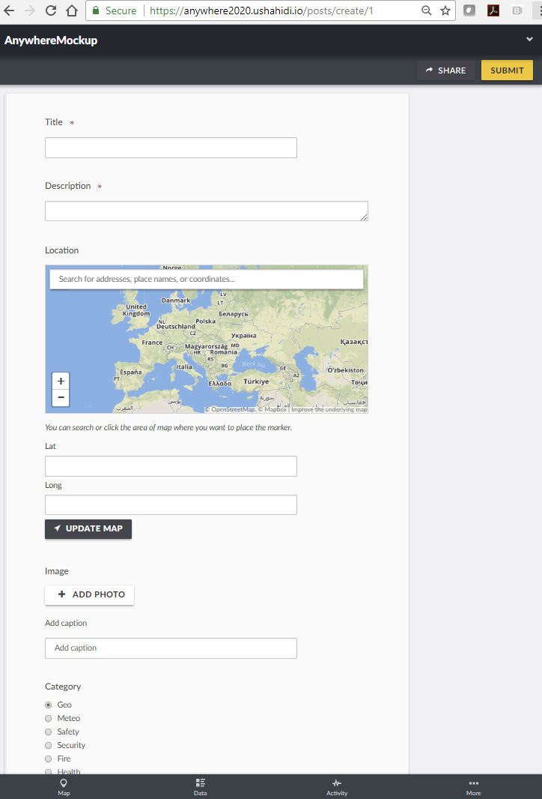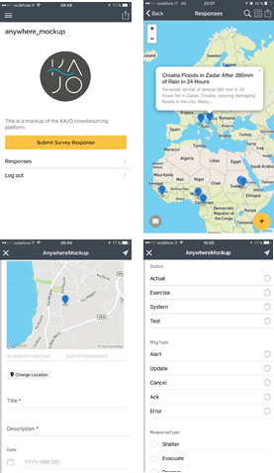

Use Case Description: (Context / Actors / Conditions / Task or Steps Decomposition / Alternate Steps)
User can subscribe to a CAP and use selected CAP parameters as triggers to use system templates to automatically pre-create the crowdsourcing requests. e.g. Flood=> trigger request for posting georeferenced water level pictures; in case of high snow storm=> trigger reporting on traffic limitations or energy interruptions; Geo-referencing images from social networks; etc.
HMI (Human Machine Interface) requirements or needs:
Web interface where user can modify/manage the pre-created requests templates (Similar to admin panel in previous section).

Use Case Description: (Context / Actors / Conditions / Task or Steps Decomposition / Alternate Steps)
User can start a social media campaign for selected region (bounding box)/language/keywords. Campaign is logged in the system (who created, when started, which keywords etc). System triggers automated collection of social media content passing the filter defined. Items are stored in no-sql database via persistent queues (no data loss) and referenced to a specific collection. User can stop/modify the collection and monitor amount of data collected.
HMI (Human Machine Interface) requirements or needs:

Use Case Description: (Context / Actors / Conditions / Task or Steps Decomposition / Alternate Steps)
User receives CAP alert from MH-EWS including the risk assessment related keywords (affected cities, infrastructure). System can trigger automatically social media campaign to start social media streamer for that particular event using event specific keywords from CAP message (including the risk/impact ones).
HMI (Human Machine Interface) requirements or needs:
CAP message with RISK/IMPACT related section for machine to machine triggering:
{
"ID":1366,
"off_lang1":"French",
"off_lang2":"",
"off_lang13":"",
"Cities":"
[Boulogne-Billancourt]
[Charenton-le-Pont]
[Clichy]
[Issy-les-Moulineaux]
[Ivry-sur-Seine]
[Levallois-Perret]
[Neuilly-sur-Seine]
[Nogent-sur-Marne]
[Paris]
[Saint-Cloud]
[Suresnes]",
"Region_name":"Paris",
"Population_Affected":85778.0,
"minx":3751378.8480999991,"miny":2884418.3940999992,"maxx":3768976.0672999993,"maxy":2894580.6076999996
}

Use Case Description: (Context / Actors / Conditions / Task or Steps Decomposition / Alternate Steps)
User can monitor overall status of the active social media collections and some statistical indicators derived from social media (e.g. total amounts of messages classified, georeferenced, top scoring keywords/hashtags/users/retweets, etc.)
HMI (Human Machine Interface) requirements or needs:
WEB-GUI

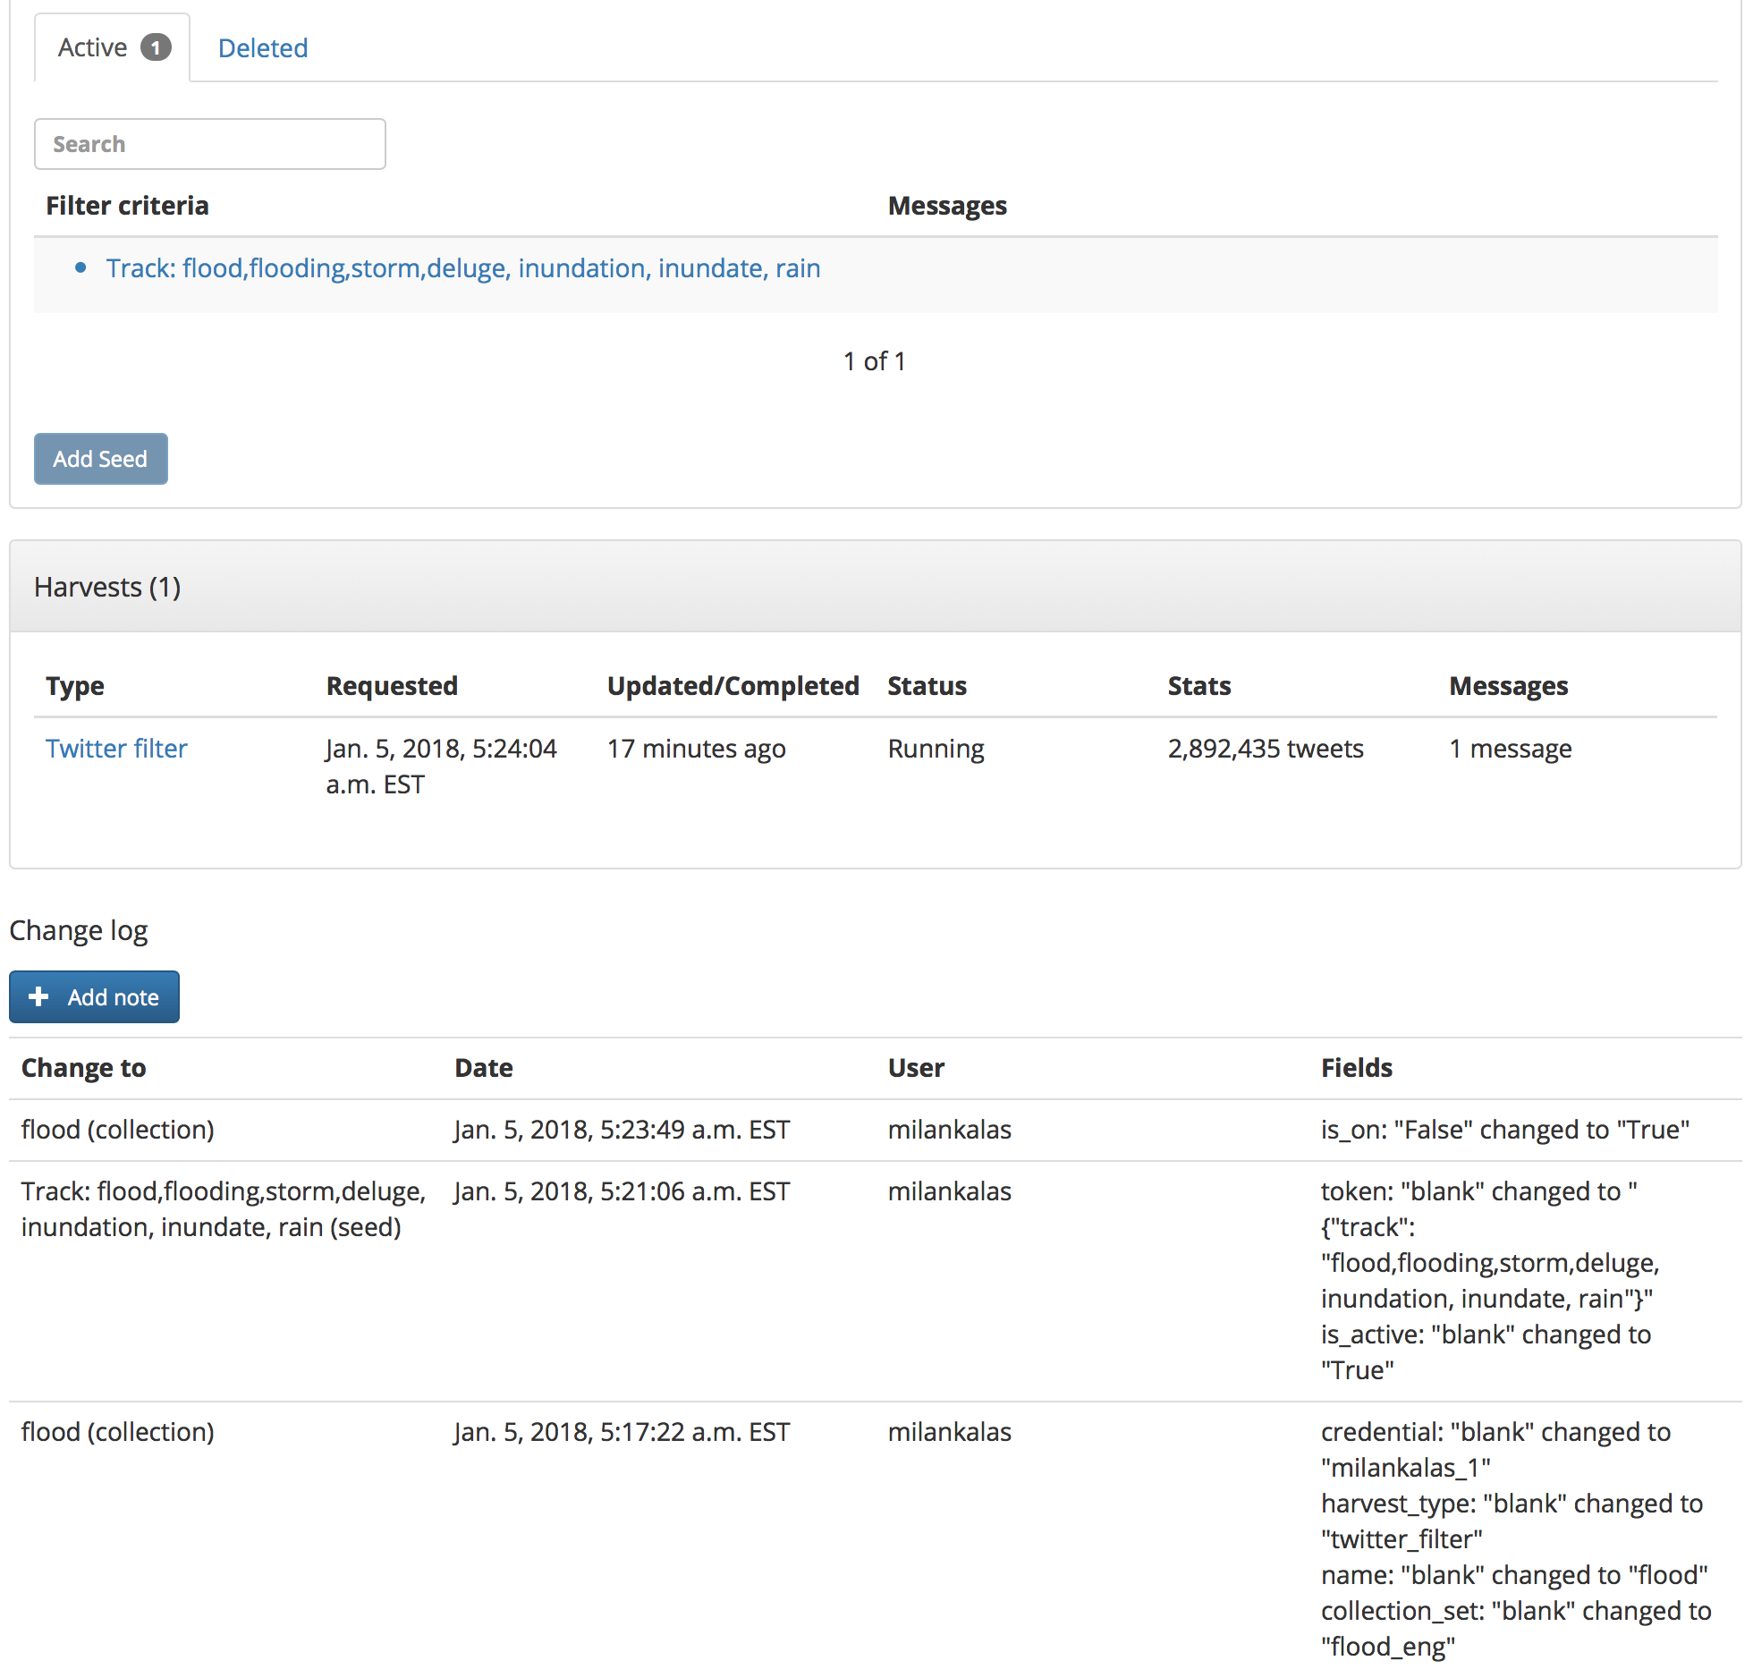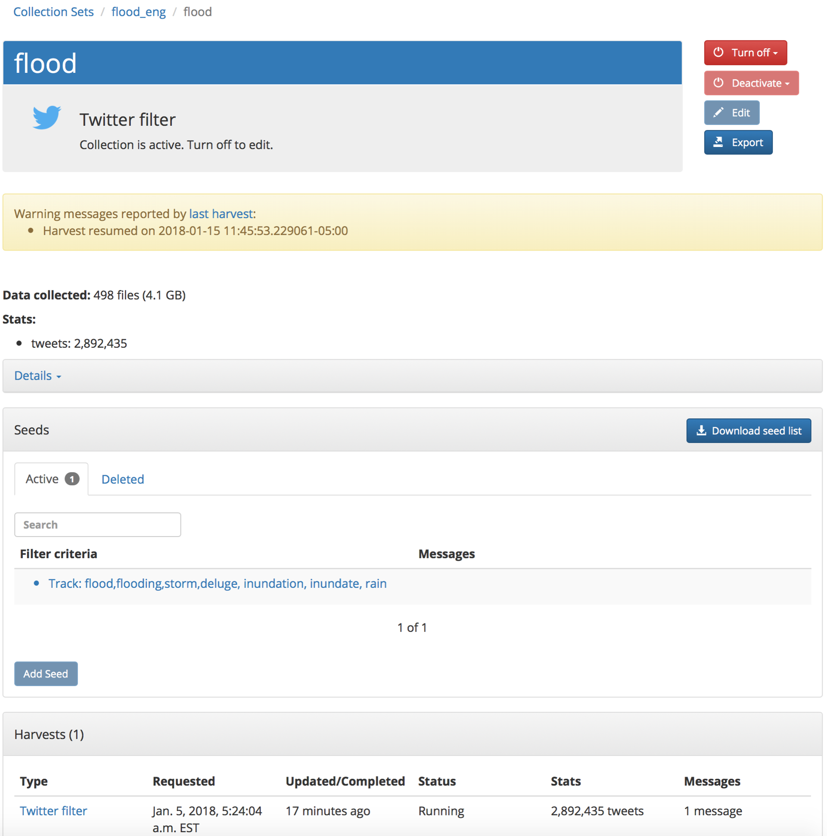

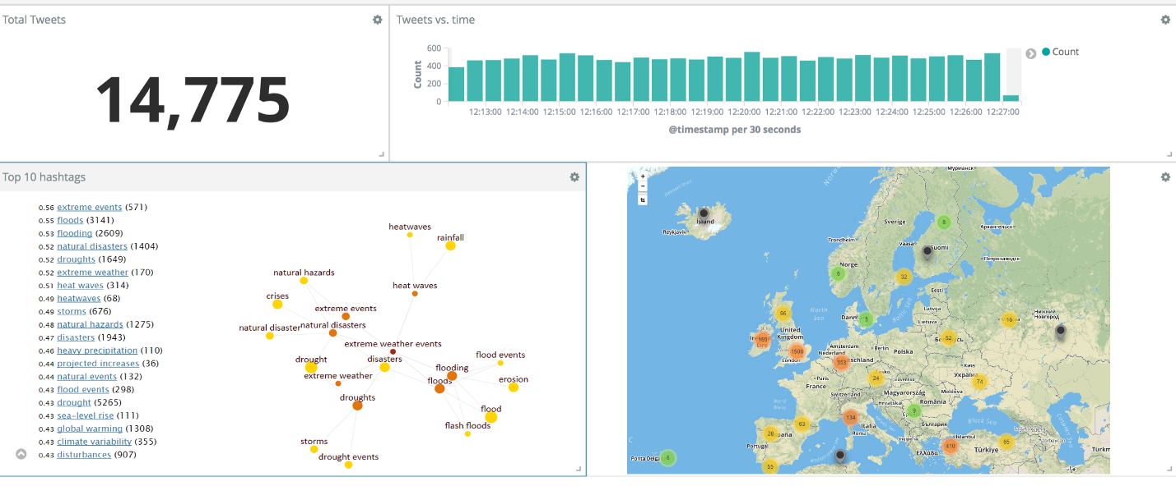

Use Case Description: (Context / Actors / Conditions / Task or Steps Decomposition / Alternate Steps)
User can see all active requests (crowdsourcing reports or social media aggregates) on the map. Filter them by date/place/category/etc.
Web GUI or mobile app

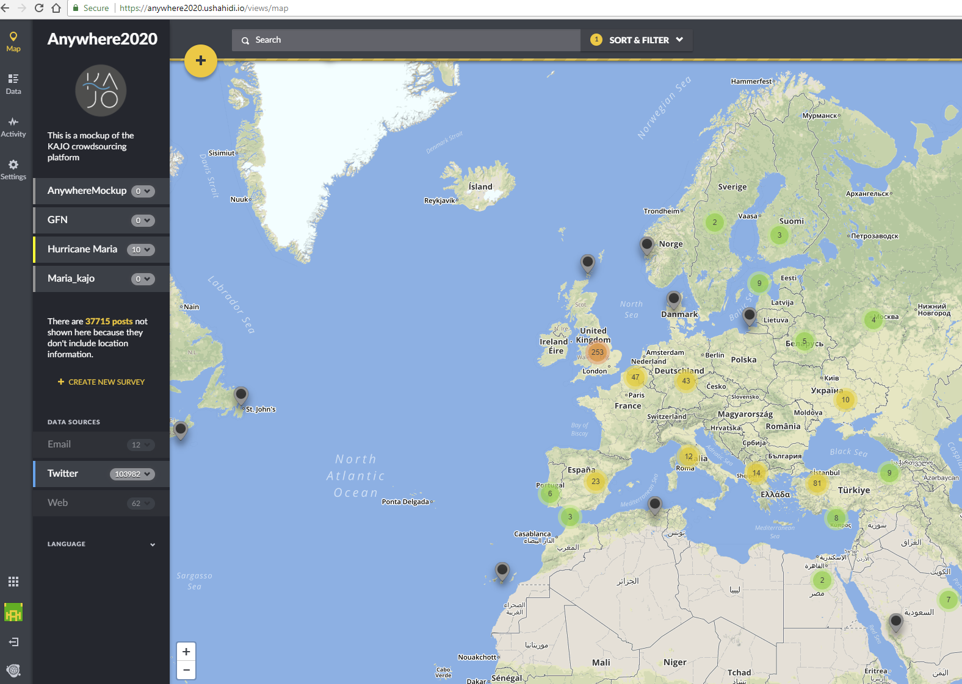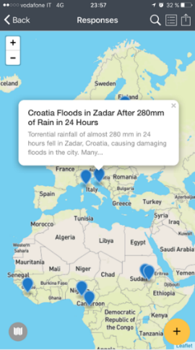

Public Protection and Disaster Relief organisations
"Use-case" refers in this document to the software engineering definition where the aim of a use case is to describe the behavior of a system from a user's point of view. In our approach, a Use-case is a list of actions (steps) which define the interactions between an actor (being a human or an external system) and the system, to achieve a goal.

